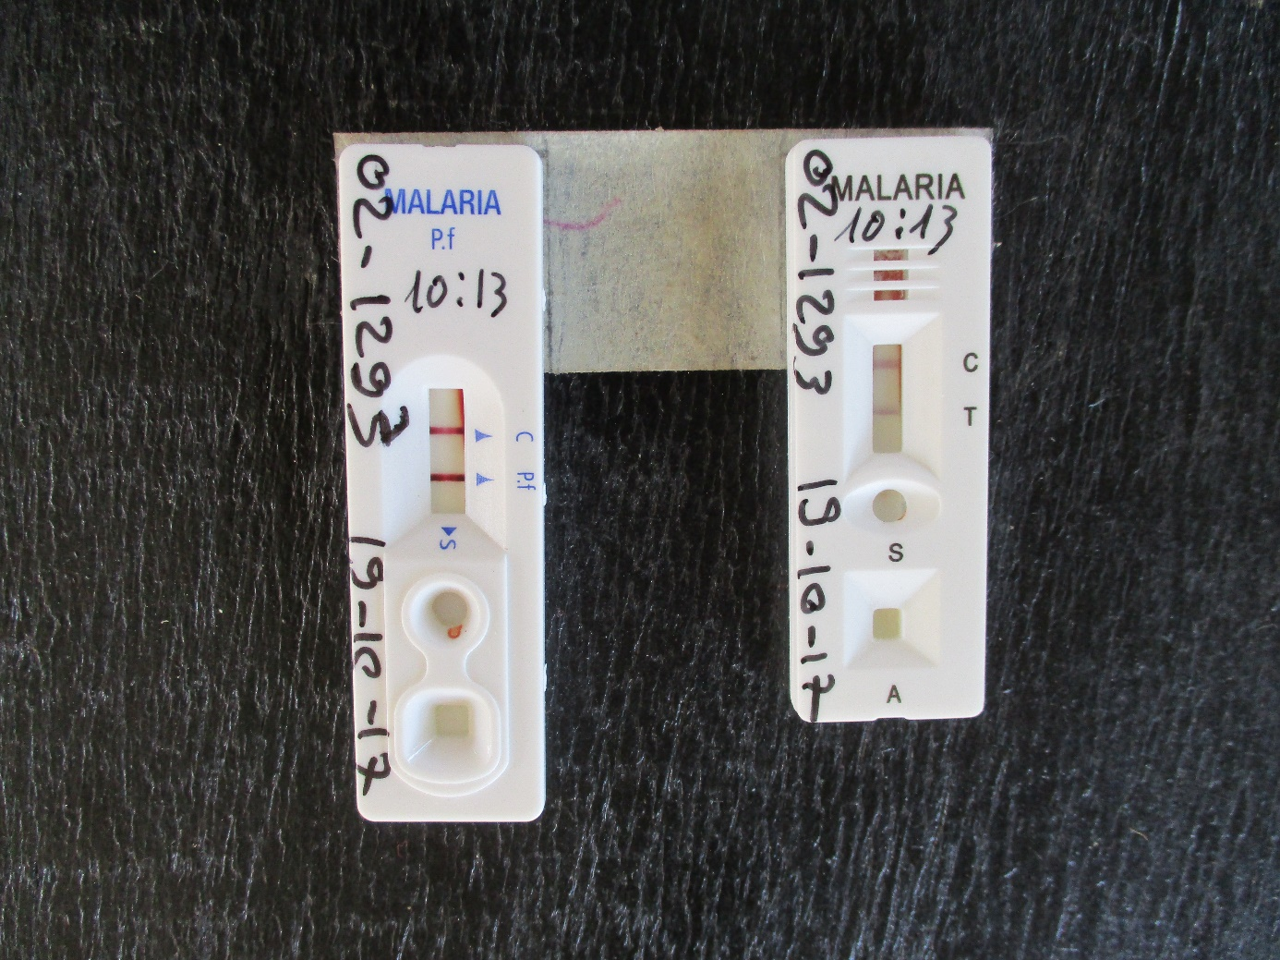

Additional file 2: Photograph of HRP2 (blue text) and pLDH (black text) malaria RDTs, high transmission seasons, Magaria, Niger. This participant had a negative blood smear.

