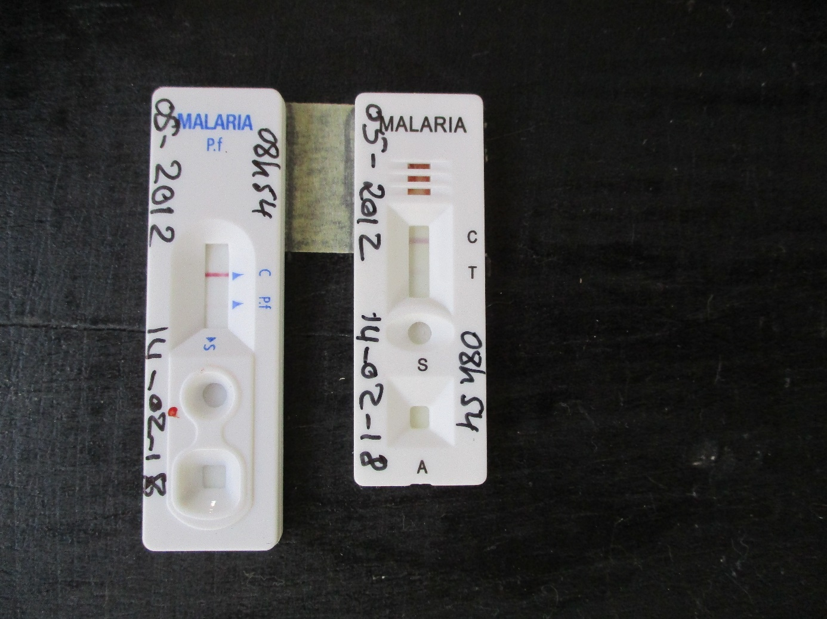

Additional File 5: Photograph of HRP2 (blue text) and pLDH (black text) malaria RDTs, low transmission season, Magaria, Niger. This participant had 24 parasites/mcl on blood smear.

