ADDITIONAL FILES FOR LEVERAGING PHONE BASED MOBILE TECHNOLOGY TO IMPROVE DATA QUALITY AT HEALTH FACILITIES IN RURAL MALAWI: A BEST PRACTICE PROJECT
Appendix 1: Personnel and their roles in the project
Table 1: Roles and responsibilities of personnel involved in the project
Name | Position | Role
Alinune Kabaghe | Team leader | Team leader/Coordination
Tinashe Tizifa | PhD student | Logistical support
William Nkhono | Data manager (postgrad) | Technical support
Spencer Mtengula | Data officer (undergrad) | Design + Training
Wamaka Msopole | District Medical Officer | Technical & implementation guidance
Ken Mkandawire | Health information system | Technical & implementation guidance
4 health facility in charge | Medical assistants | Administrative support
4 data clerks | Data clerks | Data entry

Appendix 2: Electronic Case Report form (eCRF) adopted from registers

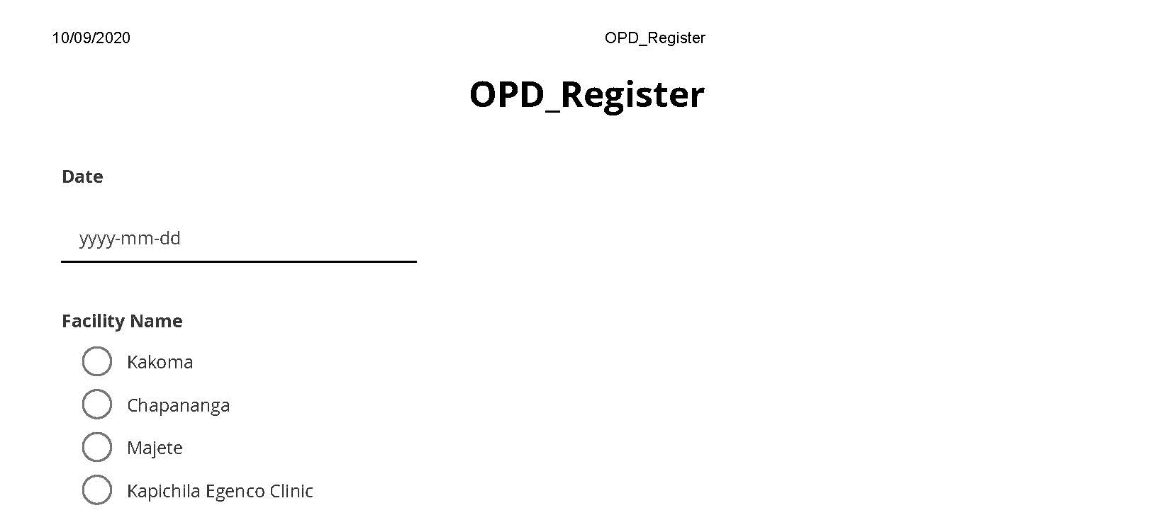
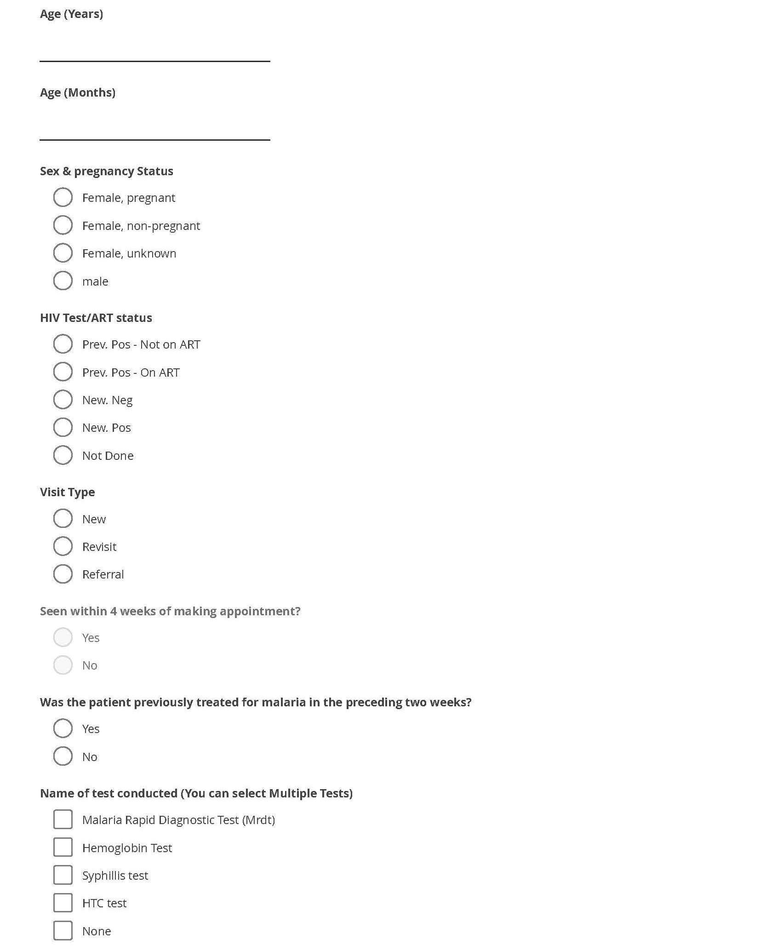
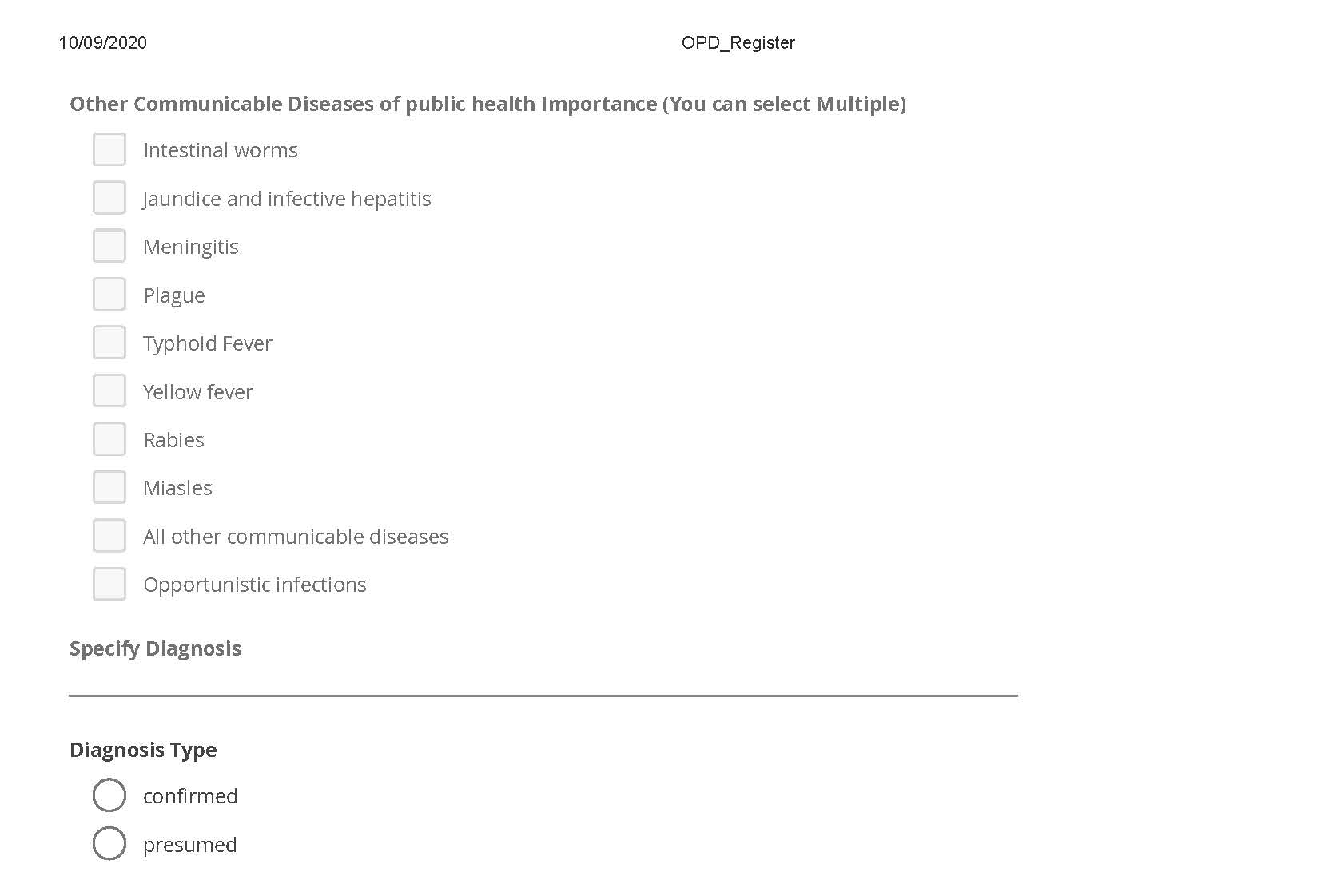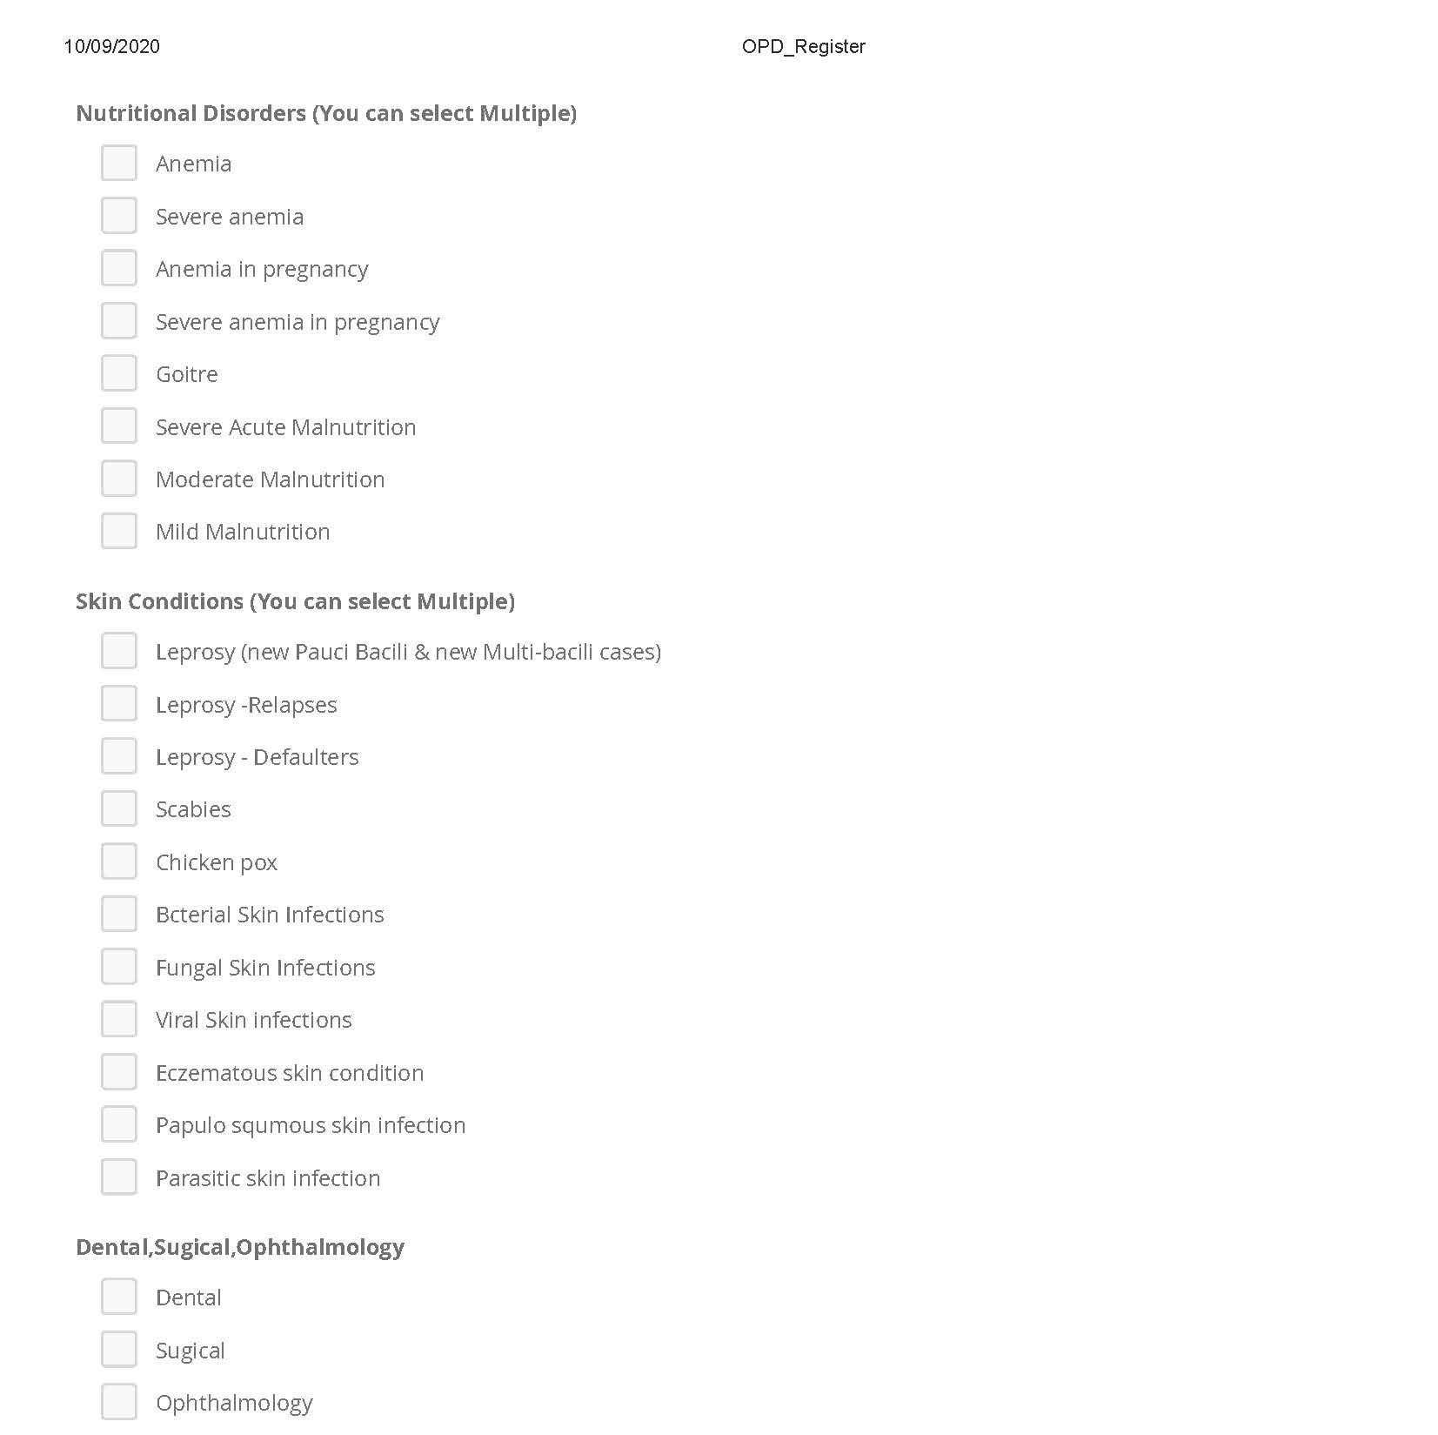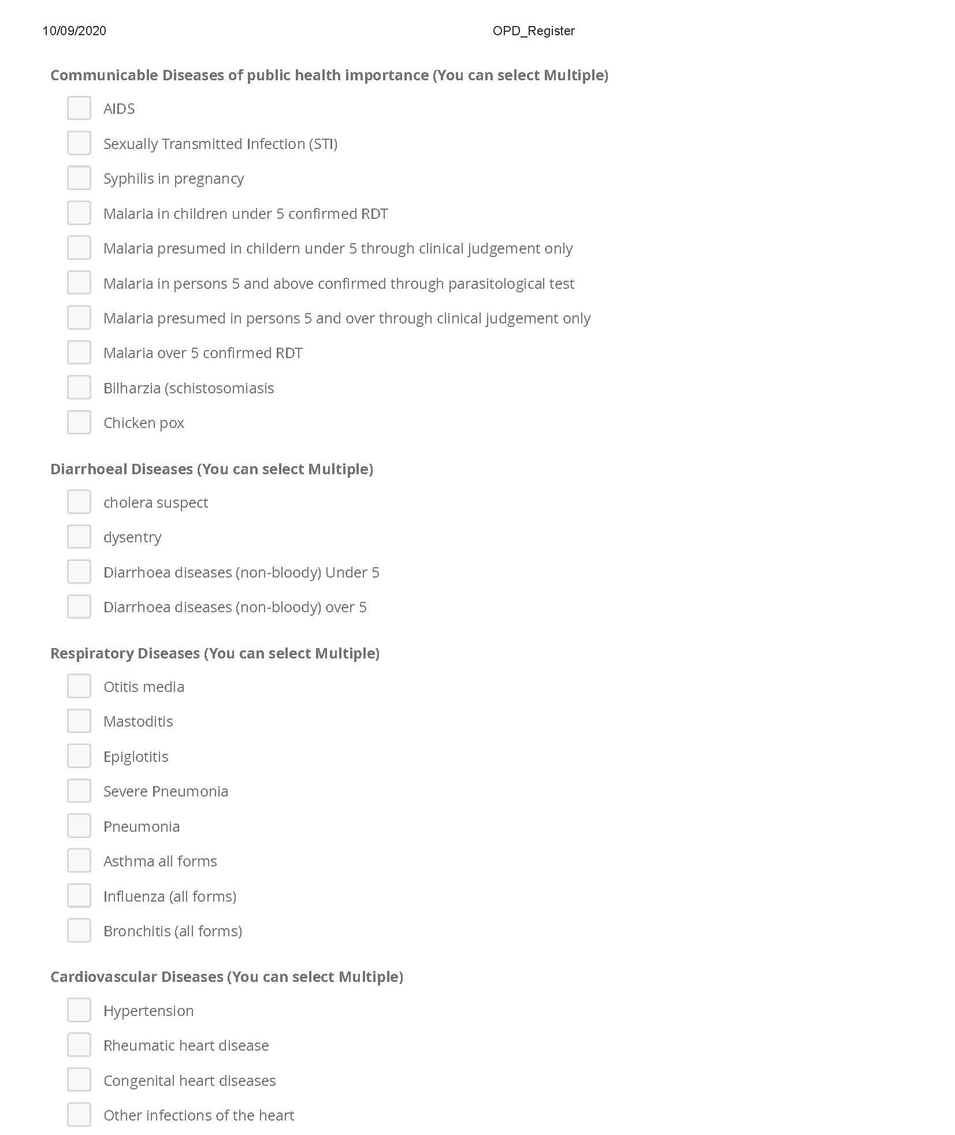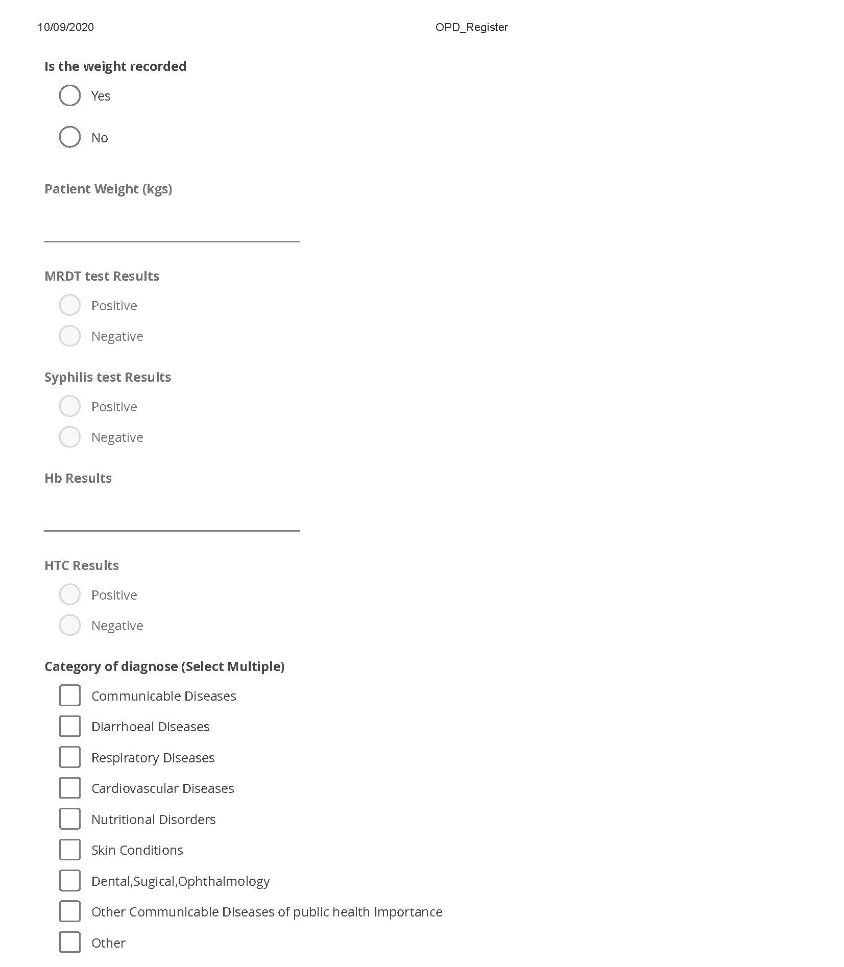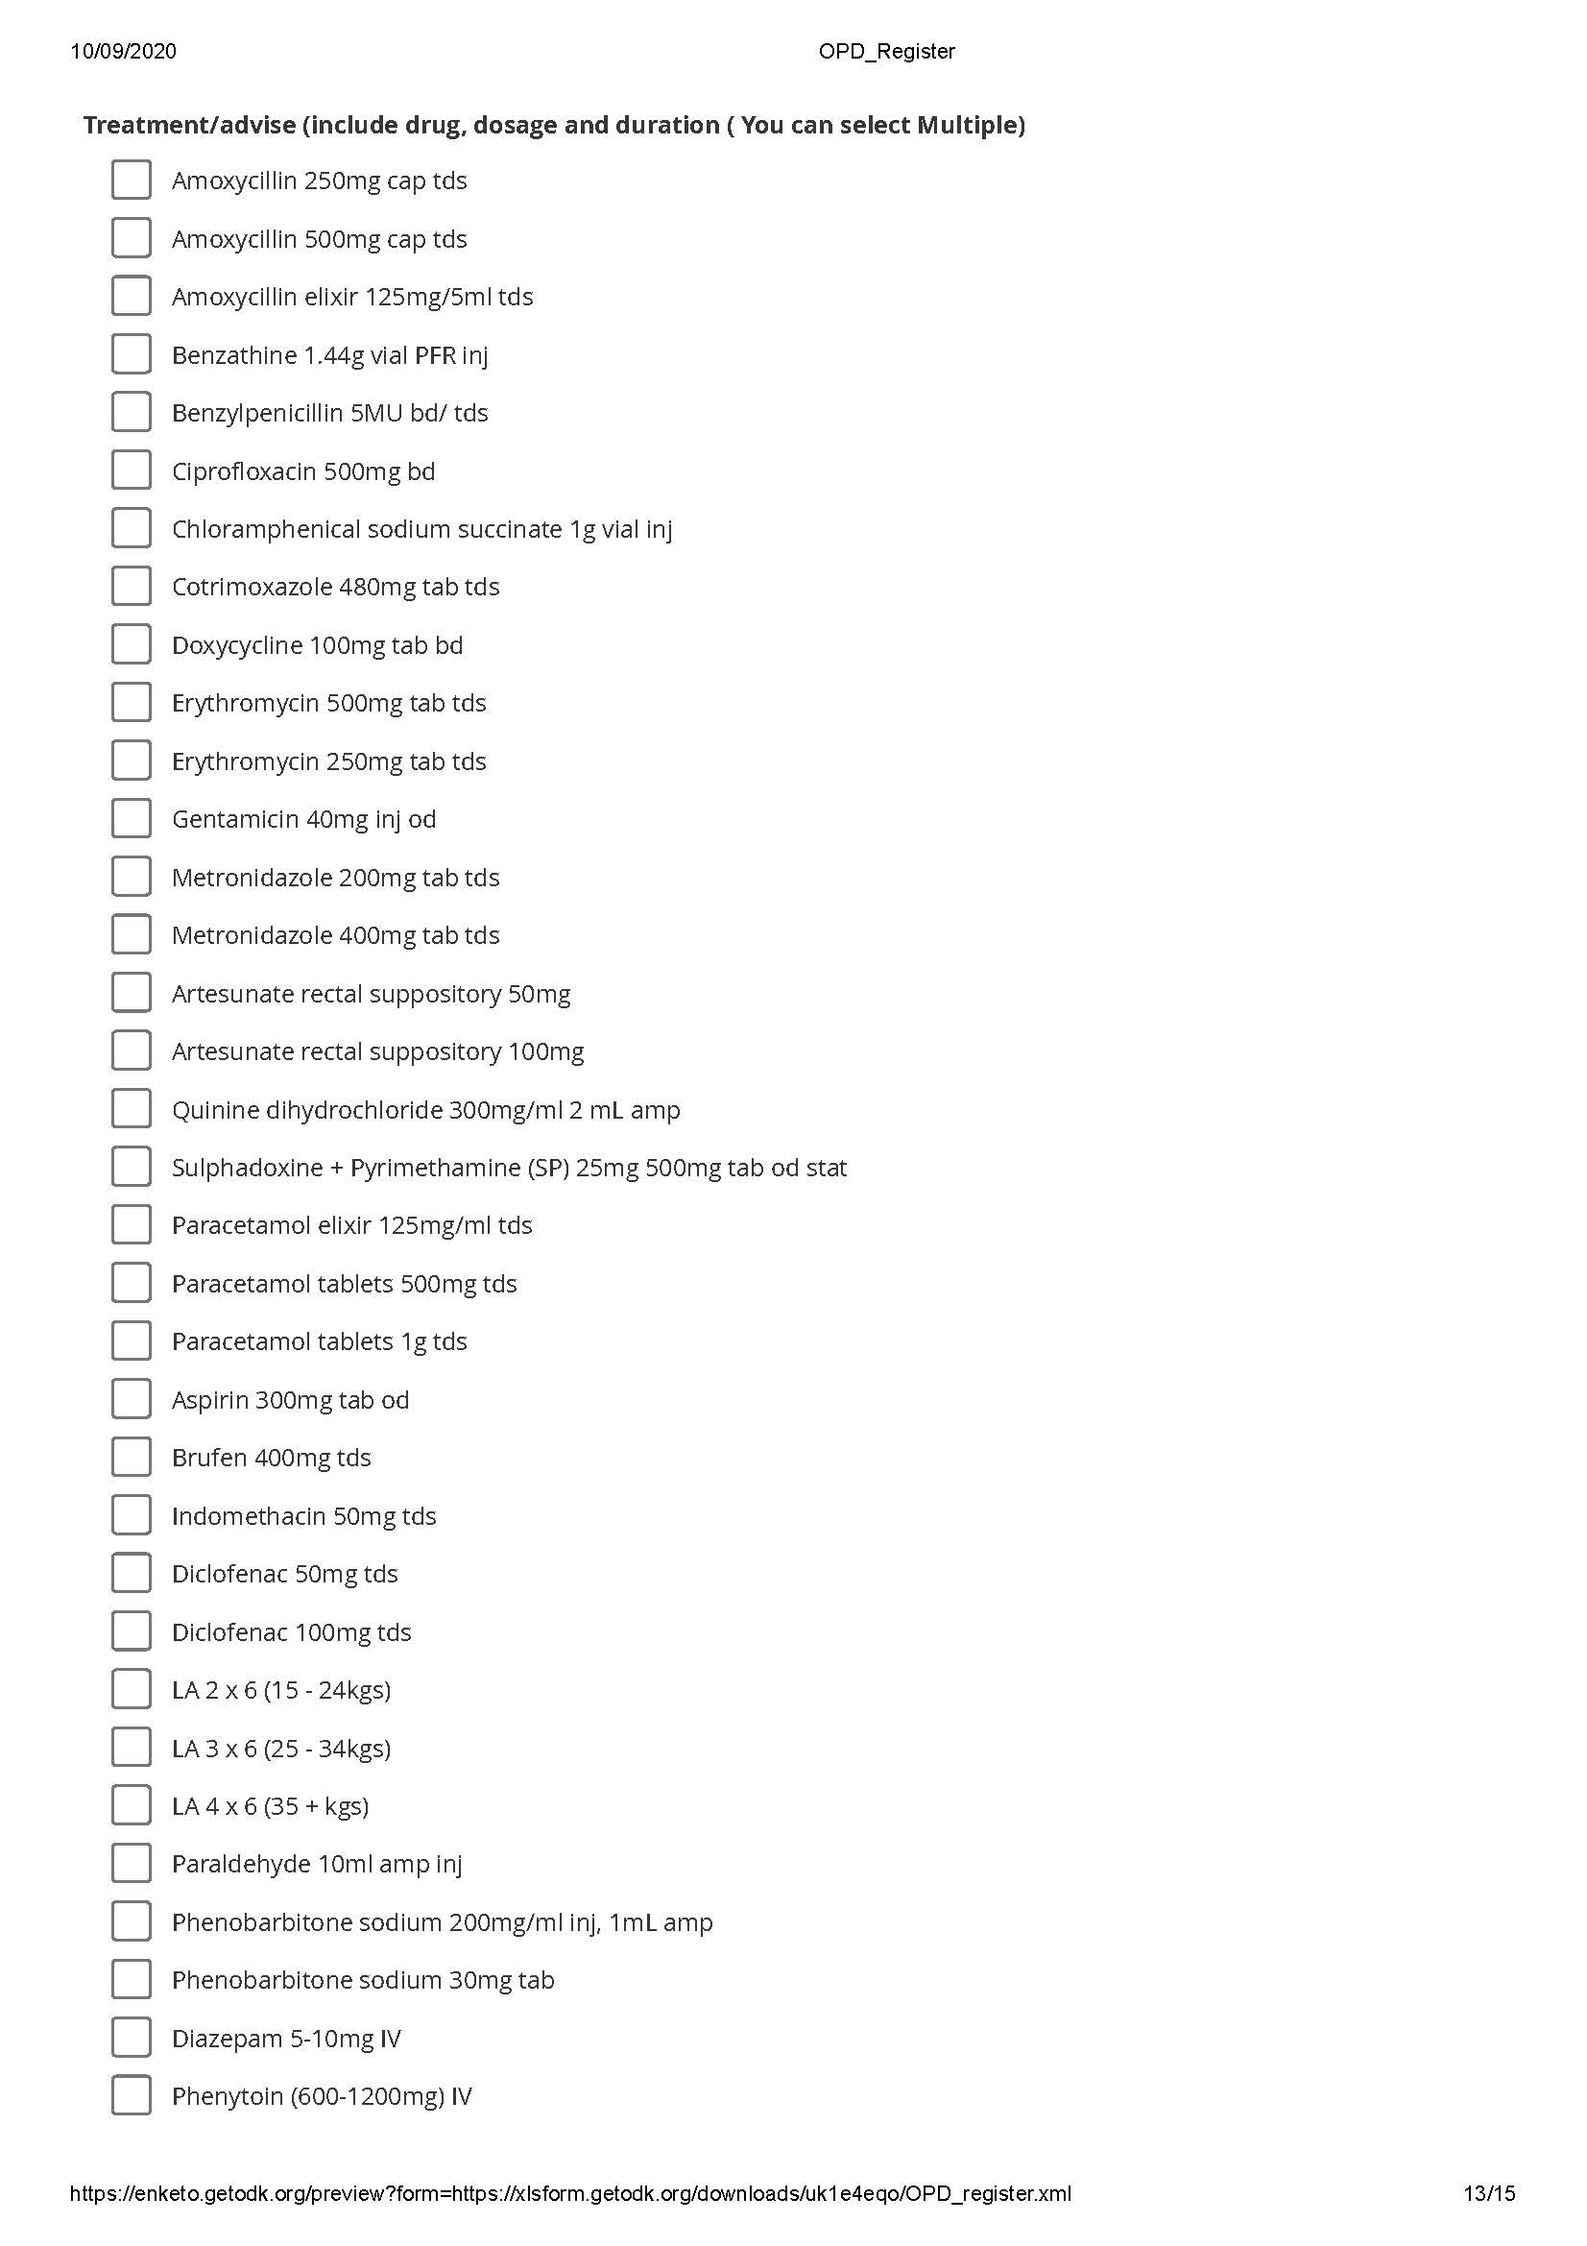
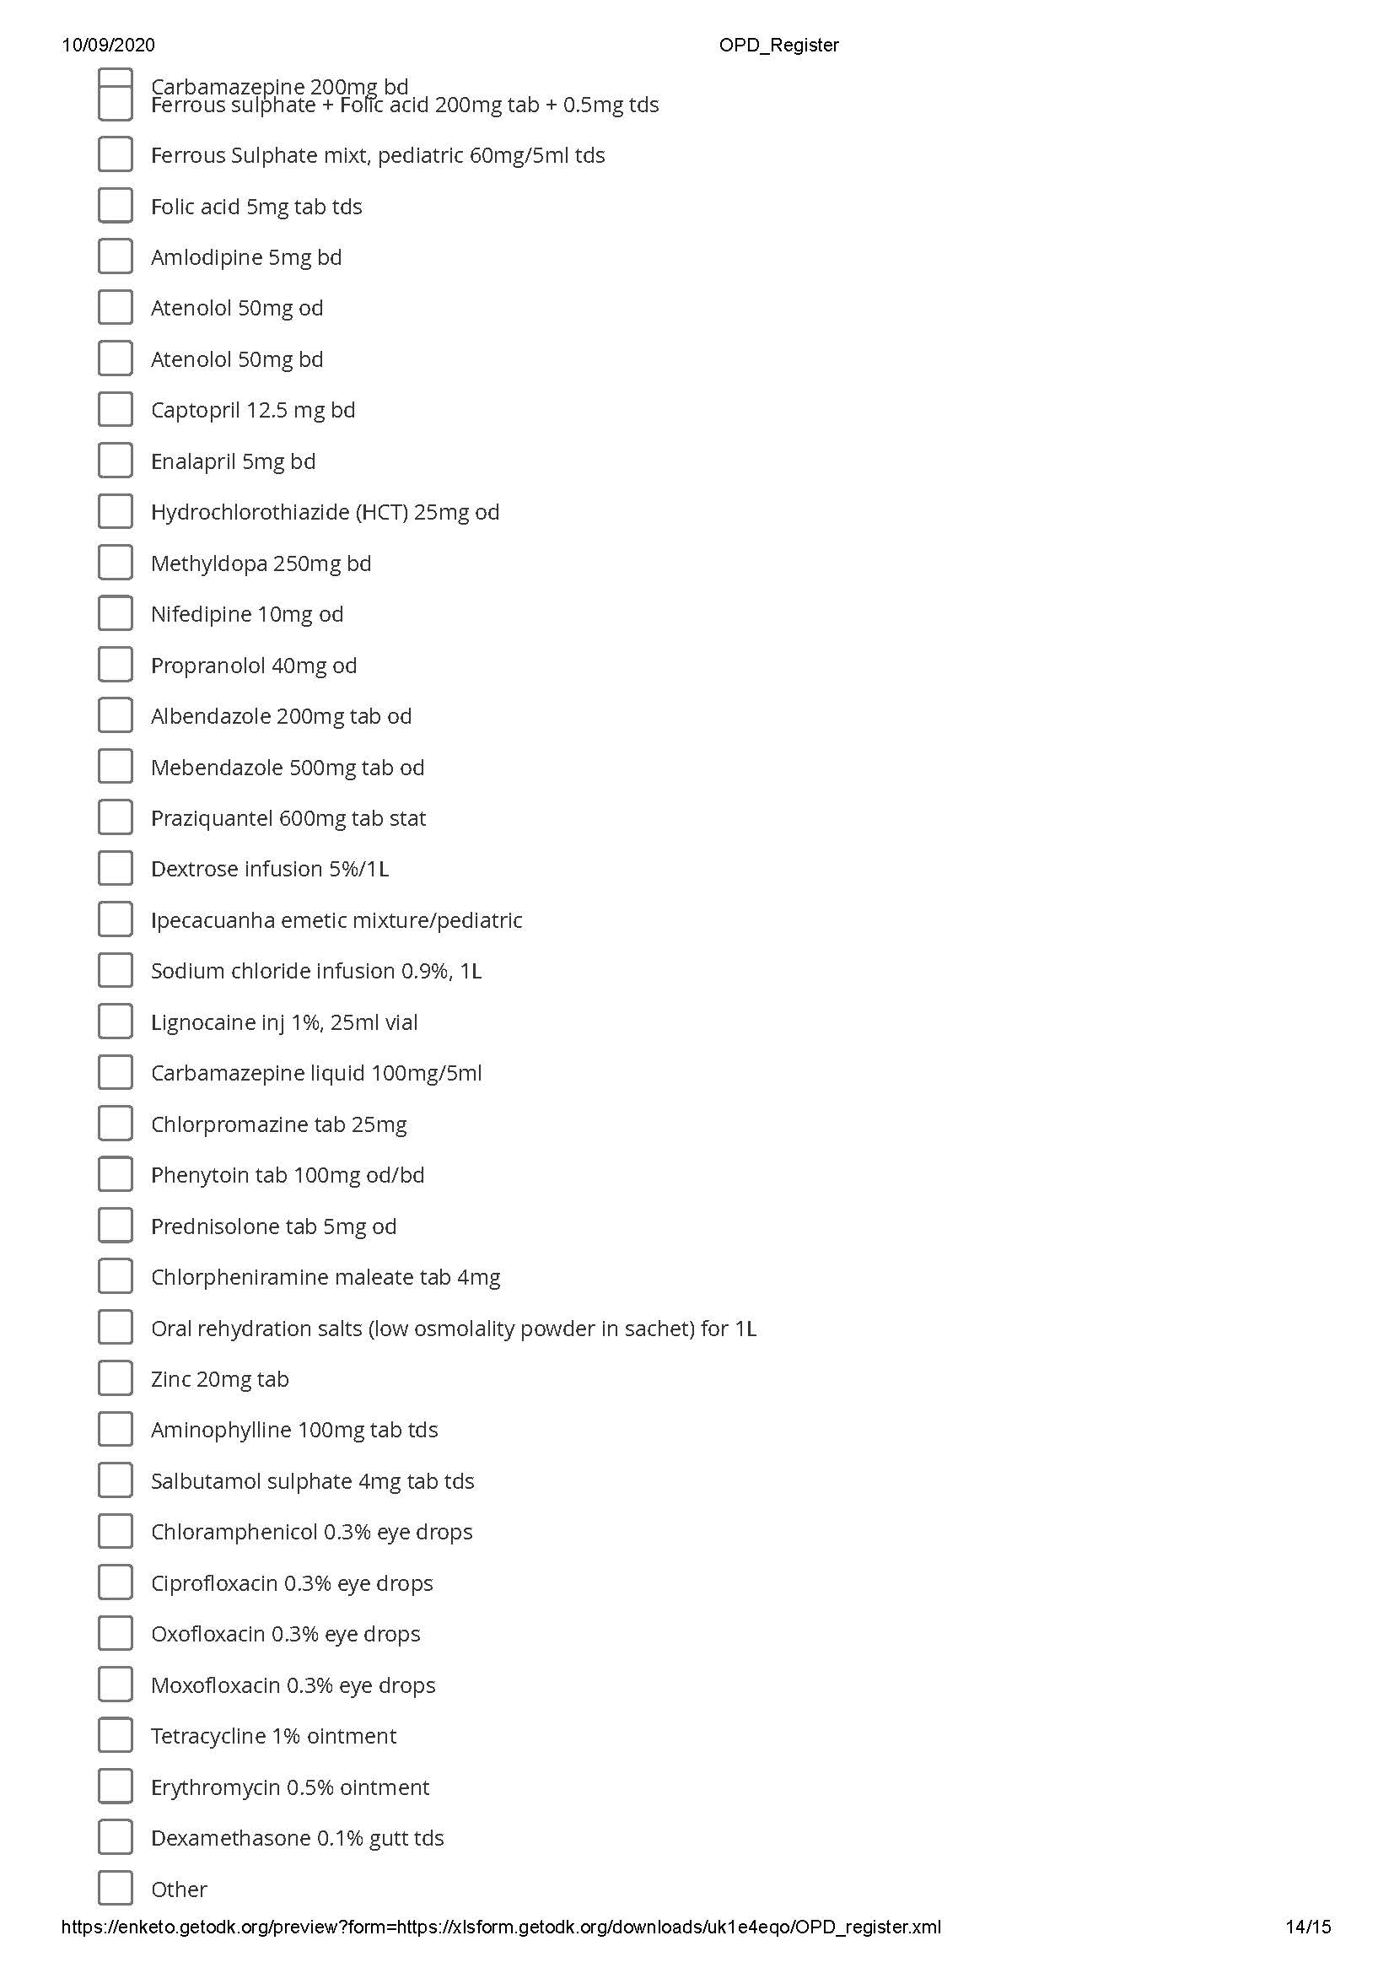

Appendix 3: Contents of the registers in its paper-based format which was later used and adopted for eCRF.
Image 1: Section of the OPD register
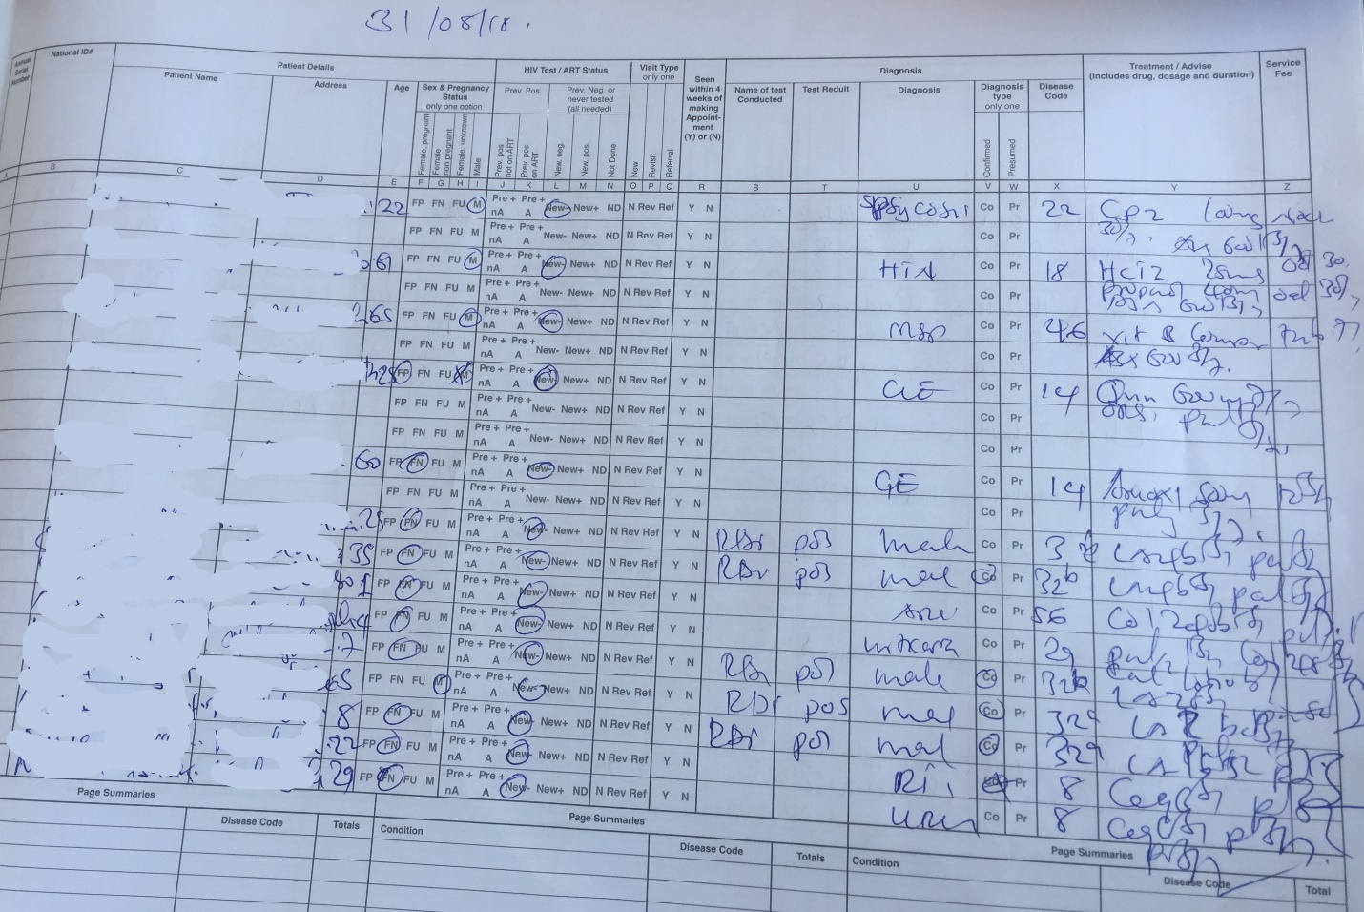

Image 2: Section of the OPD register
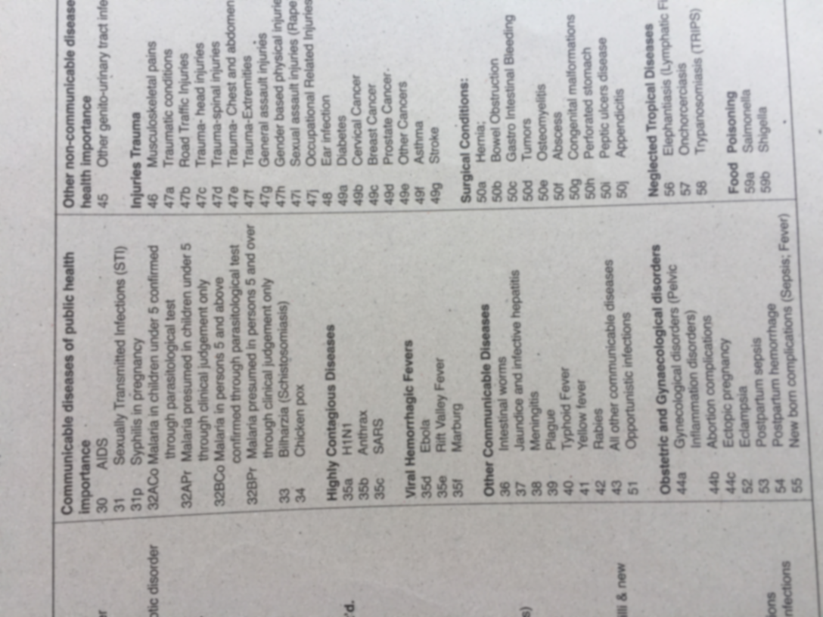

Image 3: Section of the malaria rapid diagnostic test (mRDT) register
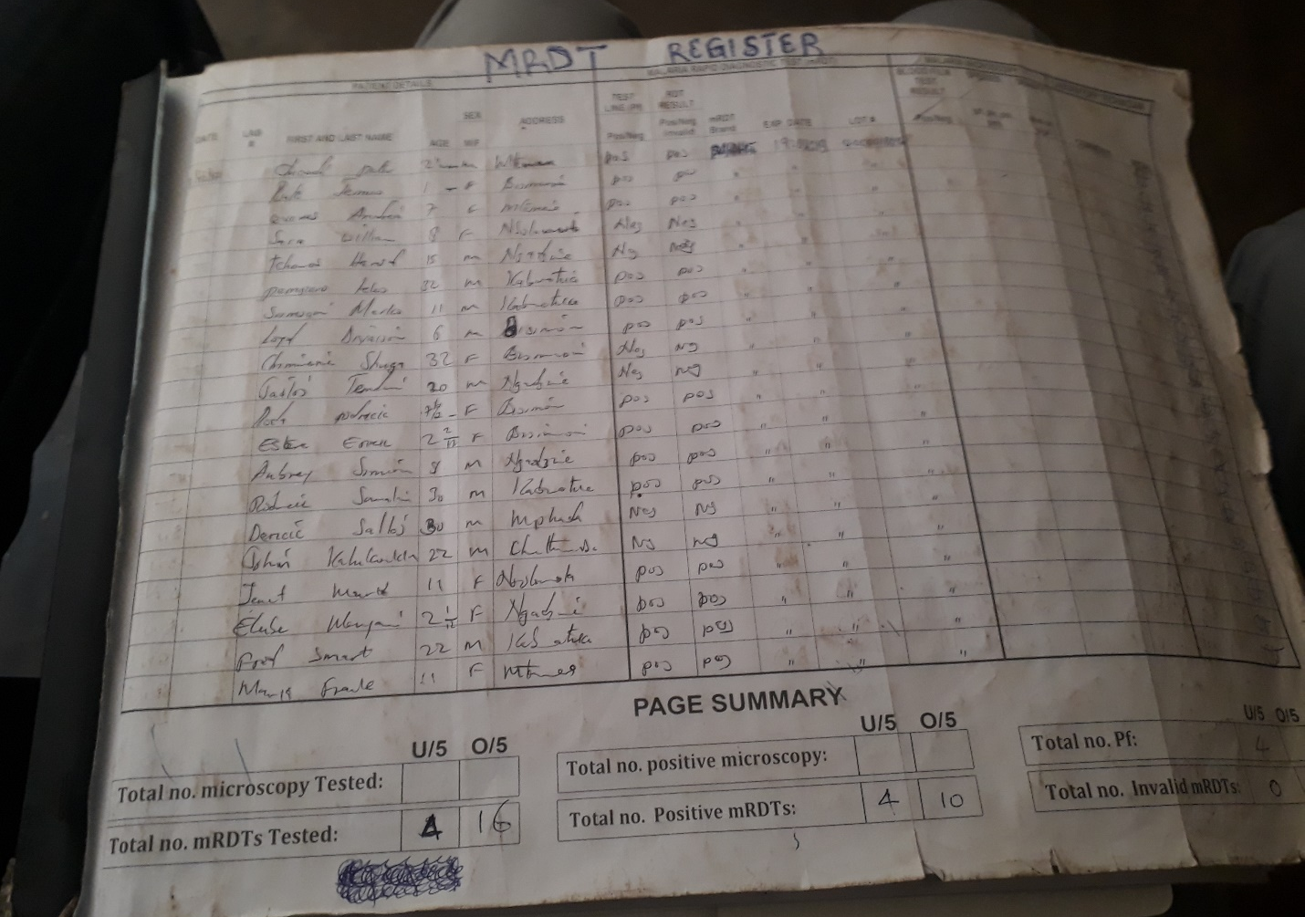

Image 4: Section of the OPD register
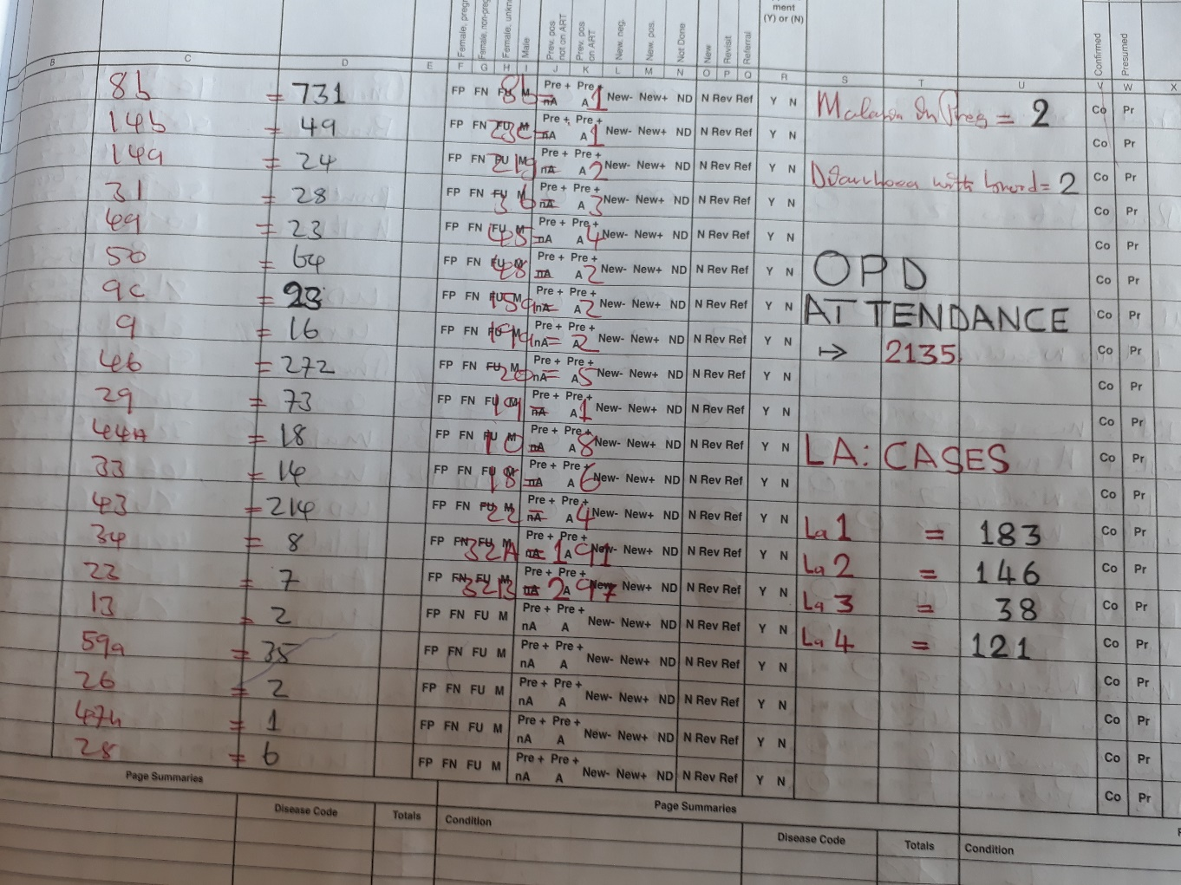
Appendix 4: Samsung tablets with ODK software used.
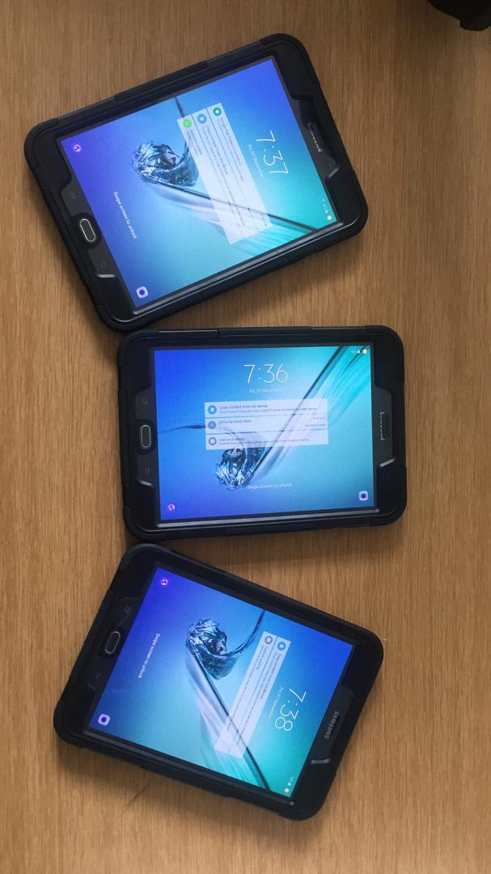
Appendix 5: Registers provided by the ministry of health, illegible print seen from registers, torn pages from registers
Image 1: Storage room containing various registers at Kakoma health center
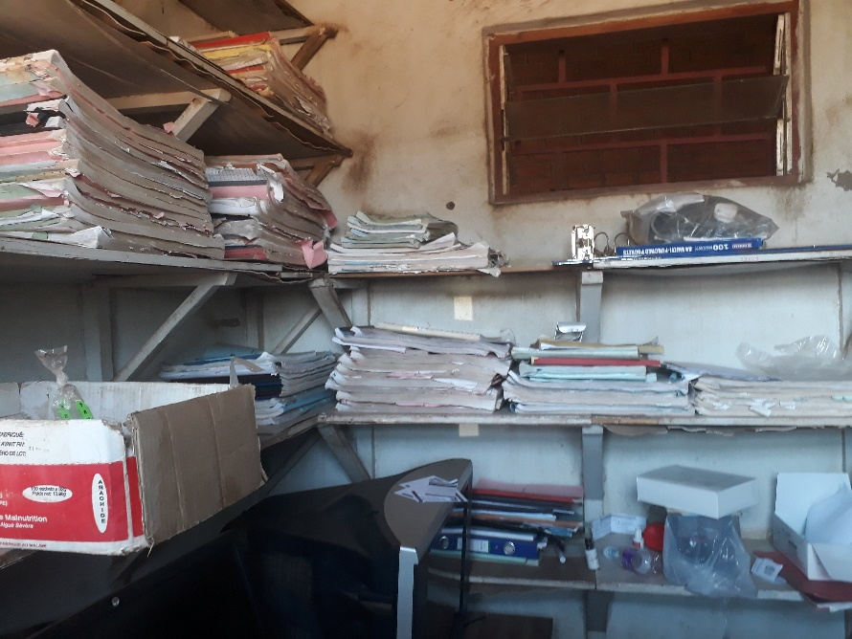
Image 2: Illegible print observed at the health facilities
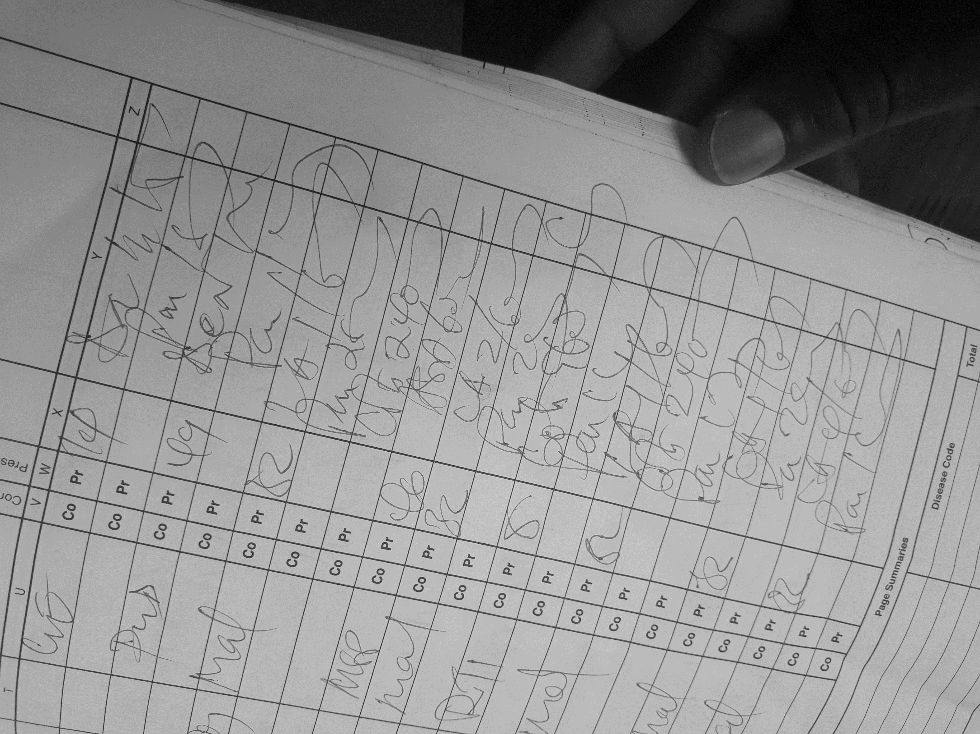

Image 3: Torn page of a register with illegible print
