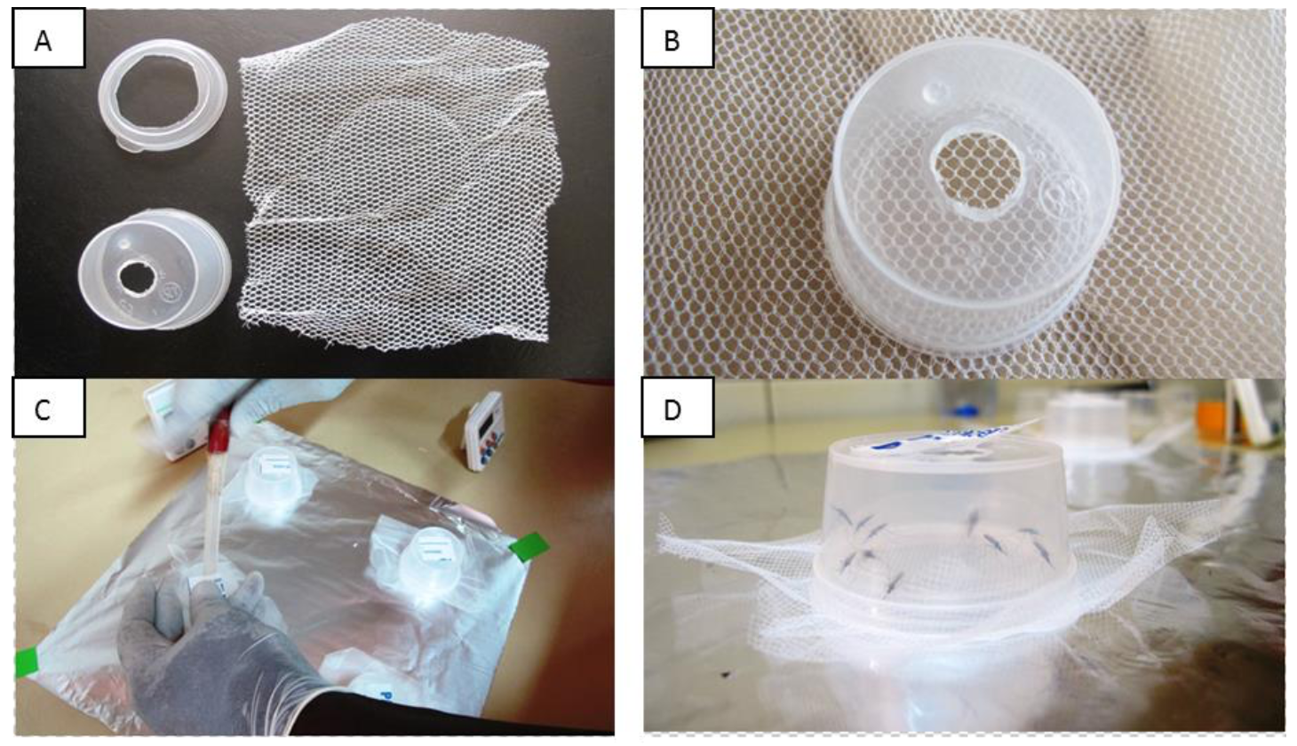Figure S1. Deli pot bioassay.

