Emerging properties of malaria transmission and persistence in urban Accra, Ghana: Evidence from a participatory system approach

Merveille Koissi Savi ^{1, *}, Daniel Callo-Concha ^{1,2}, Henri E.Z. Tonnang ³ & Christian Borgemeister ¹
Additional file
Table S1: Composition of the group building sessions
Institutions | Field of expertise | Number of participants
Ghana National Malaria Program | Entomology surveillance | 1
Malaria Initiative/ USAID | Prevention campaign and ITN distribution | 1
World Health Organization | Prevention and control | 1
Ghana Health Service | Public awareness | 1
Plant Protection and Regulatory Services/ Ministry of Food and Agriculture | Pest management | 1
Noguchi Memorial Institute for Medical Research | Genetic | 1
VectorWork | ITN distribution | 1
Korle Bu Teaching Hospital | Physician | 1
Dodowa Health Research Center | Research | 1
School of Public Health Ghana | Medical geography and malaria expert | 1
Greater Accra Municipal Assemblies | Community service | 1
Ghana National Malaria Program | Prevention and control | 1

Table S2: Operationalization of the determinants
 | Label | Operationalization
1 | Existence and enforcement of city planning and regulation | Legal dispositions regulating the construction and renovation of buildings in cities. e.g., laws preventing mosquito breeding sites in building/renovation activities. It also includes disposition on urban planning.
2 | Adequate housing construction | House building after the recommendations of the city planning offices
3 | Convenient waste and sewage management | Regular waste collection and disposal, and existence and maintenance of drain and gutters for sewage evacuation
4 | Urban agriculture | Farming activities carried out nearby urban housings. Usually associated with the use of pesticides, digging of wells, and also hosting conditions
5 | Wells excavation | For irrigation purposes, which also offer sites for mosquito egg-laying
6 | Number of breeding sites | Temporary or permanent pits and ponds that can offer breeding conditions for mosquitoes
7 | More rainfall | Between 800-1200 millimeters a year, optimal for mosquitoes mating and reproduction
8 | Householders' awareness and decision-making on malaria infection risk | People information and empowerment of measures leading to prevent the infection and properly treat malaria
9 | Hygiene and sanitation of households' compound | To preventing mosquito breeding sites
10 | Household income | Financial/monetary income of the household, correlated to higher capabilities to acquire medicines, look for medical treatment, etc.
11 | Temperature between 26 and 33°C | Ideal temperature or mating and the eggs-laying of mosquitoes
12 | Higher reproduction rate of female Anopheles | As female mosquitoes are the ones that transmit malaria, their relative increase relates to mating, egg-laying, and blood-sucking activities. A mosquito carried the parasites bite a human and inject into him the parasites. Through multiplication firstly in the leaver and then in the bloodstream, the parasite creates a series of symptoms. These symptoms can be expressed as fever, chill, sweating in that the person is symptomatic. In some cases, the person carrying alongside the parasite may not express any symptom and this person is denoted as asymptomatic.
13 | Number of female Anopheles | Related to 12
14 | Surviving of female Anopheles | Related to 12
15 | Use of insecticide in household | Specific insecticide is used in the household to kill mosquitoes, which in the long-run these tend to increase their tolerance and eventually resistance
16 | Insecticide resistant Anopheles strain | Eventually, mosquitoes mutate and get adapted to chemical compounds that are supposed to kill them
17 | Pest management with pyrethroid-based insecticide in urban agriculture | Inadequate use and disposal of insecticide and pesticide-based pyrethroid pollutes the environment and drives the resistance of mosquitoes to insecticides.
18 | Disinfection of healthcare facilities | Residuals of the pesticides applied remain in the environment and by their low doses augment mosquito resistance
19 | Mosquito bites | Infection means, not all stings are infectious
20 | Use of insecticide-treated bed-nets (ITN) | Used to repel mosquitoes and prevent infectious contacts with humans
21 | Perceived-inconvenience of ITN | Acceptability of the ITN. Some populations allude as causes to reject them: increase in temperature, the itchiness of compound contains in the ITNs, the impossibility to breath, etc.
22 | Frequency and duration of nighttime activities | Duration of the activities overnight can increase the exposure risk
23 | Use of door and windows mesh | Indoor and windows to prevent mosquitoes entry
24 | Infectious mosquito bites | Bite with a high likelihood of transmitting Plasmodium parasite to the human. Not all of the bites are infectious.
25 | Population receiving infected bites | The fraction of the population that gets the infectious bite
26 | Malaria positive cases | Population carrying Plasmodium parasite. This fraction of the population contains symptomatic and asymptomatic cases.
27 | Human migration | Mobility of the population, which may imply the arrival of infected individuals
28 | Human age category | The infectiousness is age-related, for example, children are more vulnerable to get infected than adults
29 | Immune state of human host | Natural protection good health safeguard
30 | Asymptomatic cases | The fraction of the population carrying the parasite but not expressing any symptoms of the disease
31 | Symptomatic cases | Malaria clinical cases, so showing symptoms
32 | Health literacy | Peoples level of information on how to prevent malaria infection and what to do in case been infected
33 | Visit a healthcare facility | Check-up for diagnosis or treatment
34 | Enough and well trained healthcare-workers | Personnel well-trained implies better and earlier malaria diagnostic and more timely and efficient treatment
35 | Adherence to prescription protocol | The patient adherence to the prescribed treatments is related to a prompt and more comprehensive recovery
36 | Diagnosis (anamnesis and blood analysis) | Proper and effective diagnosis, imply an adequate medicine prescription, often measures to optimize it: anamnesis and blood screening, are poorly implemented or absent
37 | Drug prescription | Prescription of malaria drug by health personnel
38 | Compliance with the treatment | Patient strict observance of the posology and prescribed doses of the prescribed medicines. Also, neglection is frequent
39 | Satisfaction with the treatment | Patient recovery with the received treatment
40 | Trust in the healthcare system | Reaction to the effectiveness of the healthcare system
41 | Inadequate utilization of the medication | Misuse of drugs, which tends to weaken its efficiency
42 | Increase in Plasmodium resistance to drug | By the inadequate treatment, non-compliance of treatment, etc. resistance of the parasite to the given medicine
43 | Alternative medicine | All the alternative used to prevent and treat malaria, often traditional medicines like phytotherapy
44 | Subsidy and availability on the preventive and curative malaria measures | There is an old tradition to subsidize malaria drugs and make them freely (no-prescription needed) available to the population
45 | Self-medication | Use of medication without a formal prescription, quite strong in the case of anti-malaria drugs

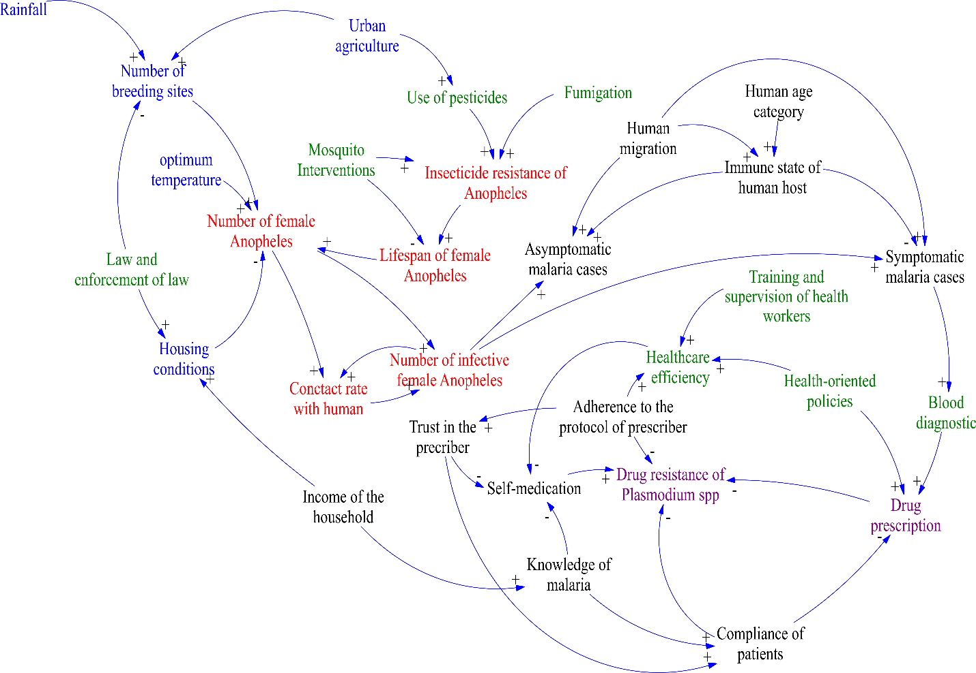
Fig. S1: Earlier system depicting the complexity of malaria in urban settings.

Fig. S2: In- and Out-degree distribution of node representing the complex system of malaria transmission and persistence in Accra, Ghana

