Additional file 1. Analysis of the potential for a malaria vaccine to reduce gaps in malaria intervention coverage

Table S1: Countries eligible for inclusion in the analysis and surveys from which data were extracted. All surveys are available for download from the Demographic and Health Surveys website [1].
Country | Surveys used
Angola (AO) | 2015 DHS
Benin (BJ) | 2012 DHS
Burkina Faso (BF) | 2010 DHS, 2014 MIS
Burundi (BU) | 2016 DHS
Cameroon (CM) | 2011 DHS
Cote d’Ivoire (CI) | 2012 DHS
Democratic Republic of Congo (CD) | 2013 DHS
Ghana (GH) | 2014 DHS, 2016 MIS
Guinea (GN) | 2012 DHS
Kenya (KE) | 2014 DHS, 2015 MIS
Liberia (LB) | 2013 DHS, 2016 MIS
Malawi (MW) | 2015 DHS, 2017 MIS
Mali (ML) | 2012 DHS, 2015 MIS
Mozambique (MZ) | 2015 AIS
Nigeria (NG) | 2013 DHS, 2015 MIS
Sierra Leone (SL) | 2013 DHS, 2016 MIS
Tanzania (TZ) | 2015 DHS, 2017 MIS
Togo (TG) | 2013 DHS, 2017 MIS
Uganda (UG) | 2016 DHS
Zambia (ZM) | 2013 DHS, 2015 MIS

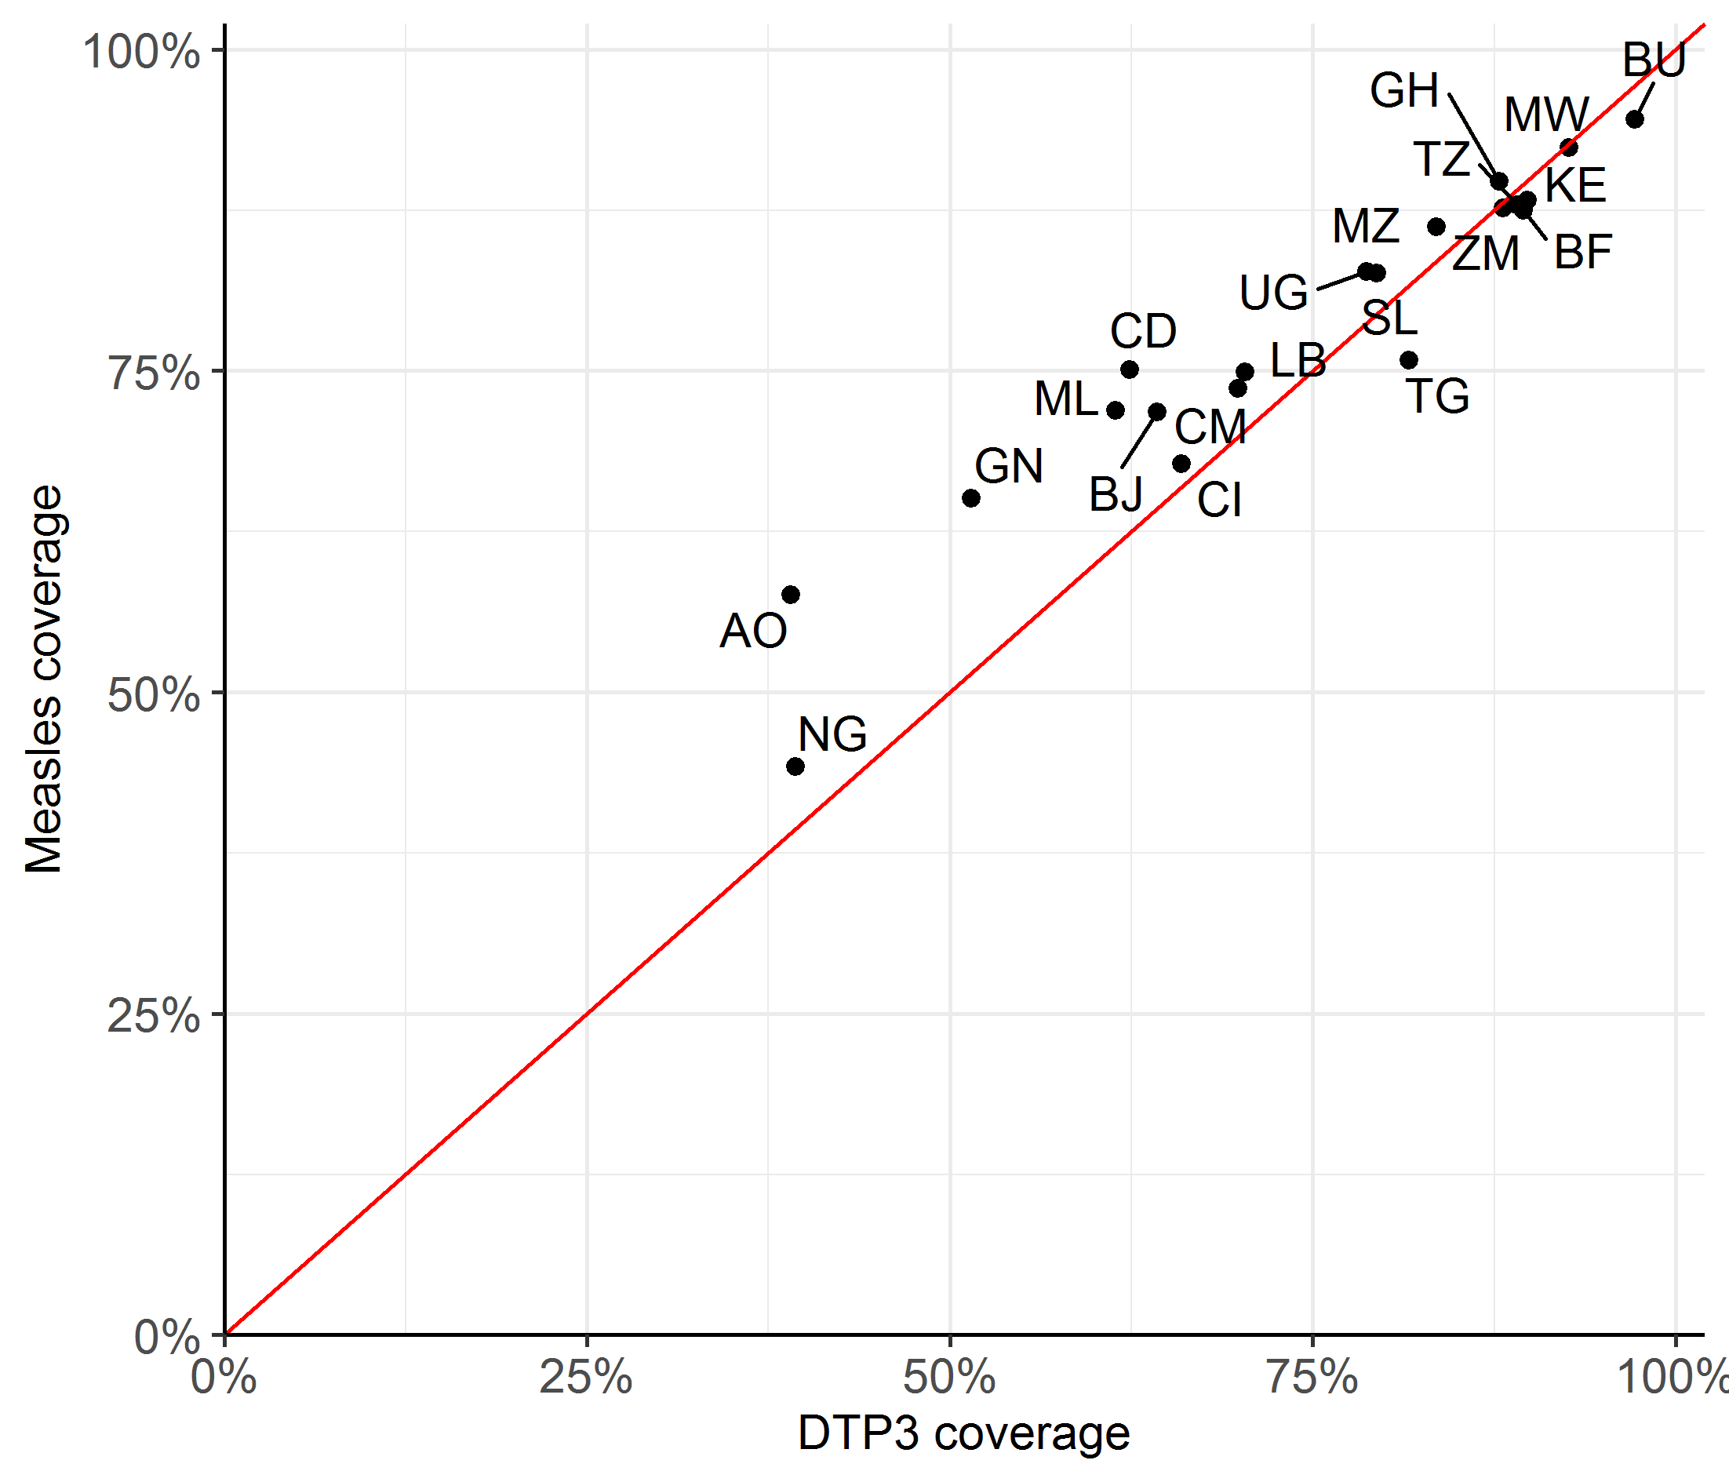

Figure S1: Coverage of the DTP3 vaccine at the country level, compared to measles vaccine dose 1 coverage. Spearman’s correlation coefficient: 0.950. The red line represents correlation of 1.0. Countries shown: AO – Angola, BF – Burkina Faso, BJ – Benin, BU – Burundi, CD - Democratic Republic of Congo, CI – Cote d’Ivoire, CM – Cameroon, GH – Ghana, GN – Guinea, KE – Kenya, LB – Liberia, ML – Mali, MW – Malawi, MZ – Mozambique, NG – Nigeria, SL – Sierra Leone, TG – Togo, TZ – Tanzania, UG - Uganda and ZM – Zambia.

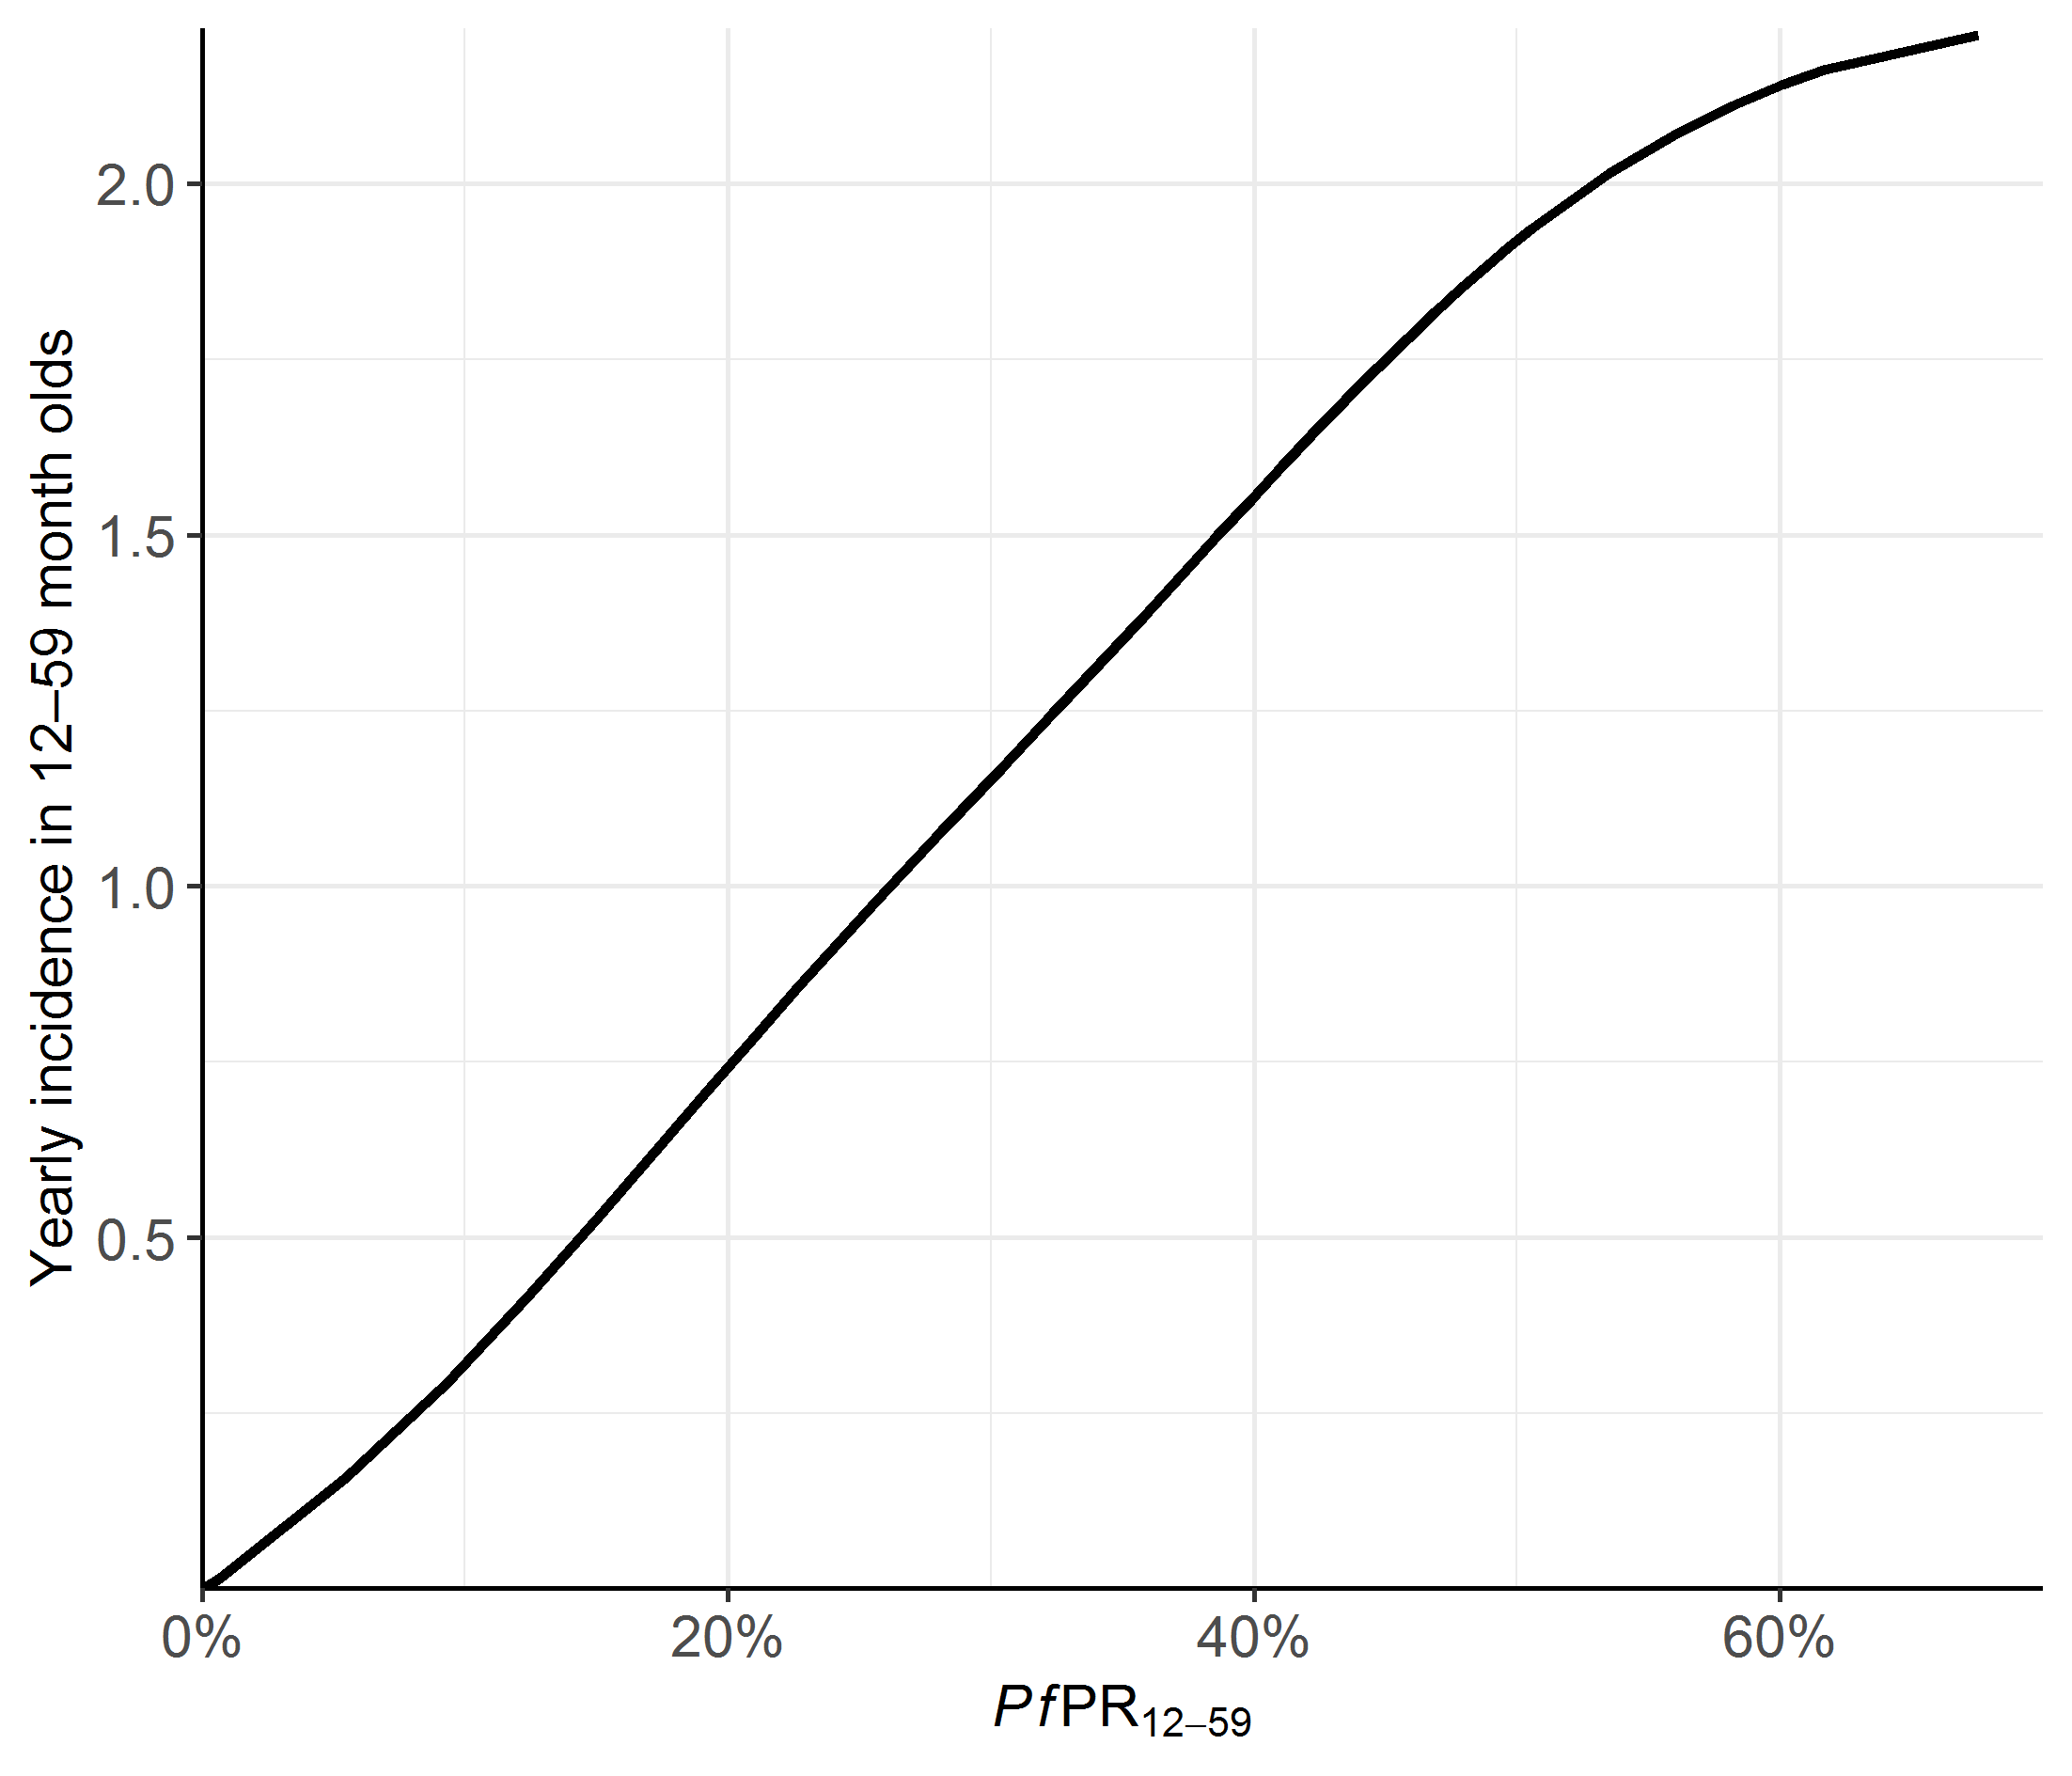
Figure S2: Yearly clinical incidence of malaria as a function of the P. falciparum parasite prevalence in children aged 12–59 months (PfPR12–59). Clinical incidence is the yearly number of events per child aged 12–59 months. This relationship was computed using a deterministic mathematical model for malaria transmission [2].
Table S2: Numbers of children and proportions of multinomial regression predictors in each country.
Country code | Number of children (thousands) | Sex |  | Age |  | Urban/ Rural |  | Mother’s education |  | Wealth Index
Country code | Number of children (thousands) | Male | Female | One | Two | Urban | Rural | None & Primary | Secondary & Tertiary | Bottom 60% | Top 40%
Angola | 5451 | 50% | 50% | 52% | 48% | 56% | 44% | 71% | 29% | 78% | 23%
Burkina Faso | 4817 | 51% | 49% | 52% | 48% | 37% | 63% | 89% | 12% | 64% | 36%
Benin | 5461 | 51% | 49% | 51% | 49% | 24% | 76% | 94% | 6% | 61% | 39%
Burundi | 4979 | 50% | 50% | 52% | 48% | 16% | 84% | 87% | 13% | 60% | 39%
Democratic Republic of Congo | 2293 | 49% | 51% | 53% | 47% | 42% | 58% | 65% | 35% | 64% | 36%
Cote d’Ivoire | 2814 | 50% | 50% | 50% | 50% | 34% | 66% | 89% | 10% | 70% | 30%
Cameroon | 6831 | 50% | 50% | 50% | 50% | 30% | 70% | 65% | 35% | 69% | 31%
Ghana | 2496 | 52% | 48% | 52% | 48% | 31% | 69% | 89% | 11% | 63% | 37%
Guinea | 2255 | 52% | 48% | 50% | 50% | 41% | 59% | 54% | 46% | 71% | 28%
Kenya | 8055 | 51% | 49% | 50% | 50% | 32% | 68% | 73% | 27% | 71% | 29%
Liberia | 2699 | 52% | 48% | 53% | 47% | 32% | 68% | 79% | 20% | 83% | 17%
Mali | 6492 | 49% | 51% | 50% | 50% | 16% | 84% | 79% | 22% | 65% | 36%
Malawi | 3608 | 50% | 50% | 51% | 49% | 26% | 74% | 90% | 10% | 58% | 41%
Mozambique | 1977 | 48% | 52% | 51% | 49% | 36% | 64% | 79% | 21% | 56% | 44%
Nigeria | 11154 | 51% | 49% | 52% | 48% | 34% | 66% | 65% | 35% | 64% | 36%
Sierra Leone | 4012 | 49% | 51% | 51% | 49% | 30% | 70% | 81% | 19% | 64% | 36%
Togo | 4032 | 50% | 50% | 53% | 47% | 24% | 76% | 81% | 19% | 62% | 37%
Tanzania | 2676 | 50% | 50% | 52% | 48% | 30% | 70% | 78% | 22% | 68% | 32%
Uganda | 5814 | 51% | 49% | 50% | 50% | 19% | 81% | 75% | 25% | 66% | 33%
Zambia | 5092 | 50% | 50% | 51% | 49% | 37% | 63% | 66% | 34% | 71% | 29%

References
1. ICF. Data. The DHS Program website. Funded by USAID. https://dhsprogram.com/Data/. Accessed 23 Mar 2020.
2. Griffin JT, Ferguson NM, Ghani AC. Estimates of the changing age-burden of Plasmodium falciparum malaria disease in sub-Saharan Africa. Nat Commun. 2014;5:3136. doi:10.1038/ncomms4136.

