DNA extraction, ITS2 amplification and sequencing
Genomic DNA was isolated from individual mosquitoes by using the QIAamp® DNA Mini Kit (QIAGEN, Hilden, Germany) following the manufacturer’s instructions. Approximately 356 bp PCR product of the ITS2 region was amplified using primers, ITS2-F (5’-TGTGAACTGCAGGACACAT-3’) and ITS2-R (5’-TATGCTTAAATTCAGGGGGT-3’). ITS2 was amplified with the following cycling parameters: 94 ℃, 2 min; 94 ℃/30 s, 50 ℃/30 s, 72 ℃/40 s for 40 cycles; and a final extension at 72 ℃ for 10 min. The total PCR reaction volume was 20 μl, and the PCR reagent mixture consisted of 2.5 μl of 10 x buffer, 0.2 mM of dNTPs, 0.3 μM of each primer, 0.05 unit of Takara Taq (Dalian, China), and 2 μl of template DNA. The PCR products were analyzed by 1.5% agarose gel electrophoresis stained with GoldView (Solarbio, Beijing, China), under UV transillumination. The sequencing reaction proceeded in both directions using an ABI Big Dye Terminator Kit (Applied Biosystems, Thermo Fisher Scientific). Further analysis was conducted with the assistance of ABI Prism 3500xL Genetic Analyzer (Applied Biosystems, Thermo Fisher Scientific) in Shanghai (Sangon Biotech).

Table 1. ITS2 sequences of Anopheles nivipes downloaded from the NCBI
ID | No. | Location | Author | Longitude | Latitude
JN654431.1 | An. niv (IN_Ass_Na1) | India: Assam, Nalbari, Kumarikata | Sarma,N.P. and Prakash,A., et al. | 91.436 | 26.443
JN654430.1 | An. niv (IN_Ass_Na2) | India: Assam, Nalbari, Kawali | Sarma,N.P. and Prakash,A., et al. | 91.436 | 26.443
JN654429.1 | An. niv (IN_Ass_Na3) | India: Assam, Nalbari, Tamulpur | Sarma,N.P. and Prakash,A., et al. | 91.436 | 26.443
DQ279441.1 | An. niv (IN_Ass_Ka1) | India: Assam, Kamrup, Sonapur | Alam,M.T., et al. | 91.969 | 26.112
DQ279440.1 | An. niv (IN_Ass_Ka2) | India: Assam, Kamrup, Sonapur | Alam,M.T., et al. | 91.969 | 26.112
DQ279439.1 | An. niv (IN_Ass_Ka3) | India: Assam, Kamrup, Sonapur | Alam,M.T., et al. | 91.969 | 26.112
DQ279438.1 | An. niv (IN_Ass_Ka4) | India: Assam, Kamrup, Sonapur | Alam,M.T., et al. | 91.969 | 26.112
DQ279437.1 | An. niv (IN_Ass_Ka5) | India: Assam, Kamrup, Sonapur | Alam,M.T., et al. | 91.969 | 26.112
DQ279436.1 | An. niv (IN_Ass_Ka6) | India: Assam, Kamrup, Sonapur | Alam,M.T., et al. | 91.969 | 26.112
DQ279435.1 | An. niv (IN_Ass_Ka7) | India: Assam, Kamrup, Sonapur | Alam,M.T., et al. | 91.969 | 26.112
DQ279434.1 | An. niv (IN_Ass_Ka8) | India: Assam, Kamrup, Sonapur | Alam,M.T., et al. | 91.969 | 26.112
DQ013796.1 | An. niv (IN_Ass_Ka9) | India: Assam, Kamrup | Alam,M.T., et al. | 91.969 | 26.112
DQ013800.1 | An. niv (IN_Ass_Ka10) | India: Assam, Kamrup | Alam,M.T., et al. | 91.969 | 26.112
JQ741975.1 | An. niv (IN_Ass_Ka11) | India: Assam, Kamrup | Rabha,B., et al. | 91.969 | 26.112
JN654427.1 | An. niv (IN_Miz_Ma1) | India: Mizoram, Mamit, Thenzwal | Sarma,N.P. and Prakash,A., et al. | 92.750 | 23.317
JN643727.1 | An. niv (IN_Miz_Ma2) | India: Mizoram, Mamit, Thenzwal | Zomuanpuii,R. and Ringngheti,L., et al. | 92.750 | 23.317
FJ526623.1 | An. niv (TH_Cm_Cm1) | Thailand,Chiang Mai | Morgan,K., et al. | 99.000 | 19.200
FJ526622.1 | An. niv (TH_Cm_Cm2) | Thailand,Chiang Mai | Morgan,K., et al. | 99.000 | 19.200
JN654426.1 | An. niv (IN_Meg_Kh1) | India: Meghalaya, Khasi hills | Sarma,N.P. and Prakash,A., et al. | 91.850 | 26.050
JN654425.1 | An. niv (IN_Meg_Kh2) | India: Meghalaya, Khasi hills | Sarma,N.P. and Prakash,A., et al. | 91.850 | 26.050
* indicated the longitude and latitude coordinates to the geographical center of a certain province, due to the samples were initially collected from various sampling sites in a certain province. An. niv, Anopheles nivipes.
Table 2. Genetic diversity indices and neutrality tests (Fu’s Fs and Tajima’s D) based on the ITS2 gene of An. nivipes
Species | n | Haplotype Code | S | Pi | h | Hd | k | Fu's Fs | Tajima's D
Total | 73 | H1(29), H2(31), H3(10), H4(1), H5(1), H6(1) | 9 | 0.00402 | 6 | 0.65100 | 1.39764 | 0.38900 | -0.85972
KH_St_Sp | 53 | H1(29), H2(23), H6(1) | 5 | 0.00193 | 3 | 0.52180 | 0.67271 | 1.07800 | -1.23604
IN_Ass_Na | 3 | H2(3) | 1 | 0.00052 | 2 | 0.18200 | 0.18182 | -0.41000 | -1.12850
IN_Ass_Ka | 11 | H3(11), H4(1) | 0 | 0.00000 | 1 | 0.00000 | 0.00000 | n.d. | n.d.
IN_Miz_Ma | 2 | H2(2) | 0 | 0.00000 | 1 | 0.00000 | 0.00000 | n.d. | n.d.
IN_Meg_kh | 2 | H2(2) | 3 | 0.00575 | 2 | 0.66670 | 2.00000 | 1.60900 | n.d.
TH_Cm | 2 | H2(1), H5(1) | 1 | 0.00287 | 2 | 1.00000 | 1.00000 | 1.00000 | n.d.

n.d., not determined; n.s., P > 0.10; #, P < 0.10; *, P < 0.05; **, P < 0.02; ***, P < 0.001. Abbreviations: n number of sequences, S number of polymorphic sites, pi nucleotide diversity, h number of haplotypes, Hd haplotype diversity. KH_St_Sp, Siem Pang County (Stung treng, Cambodia); IN_Ass_Na, Nalbari (Assam, India); IN_Ass_Ka, Kamrup (Assam, India); IN_Miz_Ma, Mamit (Mizoram, India); IN_Meg_kh, Khasi hills (Meghalaya, India); TH_Cm, Chiang Mai (Thailand).

Table 3. Analysis of molecular variance (AMOVA) of six An. nivipes populations based on ITS2
Source of variation | d. f. | Sum of squares | Variance components | % of variation | Fixation index (P)
Among groups | 1 | 18.242 | 0.08665 Va | 7.120 | F_{CT}: 0.07116 (P<0.001)
Among populations within groups | 4 | 13.173 | 0.84895 Vb | 69.720 | F_{SC}: 0.75060 (P<0.001)
Within populations | 67 | 18.900 | 0.28208 Vc | 23.170 | F_{ST}: 0.76834  (P>0.05)
Total | 72 | 50.315 | 1.21768
F_{CT}, Fixation index among groups, F_{SC}, among populations within groups, F_{ST}, within populations.

Table 4. Population groups identified by spatial analysis of molecular variance (SAMOVA) algorithm based on ITS2
K | Population grouping | F_{CT} | F_{SC}
k = 2 | [KH_St_Sp, IN_Ass_Na, IN_Miz_Ma, IN_Meg_Kh, TH_Cm][N_Ass_Ka] | 0.78476^{ns} | 0.27524^{ns}
k = 3 | [KH_St_Sp][IN_Ass_Na, IN_Miz_Ma, IN_Meg_Kh, TH_Cm][N_Ass_Ka] | 0.826269^{ns} | -0.32136^{ns}
k = 4 | [KH_St_Sp][IN_Ass_Na, IN_Miz_Ma, IN_Meg_Kh][TH_Cm][N_Ass_Ka] | 0.869666^{ns} | -0.77778^{ns}
k = 5 | [KH_St_Sp][IN_Ass_Na][IN_Miz_Ma, N_Meg_Kh][TH_Cm][N_Ass_Ka] | 0.883124^{ns} | -1.00000^{ns}
Significant values *P<0.05; **P<0.01; ***P<0.001, ns: Not significant. KH_St_Sp, Siem Pang County (Stung treng, Cambodia); IN_Ass_Na, Nalbari (Assam, India); IN_Ass_Ka, Kamrup (Assam, India); IN_Miz_Ma, Mamit (Mizoram, India); IN_Meg_kh, Khasi hills (Meghalaya, India); TH_Cm, Chiang Mai (Thailand).

Table 5. Genetic differentiation and Gene flow among the Geographic Groups based on ITS2
 | IN_Ass_Na | IN_Meg_Kh | IN_Miz_Ma | IN_Ass_Ka | TH_Cm | KS_St_Sp
IN_Ass_Na |  | inf | inf | 0.02711 | 1.5 | 1.64065
IN_Meg_Kh | 0.00000 |  | inf | 0.02975 | inf | 2.35274
IN_Miz_Ma | 0.00000 | 0.00000 |  | 0.02975 | inf | 2.35274
IN_Ass_Ka | 0.94857 | 0.94383 | 0.94383 |  | 0.04269 | 0.09557
TH_Cm | 0.25000 | 0.00000 | 0.00000 | 0.92134 |  | 0.88082
KS_St_Sp | 0.23357 | 0.17527 | 0.17527 | 0.83954 | 0.36210
The pairwise F_{ST} values and Nm values based on the ITS2 are shown below and above the diagonal, respectively. Characters in bold indicated that the significance (P<0.05). inf, infinite. KH_St_Sp, Siem Pang County (Stung treng, Cambodia); IN_Ass_Na, Nalbari (Assam, India); IN_Ass_Ka, Kamrup (Assam, India); IN_Miz_Ma, Mamit (Mizoram, India); IN_Meg_kh, Khasi hills (Meghalaya, India); TH_Cm, Chiang Mai (Thailand).

Figure 1. Map of the populations from different geographical regions. Populations of rDNA ITS2 sequences: KH, Siem Pang County (Stung treng, Cambodia); Na, Nalbari (Assam, India); Ka, Kamrup (Assam, India); Ma, Mamit (Mizoram, India); Kh, Khasi hills (Meghalaya, India); TH, Chiang Mai (Thailand).
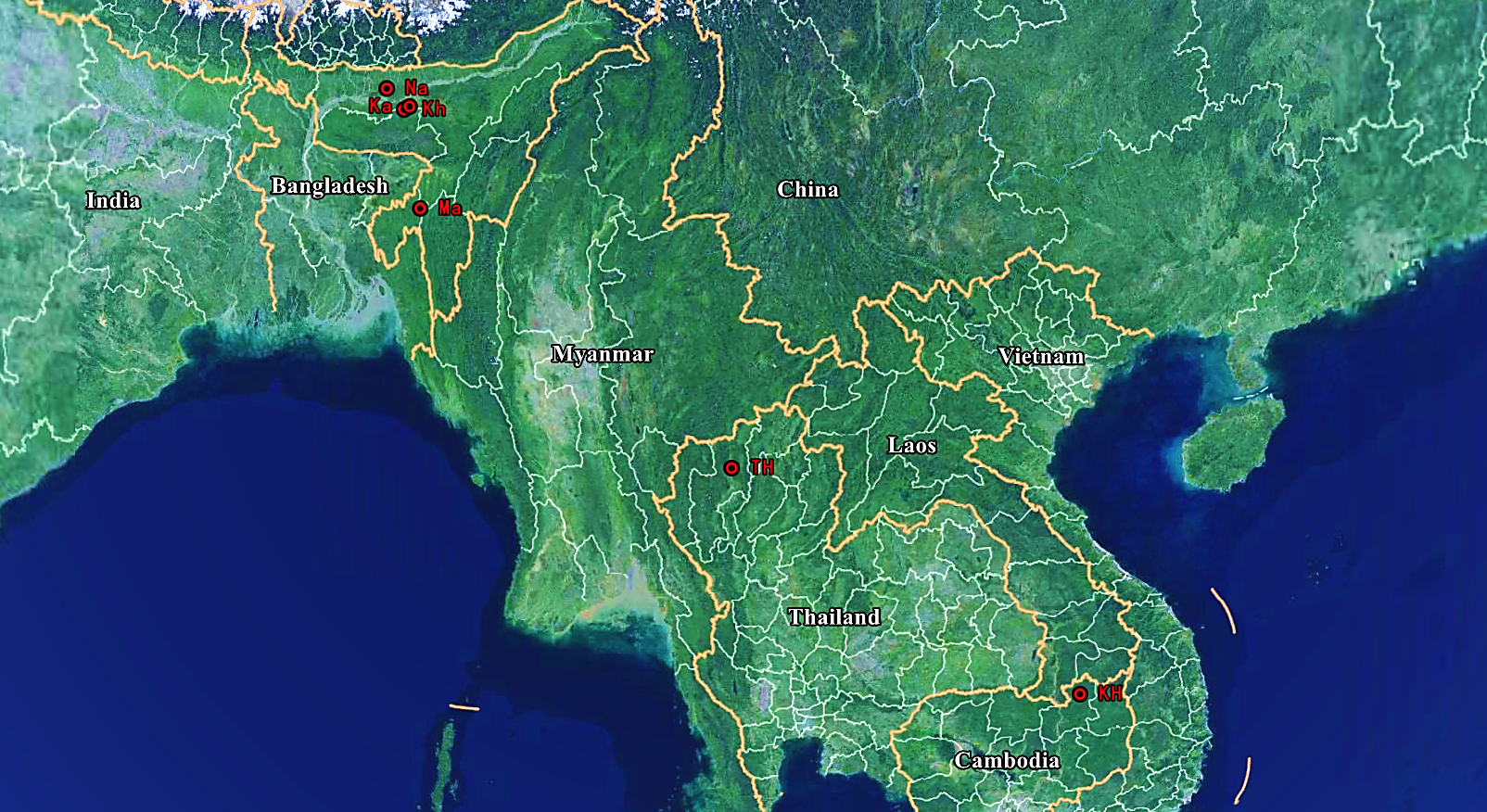

Figure 2. Distribution heatmap of haplotype based on ITS2. KH-St-Sp, Siem Pang County (Stung treng, Cambodia); IN-Ass-Na, Nalbari (Assam, India); IN-Ass-Ka, Kamrup (Assam, India); IN-Miz-Ma, Mamit (Mizoram, India); IN-Meg-Kh, Khasi hills (Meghalaya, India); TH-Cm, Chiang Mai (Thailand); The numbers of haplotypes are shown on the right side of the figure. The color scale ranges from blue to red, showing a range from minimum number (0) to maximum numbers (29) for each haplotype.
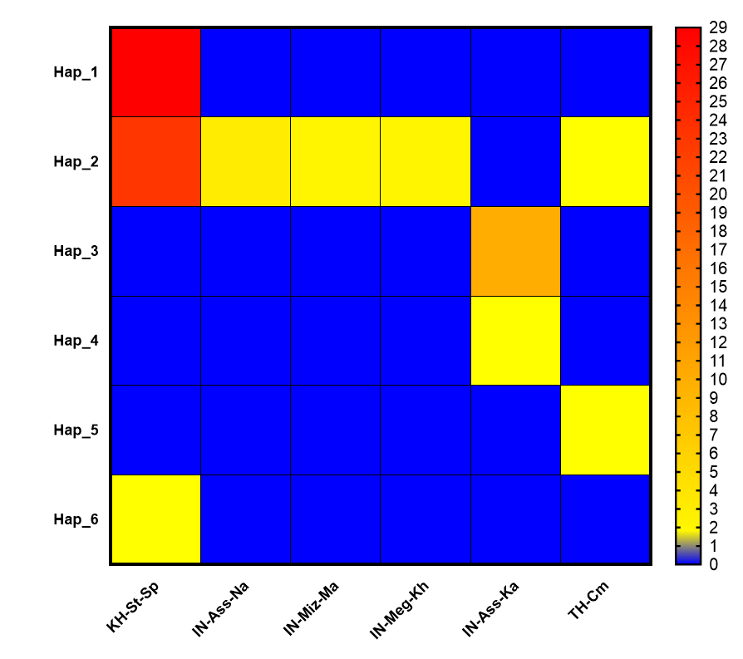

Figure 3. Phylogenetic network of 6 rDNA haplotypes of ITS2 gene in Anopheles nivipes. Localities are indicated by different colors (bottom-right). The area of each circle is approximately proportional to the frequency of the haplotype. #Samples available in Genbank. *Samples from Cambodia-Laos border. KH_St_Sp, Siem Pang County (Stung treng, Cambodia); IN_Ass_Na, Nalbari (Assam, India); IN_Ass_Ka, Kamrup (Assam, India); IN_Miz_Ma, Mamit (Mizoram, India); IN_Meg_kh, Khasi hills (Meghalaya, India); TH_Cm, Chiang Mai (Thailand).
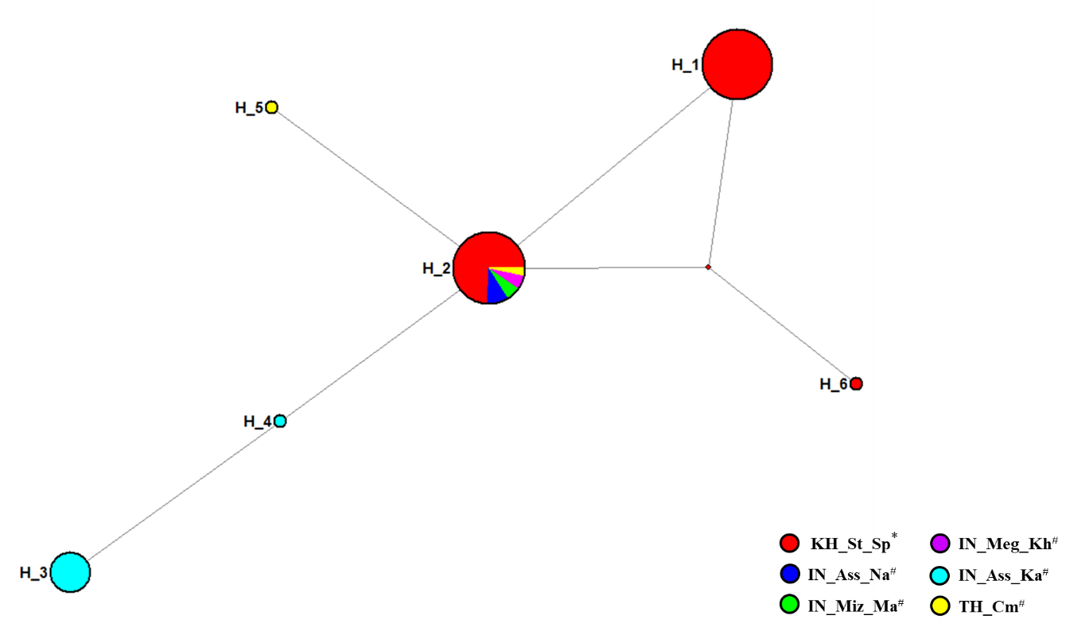

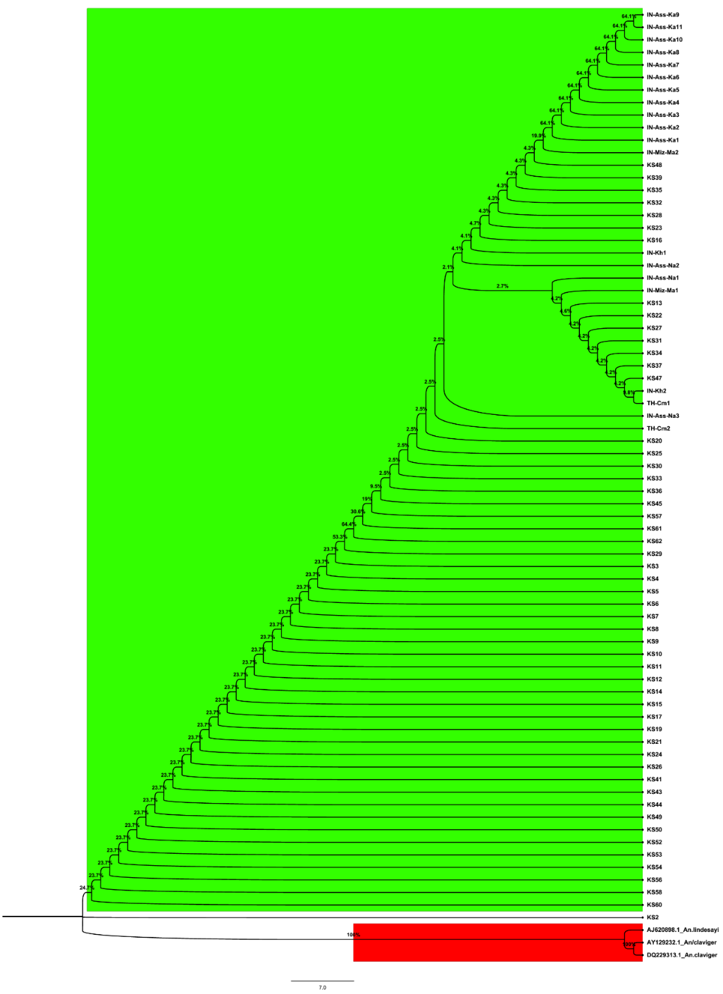
Figure 4. Neighbour-joining phylogenetic tree of Anopheles nivipes based on ITS2 from GenBank and our original data. Bootstrap values (1000 replicates) of neighbor-joining analyses are shown above/below the main lineages. Lineage designation is indicated on the right. Bars represent 7.0 substitutions per site based on ITS2. Different colors indicated different population groups of An. nivipes. An. lindesayi and An. claviger was used as the outgroup taxa. KS, Siem Pang County (Stung treng, Cambodia); IN_Ass_Na, Nalbari (Assam, India); IN_Ass_Ka, Kamrup (Assam, India); IN_Miz_Ma, Mamit (Mizoram, India); IN_Meg_Kh, Khasi hills (Meghalaya, India); TH_Cm, Chiang Mai (Thailand).

Figure 5. Isolation by distance, the relationship between geographical and genetic distances based on ITS2 sequences in Anopheles nivipes populations. Isolation by distance (IBD) was examined using a nonparametric Mantel with the web-based computer program IBDWS v.3.16.

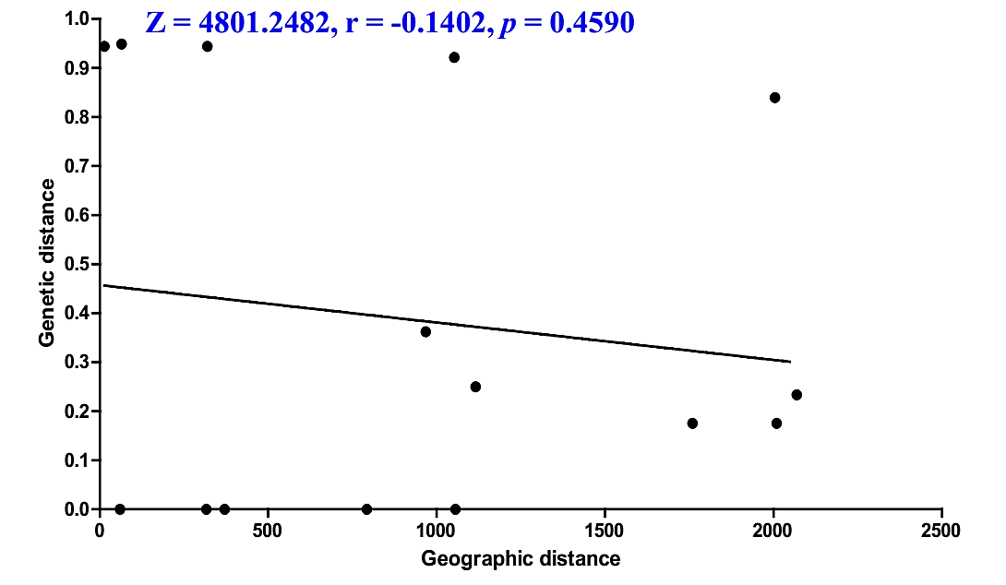

Figure 6. Neighbor-joining phylogenetic tree of An. nivipes haplotypes based on ITS2 sequences from GenBank and our original data. Bootstrap values (1000 replicates) of Neighbor-Joining analyses are shown above/below the main lineages. Lineage designation is indicated on the right. Bars represent 0.4 substitutions per site based on ITS2. Different colors indicated different population groups of An. nivipes.

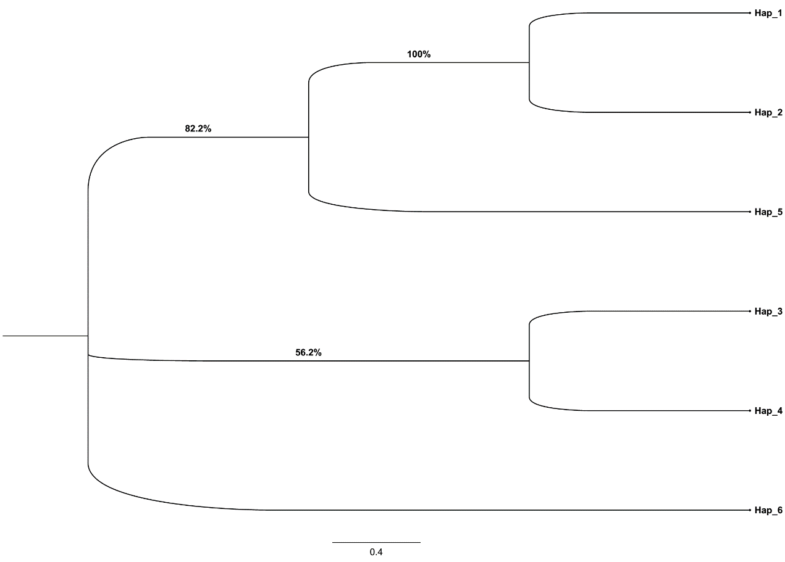

Figure 7. Cluster analysis based on ITS2 sequences in Anopheles nivipes populations. UPGMA dendrogram based on Nei‘s unbiased genetic distance between different populations of An. nivipes. Bars represent 0.5 substitutions per site based on ITS2. KS, Siem Pang County (Stung treng, Cambodia); IN_Ass_Na, Nalbari (Assam, India); IN_Ass_Ka, Kamrup (Assam, India); IN_Miz_Ma, Mamit (Mizoram, India); IN_Meg_Kh, Khasi hills (Meghalaya, India); TH_Cm_Cm, Chiang Mai (Thailand).
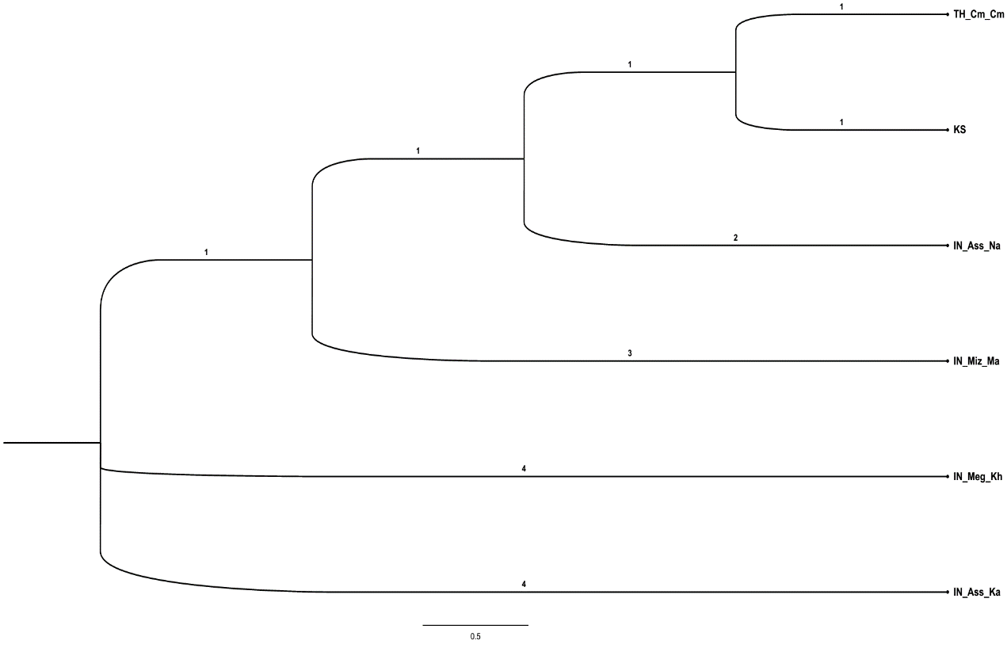

Figure 8. Mismatch distribution graphs for Siem Pang population. The X and Y-axis show the number of pairwise differences and the frequency of the pairwise comparisons, respectively. The observed frequencies are represented by a dotted line. The frequency expected under the hypothesis of constant population model is depicted by a solid line. (a) all populations-ITS2; (b) Siem Pang population-ITS2.
