Additional File 5. Weekly surveillance and consultation data.
Table S1. Percent and proportion of weekly reports received late by year and township.
Township | 2014 | 2015 | 2016 | 2017 | 2018 | 2019 | 2020 | 2021†
Township | Percent (%) (n/N*)
Hpapun | 11.4  (273/2398) | 14.8  (1907/12907) | 15.0  (3349/22277) | 10.4  (2490/23844) | 24.7  (6169/24964) | 18.6  (4626/24877) | 29.6  (7061/23873) | 43.3  (8991/20766)
Hlaingbwe | 50.4  (461/915) | 20.7  (1155/5592) | 9.9  (1418/14354) | 11.6  (2266/19526) | 12.0  (2347/19557) | 10.2  (1953/19198) | 10.4  (1918/18508) | 19.3  (1649/8533)
Kawkareik | 72.2  (164/227) | 34.4  (810/2356) | 3.9  (325/8285) | 8.6  (975/11345) | 7.7  (890/11516) | 8.0  (934/11645) | 11.5  (1358/11818) | 8.0  (514/6411)
Myawaddy | 39.5  (716/1813) | 37.2  (1578/4246) | 22.6  (1182/5235) | 20.3  (1083/5330) | 13.7  (748/5456) | 13.4  (719/5364) | 28.2  (1536/5442) | 15.1  (665/4395)
Total | 30.2  (1614/5351) | 21.7  (5450/25101) | 12.5  (6274/50151) | 11.3  (6814/60045) | 16.5  (10154/61493) | 13.5  (8232/61084) | 19.6  (11873/60641) | 29.5  (11819/40105)
Reports were considered late if entered more than 14 days from end of reporting week for malaria posts in Hpapun and more than 7 days from end of reporting week for malaria posts in Hlaingbwe, Kawkareik and Myawaddy.
*Total reports include only reports with date of data entry.
† Year ongoing

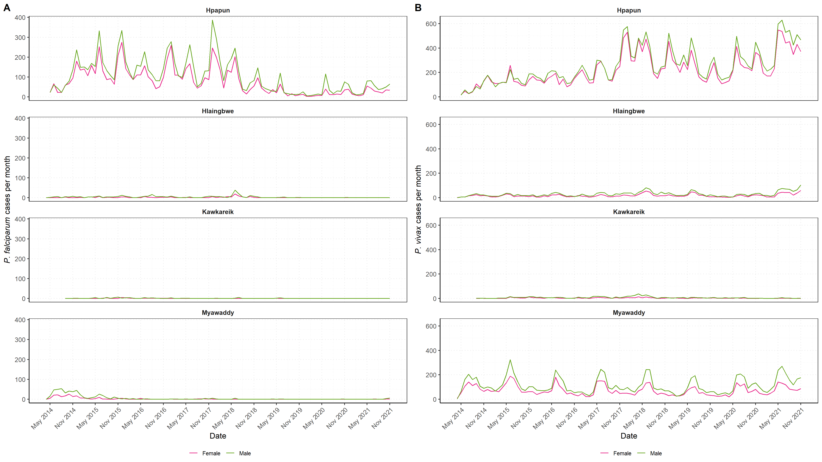Figure S1. Number of females and males diagnosed with (A) P. falciparum or (B) P. vivax by date and township. Total number of females (red line) and males (green line) diagnosed with P. falciparum or P. vivax at the METF malaria posts.

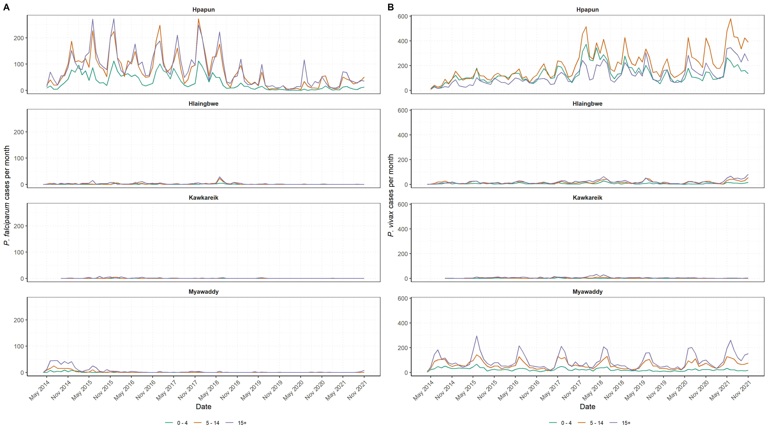 Figure S2. Number of each age group diagnosed with (A) P. falciparum or (B) P. vivax by date and township. Total number of individuals (less than 5 years of age – green line, between 5 to 15 years of age – orange line, and over 15 years of age – purple line) diagnosed with P. falciparum or P. vivax at the METF malaria posts.

Table S2. Percent and proportion of consultations in people who typically reside in the malaria post village by year and township.
Township | 2014 | 2015 | 2016 | 2017 | 2018 | 2019 | 2020 | 2021†
Township | Percent (%) (n/N*)
Hpapun | 80.9  (7463/9230) | 83.6  (31423/37585) | 87.6  (39742/45357) | 92.9  (44754/48152) | 89.6  (43320/48339) | 93.5  (40794/43645) | 93.0  (41674/44834) | 87.3  (27539/31537)
Hlaingbwe | 78.4  (1521/1940) | 86.3  (10834/12552) | 93.7  (23980/25600) | 92.7  (25551/27562) | 87.0  (21005/24145) | 91.5  (22054/24114) | 93.9  (22675/24156) | 91.3  (12280/13443)
Kawkareik | 100  (257/257) | 95.8  (4244/4431) | 98.4  (12134/12330) | 96.8  (13356/13799) | 93.4  (11317/12121) | 94.7  (11937/12609) | 95.5  (12147/12717) | 96.2  (5775/6002)
Myawaddy | 90.0  (7934/8816) | 86.2  (18073/20967) | 91.8  (17886/19477) | 91.5  (17607/19233) | 91.3  (15474/16949) | 91.2  (14844/16278) | 93.0  (13887/14936) | 91.5  (10786/11781)
Total | 84.8  (17175/20243) | 85.5  (64574/75535) | 91.2  (93742/102764) | 93.1  (101268/108746) | 89.7  (91116/101554) | 92.7  (89629/96646) | 93.5  (90383/96643) | 89.8  (56380/62763)
*Total consultations include only those with information on residence.
† Year ongoing

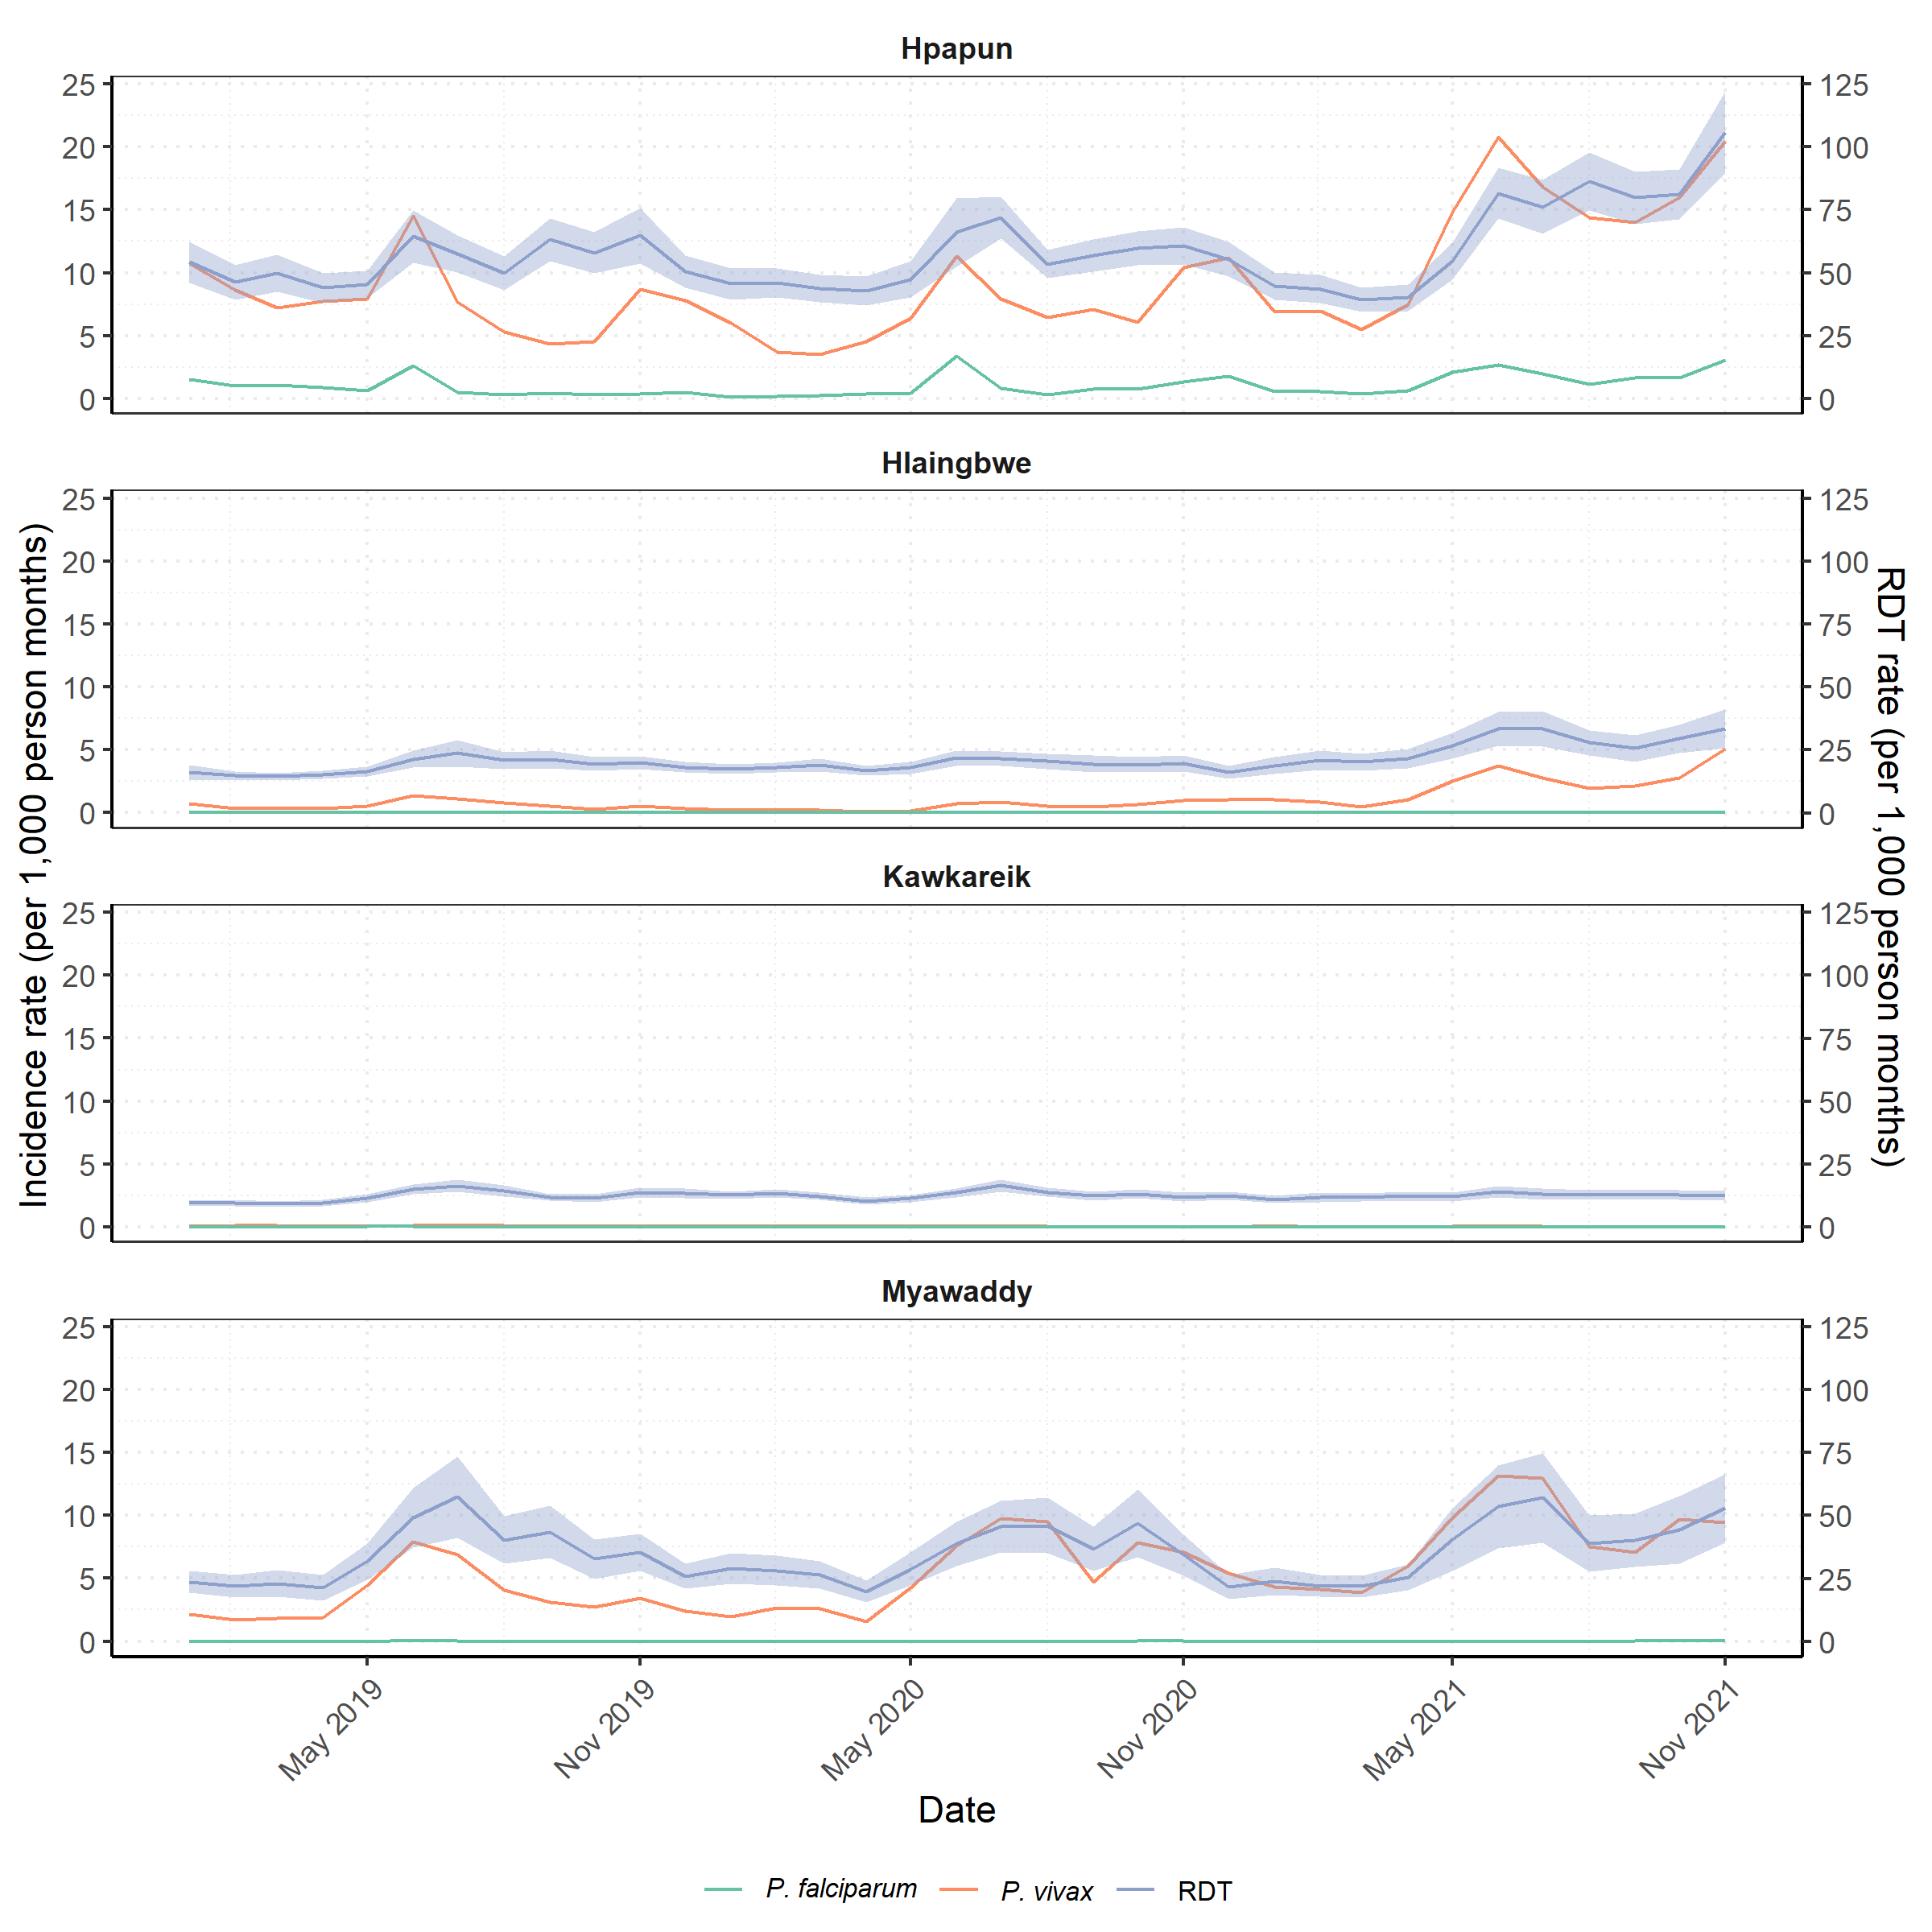
Figure S3. Average monthly rate of RDTs and malaria incidence by date and township. Average monthly rapid diagnostic testing rate (RDT – purple line) with 95% confidence intervals (purple area), and average monthly P. falciparum (green line) and P. vivax (orange line) incidence rates at the METF malaria posts from 2019 to 2021.

