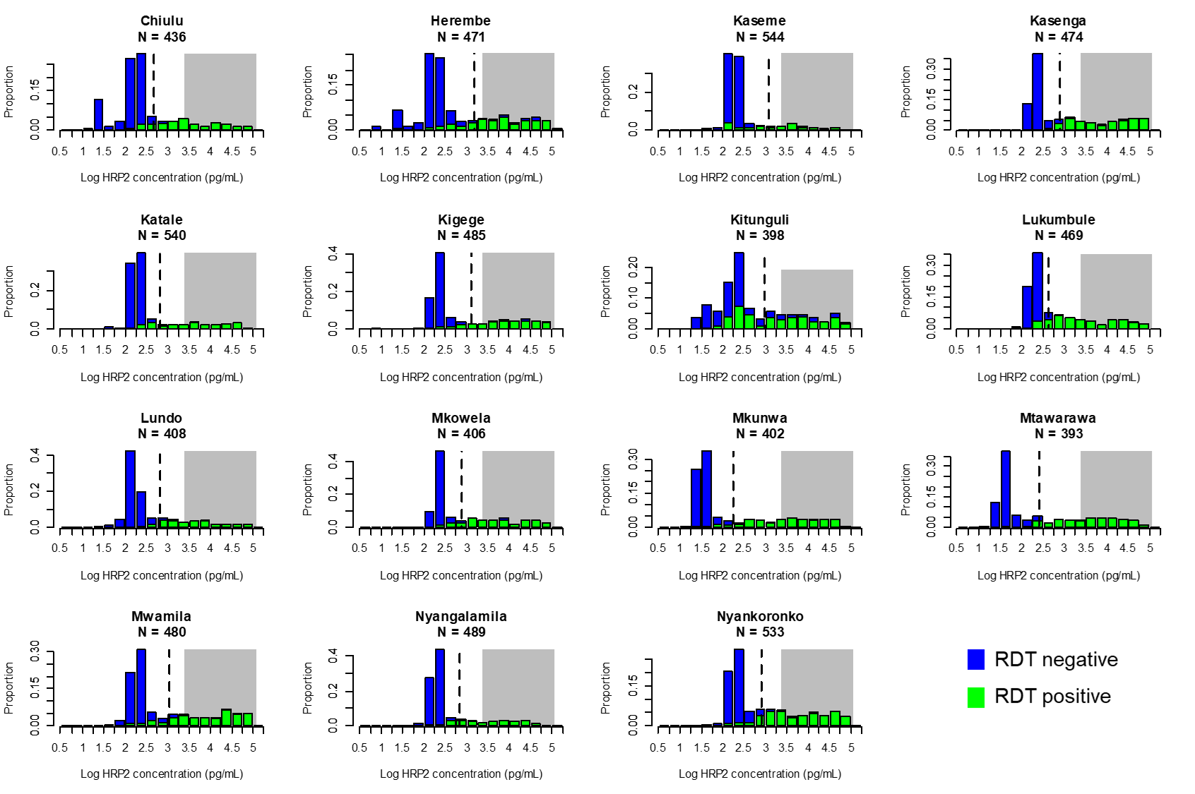

Additional File 3. Antigen concentration versus RDT result in comparison with estimated pyrogenic threshold. Histograms of log-transformed HRP2 concentration shown for each of the village enrolment sites with green bars indicating specimens from RDT-positive persons and blue bars from RDT-negative persons. Grey shading on each plot indicates HRP2 concentrations previously estimated as the pyrogenic threshold for this antigen at >3,000 pg/mL (3 ng/mL) (11), and hashed vertical lines for each plot indicate 50% reliability estimates for HRP2 limit of detection (LOD) for each study site.

