Malaria among children under 10 years in 4 endemic health areas in Kisantu Health Zone: epidemiology and transmission
Additional
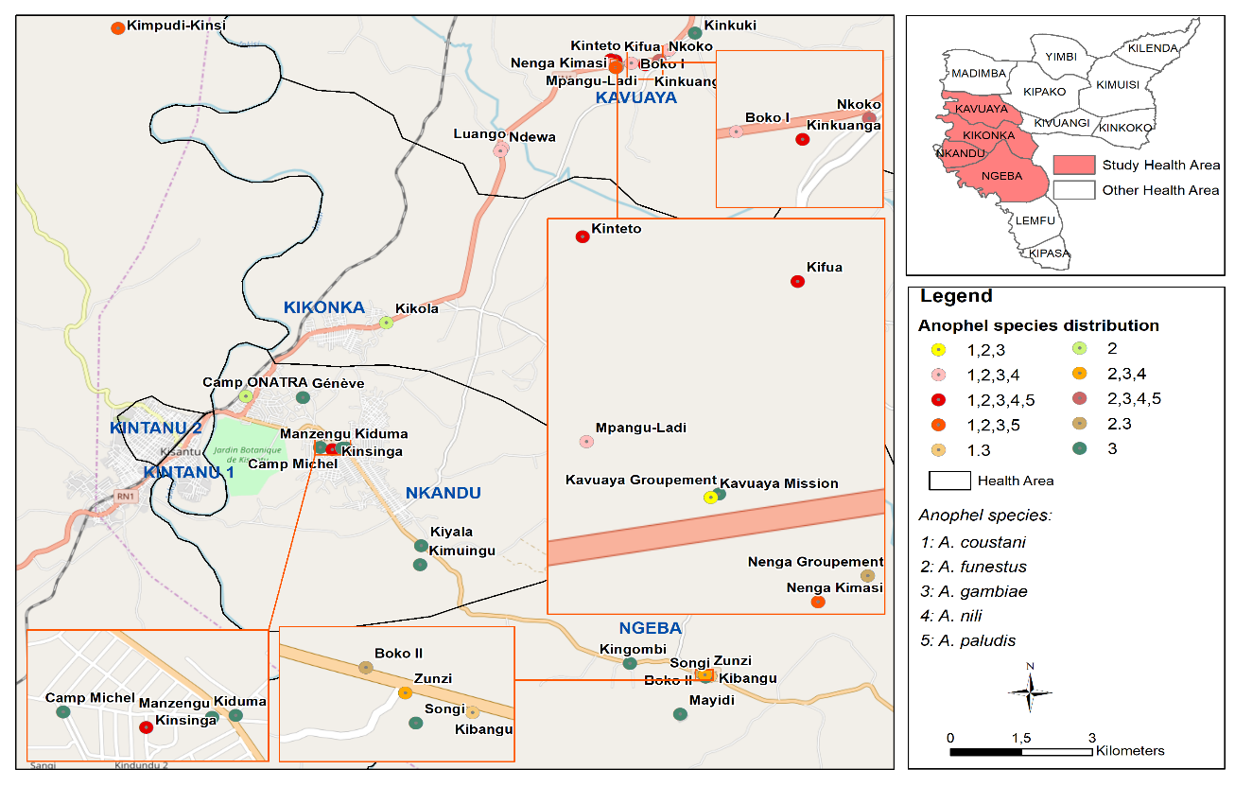
Figure 4: Mapping of distribution of Anopheles species in Kisantu Health Zone, Kongo-Central Province.

Table 6. Human biting rate was determined from human landing collections in the different villages in Kisantu only An. gambiae sl and funestus sl
Village | Mosquitoes |  |  | N  HLC  In/Out | Bites per man-night
Village | All | In | out |  | Inside | Outside | Mean HBR
Kifua | 128 | 55 | 73 | 3 | 18.3 | 24.3 | 21.3
Ndewa | 110 | 58 | 52 | 3 | 19.3 | 17.3 | 18.3
Kinteto | 91 | 24 | 67 | 3 | 8 | 22.3 | 15.2
Luango | 87 | 35 | 52 | 3 | 11.6 | 17.3 | 14.5
Nkoko | 82 | 40 | 42 | 3 | 13.3 | 14 | 13.6
Boko I | 69 | 27 | 42 | 3 | 9 | 14 | 11.5
Mpangu-Ladi | 68 | 29 | 39 | 3 | 9.6 | 13 | 11.3
Zunzi | 61 | 24 | 37 | 3 | 8 | 12.3 | 10.2
Kinkuanga | 58 | 36 | 22 | 3 | 12 | 7.3 | 9.6
Kundulu | 51 | 20 | 31 | 3 | 6.6 | 10.3 | 8.5
Kavuaya Mission | 47 | 20 | 27 | 3 | 6.6 | 9 | 7.8
Kinsinga | 39 | 25 | 14 | 3 | 8.3 | 4.6 | 6.5
Nenga Kimasi | 37 | 13 | 24 | 3 | 4.3 | 8 | 6.2
Nenga Groupement | 36 | 14 | 22 | 3 | 4.6 | 7.3 | 6
Kimpudi-Kinsi | 16 | 0 | 16 | 3 | 0 | 5.3 | 2.6
Boko II | 3 | 2 | 1 | 3 | 0.6 | 0.3 | 0.5
Camp Michel | 0 | 0 | 0 | 3 | 0 | 0 | 0
Camp Onatra | 2 | 1 | 1 | 3 | 0.3 | 0.3 | 0.3
Geneve | 2 | 1 | 1 | 3 | 0.3 | 0.3 | 0.3
Kavuaya groupement | 2 | 1 | 1 | 3 | 0.3 | 0.3 | 0.3
Kibangu | 2 | 1 | 1 | 3 | 0.3 | 0.3 | 0.3
Kiduma | 0 | 0 | 0 | 3 | 0 | 0 | 0
KIkola | 2 | 1 | 1 | 3 | 0.3 | 0.3 | 0.3
Kimuingu | 2 | 1 | 1 | 3 | 0.3 | 0.3 | 0.3
Kingombi | 2 | 1 | 1 | 2 | 0.3 | 0.3 | 0.3
Kinkuki | 2 | 1 | 1 | 3 | 0.3 | 0.3 | 0.3
Kiyala | 1 | 0 | 1 | 3 | 0 | 0.3 | 0.2
Manzengu | 2 | 1 | 1 | 3 | 0.3 | 0.3 | 0.3
Mayidi | 2 | 1 | 1 | 3 | 0.3 | 0.3 | 0.3
Songi | 2 | 1 | 1 | 3 | 0.3 | 0.3 | 0.3
Table 7. Study sites and their epidemiological stratum in Kisantu Health Zone, Kongo-Central Province
Villages | Geographical coordinates |  | Altitude | n | Prevalence (95% CI) | Stratum Epidemiological
 | South | East
Boko I | 05°03.281’ | 015°08.703’ | 515m | 59 | 1.7 (0.0-9.1) | Hypo-endemic
Boko Ii | 05°11.005’ | 015°09.507’ | 470m | 58 | 3.5 (0.4-11.9) | Hypo-endemic
Camp Michel | 05°08.147’ | 015°05.150’ | 470m | 60 | 5 (1.0-13.9) | Hypo-endemic
Camp Onatra | 05°07.502’ | 015°04.299’ | 470m | 60 | 8.3 (2.7-18.4) | Meso-endemic
Geneve | 05°07.516’ | 015°04.951’ | 470m | 60 | 15 (7.1-26.6) | Meso-endemic
Kavuaya Groupement | 05°03.306’ | 015°08.501’ | 515m | 60 | 30 (18.8-43.2) | Meso-endemic
Kavuaya Mission | 05°03.307’ | 015°08.499’ | 515m | 61 | 4.9 (1.0-13.7) | Hypo-endemic
Kibangu | 05°11.048’ | 015°09.599’ | 631m | 60 | 3.3 (0.4-11.5) | Hypo-endemic
Kiduma | 05°08.154’ | 015°05.441’ | 470m | 61 | 4.9 (1.0-13.7) | Hypo-endemic
Kifua | 05°03.249’ | 015°08.520’ | 515m | 57 | 52 (38.9-66.0) | Hyper-endemic
Kikola | 05°06.568’ | 015°05.904’ | 470m | 60 | 1.7 (0.0-8.9) | Hypo-endemic
Kimpudi-Kinsi | 05°02.840’ | 05°02.840’ | 515m | 60 | 23.3 (13.4-36.0) | Meso-endemic
Kimuingu | 05°09.364’ | 015°06.289’ | 470m | 60 | 3.3 (0.4-11.5) | Hypo-endemic
Kingombi | 05°10.886’ | 015°08.685’ | 470m | 59 | 3.4 (0.4-11.7) | Hypo-endemic
Kinkuanga | 05°03.302’ | 015°08.864’ | 515m | 60 | 35 (23.1-48.4) | Hyper-endemic
Kinkuki | 05°02.900’ | 015°09.431’ | 515m | 59 | 6.9 (1.9-16.5) | Meso-endemic
Kinsinga | 05°08.176’ | 015°05.290’ | 470m | 60 | 3.3 (0.4-11.5) | Hypo-endemic
Kinteto | 05°03.237’ | 015°08.468’ | 515m | 60 | 0.0 (0.0-5.9) | Hypo-endemic
Kiyala | 05°09.395’ | 015°06.302’ | 470m | 60 | 13.3 (5.9-24.6) | Meso-endemic
Kundulu | 05°03.111’ | 015°09.131’ | 515m | 59 | 50.9 (37.5-64.1) | Hyper-endemic
Luango | 05°04.354’ | 015°07.227’ | 515m | 59 | 20.3 (10.9-38.8) | Meso-endemic
Manzengu | 05°08.157’ | 015°05.401’ | 470m | 60 | 0.0 (5.9) | Hypo-endemic
Mayidi | 05°11.529’ | 015°09.261’ | 631m | 60 | 3.3 (3.4-11.5) | Hypo-endemic
Mpangu-Ladi | 05°03.292’ | 015°08.469’ | 515m | 60 | 26.7 (16.1-34.7) | Meso-endemic
Ndewa | 05°04.394’ | 015°07.205’ | 515m | 61 | 24.6 (14.5-37.3) | Meso-endemic
Nenga Groupement | 05°03.328’ | 015°08.537’ | 515m | 60 | 28.3 (17.5-41.4) | Meso-endemic
Nenga Kimasi | 05°03.335’ | 015°08.525’ | 515m | 60 | 36.7 (24.6-50.1) | Hyper-endemic
Nkoko | 05°03.245’ | 015°09.025’ | 515m | 57 | 28.1 (16.9-41.5) | Meso-endemic
Zunzi | 05°11.029’ | 015°09.541’ | 631m | 60 | 8.3 (2.7-18.4) | Meso-endemic
Songi | 05°11.058’ | 015°09.550’ | 631m | 60 | 1.7 (0.0-8.9) | Hypo-endemic

