Supplemental Figures

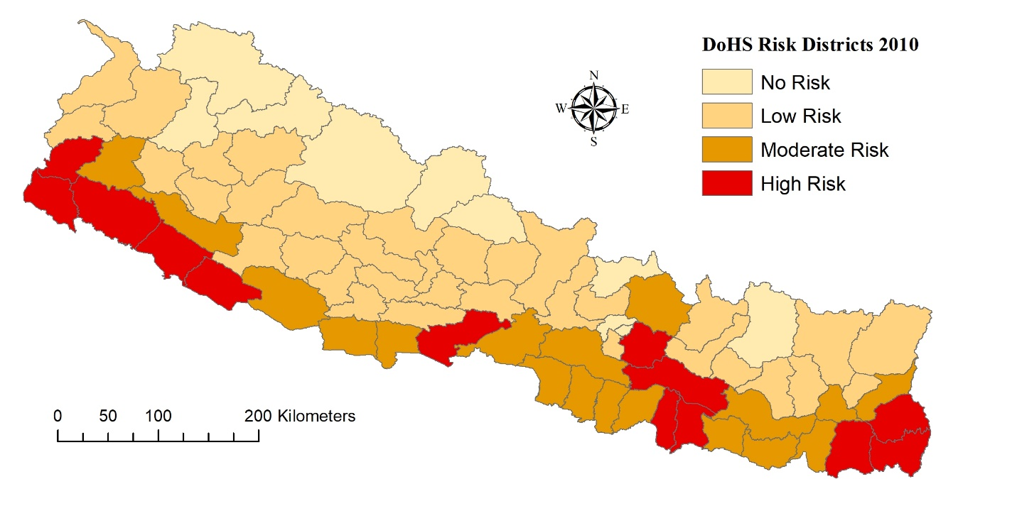
Fig. S1: DoHS Risk Districts 2010.

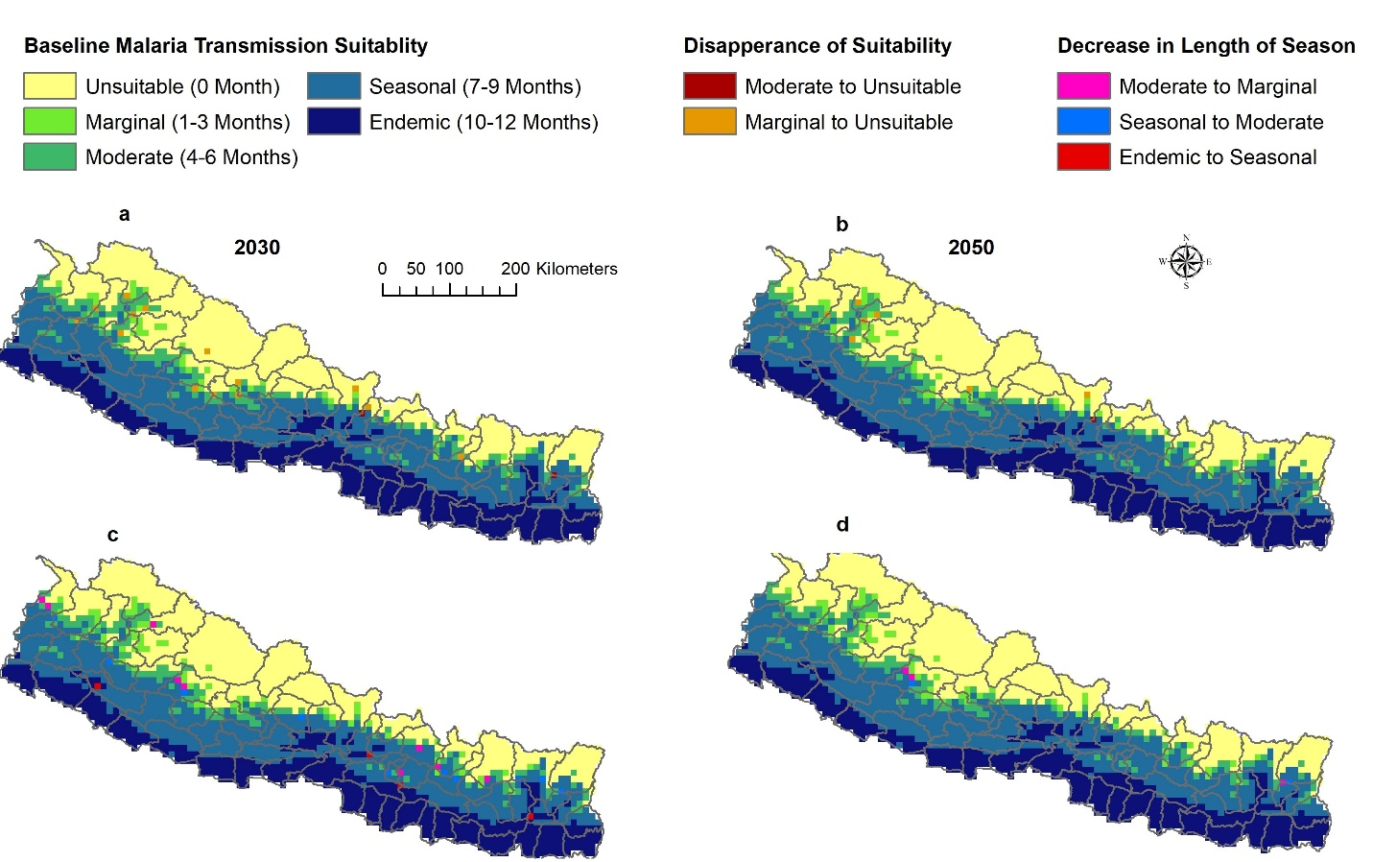
Fig. S2: Shifting malaria transmission suitability by ASPF under RCP 8.5. Areas with Disappearing Suitability (a-b) and Areas with Decrease in Length of Season (c-d).

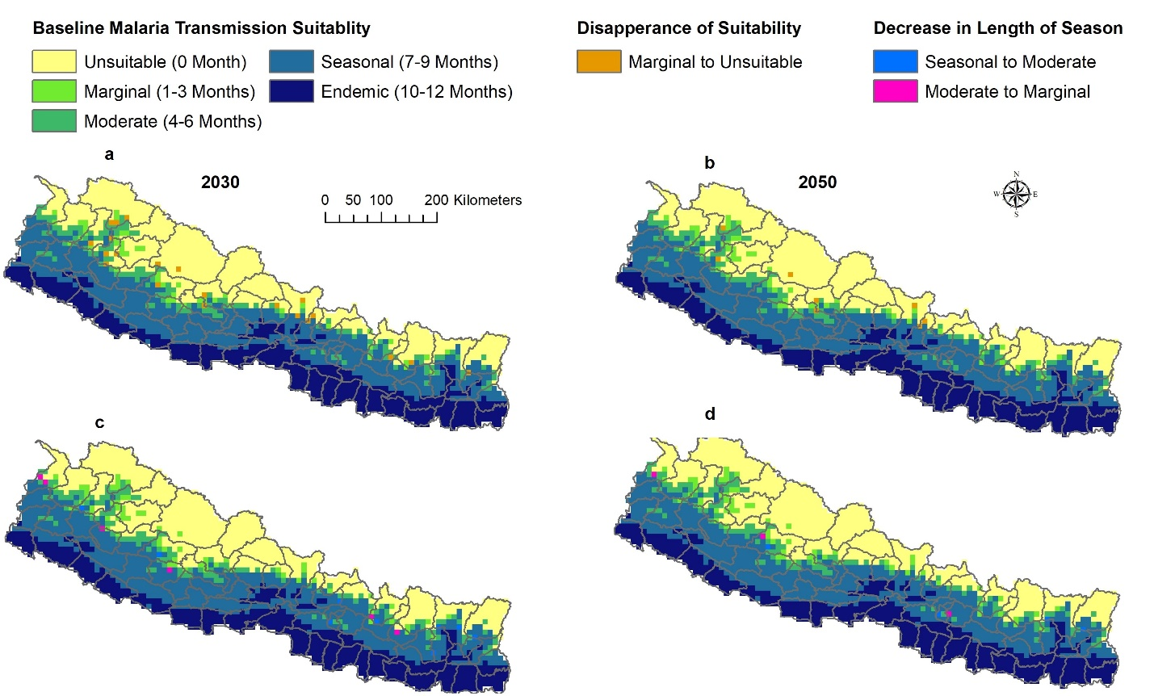
Fig. S3: Shifting malaria transmission suitability by ASPV under RCP 8.5. Areas with Disappearing Suitability (a-b) and Areas with Decrease in Length of Season (c-d).

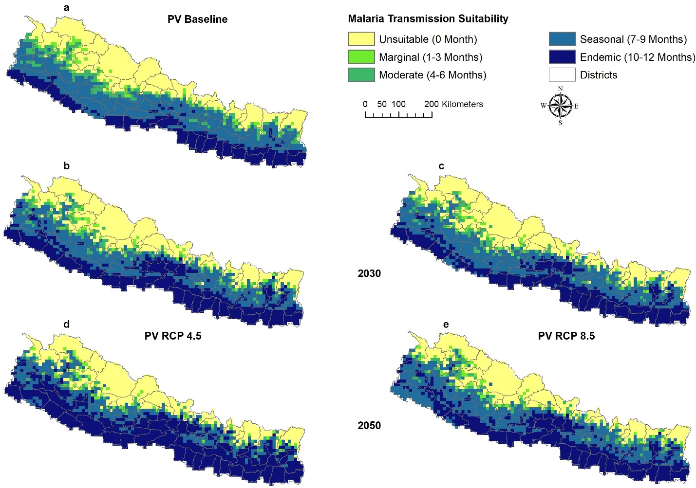
Fig. S4: Baseline and predicted malaria transmission suitability by ASPV. Baseline malaria transmission suitability (a). Future predictions include two RCPs: 4.5 (b and d and 8.5 (c and e) for two time periods 2030 (b-c) and 2050 (d-e).

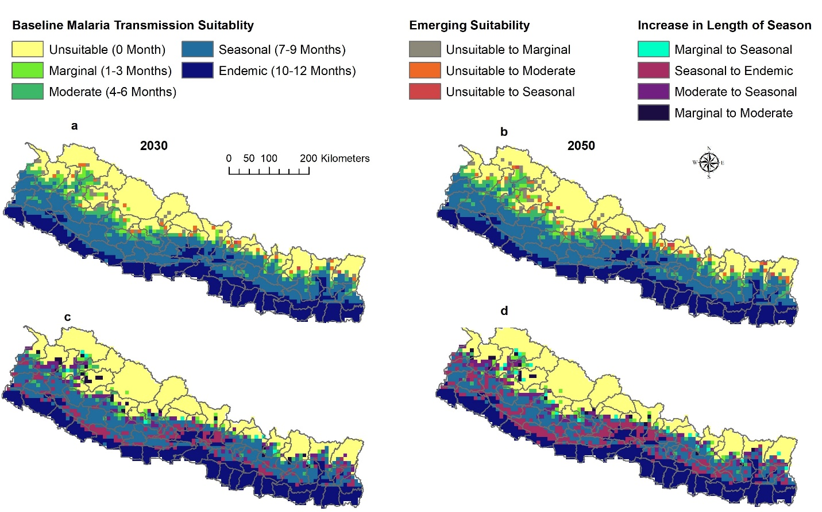
Fig. S5: Shifting malaria transmission suitability by ASPV under RCP 8.5. Areas with Emerging Suitability (a-b) and Areas with Increase in Length of Season (c-d).

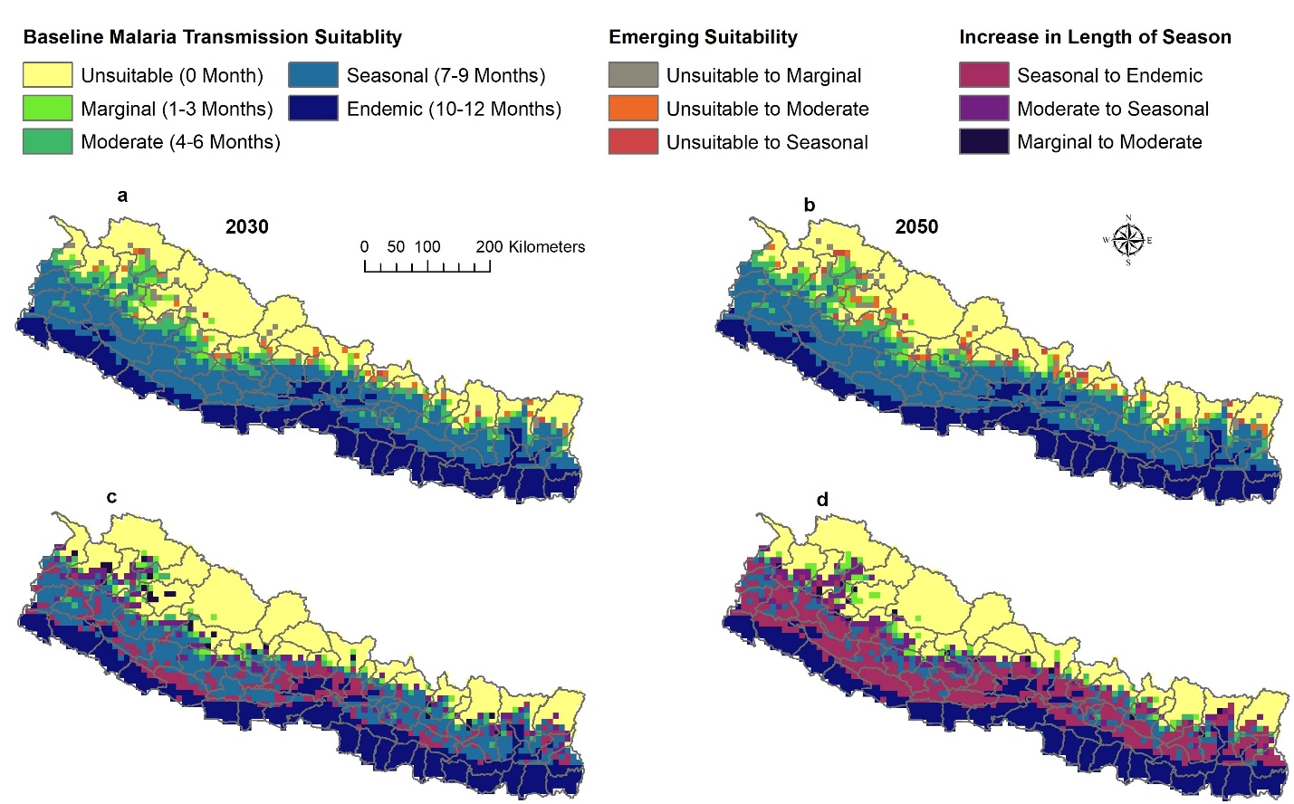
Fig. S6: Shifting malaria transmission suitability by ASPF under RCP 4.5. Areas with Emerging Suitability (a-b) and Areas with Increase in Length of Season (c-d).

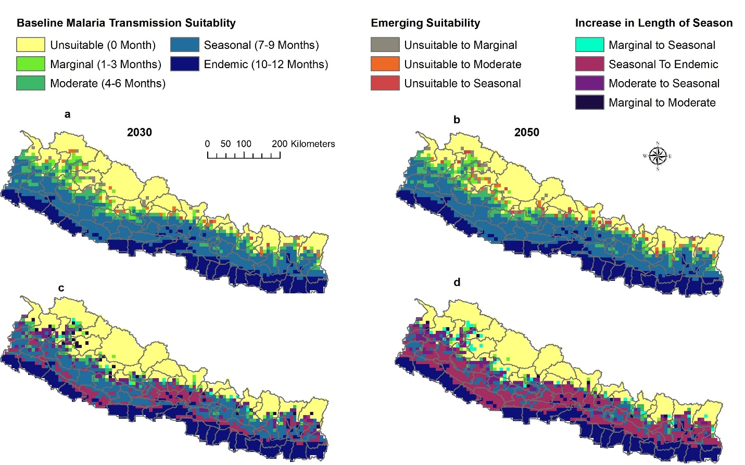
Fig. S7: Shifting malaria transmission suitability by ASPV under RCP 4.5. Areas with Emerging Suitability (a-b) and Areas with Increase in Length of Season (c-d).

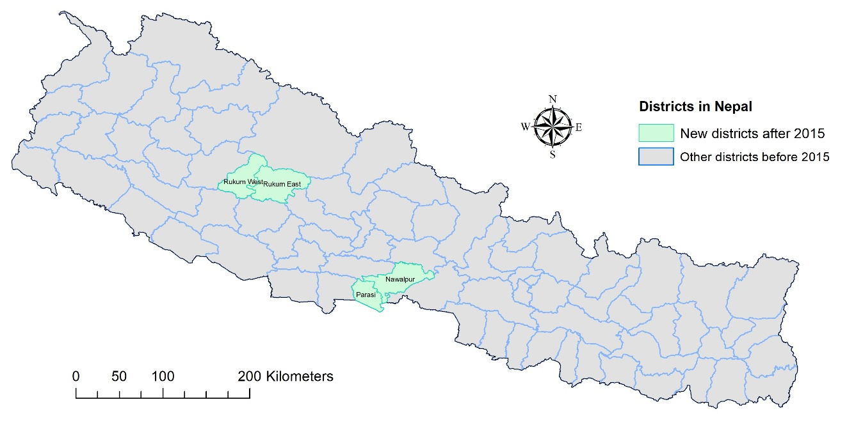
Fig. S8: Newly formed districts in Nepal after 2015.

Table S1: Warren’s I similarity metrics for comparing malaria transmission suitability between ASPF and ASPV

Comparison layers | Warren’s I metric
Warren’s I similarity metric between ASPF and ASPV
ASPF vs ASPV for RCP 4.5 2030 | 0.999
ASPF vs ASPV for RCP 4.5 2050 | 0.999
ASPF vs ASPV for RCP 8.5 2030 | 0.999
ASPF vs ASPV for RCP 8.5 2050 | 0.999
Warren’s I similarity metric between two RCPs for ASPF
RCP 4.5 vs RCP 8.5 for 2030 | 0.999
RCP 4.5 vs RCP 8.5 for 2050 | 0.998
2030 vs 2050 for RCP 4.5 | 0.998
2030 vs 2050 for RCP 8.5 | 0.999
Warren’s I similarity metric between two RCPs for ASPV
RCP 4.5 vs RCP 8.5 for 2030 | 0.999
RCP 4.5 vs RCP 8.5 for 2050 | 0.999
2030 vs 2050 for RCP 4.5 | 0.998
2030 vs 2050 for RCP 8.5 | 0.998

Table S2: Differences between malaria transmission suitability by ASPF and ASPV.

Change in Malaria Transmission Suitability | RCP 4.5 |  |  |  | RCP 8.5
 | 2030 |  | 2050 |  | 2030 |  | 2050
 | ASPF | ASPV | ASPF | ASPV | ASPF | ASPV | ASPF | ASPV
Moderate to Endemic | No | Yes | Yes | Yes | No | No | Yes | Yes
Moderate to Unsuitable | Yes | Yes | Yes | No | Yes | Yes | Yes | No
Endemic to Seasonal | Yes | No | No | Yes | Yes | Yes | No | Yes
Note: Yes means the conversion in category will occur and No means the conversion in category will not occur.

