Supplementary figures

Fig. S1 Anopheles farauti mean (±SE) biting profile from HLC at CBTA for 15 nights each during the wet (Apr) and dry (Oct) seasons between 2014 and 2017

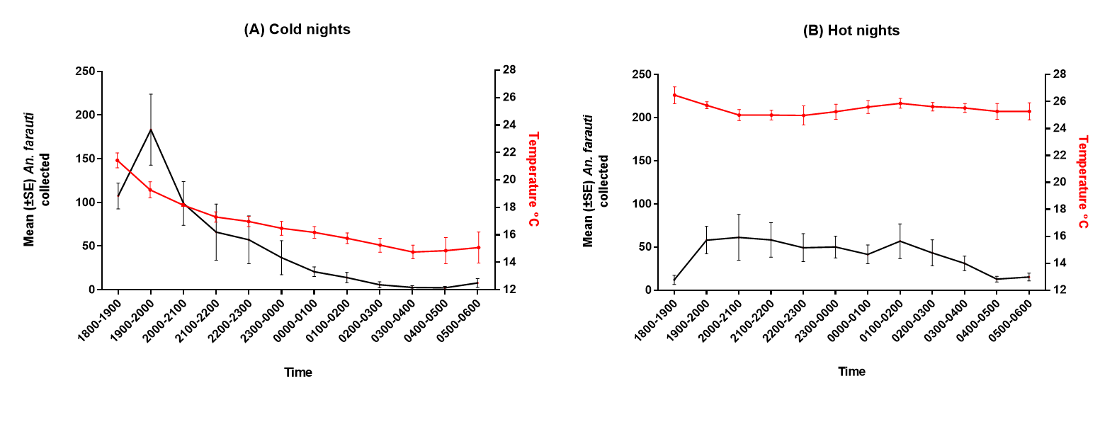
Fig. S2 (A) Anopheles farauti mean biting profile on four of the coldest nights during the study. (B) Anopheles farauti mean biting profile on four of the hottest nights during the study
Mean (±SE) An. farauti collected per person (black) compares with temperature (red).

