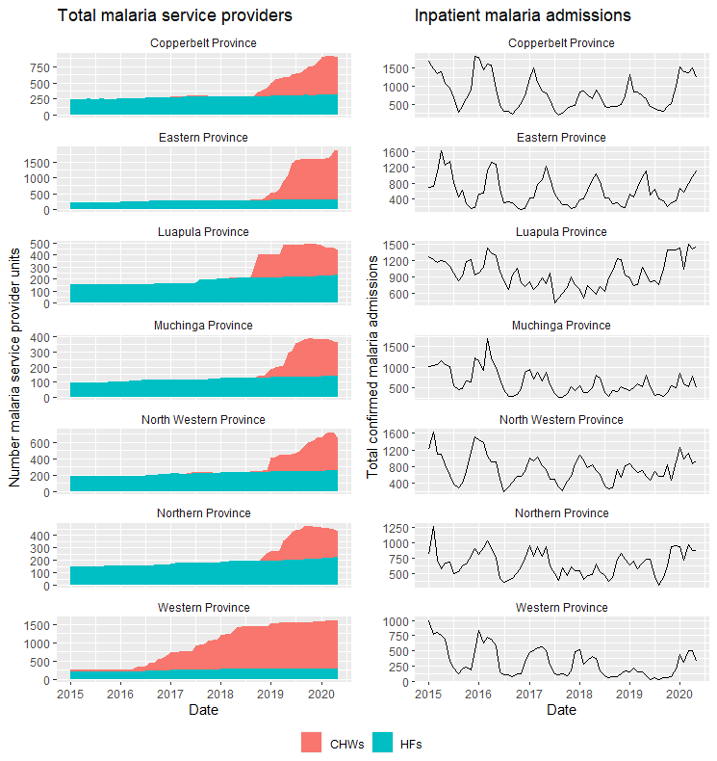
Supplementary figure 1 Stacked area plot of number of health facilities and community health workers operating by month and province (left) and line plot of total inpatient admissions with confirmed malaria among all ages by month and province (right). Note that y-axes are variable between Provinces.

