Table S1: Primer sequences, cycling conditions, and annealing temperatures for pfmsp1 block 2 and pfmsp2 nested PCR
Gene | Primer | Sequence (5’-3’) | Cycling conditions for msp1 and msp2 | Positive Control
msp1 | M1-OF | CTAGAAGCTTTAGAAGATGCAGTATTG | Primary PCR: | 3D7
 | M1-OR | CTTAAATAGTATTCTAATTCAAGTGGATCA | Initial denaturation at 95 °C for 5 min
 |  |  | followed by 25 cycles of a second
msp2 | M2-OF | ATGAAGGTAATTAAAACATTGTCTATTATA | denaturation at 94 °C for 1 min, | 3D7
 | M2-OR | CTTTGTTACCATCGGTACATTCTT | annealing at 58 °C for 2 min and
 |  |  | extension at 72 °C for 2 min, with a
 |  |  | final extension at 72 °C for 5 min
msp1 | M1-KF | AAATGAAGAAGAAATTACTACAAAAGGTGC |  | 3D7
 | M1-KR | GCTTGCATCAGCTGGAGGGCTTGCACCAGA
 | M1-MF | AAATGAAGGAACAAGTGGAACAGCTGTTAC | Nested PCR: | HB3
 | M1-MR | ATCTGAAGGATTTGTACGTCTTGAATTACC | Initial denaturation at 95 °C for 5 min
 | M1-RF | TAAAGGATGGAGCAAATACTCAAGTTGTTG | followed by 30 cycles of a second | 7G8
 | M1-RR | CATCTGAAGGATTTGCAGCACCTGGAGATC | denaturation at 94 °C for 1 min,
 |  |  | annealing at 61 °C for 2 min, and
msp2 | M2-FCF | AATACTAAGAGTGTAGGTGCARATGCTCCA | extension at 72 °C for 2 min, with a | HB3
 | M2-FCR | TTTTATTTGGTGCATTGCCAGAACTTGAAC | final extension at 72 °C for 5 min
 | M2-ICF | AGAAGTATGGCAGAAAGTAAKCCTYCTACT |  | 3D7
 | M2-ICR | GATTGTAATTCGGGGGATTCAGTTTGTTCG

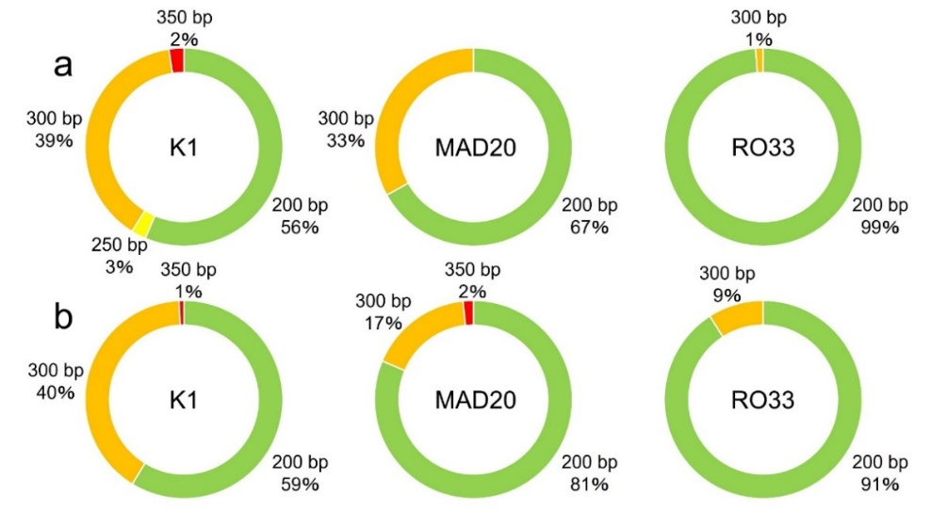

Fig. S1 Allelic frequencies in pfmsp1 block 2 in asymptomatic (a) and symptomatic (b) carriers and in both rural and urban areas

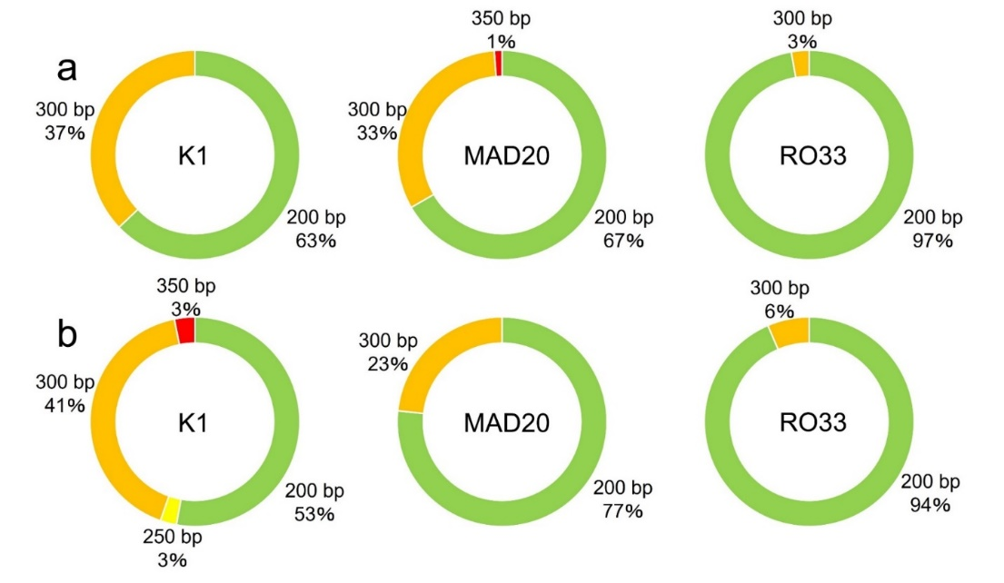

Fig. S2: Allelic frequencies in pfmsp1 block 2 in rural (a) and urban (b) areas
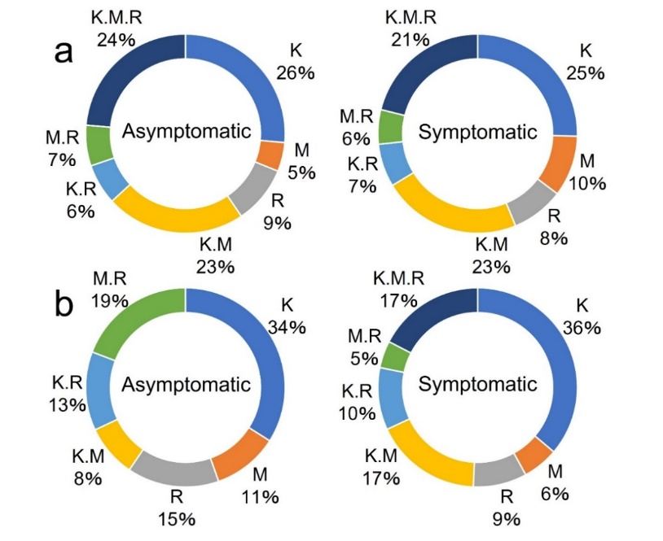

Fig. S3: Allelic frequencies in pfmsp1 block 2 in asymptomatic and symptomatic infections stratified by rural (a) and urban (b) areas

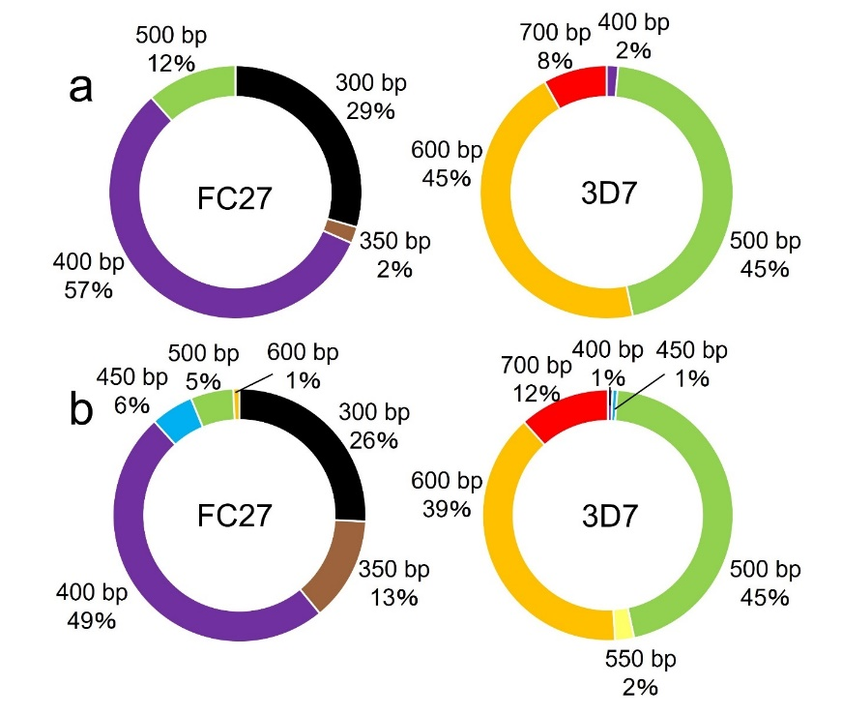
Fig. S4 Allelic frequencies in pfmsp2 in asymptomatic (a) and symptomatic (b) carriers

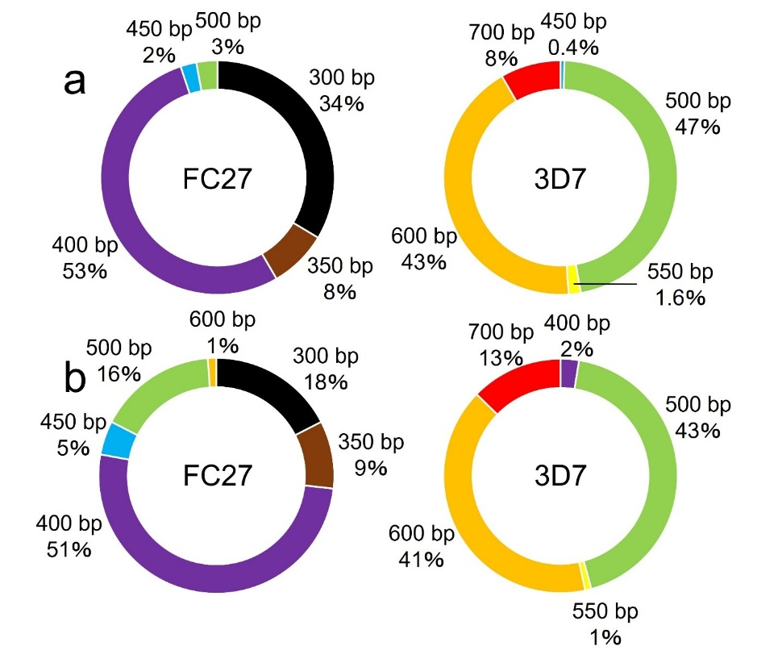

Fig. S5 Allelic frequencies in pfmsp2 in rural (a) and urban (b) areas

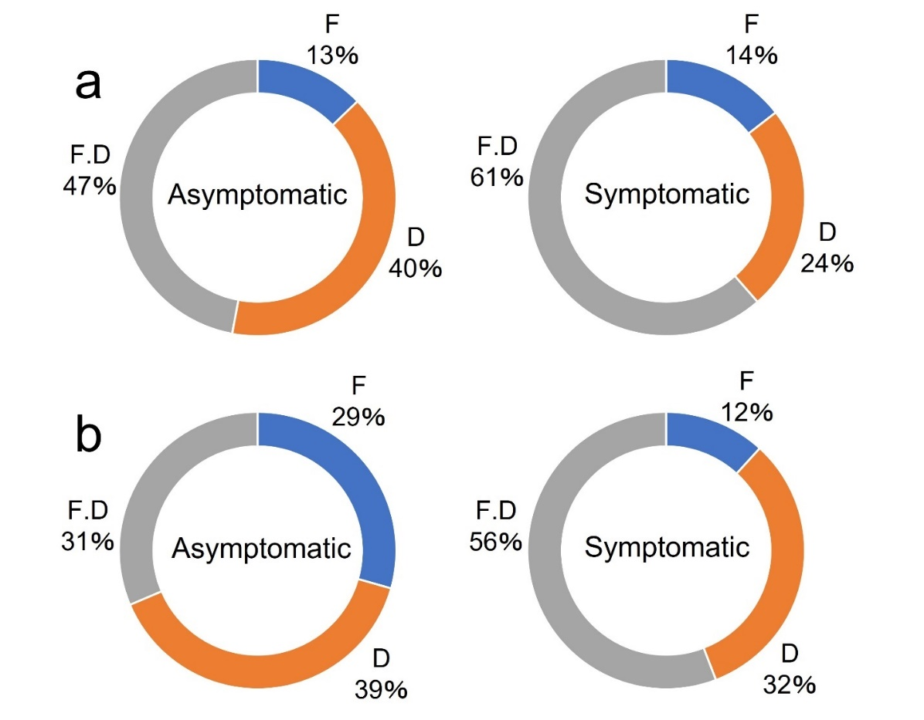
Fig. S6: Allelic frequencies in pfmsp2 in asymptomatic and symptomatic carriers stratified rural (a) and urban (b) areas

