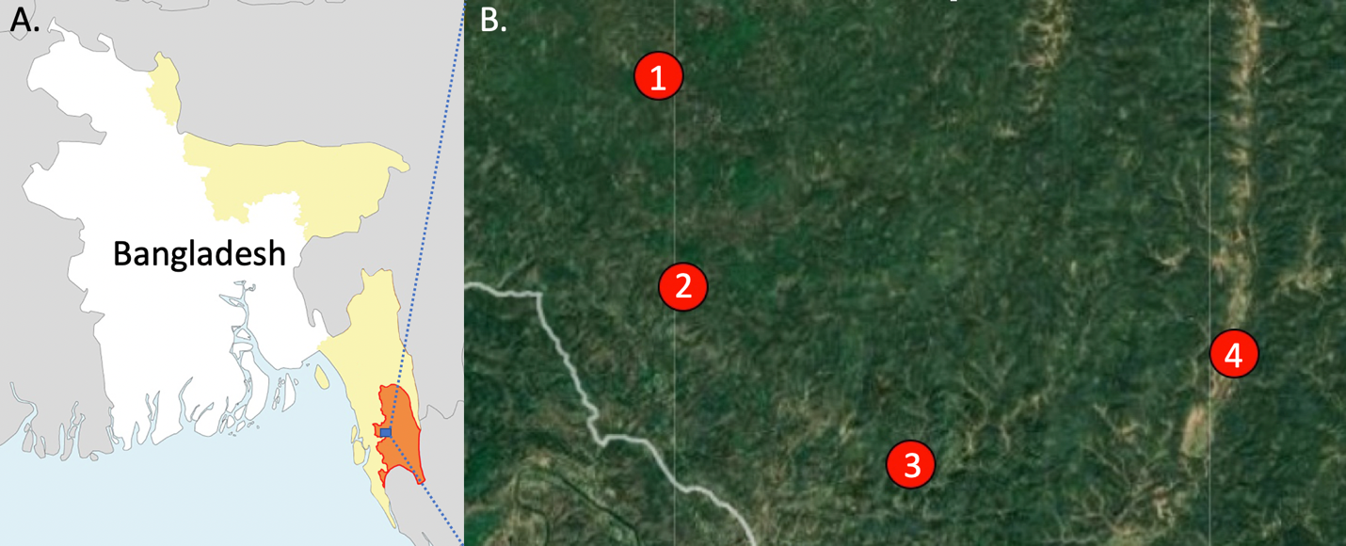
Figure 1. A. Map of Bangladesh with the malaria endemic regions labeled in yellow. Bandarban District, with the highest malaria is colored orange with the study site outlined in blue. B. The study sites 1) Noa Para, 2) 1,2,3 Rubber Bagan, 3) Prue Mong U Headman Para, and 4) Jogesh and Chikka Para. The map was published in an accompanying article (https://doi.org/10.1186/s12936-022-04375-4) which was a part of the same project.
Table 1. Trap-based sampling comparisons. Trapping method, species, and location impacted sampling rates.
Anopheles Species | HLC (Indoor) |  | HLC (Outdoor) |  | CDC-LT (Indoor) |  | CDC-LT (outdoor) |  | CDC-LT (Animal) |  | PSC
Anopheles Species | Total caught | /trap /night | Total caught | /trap /night | Total caught | /trap /night | Total caught | /trap /night | Total caught | /trap /night | Total caught | /trap /night
An. baimaii | 13 | 0.27 | 7 | 0.15 | 14 | 0.05 | 10 | 0.03 | 17 | 0.12
An. barbirostris | 3 | 0.06 | 6 | 0.13 | 5 | 0.02 | 16 | 0.05 | 23 | 0.16 | 2 | 0.00
An. jamesii | 1 | 0.02 | 1 | 0.02 | 16 | 0.05 | 16 | 0.05 | 115 | 0.82
An. jeyporiensis | 11 | 0.23 | 9 | 0.19 | 44 | 0.15 | 66 | 0.23 | 66 | 0.47 | 1 | 0.00
An. karwari | 2 | 0.04 | 1 | 0.02 | 25 | 0.09 | 41 | 0.14 | 283 | 2.02
An. kochi |  |  | 4 | 0.08 | 29 | 0.10 | 95 | 0.33 | 158 | 1.13 | 3 | 0.01
An. maculatus | 14 | 0.29 | 11 | 0.23 | 56 | 0.19 | 89 | 0.30 | 171 | 1.22 | 1 | 0.00
An. nigerrimus | 1 | 0.02 |  |  | 2 | 0.01 | 12 | 0.04 | 39 | 0.28 | 8 | 0.02
An. nivipes | 12 | 0.25 | 4 | 0.08 | 53 | 0.18 | 93 | 0.32 | 800 | 5.71
An. peditaeniatus | 10 | 0.21 | 6 | 0.13 | 28 | 0.10 | 52 | 0.18 | 152 | 1.09 | 7 | 0.02
An. subpictus |  |  |  |  | 1 | 0.00 | 1 | 0.00 | 2 | 0.01 | 4 | 0.01
An. tesselatus | 5 | 0.10 |  |  | 2 | 0.01 | 2 | 0.01 | 13 | 0.09 | 34 | 0.08
An. vagus | 7 | 0.15 | 1 | 0.02 | 211 | 0.72 | 144 | 0.49 | 22 | 0.16 | 1027 | 2.45
An. varuna | 4 | 0.08 | 3 | 0.06 | 24 | 0.08 | 32 | 0.11 | 48 | 0.34 | 12 | 0.03
Total | 83 | 1.72 | 53 | 1.11 | 510 | 1.75 | 669 | 2.28 | 1909 | 13.62 | 1099 | 2.62

