Additional file 6
Four subfigures of SNPs change at 2014, 2020, 2021 and 2022
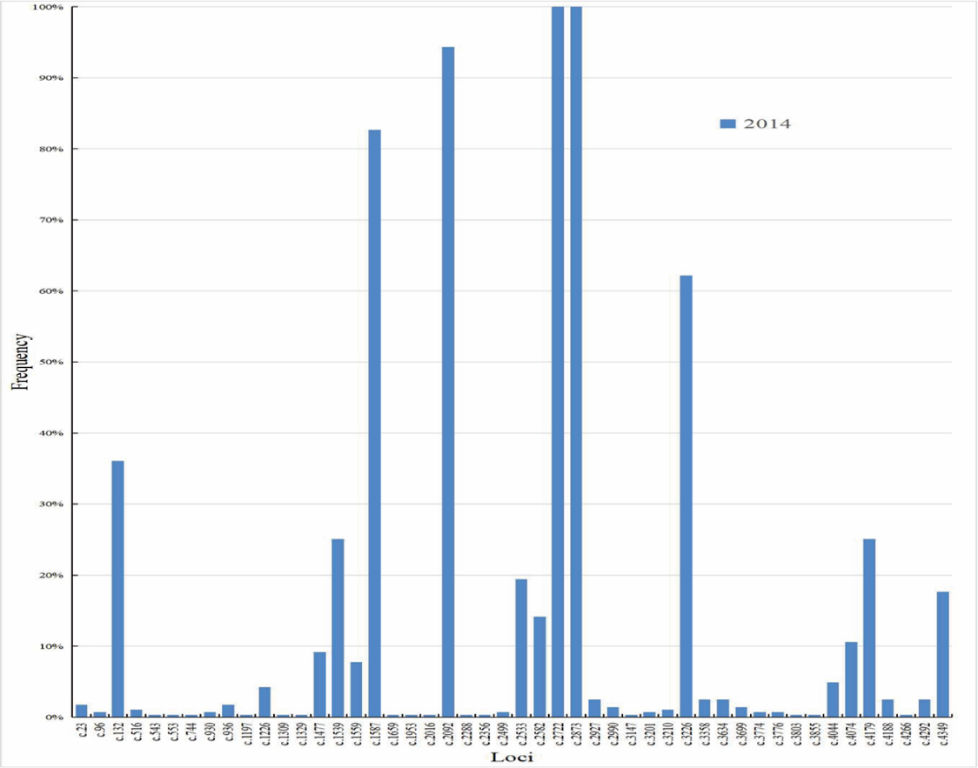
Fig. S1 The subfigure of SNPs composition at 2014
Fig. S2 The subfigure of SNPs composition at 2020
Fig. S3 The subfigure of SNPs composition at 2021
Fig. S4 The subfigure of SNPs composition at 2022

