Additional file 1
Table S1. Primer sequences in this study
Gene | Locus | Round | Primers | Sequence (5’ → 3’) | Amplicons (bp)
pfcrt  (2) | 336-366 | 1st | CRT1-1 | GATTATTTTCATTGTCTTCCACA | 304
pfcrt  (2) | 336-366 | 1st | CRT1-2 | GATCTCTATACCTTCAACATTATTCC | 304
pfmdr1  (3) | 1034, 1042, 1246 | 1st | MDR1-1 | GTGTATTTGCTGTAAGAGCT | 860
pfmdr1  (3) | 1034, 1042, 1246 | 1st | MDR1-2 | GACATATTAAATAACATGGGT TC | 860
pfmdr1  (3) | 1034, 1042, 1246 | 1st | MDR2-1 | CAGATGATG AAATGTTTAAAG ATC | 860
pfmdr1  (3) | 1034, 1042, 1246 | 1st | MDR2-2 | TAAATAACATGGGTTCTTGACT | 860
pfK13 (5) | 390 - 620 | 1st | K13-1-1 | CGGAGTGACCAAATCTGGGA | 2063
pfK13 (5) | 390 - 620 | 1st | K13-1-2 | GGGAATCTGGTGGTAACAGC | 2063
pfK13 (5) | 390 - 620 | 2nd | K13-2-1 | GCCTTGTTGAAAGAAGCAGA | 849
pfK13 (5) | 390 - 620 | 2nd | K13-2-2 | GCCAAGCTGCCATTCATTTG | 849

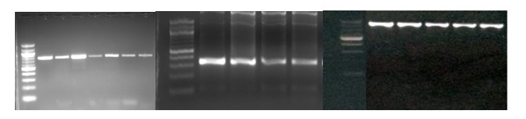
- (B) (C)
Figure S1. PCR product result for (A) K13¹ propeller domain (B) pfcrt exon 10² (C) pfmdr1³ in electrophorese gel 2%
¹product size 784 bp
² product size 304 bp
³Product size 860 bp

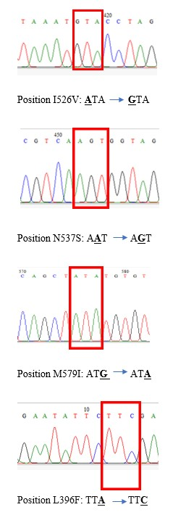
Figure S2. Chromatograms of sequence analysis on mutation position of the Kelch13 BTB/POZ and propeller domain in Sumba. The arrow shows the mutation position.
Table S2. Summary of Confidence Interval (CI) 95% with lower and upper CI in each molecular marker associated with drug resistance
Molecular Marker | Category | Estimates | Lower CI | Upper CI
Kelch13 | Mutation | 0.011 | 0 | 0.6
Kelch13 | Wild Type | 0.989 | 0.94 | 1
Haplotype pfmdr1 | SDD | 0.204 | 0.128 | 0.301
Haplotype pfmdr1 | SND | 0.796 | 0.699 | 0.872
Pfcrt I356L | 356L | 0.71 | 0.52 | 0.858
Pfcrt I356L | Wild Type | 0.29 | 0.142 | 0.48
pfpm2 CNVs | Single Copy | 0.847 | 0.760 | 0.912
pfpm2 CNVs | Multiple Copies | 0.153 | 0.088 | 0.240
pfmdr1 CNVs | Single Copy | 0.962 | 0.894 | 0.992
pfmdr1 CNVs | Multiple Copies | 0.038 | 0.008 | 0.106

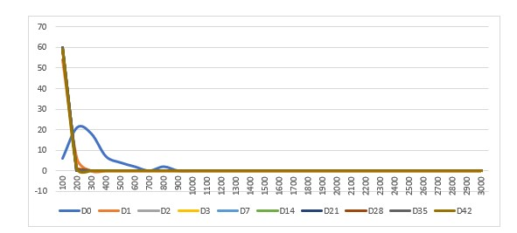
Figure S3. Line plot showing parasite density based on frequency per day observations in Papua

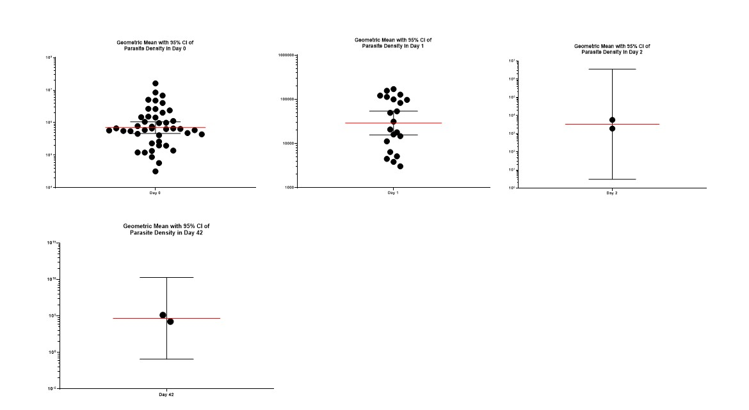
Figure S4. Geometric mean of parasite density during observation period 2020 to 2021 in Papua

