Additional File
Vaccine | Disease | Age Administered
BCG (Baccille Calmette Guérin) | Tuberculosis | Birth
OPV (Oral Polio Vaccine) | Polio | Birth
OPV (Oral Polio Vaccine) | Polio | 6 weeks
OPV (Oral Polio Vaccine) | Polio | 10 weeks
IPV (Inactivated Polio Vaccine) | Polio | 14 weeks
Rotavirus | Rotavirus | 6 weeks
Rotavirus | Rotavirus | 10 weeks
PCV10 (Pneumococcal conjugate vaccine 10-valent) | Pneumonia | 6 weeks
PCV10 (Pneumococcal conjugate vaccine 10-valent) | Pneumonia | 10 weeks
PCV10 (Pneumococcal conjugate vaccine 10-valent) | Pneumonia | 14 weeks
Pentavalent (DTwP-Hib-HepB Whole cell) vaccine | Diphtheria, Pertussis, Tetanus, Hepatitis B and Hib (influenza, pneumonia) | 6 weeks
Pentavalent (DTwP-Hib-HepB Whole cell) vaccine |  | 10 weeks
Pentavalent (DTwP-Hib-HepB Whole cell) vaccine |  | 14 weeks
RTS,S/ASO1 vaccine* | Malaria | 6 months
RTS,S/ASO1 vaccine* | Malaria | 7 months
RTS,S/ASO1 vaccine* | Malaria | 9 months
RTS,S/ASO1 vaccine* | Malaria | 24 months
Vitamin A supplements | Vitamin A Deficiency | 6 months
Vitamin A supplements | Vitamin A Deficiency | 1-5 years (bi-annual interval)
MR (Measles-Rubella) | Measles, Rubella | 9 months
MR (Measles-Rubella) | Measles, Rubella | 18 months
Table S1: Kenya national Extended Programme for Immunisation (EPI) vaccine schedule
*Delivered only in select subnational regions

Figure S1: Flowchart of the selection process to determine facilities routinely offering vaccination services in RTS, S/AS01 intervention areas (23 sub-counties) from DHIS2 listing.
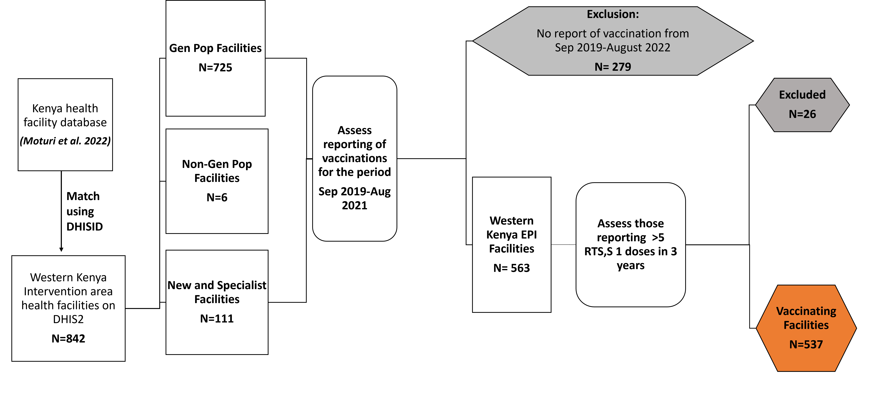
1
Non-Gen Pop includes facilities such as school and army clinics that only serve select populations

Figure S2: Gantt chart illustration of numerator and denominator counts used for coverage computation.
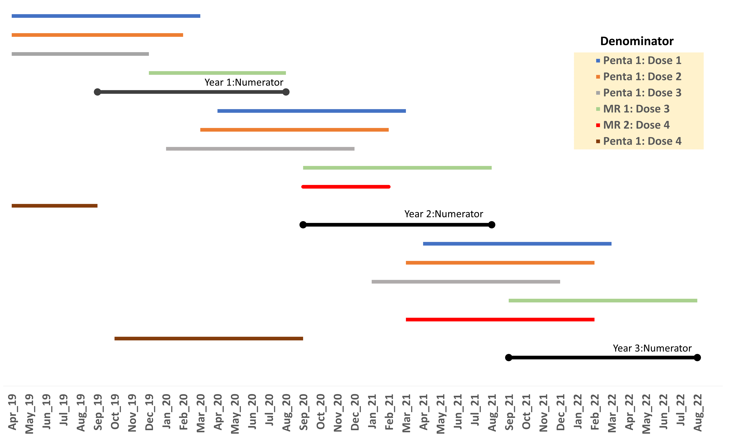

Figure S3: Annual population density maps of children under 1 year within RTS,S/AS01 implementation sub-counties for the years 2019-2022
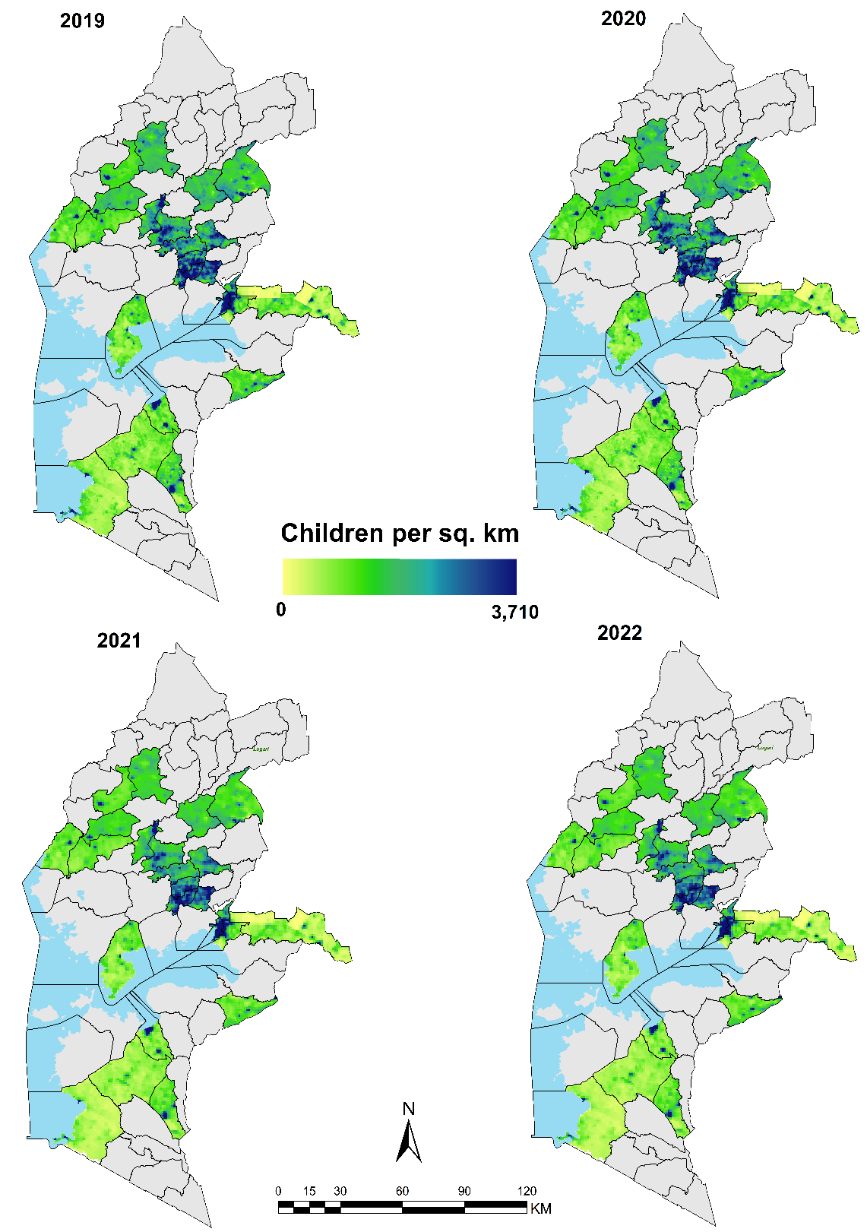

Table S2: Characteristics of 537 vaccinating facilities within the 23 implementation sub-counties
Category |  | N=537 |  | %
Owner
 | MoH |  | 388 |  | 72.3
 | Private |  | 79 |  | 14.7
 | FBO |  | 52 |  | 9.7
 | NGO |  | 13 |  | 2.4
 | Other |  | 5 |  | 0.9
Type
 | Clinic |  | 37 |  | 6.9
 | Dispensary |  | 294 |  | 54.7
 | Health Centre |  | 122 |  | 22.7
 | Hospital |  | 53 |  | 9.9
 | Maternity & Nursing Home |  | 12 |  | 2.2
 | Medical Centre |  | 19 |  | 3.5
Level of care
 | Primary |  | 485 |  | 90.3
 | Secondary |  | 52 |  | 9.7
Other include facilities such as government prisons, schools and parastatals that serve select populations.

Figure S4: Animation of cumulative Penta 1 and RTS,S/AS01 vaccines administered at facility level from September 2019 to August 2022 (N=537)

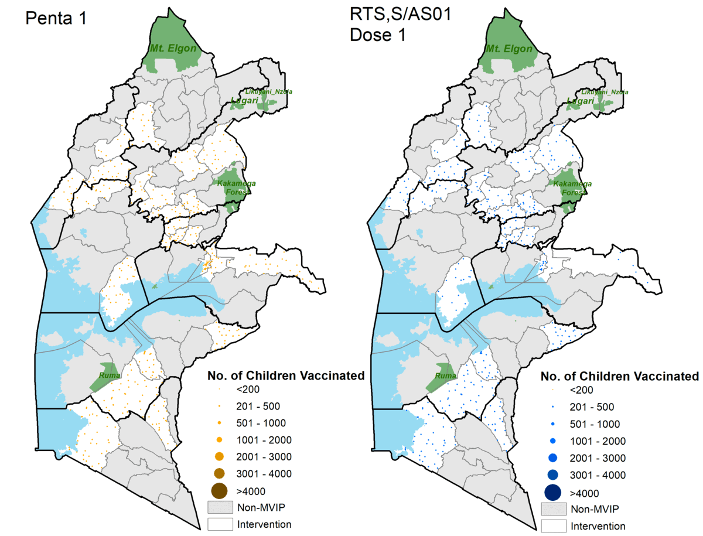

Figure S5: Chart showing sub-county coverage rankings of RTS,S/AS01 vaccine doses for each denominator
