Additional File 5: Scatter plot showing the association between duration of fever and gametocyte density

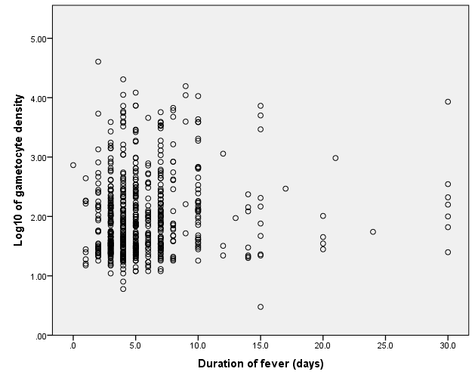

Pearson’s correlation coefficient (r) = 0.113, p value < 0.004

