Additional File 6: Scatter plot showing the association between asexual parasite density and gametocyte density stratified by ethnicity
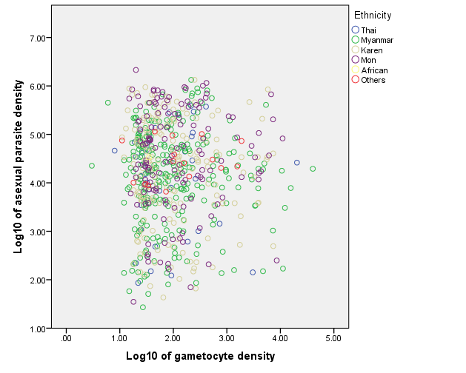

Ethnicity | Pearson’s correlation coefficient (r) | p value
Thai | 0.011 | 0.947
Myanmar | 0.013 | 0.827
Karen | -0.037 | 0.627
Mon | 0.019 | 0.824
Others | 0.183 | 0.498
Total | 0.011 | 0.786
* Pearson’s correlation of African ethnicity cannot be determined due to the small sample size

