Additional File 3. Images of bas-fonds in central Côte d’Ivoire
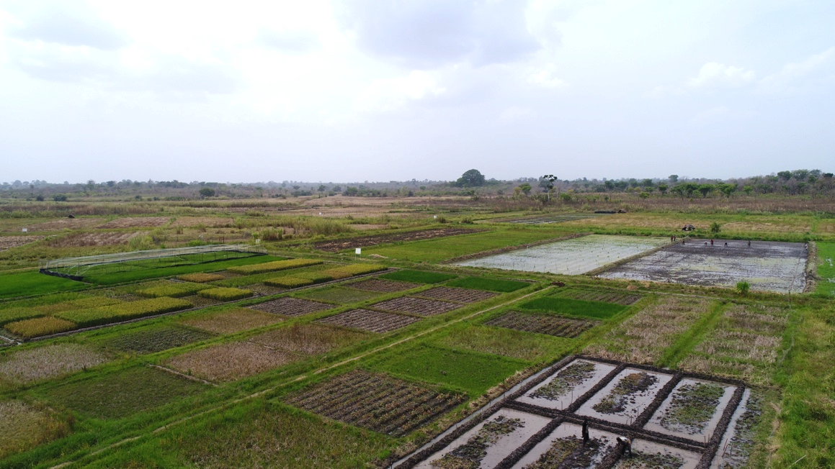
(A) Image of M’bé irrigation scheme taken from a drone
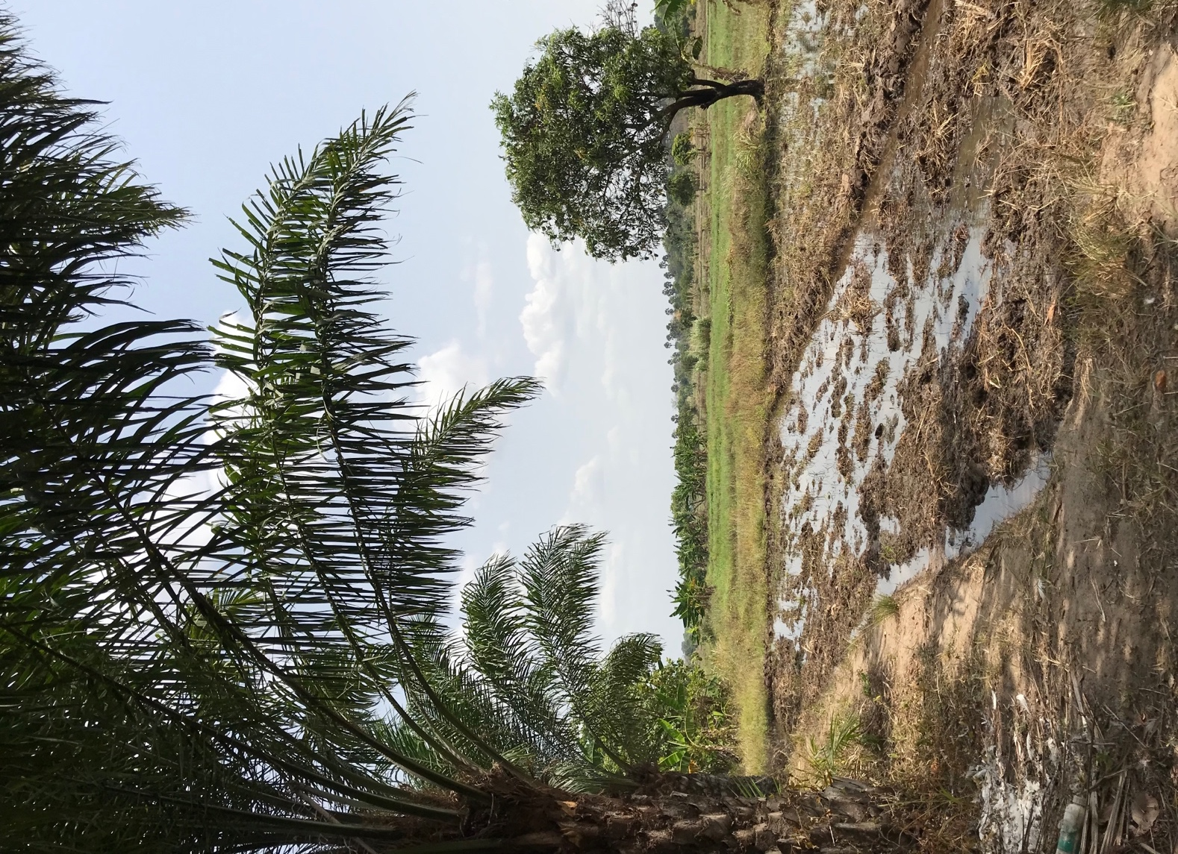
(B) Image of M’bé irrigation scheme taken during the wet season

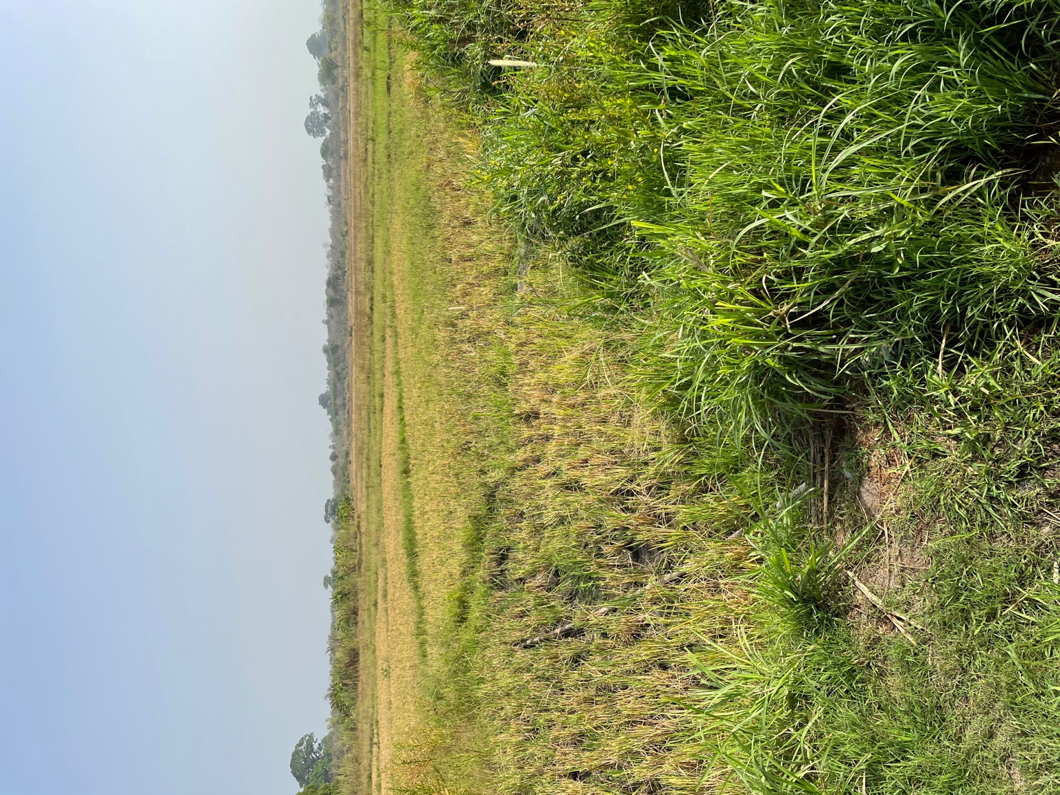
(C) Image of M’bé irrigation scheme taken during the dry season

