Additional file 1: Captions

S1. Primaquine dosing tables used for 7day Pv radical cure treatment 2019 - 2020
Weight | For Administration at Public Health Facilities | # of days
Weight | # of PQ Tablets | # of days
20kg - 30kg | 1 tablet of 7.5mg | 14
31kg - 45kg | 1 tablet of 15mg  (or 2 tablets of 7.5mg if 15mg unavailable) | 14
46kg - 60kg | 1 tablet of 15mg + 1 tablet of 7.5mg  (or 3 tablets of 7.5mg if 15mg unavailable) | 14
61kg – 99kg | 2 tablets of 15mg  (or 4 tablets of 7.5mg if 15mg unavailable) | 14

S2. Health facilities selected for key informant interviews
Province | OD | Facility | P.vivax cases (Nov 2019 – Oct 2020)
Battambang | Maung Russei | Prey Tralach | 20
Battambang | Sampov Luon | Trang | 24
Battambang | Thma Koul | Khleang Meas | 6
Battambang | Battambang | Ta Sanh | 1
Kampong Chhnang | Kampong Chhnang | Akphivoadth | 54
Kampong Chhnang | Kampong Chhnang | Chieb | 131
Kampong Chhnang | Boribo | Trapeang Chan | 68
Kampong Chhnang | Kampong Tralach | Thlok Vien | 4
Kampong Speu | Kampong Speu | Trapeang Cho | 512
Kampong Speu | Kampong Speu | Oral | 739
Kampong Speu | Ou Dongk | Amleang | 7
Kampong Speu | Phnom Srouch | Traeng Trayueng | 110
Kampong Speu | Kong Pisey | Kak Preah Khe | 28
Pailin | Pailin | Krachab | 6
Pailin | Pailin | Phnom Spong | 2
S3. Province Level P. vivax Incidence, 2019-2020
Province | Radical Cure | PV Cases Oct 2019 | Oct 2019 Inci-dence | PV Cases Feb 2020* | Feb 2020  Inci-dence | 2019 PV Inci-dence | Mean LST Day 2018 (°C) | Population | Data Resolution | Inclusion Status
Kampong Chhnang | Rollout | 116 | 0.2 | 54 | 0.05 | 2.99 | 30.98 | 500,874 | Line list | Intervention
Battambang | Rollout | 34 | 0.03 | 11 | 0.01 | 0.4 | 31.23 | 1,351,868 | Line list | Intervention
Pailin | Rollout | 4 | 0.04 | 2 | 0.02 | 0.39 | 30.18 | 184,835 | Line list | Intervention
Kampong Speu | Rollout | 310 | 0.38 | 156 | 0.18 | 4.74 | 31.02 | 782,248 | Line list | Intervention
Kratie | No Inter-vention | 116 | 0.25 | 66 | 0.14 | 3.98 | 30.99 | 375,568 | Aggregate (HF) | Control
Siem Reap | No Inter-vention | 17 | 0.01 | 8 | 0.01 | 0.26 | 30.97 | 1,178,783 | Line list | Control
Kampong Thom | No Inter-vention | 21 | 0.03 | 17 | 0.02 | 0.63 | 30.63 | 673,506 | Line list | Control
Oddar Meanchey | No Inter-vention | 0 | 0 | 0 | 0 | 2 | 32.41 | 403,304 | Aggregate (HF) | Control

S4. GLS Regression Model (p=5)
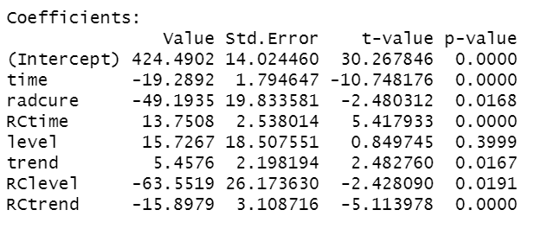

Label name:
- (intercept) level of relapse for controls at time 0
- time: existing trend in controls
- radcure: difference in level between radical cure & control
- RCtime: trend of radical cure over time relative to control
- level: after RC, increase in relapse in controls
- trend: after RC, increase in trend in relapse in controls
- RClevel: after RC, drop in relapse relative to controls
- RCtrend: after RC, drop in relapse trend relative to controls

