Additional file 1
Table S1. Replicated Latin rectangle design for experimental huts heights.
 | Experimental Hut Typology
Session | Hut 1 | Hut 2 | Hut 3 | Hut 4
1 | 4 | 2 | 1 | 3
2 | 1 | 3 | 4 | 2
3 | 3 | 4 | 2 | 1
4 | 2 | 1 | 3 | 4
5 | 3 | 1 | 2 | 4
6 | 4 | 2 | 3 | 1
7 | 2 | 4 | 1 | 3
8 | 1 | 3 | 4 | 2
9 | 4 | 2 | 1 | 3

Typology 1: hut at ground level (control hut).
Typology 2: raised hut (2 m) with free ground storey.
Typology 3: raised hut (2m) with air-permeable walls in ground storey.
Typology 4: raised hut (2m) with solid walls in ground storey.

Table S2. Insect collection for all experimental nights.
 | Hut typology
 | Hut on the ground | Raised hut with solid walls on ground storey | Raised hut with air-permeable walls on ground storey | Raised hut with free ground storey
An. gambiae female | 1259 | 873 | 981 | 655
An. gambiae male | 1 | 0 | 0 | 1
An. pharoensis female | 1 | 0 | 0 | 3
An. pharoensis male | 0 | 0 | 0 | 0
An. ziemani female | 9 | 3 | 5 | 0
An. ziemani male | 1 | 1 | 0 | 0
An. rufipes female | 6 | 0 | 0 | 0
An. rufipes male | 0 | 0 | 0 | 0
An. funestus female | 11 | 6 | 4 | 2
An. funestus male | 0 | 0 | 0 | 0
An. squamosus female | 6 | 2 | 1 | 2
An. squamosus male | 0 | 0 | 0 | 0
Culex quinquefsciatus female | 610 | 588 | 645 | 598
Culex quinquefsciatus male | 22 | 8 | 14 | 19
Cx thalassius female | 34 | 58 | 52 | 45
Cx thalassius male | 2 | 4 | 1 | 1
Mansonia spp. female | 8535 | 4281 | 5021 | 4145
Mansonia spp. male | 0 | 1 | 0 | 2
Aedes aegypti female | 7 | 3 | 6 | 1
Aedes aegypti male | 1 | 0 | 0 | 0

Table S3. Maximum and mean relative humidity levels in huts at different heights.

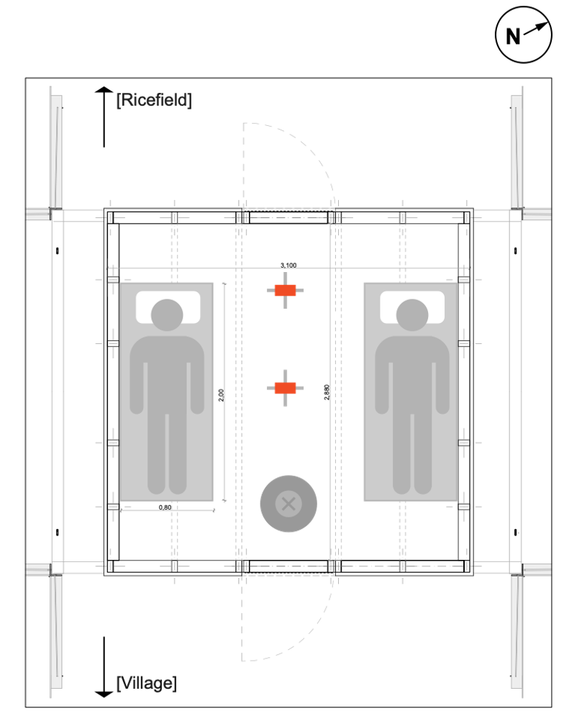
Fig. S1. Position of light trap (shown as x), data loggers (red) and sleepers.
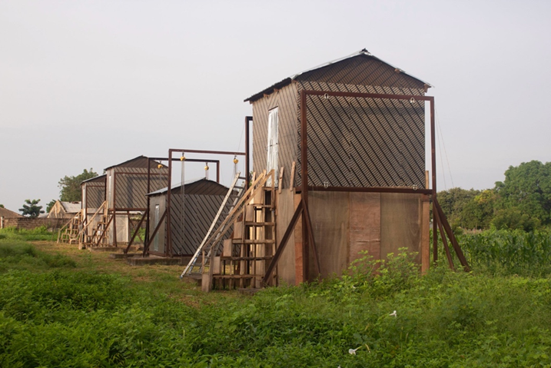

Fig. S2. Experimental huts showing position of staircases.

Fig. S3. Wind direction and speed (10⁻¹ ms⁻¹) mosquito collection nights. A= 21.00 h to 23.59 h and B= 00.00 h to 06.59 h.

