Comparing malaria risk exposure in rural Cambodia population using GPS tracking and questionnaires

Anaïs Pepey¹, Marc Souris², Saorin Kim¹, Thomas Obadia^{3,4}, Sophy Chy¹, Malen Ea¹, Sivkeng Ouk¹, Franck Remoue⁵, Siv Sovannaroth⁶, Ivo Mueller^{7,8}, Benoit Witkowski^{1*ψ}, Amélie Vantaux^{1*ψ}

Additional file 1: Additional tables and figures

Table S1: Primers sequences and real-time PCR conditions used to detect Plasmodium species.
*35 cycles when nested real-time PCR, 45 cycles when real-time PCR alone.
PCR | Primer | Sequence (5'-3') | Master Mix | Assay parameters
Real-time PCR screening
Screening PCR | RTPCRScreening2_F | TGGAGTGGATGGTGTTTTAGA | Hot FirePol EvaGreen qPCR Mix Solis Biodyne 1X (#08-24-00020), Primers 150 nM, 5 μl DNA template.  Total volume 20 μl | 95°C-15 min; 45 cycles: 95°C-15 sec/60°C-20 sec/72°C-20 sec 95°C-2 min 68°C-2 min
Screening PCR | RTPCRScreening2_R | TTGCACCCCAATARCTCATTT
Nested real-time PCR species
Primary PCR | RTPCRScreening2_F | TGGAGTGGATGGTGTTTTAGA | Hot FirePol DNA Pol. Solis BioDyne 1.25 U (#01-02-01000), dNTP 200 μM, MgCl2 2.5mM, Primers 250 nM, 5 μl DNA template.  Total volume 20 μl | 94°C −15 min 20 cycles: 94°C-30 sec/ 58°C −1 min/ 72°C-1 min 72°C-10 min
Primary PCR | RTPCRSreening3_R | ACCCTAAAGGATTTGTGCTACC
Nested real-time PCR Pf | Pf_RTPCR_F | ATGGATATCTGGATTGATTTTATT  TATGA | Hot FirePol EvaGreen HRM Mix Solis Biodyne 1X (#08-33-00001), Primers 250 nM, 5 μl template Primary PCR products 1:10.  Total volume 20 μl | 95°C-15 min 35–45 cycles*: 95°C-10 sec/62°C-20 sec/72°C-25 sec 95°C-1 min 40°C-1 min
Nested real-time PCR Pf | Pf_RTPCR_R | TCCTCCACATATCCAAATTACTGC
Nested real-time PCR Pv | Pv_RTPCR_F | TGCTACAGGTGCATCTCTTGTATTC
Nested real-time PCR Pv | Pv_RTPCR_R | ATTTGTCCCCAAGGTAAAACG
Nested real-time PCR Pm | Pm_RTPCR_F | ACAGGTGCATCACTTGTATTTTTTC
Nested real-time PCR Pm | Pm_RTPCR_R | TGCTGGAATTGAAGATAATAAATTA  GTAATAACT
Nested real-time PCR Po | Po_RTPCR_F | GTTATATGGTTATGTGGAGGATATA  CTGTT
Nested real-time PCR Po | Po_RTPCR_R | CGAATGGAAGAATAAAATGTAGTA  CG
Nested real-time PCR Pk | Pk_RTPCR_F | CTCCAGAAATTTCTTACGCATACTAC
Nested real-time PCR Pk | Pk_RTPCR_R | CCCAAGGTAAAACATAACCTATAA  AA

Protocol S1: Anti-Anopheles saliva quantification by ELISA:
The wells were coated with 100 μL of gSG6-P1 peptide solution (20µg/mg) for 2h30min at 37ºC. Plate wells were then blocked for 1h at 37ºC using 200 μL of blocking buffer, then washed. Individual sera were incubated in 100 μL duplicate at 4ºC overnight at a 1/10 dilution for DBS eluate and 1/40 for serum (in PBS—Tween 0.1%). After washing the plate, secondary human IgG in PBS-tween 1% (final concentration 1/1000) was added and incubated at 37ºC for 1h30min, then was washed again. The signal peptide (final concentration 1/1000) was incubated at 37ºC for 1h, then washed. Colorimetric development was carried out using ABTS in 0.05M citrate buffer (pH=4) containing 0.003% H₂O₂ and incubated at room temperature for 2h. Absorbance (OD) was measured at 415 nm.
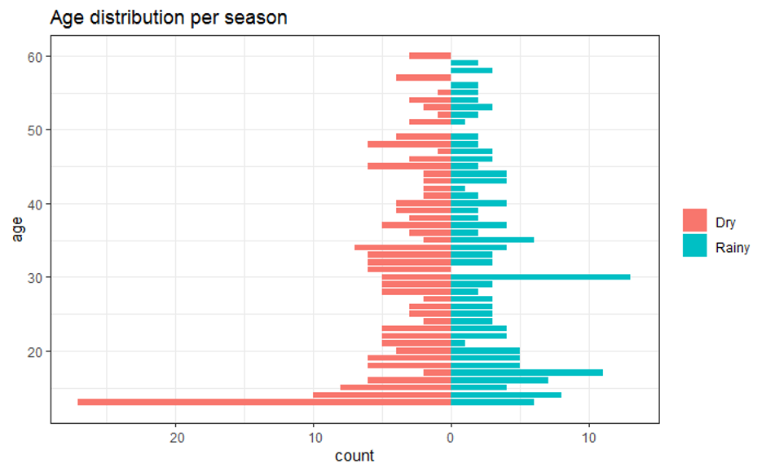
Figure S1: Age distribution among study population for dry and rainy season (N = 360).
Table S2: Transportation and relatives going to the different environments with the participants at least once. Each category respectively encompasses i) children: kids and grandkids; ii) women: all women from family but daughters (sisters, wives, mothers, etc.); iii) men: all men from the same family but sons (brothers, fathers, etc.); iv) co-workers: unrelated adult people working with them. Data from all participants declaring their visits at day 14 (N = 184).
Visits | N | % | CI | Relatives | N | % | CI | Transportation | N | % | CI
Nearby forest | 141 | 76.6 | [69.8 - 82.5%] | Children | 5 | 3.5 | [1.2 - 8.1%] | Walking | 123 | 87.2 | [80,6 – 92.3%]
 |  |  |  | Women | 7 | 5 | [2.0 - 9,0%] | Bike | 17 | 12.1 | [7.2 - 18.6%]
 |  |  |  | Men | 9 | 6.4 | [3.0 - 11.8%] | Car | 0 | 0 | [0 – 2.6%]
 |  |  |  | Coworkers | 11 | 7.8 | [4.0 - 13.5%]
Deep forest | 74 | 40.2 | [33.1 - 47.7%] | Children | 3 | 4.1 | [0.08 - 11.4%] | Walking | 4 | 5.4 | [1.5 - 13.7%]
 |  |  |  | Women | 6 | 8.1 | [3.0 - 16.8%] | Bike | 65 | 87.8 | [78.2 - 94.3%]
 |  |  |  | Men | 28 | 37.8 | [26.8 - 49.9%] | Car | 4 | 5.4 | [1.5 - 13.3%]
 |  |  |  | Coworkers | 37 | 50 | [38.1 - 61.9%]
Rubber plantation | 3 | 1.6 | [0.3 - 4.7%] | Children | 0 | 0 | [0 – 70.8%] | Walking | 1 | 33.3 | [0.8 - 90.6%]
 |  |  |  | Women | 0 | 0 | [0 – 70.8%] | Bike | 2 | 66.7 | [9.4 - 99.2%]
 |  |  |  | Men | 1 | 33.3 | [0.8 - 90.6%] | Car | 0 | 0 | [0 – 70.8%]
 |  |  |  | Coworkers | 0 | 0 | [0 – 70.8%]  0
Cashew plantation | 108 | 58.7 | [51.2 - 65.9%] | Children | 23 | 21.3 | [14.0 - 30.2%] | Walking | 25 | 23.1 | [15.6 - 32.2%]
 |  |  |  | Women | 48 | 44.4 | [34.9 - 54.3%] | Bike | 79 | 73.1 | [63.8 - 81.2%]
 |  |  |  | Men | 19 | 17.6 | [10.9 - 26.1%] | Car | 1 | 0.9 | [0.02 - 5.0%]
 |  |  |  | Coworkers | 3 | 2.8 | [0.6 - 7.9%]
Cassava field | 49 | 26.6 | [20.4 - 33.6%] | Children | 9 | 18.4 | [8.8 - 32.0%] | Walking | 8 | 16.3 | [7.3 - 29.7%]
 |  |  |  | Women | 29 | 59.2 | [44.2 - 73.0%] | Bike | 41 | 83.7 | [70.3 - 92.7%]
 |  |  |  | Men | 14 | 28.6 | [16.6 - 43.3%] | Car | 0 | 0 | [0 – 7.3%]
 |  |  |  | Coworkers | 3 | 6.1 | [1.3 - 16.9%]
Rice field | 15 | 8.2 | [4.6 - 13.1%] | Children | 1 | 6.7 | [0.2 - 31.9%] | Walking | 9 | 60 | [32.3 - 83.7%]
 |  |  |  | Women | 2 | 13.3 | [1.7 - 40.5%] | Bike | 6 | 40 | [16.3 - 67.7%]
 |  |  |  | Men | 1 | 6.7 | [0.2 - 31.9%] | Car | 0 | 0 | [0 – 21.8%]
 |  |  |  | Coworkers | 1 | 6.7 | [0.2 - 31.9%]

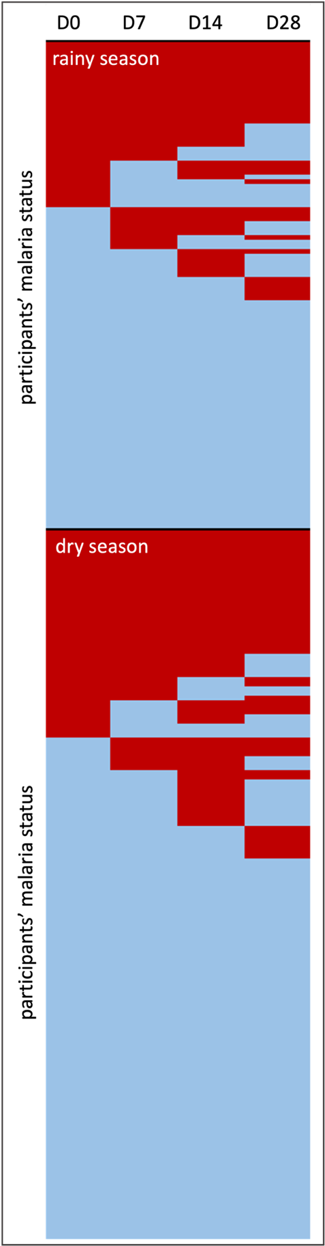
Figure S2: Participants’ incidence (red: RTPCR positive, blue: negative) at day 0, day 7, day 14 and day 28 of follow-up over rainy season (N = 105) and dry season (N = 153) from participants with a complete dataset (N = 258).

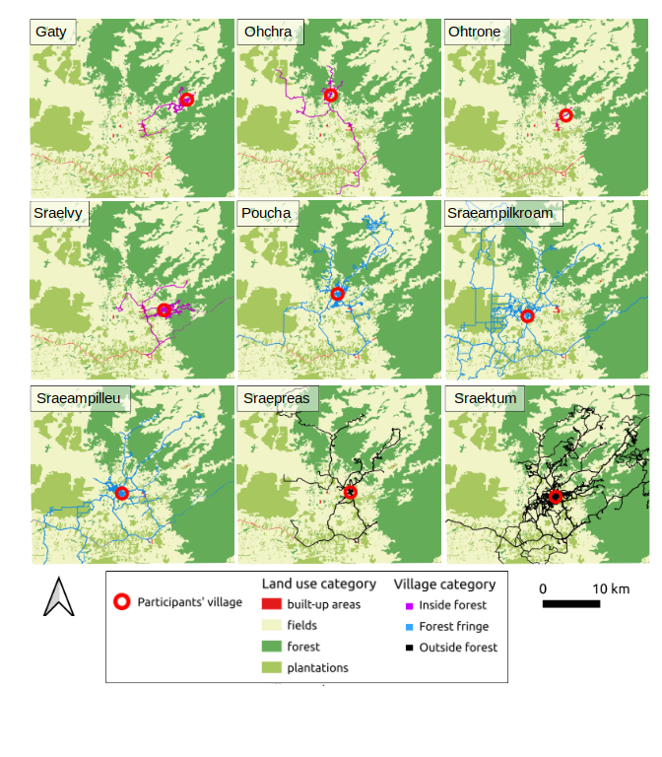
Figure S3: Optimal GPS points of participants by villages inside the forest [Gaty (N = 10), Ohchra (N = 8), Ohtrone (N= 1), Sraelvy (N = 26)], at the forest fringes [Poucha (N = 22), Sraeamplikroam (N = 27), Sreaempilleu (N = 28)] and outside the forest [Sreapreas (N = 119) and Sraektum (N = 17)].

Table S3: Tukey post-hoc test results on the prevalence over follow-up of each village age category. Significant results are in bold.
Pairwise comparison | OR | OR 95% CI | P-value
Forest fringe - Inside forest | 2.17 | [1.32 – 3.02] | 0.17
Inside forest - Outside forest | 1.08 | [0.33 – 1.83] | 0.98
Forest fringe - Outside forest | 2.34 | [1.67 – 3] | 0.03

Table S4: GLMMs comparisons of malaria status and time spent in a category of land use on optimal data, using all data, night (18:00 to 5:59) data and slow (<5 km/h) data for all participants with a valid optimal GPS dataset (N = 258).
Dataset | Land use  category | Time  variable | χ²₁ | P-value
night | forest | Standardised time | 0.02 | 0.89
night | fields | Standardised time | 0.04 | 0.84
night | plantations | Standardised time | 0.37 | 0.54
night | village | Standardised time | 0.07 | 0.79
night | forest | Total hours | 1.74 | 0.19
night | fields | Total hours | 0.56 | 0.45
night | plantations | Total hours | 0.24 | 0.63
night | village | Total hours | 0.09 | 0.77
slow | forest | Standardised time | 0.01 | 0.93
slow | fields | Standardised time | 1.02 | 0.31
slow | plantations | Standardised time | 0.04 | 0.85
slow | village | Standardised time | 0.39 | 0.53
slow | forest | Total hours | 0.34 | 0.56
slow | fields | Total hours | 3.04 | 0.08
slow | plantations | Total hours | 0.30 | 0.58
slow | village | Total hours | 0.29 | 0.59

Table S5: Standardised time (in decimal hours) spent in average in forest and plantations over follow-up per village (N = 258).
Village | Village category | N | Forest  slow speed | Forest  at night | Plantations  slow speed | Plantations  at night
Gaty | Inside forest | 10 | 2.3 | 0.1 | 24.6 | 33.5
Ohchra | Inside forest | 8 | 12 | 2.2 | 3.1 | 0.2
Ohtrone | Inside forest | 1 | 0.6 | 2 | 0.2 | 0.1
Sraelvy | Inside forest | 26 | 15.8 | 15.3 | 69.7 | 74.8
Poucha | Forest fringe | 22 | 6.6 | 1.4 | 0.8 | 0.4
Sraeampilkroam | Forest fringe | 27 | 22.6 | 20.5 | 22.8 | 20.7
Sraeampilleu | Forest fringe | 28 | 54.4 | 51.4 | 32.1 | 31.6
Sraektum | Outside forest | 119 | 28.2 | 19.3 | 29.8 | 31.9
Sraepreas | Outside forest | 17 | 21.1 | 9.5 | 4.7 | 2.2
Total | - | 258 | 25.3 | 19 | 28.1 | 29.3

Table S6: GLMMs comparisons of malaria status and time spent in a category of land use with village of residence as a covariate. Time variable was extracted from optimal data, as night data (18:00 to 5:59) or slow data (<5 km/h) for all participants with a valid optimal GPS dataset (N = 258).
Dataset | Land use  category | Time  variable | χ²₁ | P-value
night | forest | Standardised time | 0.22 | 0.64
night | fields | Standardised time | 0.06 | 0.81
night | plantations | Standardised time | 0.37 | 0.54
night | village | Standardised time | 0.11 | 0.74
night | forest | Total hours | 1.13 | 0.29
night | fields | Total hours | 0.09 | 0.77
night | plantations | Total hours | 0.34 | 0.56
night | village | Total hours | 0.11 | 0.74
slow | forest | Standardised time | 0.10 | 0.75
slow | fields | Standardised time | 0.11 | 0.74
slow | plantations | Standardised time | 0.30 | 0.58
slow | village | Standardised time | 0.004 | 0.95
slow | forest | Total hours | 0.40 | 0.52
slow | fields | Total hours | 0.20 | 0.65
slow | plantations | Total hours | 0.22 | 0.64
slow | village | Total hours | 0.13 | 0.71

Table S7: GLMMs comparisons of malaria status and season, socioeconomic variables and distance for all participants with incident infections and with a valid optimal GPS dataset (N = 177). The village GLMM induced a singular convergence due to small sample size and the results are not included.
Variable | χ²₁ | P-value
season | 0.53 | 0.47
Socioeconomic factors
main income | 8.48 | 0.29
village category | 2.11 | 0.35
age category | 2.44 | 0.30
Distance
all | 0.02 | 0.88
slow | 1.32 | 0.25
night | 0.05 | 0.08

Table S8: GLMMs comparisons of malaria status and time spent in a category of land use. Time variable was extracted from optimal data, as night data (18:00 to 5:59) or slow data (<5 km/h) for all participants with incident infections and with a valid optimal GPS dataset (N = 177). Analysis with village of residence as a covariate was not performed due to the small sample size and convergence issues.
Dataset | Land use  category | Time  variable | χ²₁ | P-value
night | forest | Standardized time | 0.03 | 0.86
night | fields | Standardized time | 2.37 | 0.12
night | plantations | Standardized time | 0.42 | 0.52
night | village | Standardized time | 0.82 | 0.37
night | forest | Total hours | 0.28 | 0.60
night | fields | Total hours | 0.77 | 0.38
night | plantations | Total hours | 0.00 | 0.97
night | village | Total hours | 0.04 | 0.85
slow | forest | Standardized time | 0.52 | 0.47
slow | fields | Standardized time | 2.92 | 0.09
slow | plantations | Standardized time | 0.33 | 0.57
slow | village | Standardized time | 0.91 | 0.34
slow | forest | Total hours | 0.72 | 0.40
slow | fields | Total hours | 1.06 | 0.30
slow | plantations | Total hours | 0.00 | 0.95
slow | village | Total hours | 0.07 | 0.79

Table S9: Anti-Anopheles saliva antibodies univariate models results and their significance value (N = 197). Variables with significant P-value (P < 0.05) are indicated in bold.
Qualitative | Seroprevalence (%) | CI | χ² | df | P-value
Season |  |  | 35.36 | 1 | < 0.0001
dry | 30.5 | [23.2 -38.5 %]
rainy | 66.4 | [57.2 - 74.8%]
Age category |  |  | 0.37 | 2 | 0.83
younger [≤ 20 years old] | 43.9 | [33.0 - 55.3%]
mid [21-39 years old] | 48.2 | [38.8 - 57.8%]
older [≥ 40 years old] | 45.9 | [34.3 - 57.9%]
Village category |  |  | 3.41 | 2 | 0.18
inside forest | 57.8 | [42.2 - 72.3%]
forest fringe | 40.7 | [30.0 - 52.2%]
outside forest | 45.8 | [37.5 - 54.3%]
Malaria status |  |  | 1.76 | 1 | 0.19
positive | 50.4 | [41.6 - 59.2%]
negative | 42.3 | [33.9 - 51.1%]
ST in forest slow | - | - | 1.45 | 1 | 0.23
ST in forest at night | - | - | 1.71 | 1 | 0.19
ST in fields slow | - | - | 2.05 | 1 | 0.15
ST in fields at night | - | - | 1.82 | 1 | 0.18
ST in plantations slow | - | - | 0.21 | 1 | 0.64
ST in plantations at night | - | - | 0.14 | 1 | 0.70
ST in village slow | - | - | 2.49 | 1 | 0.11
ST in village at night | - | - | 2.60 | 1 | 0.11
Quantitative | Average ΔOD | SD | χ² | df | P-value
Season |  |  | 58.48 | 1 | < 0.0001
dry | 0.48 | 0.20
rainy | 0.98 | 0.61
Age category |  |  | 0.75 | 2 | 0.68
younger [≤ 20 years old] | 0.66 | 0.47
mid [21-39 years old] | 0.72 | 0.53
older [≥ 40 years old] | 0.69 | 0.49
Village category |  |  | 5.55 | 2 | 0.06
inside forest | 0.87 | 0.58
forest fringe | 0.62 | 0.42
outside forest | 0.69 | 0.50
Malaria status |  |  | 0.3 | 1 | 0.61
positive | 0.72 | 0.52
negative | 0.68 | 0.48
ST in forest slow | - | - | 1.35 | 1 | 0.24
ST in forest at night | - | - | 1.65 | 1 | 0.20
ST in fields slow | - | - | 2.99 | 1 | 0.08
ST in fields at night | - | - | 2.57 | 1 | 0.11
ST in plantations slow | - | - | 0.82 | 1 | 0.36
ST in plantations at night | - | - | 0.74 | 1 | 0.39
ST in village slow | - | - | 2.58 | 1 | 0.11
ST in village at night | - | - | 2.43 | 1 | 0.12

Table S10: Average ΔOD per village (N = 270).
Village | Village category | N | Average ΔOD
Gaty | Inside forest | 10 | 1.09
Ohchra | Inside forest | 8 | 0.42
Ohtrone | Inside forest | 1 | 0.43
Sraelvy | Inside forest | 26 | 0.94
Poucha | Forest fringe | 22 | 0.45
Sraeampilkroam | Forest fringe | 24 | 0.42
Sraeampilleu | Forest fringe | 35 | 0.86
Sraektum | Outside forest | 128 | 0.68
Sraepreas | Outside forest | 16 | 0.74
Total | - | 270 | 0.70

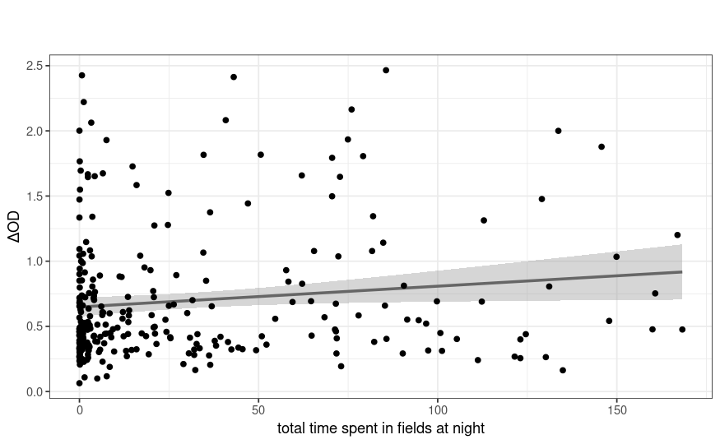
Figure S4: Association between ΔOD and the total time spent (in decimal hours) in fields at night by participants (N = 270).

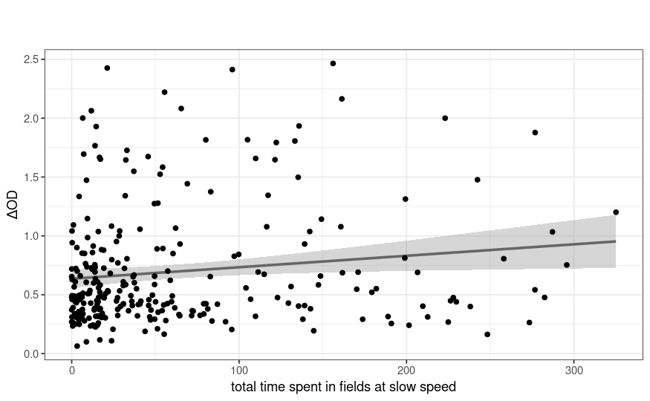
Figure S5: Association between ΔOD and the total time spent in fields (in decimal hours) at slow speed by participants (N = 270).

Table S11: GLMMs comparisons of serostatus and time spent in a category of land use with village of residence as a covariate. Time variable was extracted from optimal data, as night data (18:00 to 5:59) or slow data (<5 km/h) for all participants with a valid optimal GPS dataset (N = 270). Significant P-values are indicated in bold.
Dataset | Land use  category | Time  variable | χ²₁ | P-value
night | forest | Standardised time | 0.30 | 0.58
night | fields | Standardised time | 2.25 | 0.13
night | plantations | Standardised time | 2.71 | 0.10
night | village | Standardised time | 0.54 | 0.46
night | forest | Total hours | 0.50 | 0.48
night | fields | Total hours | 4.23 | 0.04
night | plantations | Total hours | 2.49 | 0.11
night | village | Total hours | 0.54 | 0.46
slow | forest | Standardised time | 0.26 | 0.61
slow | fields | Standardised time | 2.23 | 0.14
slow | plantations | Standardised time | 2.95 | 0.09
slow | village | Standardised time | 0.48 | 0.49
slow | forest | Total hours | 0.83 | 0.36
slow | fields | Total hours | 4.03 | 0.04
slow | plantations | Total hours | 2.05 | 0.15
slow | village | Total hours | 0.17 | 0.68
Table S12: Comparison of participants’ responses to questionnaire to their GPS data, for all land use categories (N = 197). Underlined numbers correspond to count of participants with discordant data between GPS and questionnaire.
 | Data from questionnaire
Dataset from GPS device | visiting | not visiting
visiting | 133 | 6 | forest
not visiting | 47 | 11 | forest
visiting | 92 | 29 | plantations
not visiting | 48 | 28 | plantations
visiting | 95 | 94 | fields
not visiting | 1 | 7 | fields

