Additional File
Table S1
Allele frequency differentiation (FST) between different An. coluzzii cohorts across Africa.
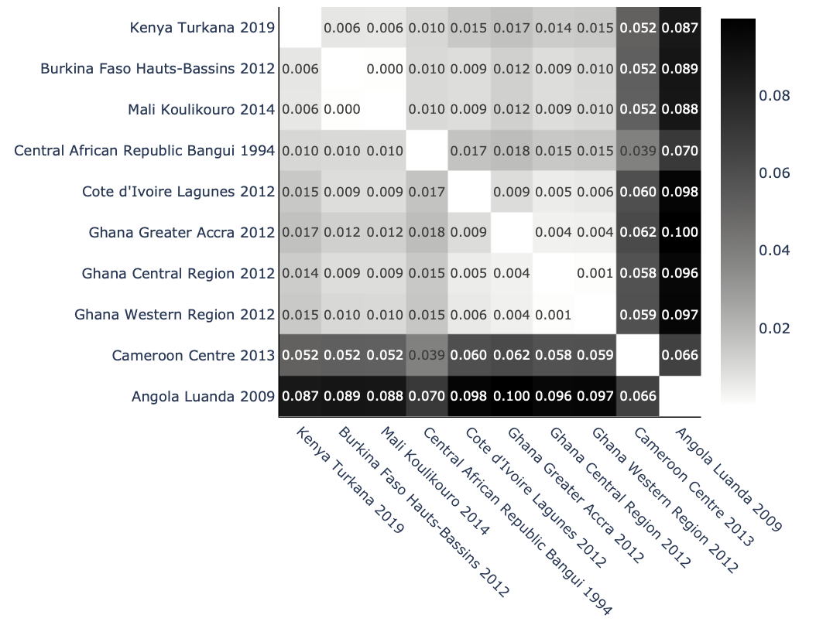

Figure S1
Taxon assignment using ancestry informative marker (AIM) genotypes. Plot rows represent an individual sample and columns are the AIM variants that have been genotyped. Each AIM is coloured by whether its genotype is typical of An. arabiensis (green), either An. gambiae or An. coluzzii (purple), An. coluzzii (red), An. gambiae (blue) or the variant is a heterozygote for the species comparison (yellow). a, Scatter plot of AIM genotype fractions, for all samples in this study. Each marker is a sample. The X axis plots the fraction of genotypes called as arab/arab in panel a. The Y axis plots the fraction of genotypes called as colu/colu in panel b, excluding chromosome arm 2L where there is a common known introgression. b, Sample genotypes at AIMs differentiating between An. gambiae and An. coluzzii, shown for all samples in this study not assigned as not An. arabiensis. c, Sample genotypes at AIMs differentiating between An. arabiensis and (An. gambiae, An. coluzzii) for samples from Turkana, Kenya.

Panel A.
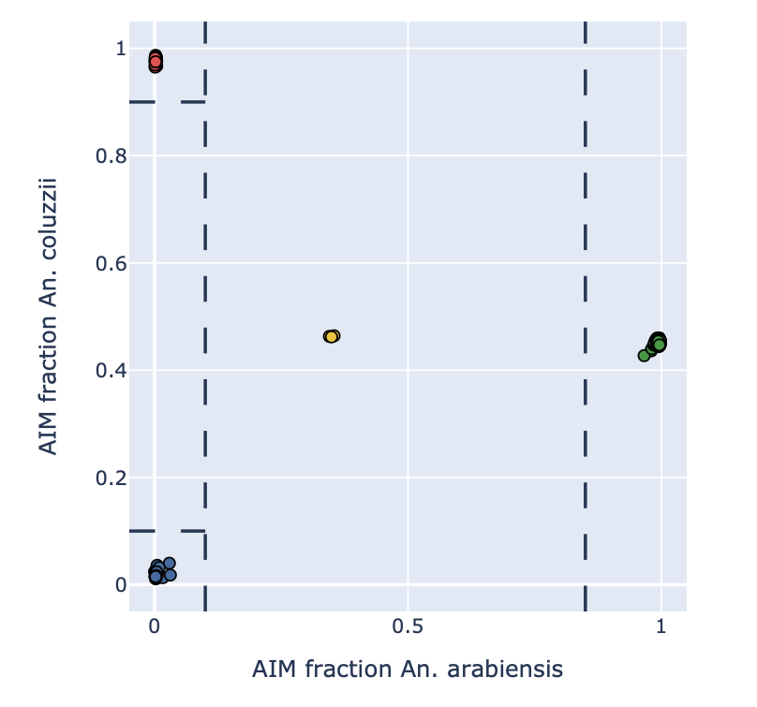
Panel B.
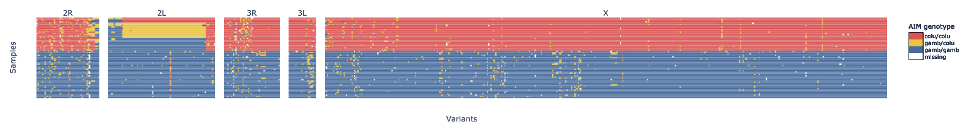
Panel C.
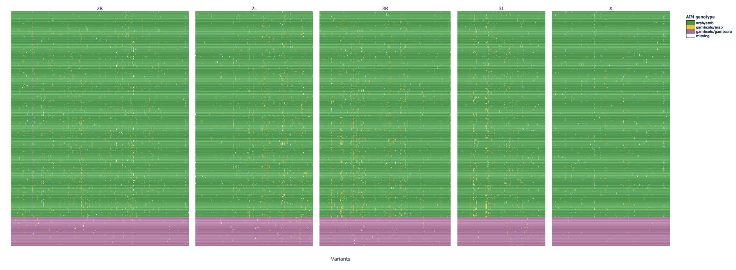
Figure S2
Principal components analysis of the 2La (2L:20,528,089-42,165,182) and 2Lb (2R:19,444,433-26,313,071) inversion regions to compare the karyotype of Kenyan An. coluzzii to other An. coluzzii cohorts across Africa. Principal Component 1 (PC1) from a Principal Component Analysis (PCA) within the 2La genomic region is plotted on the X axis, and the three groupings correspond to the three possible 2La karyotypes. PC1 from a PCA within the 2Rb genomic region is plotted on the Y axis, and the three groupings correspond to the three possible 2Rb karyotypes. Kenyan An. coluzzii cluster with An. coluzzii from Burkina Faso, Mali and Northern Cameroon, indicating shared karyotypes.
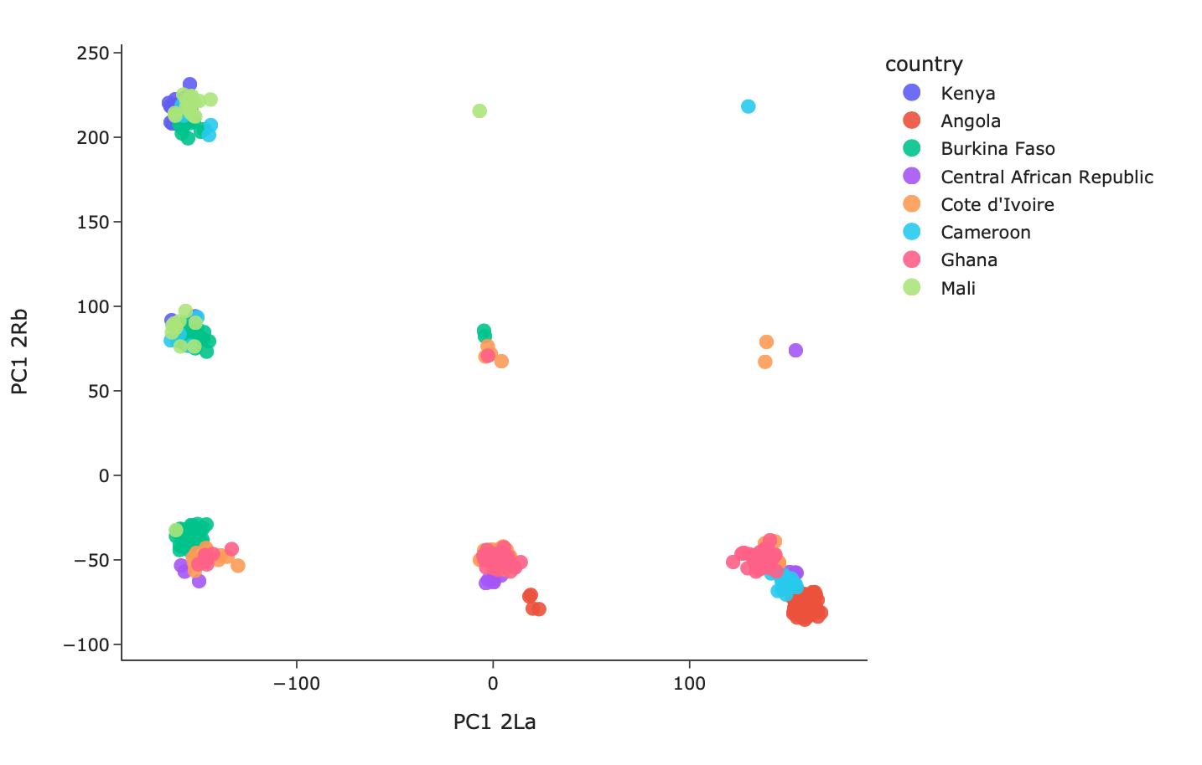

Figure S3
Bar plots of nucleotide diversity, Watterson's theta and Tajima's D comparing Kenyan An. coluzzii to other An. coluzzii cohorts.
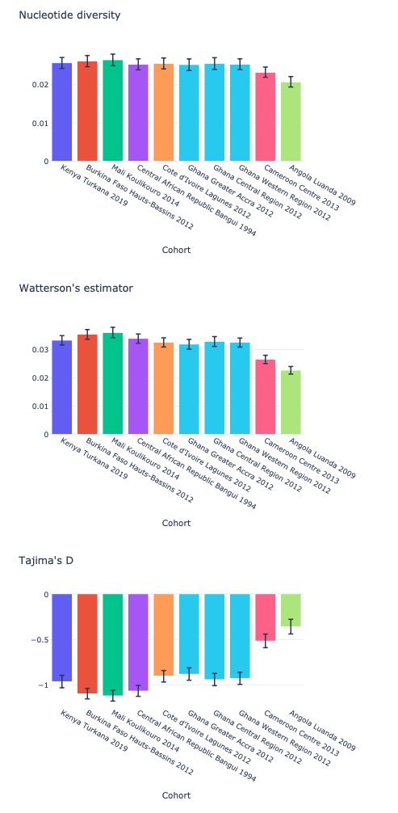

Figure S4
Figure S4. Amino acid frequencies for the resistance to dieldrin gene Rdl in An. coluzzii. The A296G/T345M and A296S/T345S substitution pairs are associated with insecticide resistance to dieldrin.

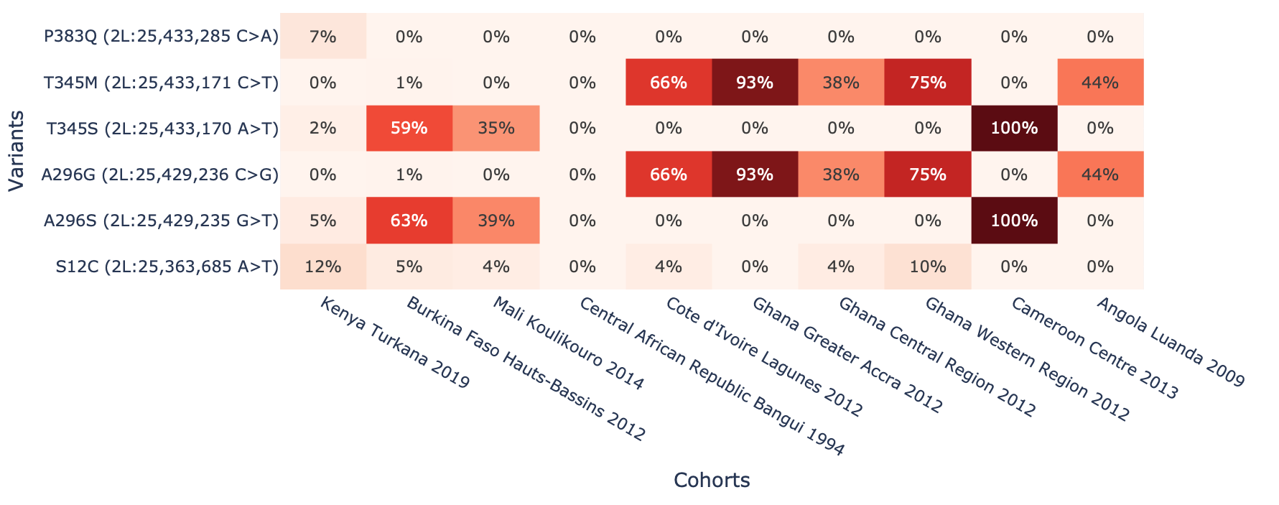

Figure S5
Figure S5. Amino acid frequencies for the Ace1 gene in An. coluzzii. The G280S substitution has been implicated in insecticide resistance to pyrethroids and organophosphates.
