Table S1: 24hr Sugar-fed Female Mosquito Mortality Per Trial

24hr Sugar-Fed Female Mortality
Trial | (%)
0 | 0.00%
1 | 2.86%
2 | 1.79%
3 | 4.08%
4 | 0.00%
5 | 11.43%
6 | 4.26%
7 | 4.76%

Figure 1S: ATSB corrected mortality by collection round (left corrected for natural (sugar control mortality) and right panel corrected for starvation (water control) mortality) and time.

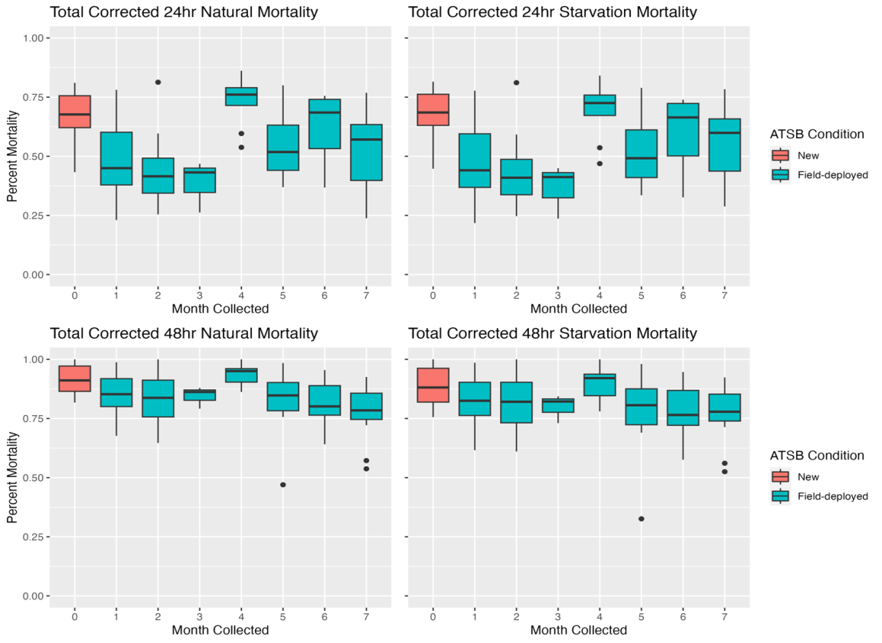

Figure 2S: ATSB corrected mortality by collection round (left corrected for natural (sugar control mortality) and right panel corrected for starvation (water control) mortality), time, and sex.

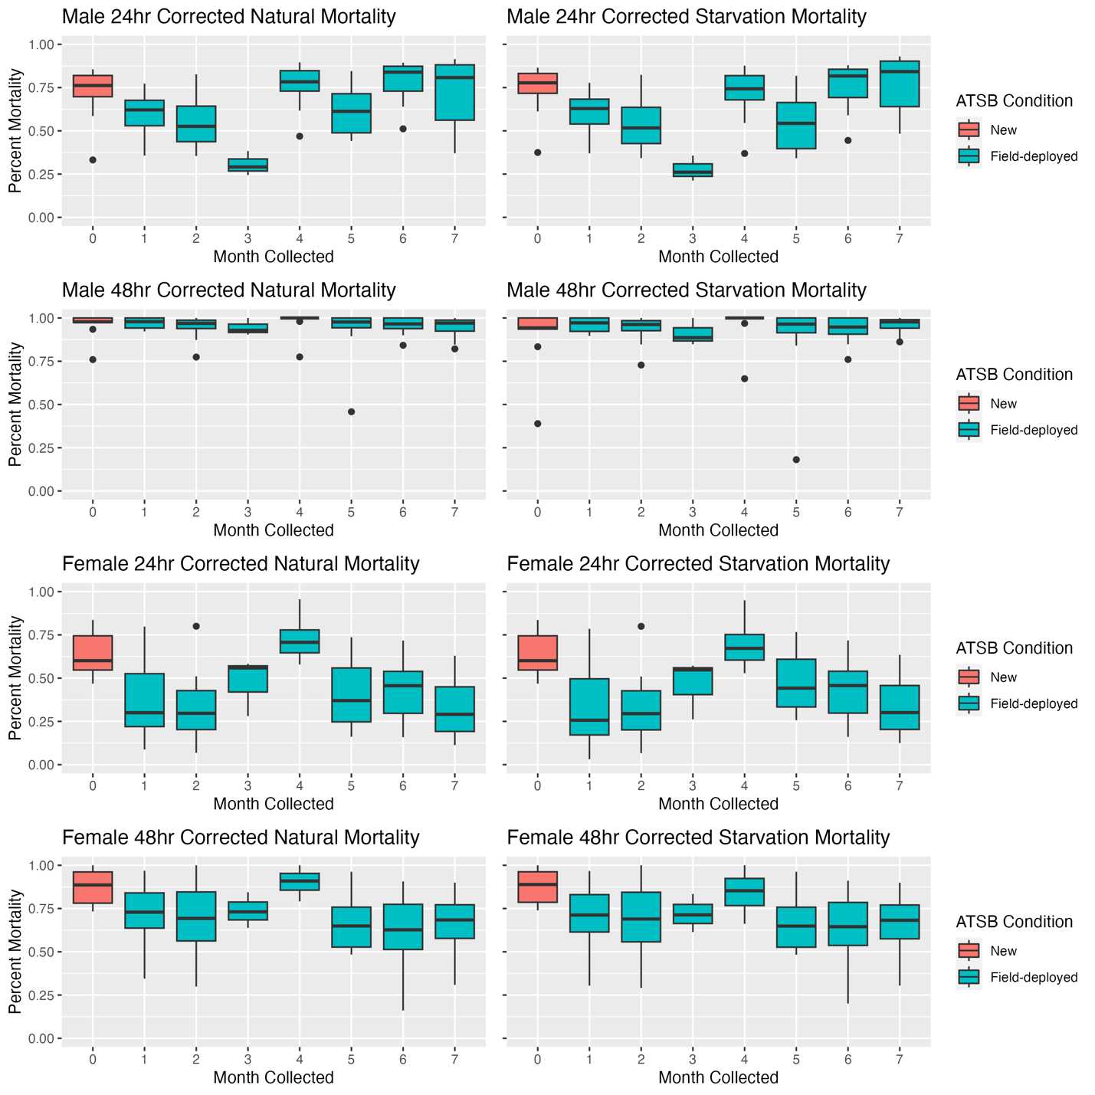

Table 2S: Effect of ATSB collection round on corrected mortality (bioefficacy) by sex
 | Total Mortality |  |  | Male Mortality |  |  | Female Mortality
Characteristic | Beta | 95% CI¹ | p-value | Beta | 95% CI¹ | p-value | Beta | 95% CI¹ | p-value
Condition
New | — | — |  | — | — |  | — | —
Field-deployed | -0.08 | -0.14, -0.01 | 0.027 | -0.01 | -0.06, 0.04 | 0.6 | -0.16 | -0.27, -0.05 | 0.006
Month Collected
0 | — | — |  | — | — |  | — | —
1 | -0.07 | -0.15, 0.02 | 0.12 | 0.01 | -0.06, 0.07 | 0.8 | -0.14 | -0.28, -0.01 | 0.042
2 | -0.09 | -0.17, 0.00 | 0.045 | -0.02 | -0.08, 0.05 | 0.6 | -0.19 | -0.32, -0.05 | 0.008
3 | -0.07 | -0.20, 0.06 | 0.3 | -0.02 | -0.12, 0.08 | 0.7 | -0.13 | -0.35, 0.08 | 0.2
4 | 0.02 | -0.06, 0.11 | 0.6 | 0.01 | -0.05, 0.08 | 0.7 | 0.03 | -0.10, 0.17 | 0.6
5 | -0.08 | -0.17, 0.00 | 0.046 | -0.04 | -0.10, 0.03 | 0.2 | -0.20 | -0.33, -0.06 | 0.005
6 | -0.10 | -0.19, -0.02 | 0.020 | -0.01 | -0.07, 0.06 | 0.8 | -0.25 | -0.39, -0.12 | <0.001
7 | -0.14 | -0.22, -0.05 | 0.002 | -0.02 | -0.09, 0.05 | 0.6 | -0.22 | -0.36, -0.08 | 0.002
Round Linear | -0.01 | -0.02, 0.00 | 0.012 | 0.00 | -0.01, 0.00 | 0.4 | -0.02 | -0.04, -0.01 | 0.006
Round Linear (Field-deployed only) | -0.01 | -0.02, 0.00 | 0.2 | 0.00 | -0.01, 0.01 | 0.5 | -0.01 | -0.04, 0.01 | 0.2
Round Linear (Field-deployed only w/o round 4) | -0.01 | -0.02, 0.00 | 0.2 | 0.00 | -0.01, 0.01 | 0.5 | -0.01 | -0.03, 0.01 | 0.2
¹CI = Confidence Interval

