Supplemental Figures
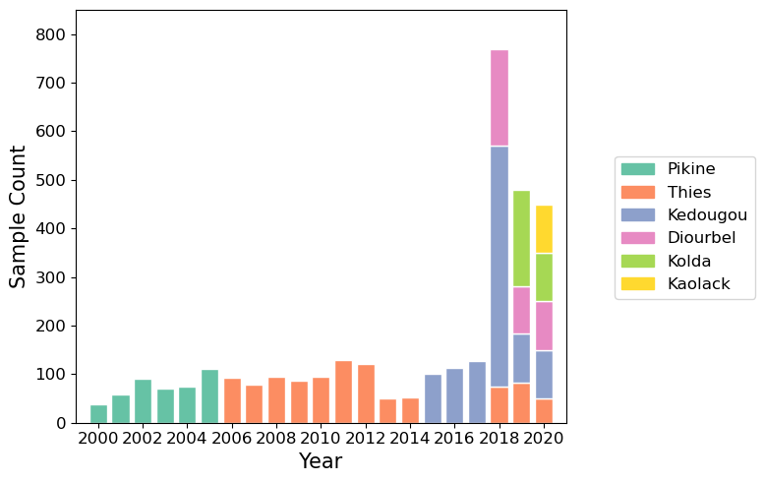
Fig. S1 Sample sizes for SNP-based molecular surveillance. Sample size per year per region for the SNP-based molecular surveillance.

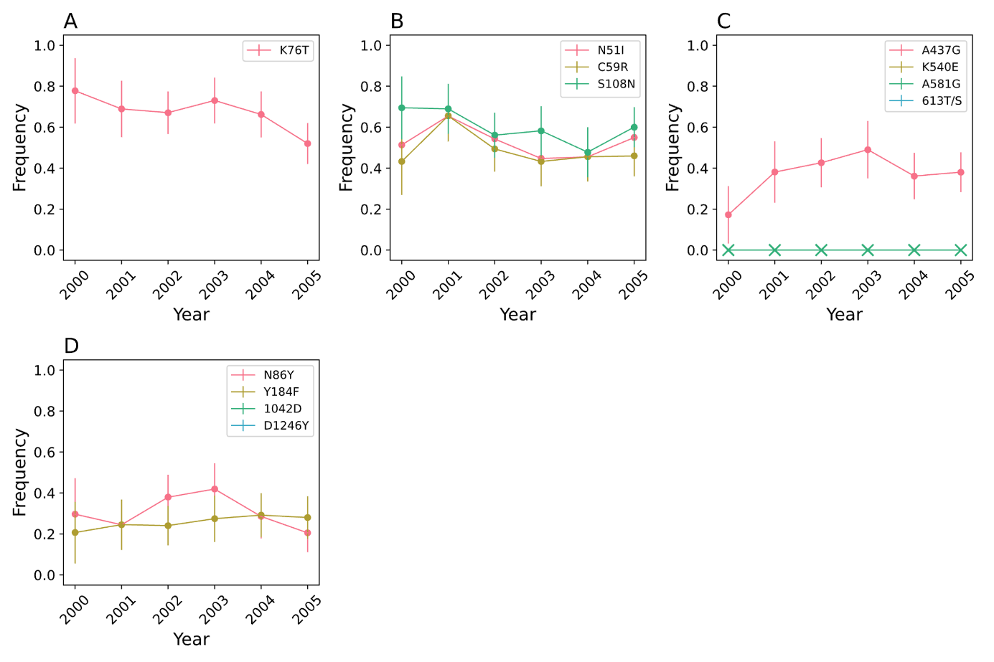
Fig. S2 SNP-based molecular surveillance in Pikine for A) Pfcrt, B) Pfdhfr, C) Pfdhps and D) Pfmdr1. The Pfdhfr I174L and Pfkelch13 SNPs were not examined in Pikine. Error bars indicate two binomial standard deviations from the mean. X’s denote years where samples were collected but the mutation was not observed. Gaps in the data were because samples were not collected for that year.
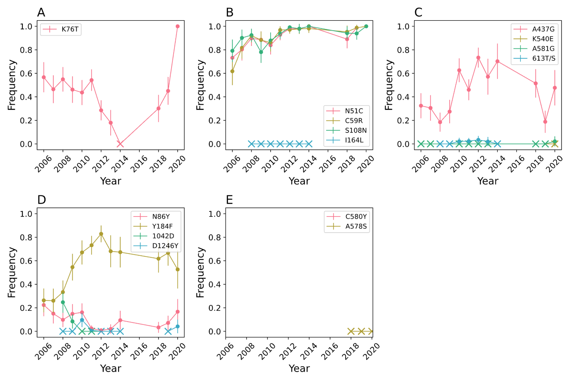
Fig. S3 SNP-based molecular surveillance in Thiès for A) Pfcrt, B) Pfdhfr, C) Pfdhps, D) Pfmdr1, and E) Pfkelch13. Error bars indicate two binomial standard deviations from the mean. X’s denote years where samples were collected but the mutation was not observed. Gaps in the data were because samples were not collected for that year.

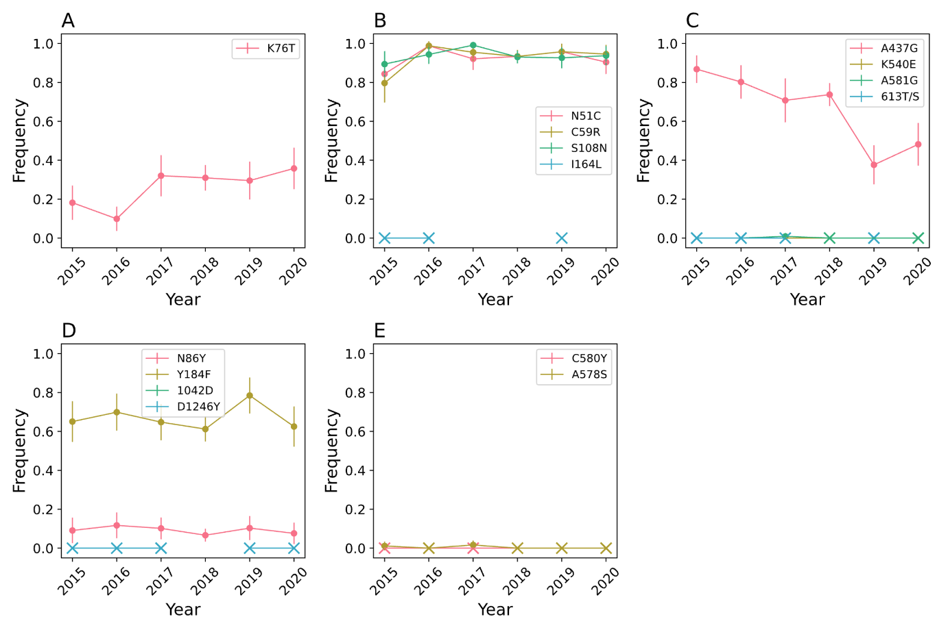
Fig. S4 SNP-based molecular surveillance in Kédougou for A) Pfcrt, B) Pfdhfr, C) Pfdhps, D) Pfmdr1, and E) Pfkelch13. Error bars indicate two binomial standard deviations from the mean. X’s denote years where samples were collected but the mutation was not observed. Gaps in the data were because samples were either not collected or not genotyped for that year.
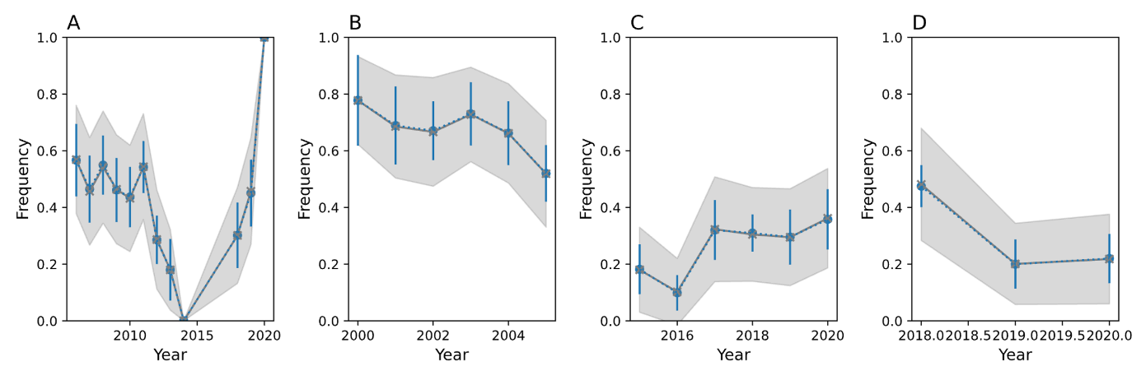
Fig. S5 Down-sampled estimates of Pfcrt K76T for A) Thies, B) Pikine, C) Kédougou, and E) Diourbel. In blue are the estimated allele frequencies and 95% confidence intervals obtained from the raw data. In grey are average allele frequencies and 95% confidence intervals after down-sampling the data from each site-year to 29 samples, which was the smallest number of samples collected across all examined site-years involving Thies, Pikine, Kédougou, and Diourbel.
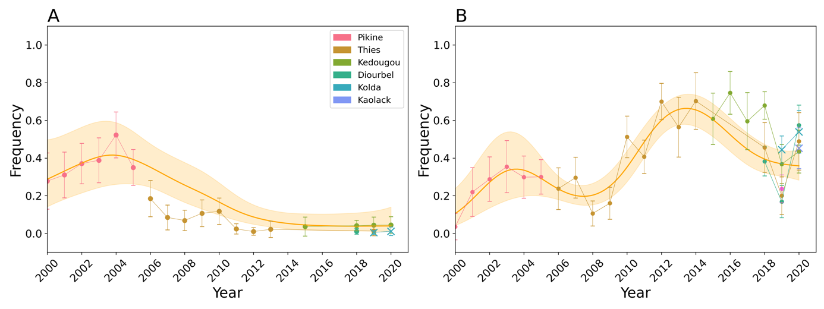
Fig. S6 A) Frequency of Pfdhfr triple sensitive (N51, C59, S108) parasites. B) Frequency of “quadruple” (Pfdhfr triple mutant + Pfdhps A437G) parasites. The scatterplots show the observed frequencies and their 95% binomial confidence interval. Model predictions from a calibrated generalized additive model and the 95% confidence intervals are shown in orange. The model was calibrated with data from Pikine, Thiès, Diourbel, and Kédougou (denoted with circles). The data from Kolda and Kaolack (denoted with X) were not used for model calibration.
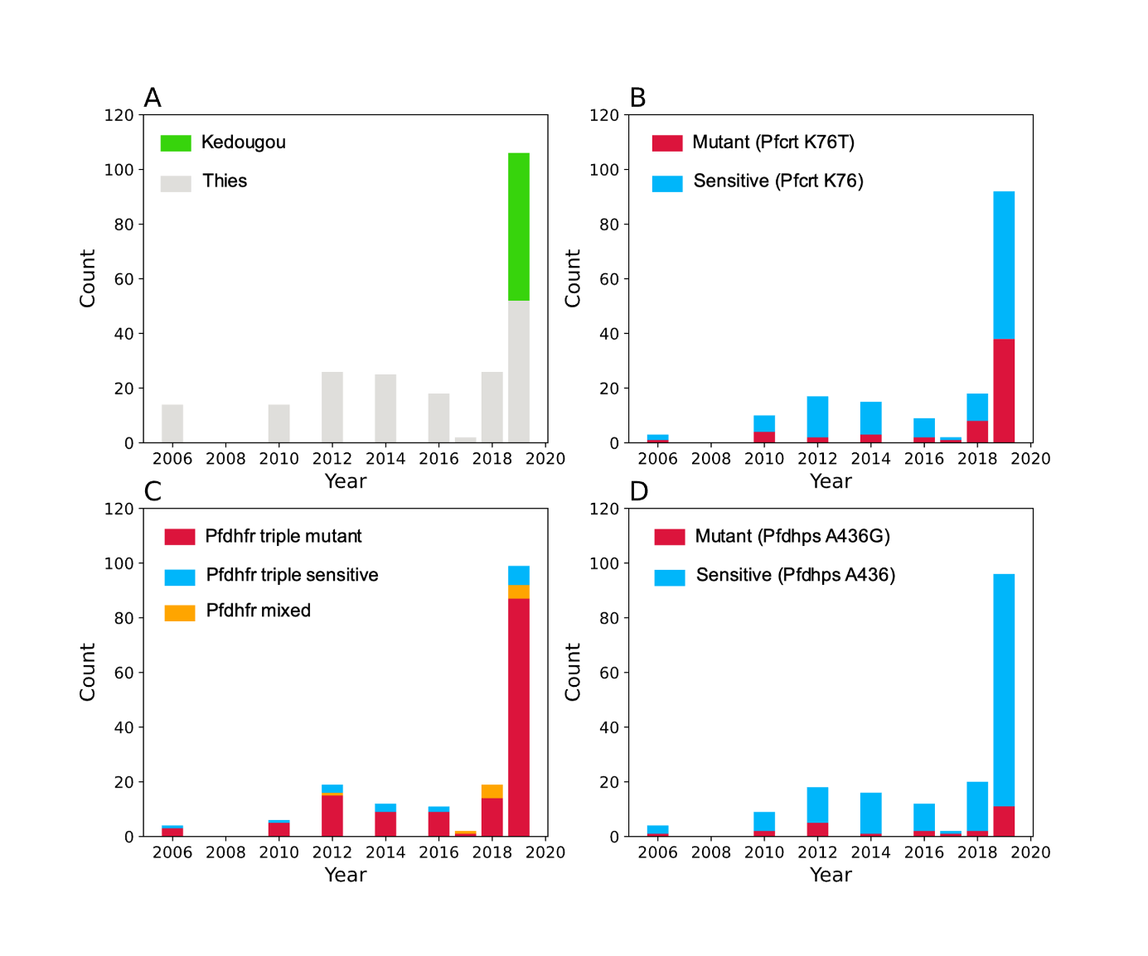
Fig. S7 Sampling distribution for our whole genome sequence collection (A). Grey indicates that the sample came from Thiès. Green indicates the sample came from Kédougou. Sampling distributions for B) the Pfcrt genomic region, C) the Pfdhfr genomic region, and D) the Pfdhps genomic regions. For B and D, blue denotes samples with the sensitive allele and red indicates those with the resistance allele. For C, red denotes samples that are Pfdhfr triple mutant, blue indicates those that are Pfdhfr triple sensitive, and orange indicates those with a mix of resistant and sensitive alleles at the three examined Pfdhfr loci.

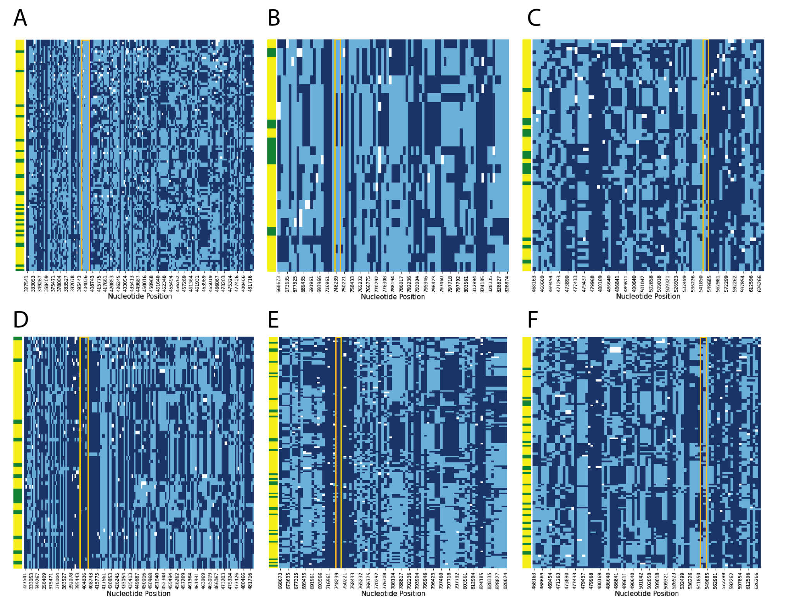
Fig. S8 SNPs used to define genomic haplotypes. Genomic haplotypes surrounding the wild-type mutations: A) Pfcrt K76, B) Pfdhfr C59, C) Pfdhps A437 and the drug resistance mutations: D) Pfcrt K76T, E) Pfdhfr C59R, F) Pfdhps A437G. 171 samples and 173 SNPs were examined for Pfcrt, 170 samples and 85 SNPs for Pfdhfr, 182 samples and 83 SNPs for Pfdhps. Each row represents a sample. The left most column indicates whether the sample was collected before 2014 (green) or after 2014 (yellow). Alleles corresponding to the 3D7 reference are indicated by light blue and alleles corresponding to the alternative allele are indicated by dark blue. White corresponds to missing data. The orange boxes highlight the boundaries of the Pfcrt (A/D), Pfdhfr (B/E), and Pfdhps (C/F) genes,
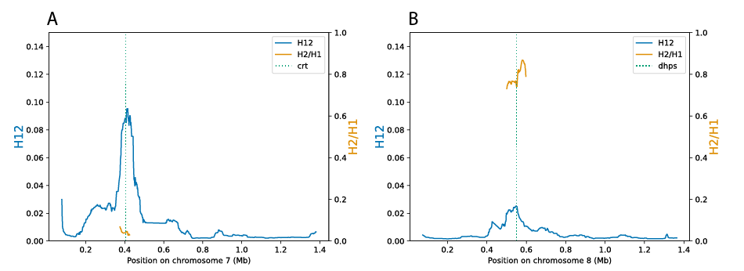
Fig. S9 Evidence of Hard and Soft Sweeps H12 (blue, left y-axis) and H2/H1 (orange, right y-axis) statistics for A) chromosome 7 and B) chromosome 8. The dotted green lines show the location of Pfcrt or Pfdhps.

Supplemental Tables
Supplemental Table 1 Sample sizes for SNP-based molecular surveillance.
Year | Pikine | Thies | Kaolack | Diourbel | Kolda | Kedougou
2000 | 38
2001 | 59
2002 | 91
2003 | 71
2004 | 74
2005 | 111
2006 |  | 92
2007 |  | 79
2008 |  | 94
2009 |  | 87
2010 |  | 95
2011 |  | 130
2012 |  | 120
2013 |  | 50
2014 |  | 53
2015 |  |  |  |  |  | 100
2016 |  |  |  |  |  | 112
2017 |  |  |  |  |  | 128
2018 |  | 74 |  | 200 |  | 496
2019 |  | 83 |  | 97 | 200 | 100
2020 |  | 50 | 100 | 100 | 100 | 100

Supplemental Table 2 Regional and health facility IPTp coverage where samples were collected: Pikine (Deggo), Thiès (SLAP), Diourbel (Sessene), Kaolack (P. Assainies), Kolda (Bagadadji), and Kédougou (Bandafassi).

Supplemental Table 3 Regional SMC and health facility coverage where samples were collected: Pikine (Deggo), Thiès (SLAP), Diourbel (Sessene), Kaolack (P. Assainies), Kolda (Bagadadji), and Kédougou (Bandafassi).

