Supplementary Appendix
Title: Examining geographical inequalities for malaria outcomes and spending on malaria in 43 malaria-control countries, 2010–2020
Authors: Angela E. Apeagyei*, Nishali K. Patel*, Ian Cogswell, Kevin O’Rourke, Golsum Tsakalos, Joseph Dieleman
* Joint first authors

Affiliations: 1 Institute for Health Metrics and Evaluation, University of Washington, Seattle, WA, USA
2 Department of Health Metrics Sciences, University of Washington, School of Medicine, Seattle, WA, USA

Corresponding: Angela E. Apeagyei (amicah@uw.edu)
List of Appendix Contents:
Appendix A: WHO Conceptual Framework on the Determinants of Health Equity
Appendix B: Lorenz curves for malaria incidence, mortality, and case fatality inequality
Appendix C: Regression results

Appendix A
WHO’s conceptual framework on the determinants of health equity

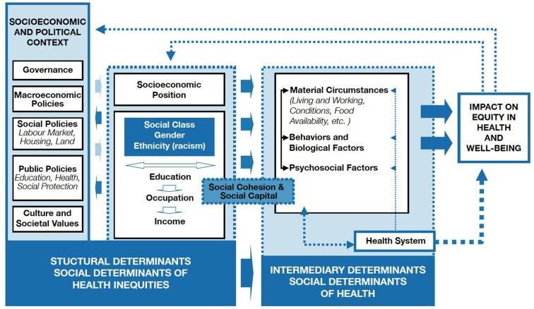

Source: Solar O, Irwin A. A conceptual framework for action on the social determinants of health. Social Determinants of Health Discussion Paper 2 (Policy and Practice)

Appendix B
Fig B1. The Lorenz curves of the distribution of malaria incidence, 2010 - 2020
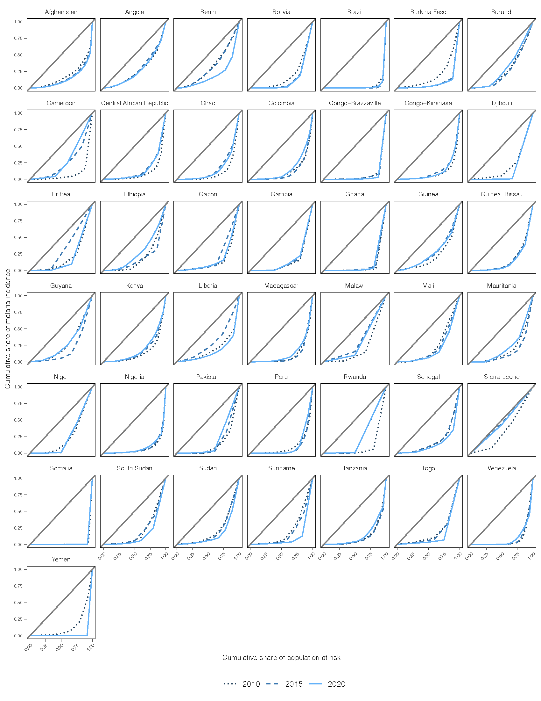
Fig B2. The Lorenz curves of the distribution of malaria case fatality, 2010 - 2020

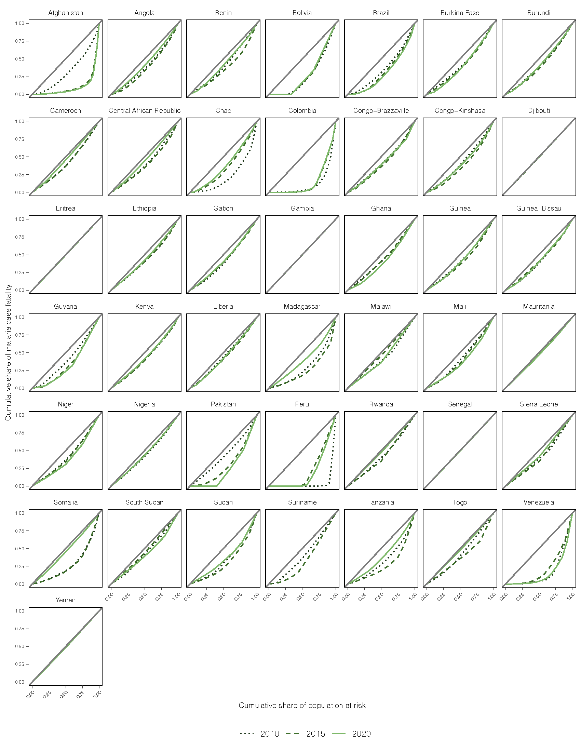

Appendix C

Table C1: Regression results using country only fixed effects (admin1 state-level outcomes)
 | Incidence | Case fatality
ln(Total malaria spending) | -0.027 (0.013) | 0.014 (0.015)
Gov’t malaria spending | 0.084 (0.066) | 0.075 (0.065)
Spending on treatment | - | -0.004 (0.083)
Spending prevention | -0.058 (0.055) | -
Spending on health systems strengthening | -0.138 (0.044) *** | -0.144 (0.052) ***
National malaria incidence | -0.092 (0.095) | -0.014 (0.087)
Healthcare access and quality index | -0.004 (0.005) | -0.011 (0.006) *
Age-dependency ratio | -0.001 (0.002) | -0.002 (0.002)
ln(GDP per capita) | -0.077 (0.037) ** | 0.041 (0.036)
Average maternal education | 0.015 (0.020) | 0.026 (0.025)
Population-weighted mean temperature | 0.025 (0.013) * | 0.019 (0.016)
Number of observations | 471 | 468
R² | 0.055 | 0.041
Adjusted R² | -0.063 | -0.079
F statistic | 2.435 (df = 10; 418)*** | 1.761 (df = 10; 415) *
Results based on a fixed effects model for the Gini coefficient
Number of clusters = 43
*** significant at the 0.01 level, ** significant at the 0.05 level, * significant at 0.10 level

Table C2: Regression results using mortality inequality as the outcome (admin1 state-level outcomes)
 | Model 1 (country and time fixed effects) | Model 2 (country only fixed only) |  |  | Model 3 (Stratified analysis)
ln(Total malaria spending) | 0.007 (0.014) | 0.005 (0.013) | -0.005 (0.028)
Gov’t malaria spending | 0.075 (0.065) | 0.080 (0.066) | -0.096 (0.110)
Spending on treatment | 0.136 (0.071) * | 0.168 (0.069) ** | 0.067 (0.229)
Spending prevention | -0.059 (0.064) | -0.034 (0.062) | -0.085 (0.123)
Spending on health systems strengthening | -0.114 (0.049) ** | -0.091 (0.046) ** | -0.063 (0.101)
National malaria incidence | -0.091 (0.096) | -0.135 (0.105) | -0.321 (0.121) **
Healthcare access and quality index | -0.009 (0.006) | -0.001 (0.006) | 0.001 (0.012)
Age-dependency ratio | -0.002 (0.002) | -0.002 (0.002) | 0.004 (0.002)
ln(GDP per capita) | -0.102 (0.038) *** | -0.113 (0.038) *** | -0.018 (0.056)
Average maternal education | -0.098 (0.026) *** | 0.009 (0.022) | -0.168 (0.051) **
Population-weighted mean temperature | 0.024 (0.017) | 0.014 (0.014) | 0.026 (0.032)
Number of observations | 468 | 468 | 230
R² | 0.075 | 0.052 | 0.096
Adjusted R² | -0.069 | -0.070 | -0.102
F statistic | 2.980 (df = 11;404) *** | 2.053 (df = 11; 414) ** | 1.800 (df = 11;188) *
Results based on a fixed effects model for the Gini coefficient
Number of clusters for Models 1 and 2 = 43
Number of clusters for Model 3 = 20
*** significant at the 0.01 level, ** Significant at the 0.05 level, * significant at 0.10 level

