Supplement
In the human section, the model was expanded to account for hypnozoite carriers with the subscript $L$, a dormant state with the subscript $D$, and a latent dormancy state with the subscript $LD$. States with the subscript $D$ and $LD$ are a way of allowing delay before the hypnozoites can be activated. Hypnozoites cannot be activated until they move into the $L$ boxes. An individual infected through an infectious mosquito bite will immediately develop a primary blood-stage infection and will also acquire dormant liver-stage parasites. These hypnozoites relapse at a rate$f$ and die, either because of the hypnozoite itself or because of the hepatocyte renewal. During dormancy, liver-stage infections may be cleared by natural hepatocyte death at rate $γ_{_D}$. Latent liver-stage infections are assumed to clear at rate $γ_{_L}$. The diagrams of P. vivax transmission model are shown in Fig. 6.

Humans susceptible to infection are bitten by female mosquitoes carrying sporozoites, or dormant liver-stage parasites in humans are reactivated, causing a new blood-stage infection. Infectious humans can infect susceptible mosquitoes when mosquitoes ingest gametocytes during the blood meal. The Ross-MacDonald model defines the force of infection on humans $λ_{h}$ (or ${ac I_{m}/ P}_{h}$ ) as the product of the mosquito biting rate per human $a$, the probability of infection following a bite by an infectious mosquito $c$, and the proportion of infectious mosquitoes $I_{m}$ over total human population $P_{h}$. The force of infection on mosquitoes $λ_{m}$ (or ${ab(I}_{0}+I_{L}+I_{D}+I_{LD})/ P_{h}$ ) can be calculated as the product of the mosquito biting rate per human$a$, and the probability of mosquito infected following a bite on infectious humans $b$, and the proportion of infectious humans ${(I}_{0}+I_{L}+I_{D}+I_{LD})$ over total human population $P_{h}$. In the following system of equations, the Gamma distribution is assumed to be the sum of $K$ exponential distributions, each with rate $K_{δ}$. All parameters and their calibrated values used in the model are listed in Table 4.

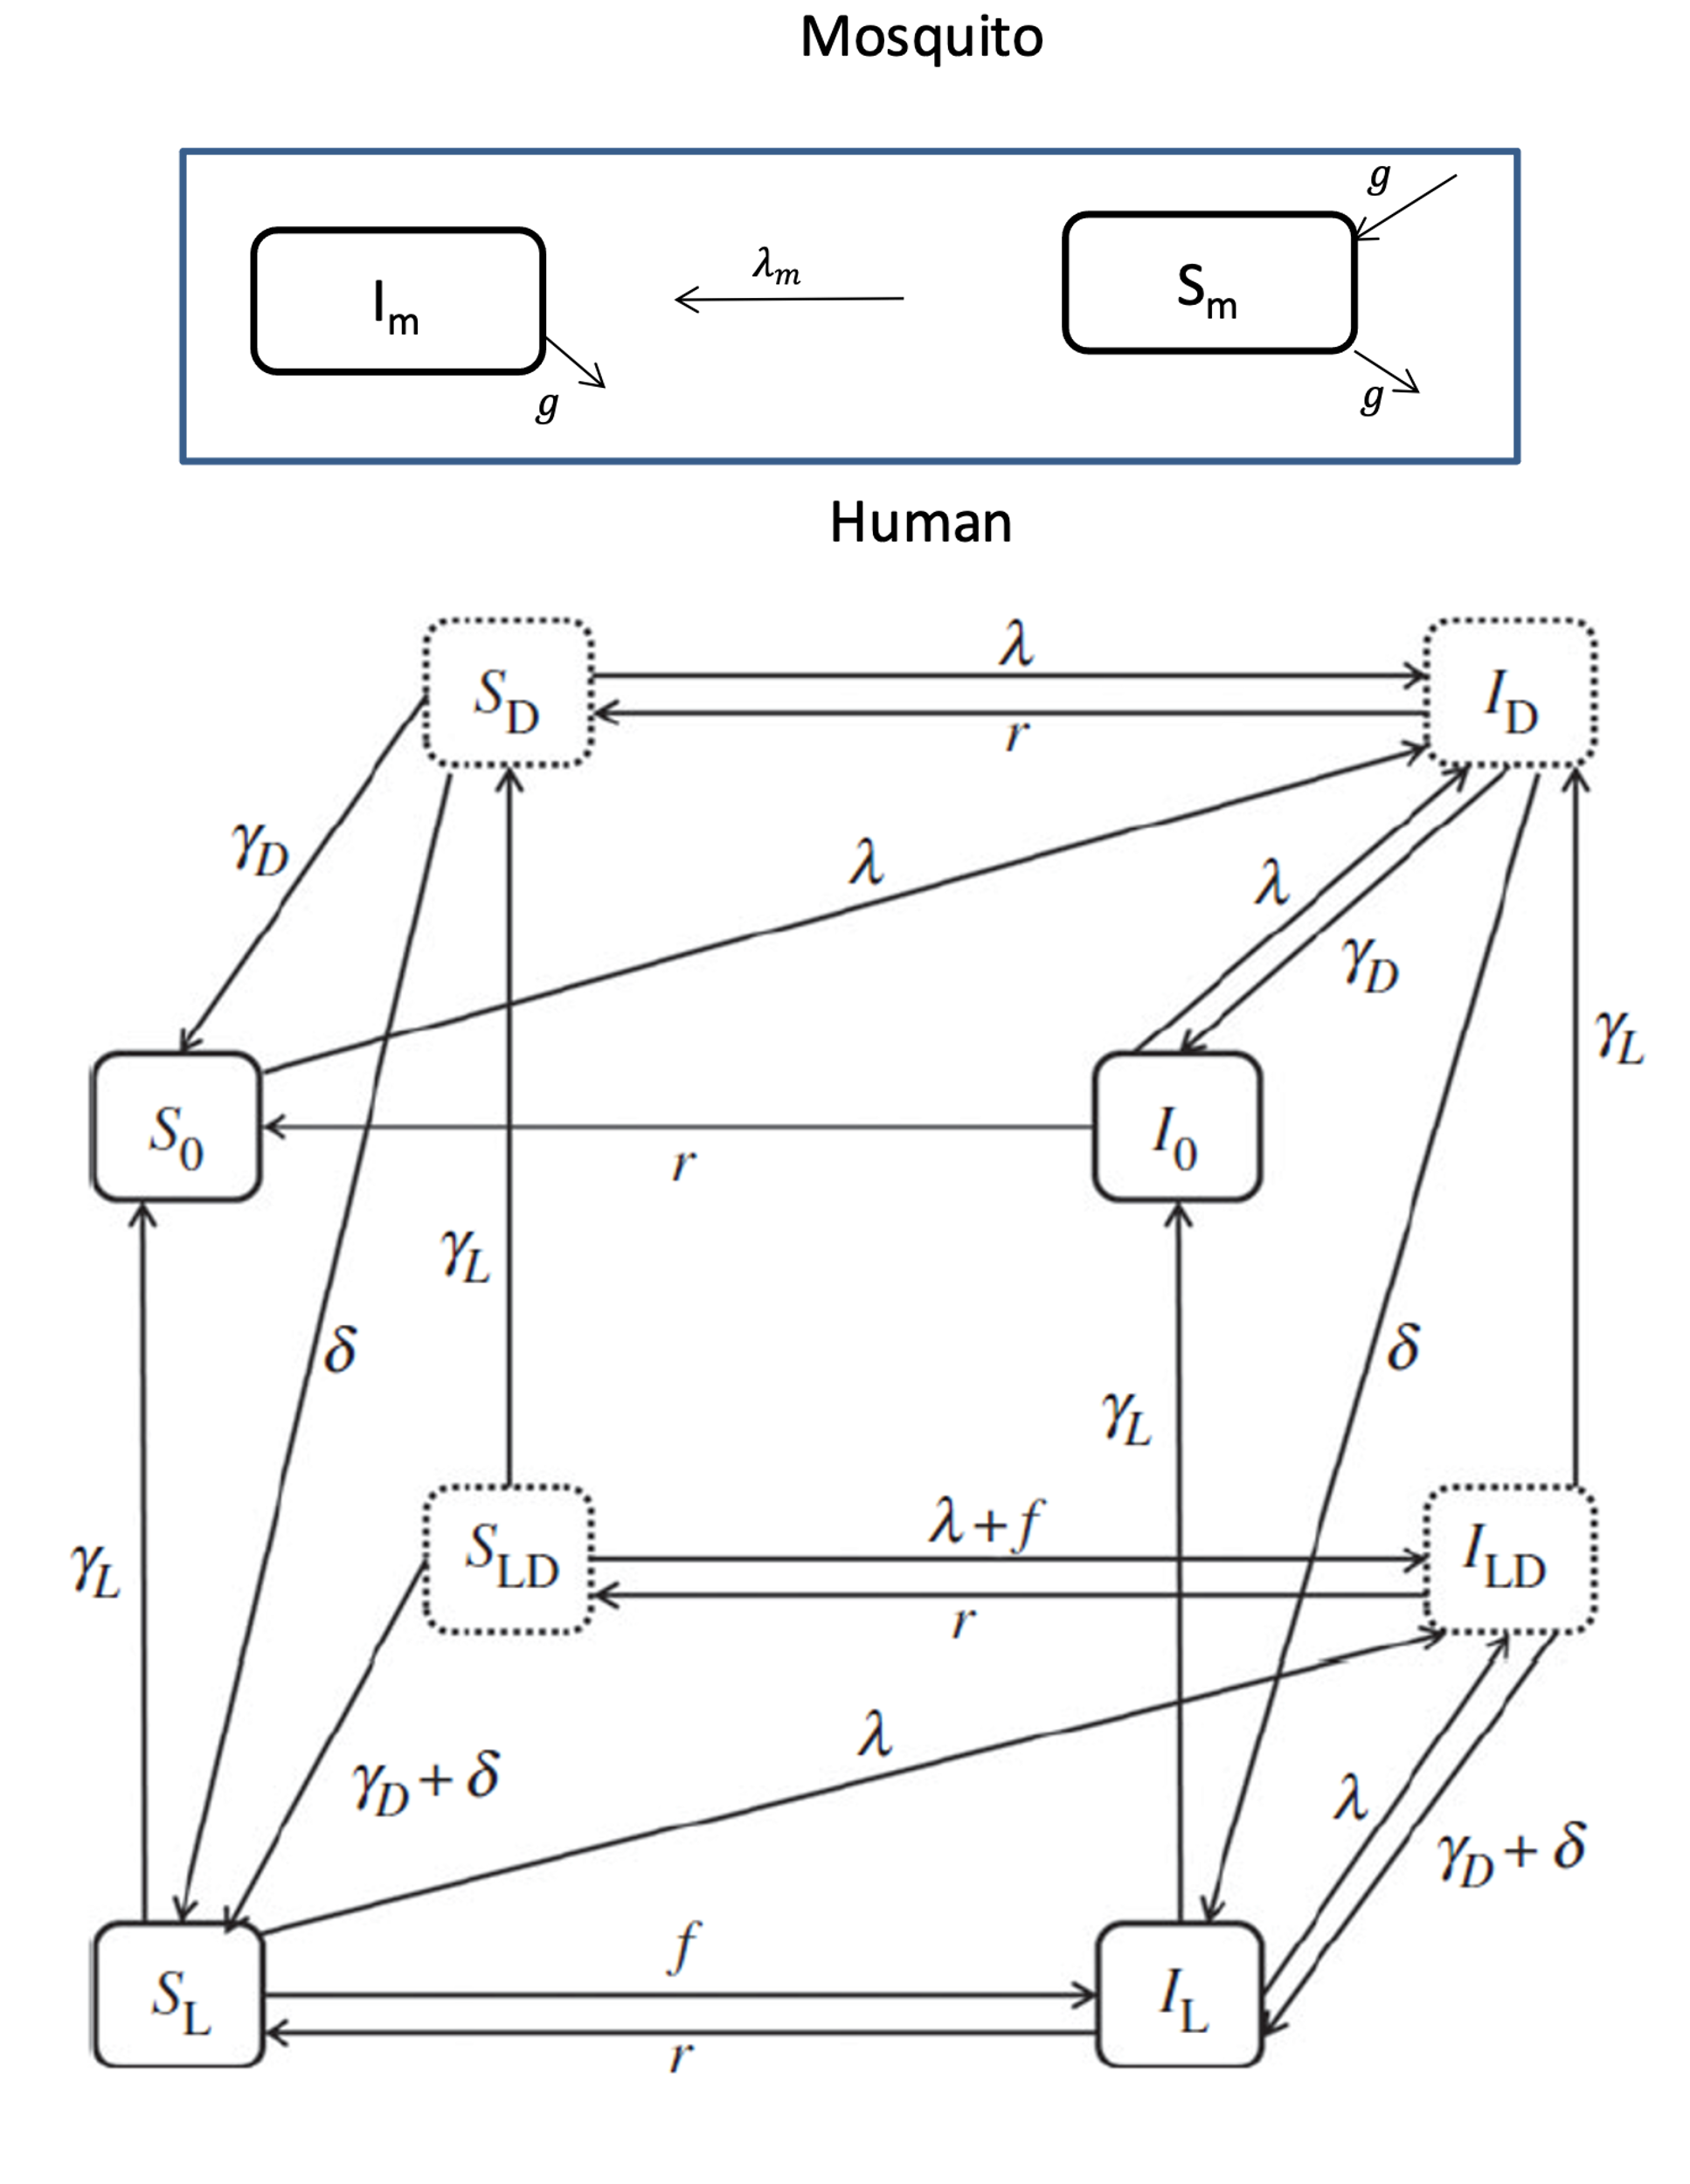Fig. S1 Diagrams of P. vivax transmission model in mosquitoes and humans. Each compartment represents a proportion of the total mosquito or human population[14]. (1) Malaria transmission dynamics model in mosquitoes: $S_{m}$ represents the proportion of mosquitoes susceptible to infection. $I_{m}$ denotes the proportion of infectious mosquitoes. The factor characterizing the move from $S_{m}$ to $I_{m}$ is the force of infection on mosquitoes $λ_{m}$ (or ab${(I}_{0}+I_{L}+I_{D}+I_{LD})/ P_{h}$). An assumption made in this model is that mosquitoes die at a constant rate $g$ and new mosquitoes are born at that same rate. (2) P. vivax malaria transmission dynamics model of hypnozoites in liver hepatocytes with 8 compartments: $S_{0}$ represents every individual without hypnozoites positive susceptible of being infected through an infectious mosquito bite and $I_{0}$ represents the proportion of infected individuals without hypnozoites positive among the population. $S_{L}$ represents every individual with hypnozoites positive susceptible of being infected through an infectious mosquito bite and $I_{L}$ represents the proportion of infected individuals with hypnozoites positive among the population. Dormant states $S_{D}$and $I_{D}$ are subscripted with D, whereas latent dormancy states $S_{LD}$and $I_{LD}$ are subscripted with _LD. States with the subscript D and LD are a way of allowing delay before the hypnozoites can be activated. Hypnozoites can only be activated until they move into the _L boxes. The movement between these two compartments depends on four factors: the force of infection on humans $λ_{h}$ (or ${{ac I}_{m}/P}_{h}$), the blood-stage infection recovery rate $r_{h}$, hypnozoites relapse rate$f$, and rate of hypnozoite clearance $γ_{L}$ (latent stage) and $γ_{D}$ (dormant stage).

P. vivax transmission dynamics can be described with the following equations:
$$\frac{dS_{0}}{dt}=-λ_{h}S_{0}+rI_{0}+γ_{L}S_{L}+γ_{D}\sum_{j=1}^{K}{S_{D}^{j}}$$
$$\frac{dI_{0}}{dt}=-λ_{h}I_{0}-rI_{0}+γ_{L}I_{L}+γ_{D}\sum_{j=1}^{K}{I_{D}^{j}}$$
$$\frac{dS_{L}}{dt}=-λ_{h}S_{L}-fS_{L}+rI_{L}-γ_{L}S_{L}+γ_{D}\sum_{j=1}^{K}{S_{LD}^{j}}+KδS_{D}^{K}+KδS_{LD}^{K}$$
$$\frac{dI_{L}}{dt}=-λ_{h}I_{L}+fS_{L}-rI_{L}-γ_{L}I_{L}+γ_{D}\sum_{j=1}^{K}{I_{LD}^{j}}+KδI_{D}^{K}+KδI_{LD}^{K}$$
$$\frac{dS_{D}^{1}}{dt}=-λ_{h}S_{D}^{1}+rI_{D}^{1}+γ_{L}S_{LD}^{1}-γ_{D}S_{D}^{1}-KδS_{D}^{1}$$
$$\frac{dS_{D}^{k}}{dt}=-λ_{h}S_{D}^{k}+rI_{D}^{k}+γ_{L}S_{LD}^{k}-γ_{D}S_{D}^{k}+KδS_{D}^{k-1}-KδS_{D}^{k}$$
$$\frac{dI_{D}^{1}}{dt}=λ_{h}(S_{0}+I_{0})+λS_{D}^{1}-rI_{D}^{1}+γ_{L}I_{LD}^{1}-γ_{L}I_{D}^{1}-KδI_{D}^{1}$$
$$\frac{dI_{D}^{k}}{dt}=λ_{h}S_{D}^{k}-rI_{D}^{k}+γ_{L}I_{LD}^{k}-γ_{D}I_{D}^{k}+KδI_{D}^{k-1}-KδI_{D}^{k}$$
$$\frac{dS_{LD}^{1}}{dt}=-λ_{h}S_{LD}^{1}-fS_{LD}^{1}+rI_{LD}^{1}-γ_{L}S_{LD}^{1}-γ_{D}S_{LD}^{1}-KδS_{LD}^{1}$$
$$\frac{dS_{LD}^{k}}{dt}=-λ_{h}S_{LD}^{k}-fS_{LD}^{k}+rI_{LD}^{k}-γ_{L}S_{LD}^{k}-γ_{D}S_{LD}^{k}+KδS_{LD}^{k-1}-KδS_{LD}^{k}$$
$$\frac{dI_{LD}^{1}}{dt}=λ_{h}(S_{L}+I_{L})+λS_{LD}^{1}+fS_{LD}^{1}-rL_{LD}^{1}-γ_{L}I_{LD}^{1}-γ_{D}I_{LD}^{1}-KδI_{LD}^{1}$$
$$\frac{dI_{LD}^{k}}{dt}=λ_{h}S_{LD}^{k}+fS_{LD}^{k}-rL_{LD}^{k}-γ_{L}I_{LD}^{k}-γ_{D}I_{LD}^{k}+KδI_{LD}^{k-1}-KδI_{LD}^{k}$$
$$λ_{h}=ac\frac{I_{m}}{P_{h}}$$
$$\frac{dS_{m}}{dt}=gM_{0}C-λ_{m}S_{m}-g_{1}S_{m}$$
$$\frac{dI_{m}}{dt}=λ_{m}S_{m}-g_{1}I_{m}$$
$$\frac{dS_{L}}{dt}=-λS_{L}-fS_{L}+rI_{L}-γ_{L}S_{L}+γ_{D}\sum_{j=1}^{K}{S_{LD}^{j}}+KδS_{D}^{K}+KδS_{LD}^{K}$$

$$λ_{m}=ab\frac{\sum_{j=1}^{K}{(}I_{0}^{j}+I_{L}^{j}+I_{D}^{j}+I_{LD}^{j})}{P_{h}}$$
Seasonality:
$$C=1+\cos\left(\frac{2πt}{ω}-φ\right)$$
While the model builds on the theoretical framework established in reference [14], it incorporates several significant modifications and extensions tailored specifically to address the unique epidemiological data and intervention strategies employed in Central China. Here is the detail about how the model was originally developed and its key differentiators:
Model Structure and Components:
Original Model: The foundational model from reference [14] incorporates a within-host component focusing on hypnozoite behavior and a binary model simplifying infection states. It primarily addresses relapse frequencies and transmission dynamics influenced by geographic differences (tropical vs. temperate strains).
AdoptedModel: While adopting the basic structure, the adopted model expands on this by integrating specific public health interventions used historically in Central China, which were not explicitly modeled in reference [14]. This includes tailored strategies like specific MDA regimens and local vector control measures.
Key Assumptions and Parameters:
Several parameters have been updated and recalibrated to reflect more recent epidemiological data and the specific environmental and socio-economic context of the region studied, which affects transmission dynamics beyond the scope of the original model.
Purpose and Findings:
Original study: Aimed to understand the impact of varying relapse frequencies on transmission potential across different climatic zones.
This Study: Focuses on assessing the historical impact of malaria intervention strategies in Central China, using a modified version of the model to simulate and optimize intervention timing and combination based on local malaria incidence data.
Model Development and Validation:
The adopted model underwent extensive recalibration using local data from the 1970s and 1980s, unlike the more generalized approach in reference [14]. This ensures that the model predictions are robust and applicable to local public health strategies.
Furthermore, the adopted model introduces the seasonality factor and considers the contribution to mosquito transmission from four compartments of the population: $I_{0}^{},{ I}_{L}^{},{ I}_{D}^{},{I }_{LD}^{}$. This approach is more detailed compared to the model in reference 11, which only considered two compartments: $I_{0}^{},{ I}_{L}^{}$.
Mean square error is often used to evaluate the model fit. In this paper,several interventions were introduced into the mathematic model to simulate malaria incidence and compared the performance of these interventions and their combinations by calculating MSE, that is, the mean value of the sum of squares of the errors between the predicted incidence data and the real historical incidence data. The intervention coverage combinations that lead to onset curves similar to the historical data curve are preferred. This indicates that these combinations may have been used in the anti-malaria campaign of the P. R. China and could have successfully reduced the transmission of malaria. In order to improve the fitting effect, the weighted MSE calculation method is used due to the large variation of the data in the first five years. The weighted MSE formula is as follows,
$${MSE}_{w}=\sum_{i=1}^{13}{{y_{i}(y_{i}-{\hat{y}}_{i})}^{2}/n}$$
Here $y_{i}$ denotes the historical data of year $i$, ${\hat{y}}_{i}$ denotes the simulated data from the model of year $i$.

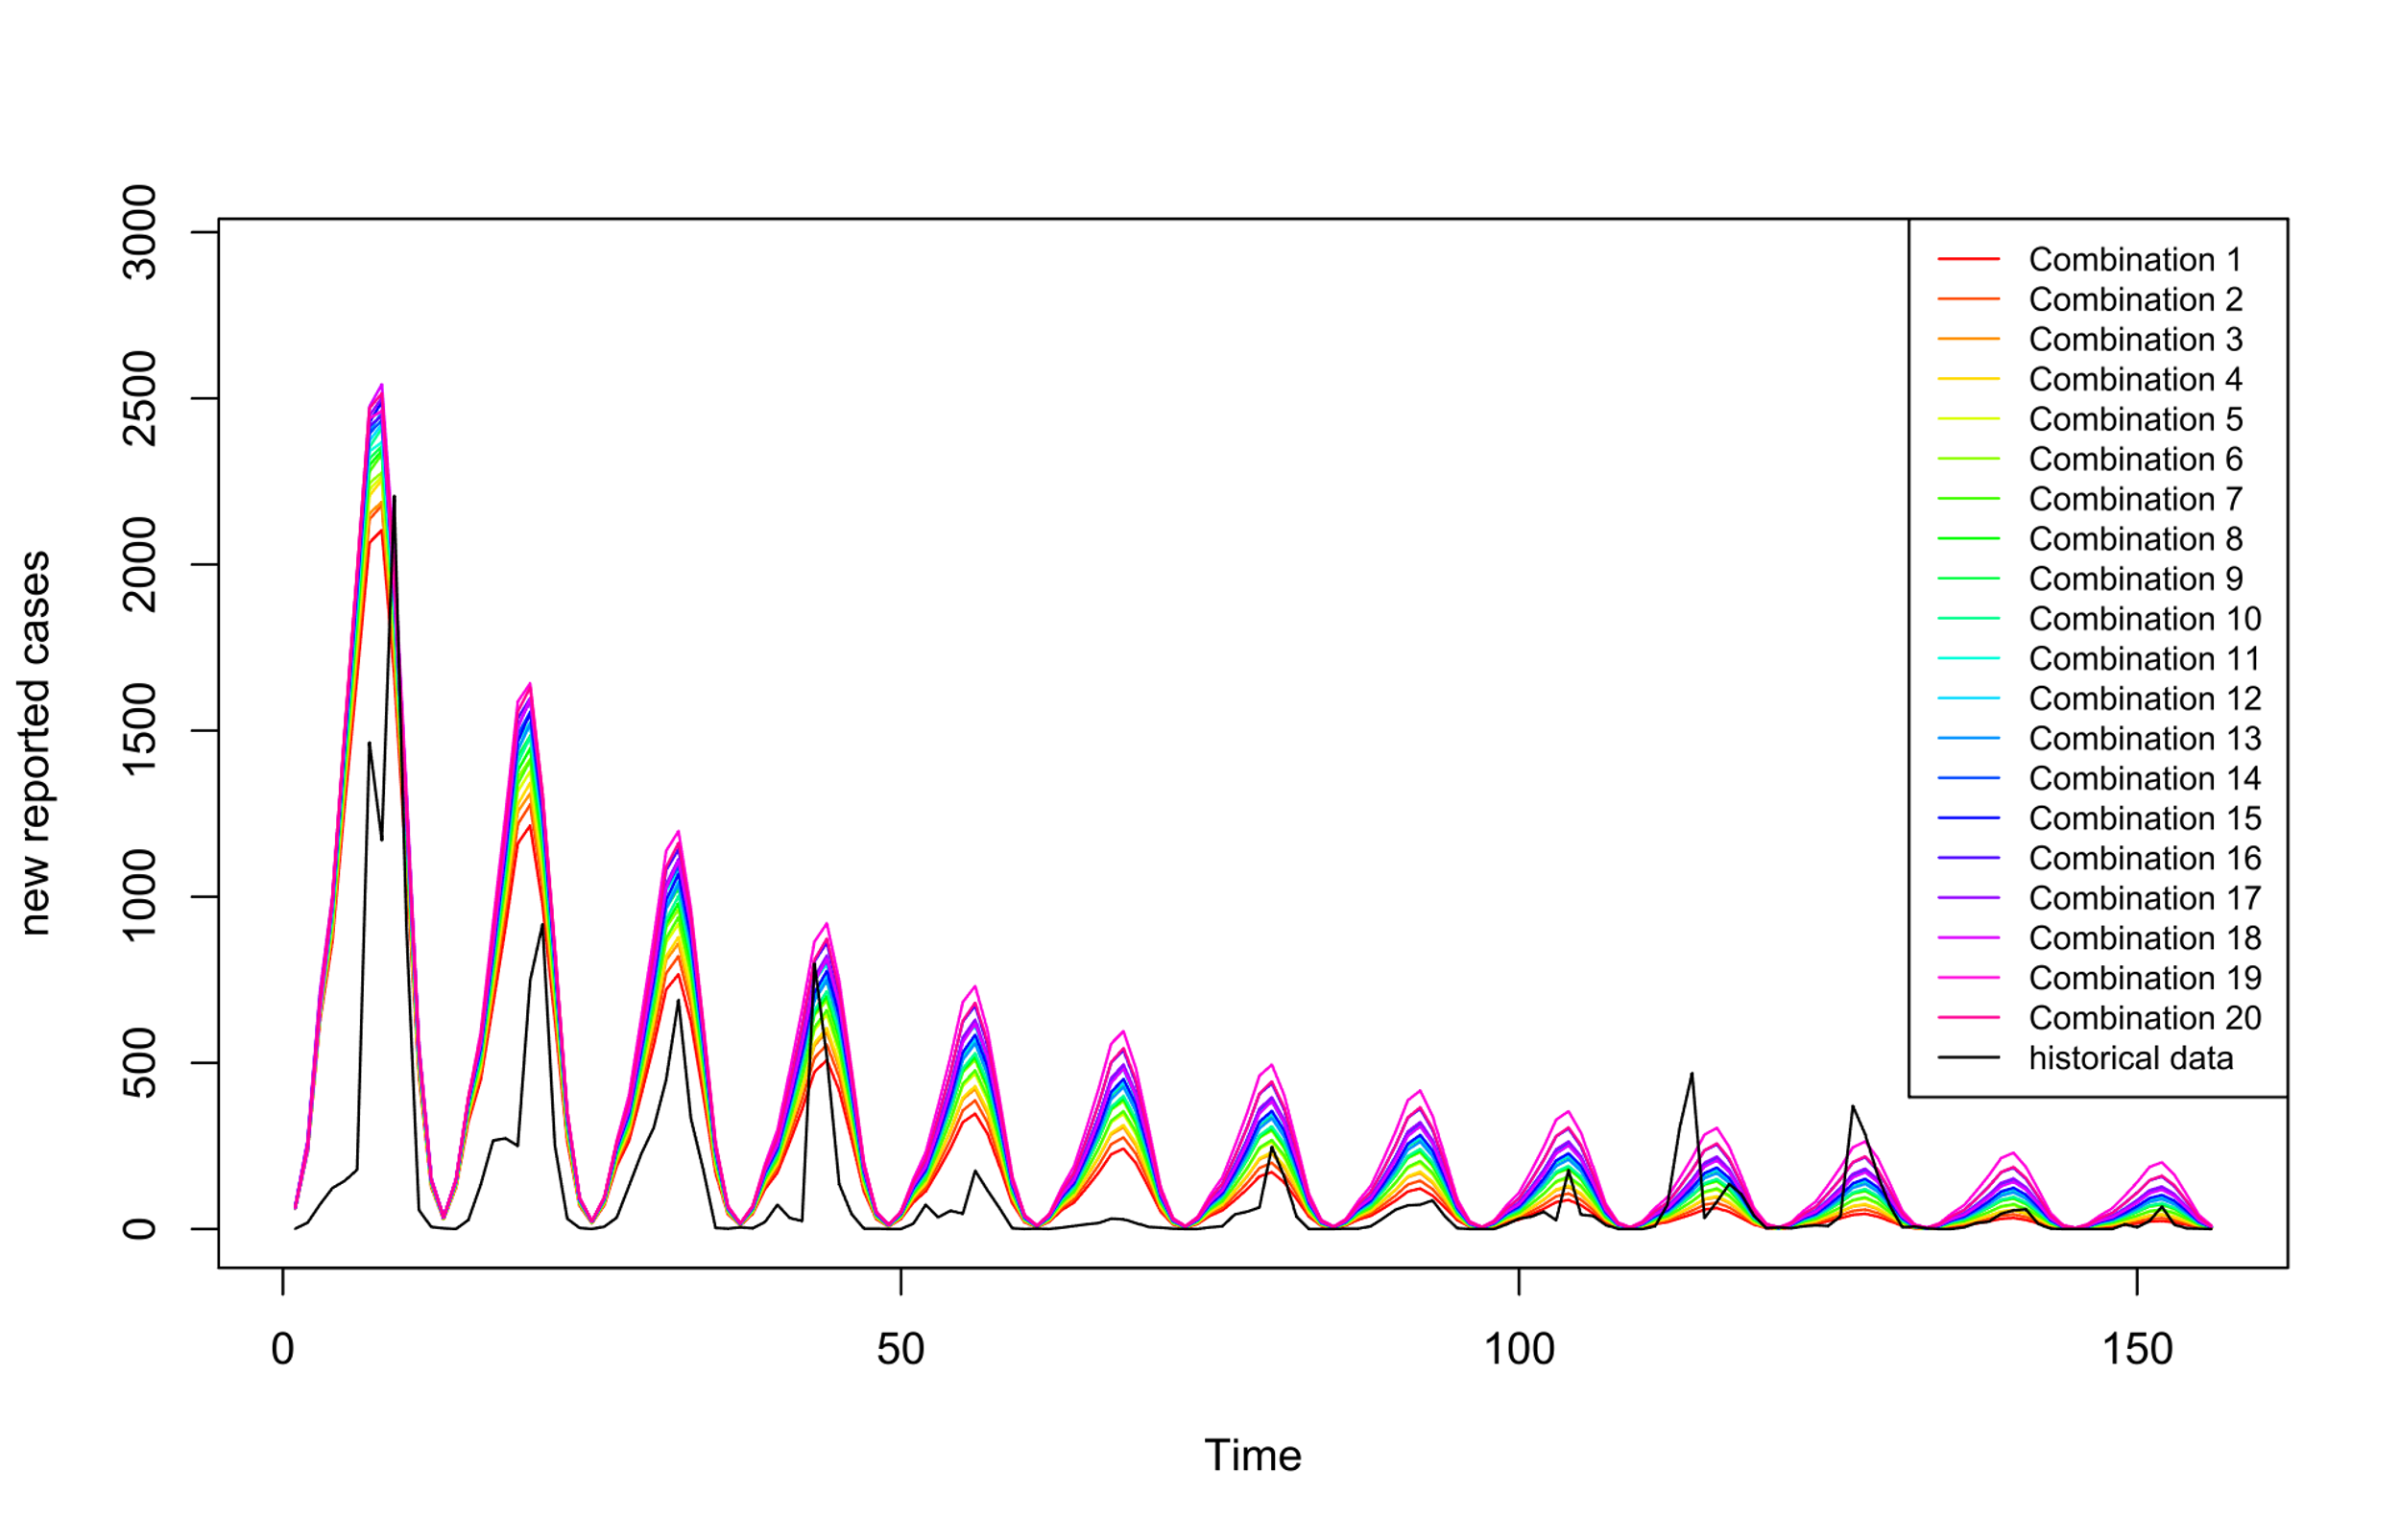Fig. S2 Monthly malaria cases result of different intervention combinations in Table 4
Fig. S2 presents 21 distinct colored curves, with the black curve representing historical data and the remaining curves corresponding to the simulated results of various intervention combinations as detailed in Table 4. It is evident that while the curves derived from the 20 different combinations of intervention coverage rates exhibit similarity, but they each demonstrate distinct variations in their fit to the actual historical data.

