SUPPLEMENTARY INFORMATION

Supplementary Table 1. Primer and probe concentrations in multiplex qPCR for the detection of pfhrp2/3 deletions

Gene | Sequence 5'-3' (Reference [28]) |  | Concentration
pfhrp2 | Forward | TAA TTS CGY ATT TAA TAA TAA CTT GTG | 900nM
pfhrp2 | Reverse | CAT CAT CTA CAT GTG CTG GAG | 900nM
pfhrp2 | Probe | 6FAM - ATG CAA AAG GAC TTA ATT TAA ATA AGA GAT T - QSY | 200nM
pfhrp3 | Forward | ACG GAT TTC ATT TTA ACC CTT CAC GA | 200nM
pfhrp3 | Reverse | TGA GAA TCA TCA AAA CAA GCA TTA GC | 200nM
pfhrp3 | Probe | VIC - ACA ATT CCC ATA CTT TAC ATC ATG CA - QSY | 120nM
pfldh | Forward | ACG ATT TGG CTG GAG CAG AT | 120nM
pfldh | Reverse | TCT CTA TTC CAT TCT TTG TCA CTC TTT C | 120nM
pfldh | Probe | ABY - GTA ATA GTA ACA GCT GGA TTT ACC AAG GCC CCA - QSY | 80 nM
humtubb | Forward | AAG GAG GTC GAT GAG CAG AT | 120nM
humtubb | Reverse | GCT GTC TTG ACA TTG TTG GG | 120nM
humtubb | Probe | JUN - TTA ACG TGC AGA ACA AGA ACA GCA GCT - QSY | 80 nM

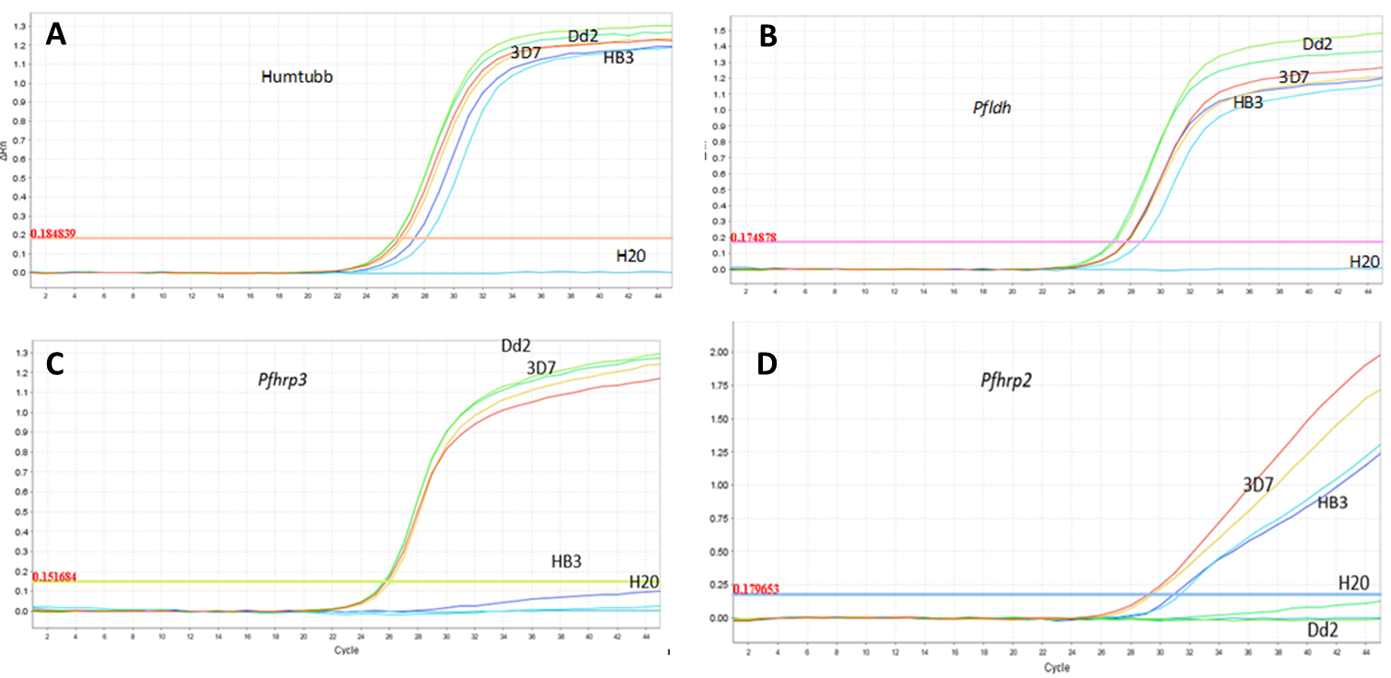Supplementary Figure 1. Validation of multiplex pfhrp2/3 qPCR assay.
Validation of the assay using four controls to amplify the genes of interest. Reference samples from continuous cultures previously spotted in DBS were used, namely 3D7 (wild type without deletion; from West Africa; MR4, BEI resources), Dd2 (with deletion in the pfhrp2 gene; from Indochina MR4, BEI resources), and HB3 (with deletion in the pfhrp3 gene; from Honduras MR4, BEI resources).

