Additional File 1. Description of three types of novel non-invasive diagnostic tools under development for malaria diagnosis, provided to study team by study sponsor to stimulate questions during focus group discussions and key informant interviews.
 | Instruments based on the detection of Volatile Organic Compounds (VOCs) | Instruments that detect malaria infection through the skin | Saliva based rapid diagnostic tests (RDTs)
Overview | VOCs are a heterogeneous group of low molecular weight organic chemicals that are emitted from the human body as gases, resulting in their presence in exhaled breath, sweat, urine and other body fluids | Instruments based on the use of spectrophotometers to measure the absorption or transmission of light through the skin (ear/arm/hand). They are handheld devices that use near-infrared (NIR) or ultraviolet-visible (UV-Vis) light to detect the presence of malaria parasites in the blood. | Saliva is used to test for the presence of gametocytes in the microvasculature using high-affinity antibodies to a parasite protein that is abundant in saliva in asymptomatic individuals.
Estimated sensitivity | ~90% | ~90% 1,
Estimated specificity | ~90% 1 | ~90% 1,2
Estimated accuracy |  |  | 75-83%
Estimated cost | N/A | 2000-5000 USD (device and 0.20 USD (analysis) | < 5 USD
Infrastructure requirements | Minimal, battery-operated | Minimal, battery-operated | Minimal, no power source needed
Estimated time to result | ~2 minutes | ~2 minutes | 15 to 30 minutes
Level of skill needed to operate | Community level. Non-health worker | Community level. Non-health worker | Same as other oral fluid RDTs (such as  COVID-19, HCV, HIV)
Image | 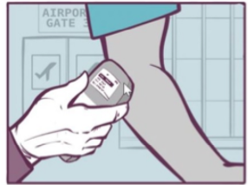  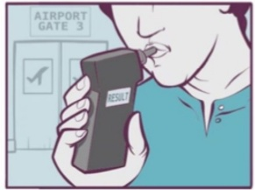 | 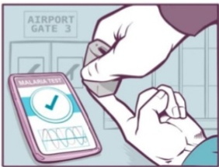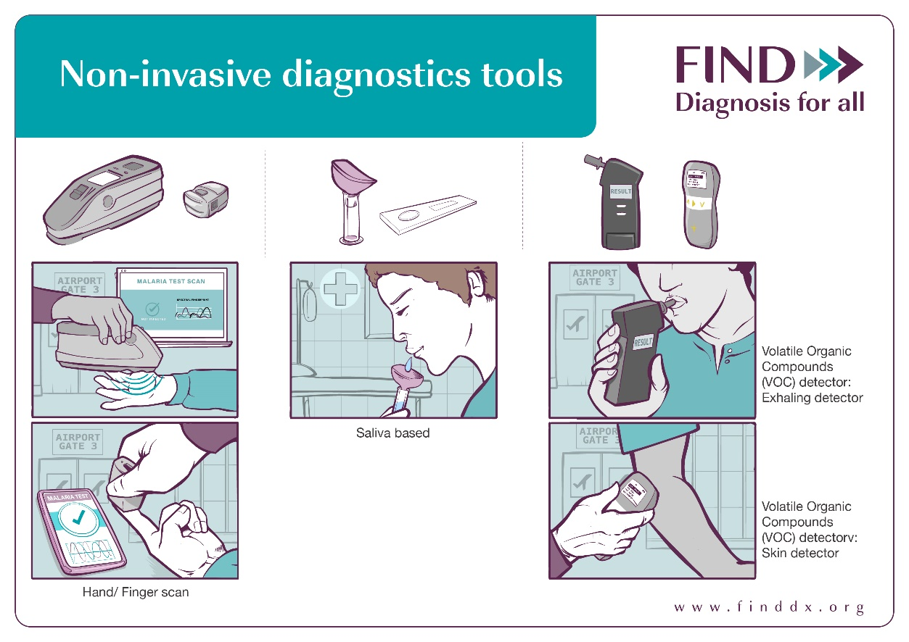
Please note photos are for demonstration purposes only and may not reflect the final design of the malaria non-invasive tests.
The sensitivity, specificity and cost are based on prototypes and expert opinion and may change

Based on ideal characteristics for prototype device
Garcia GA, Kariyawasam TN, Lord AR, da Costa CF, Chaves LB, Lima-Junior JDC, Maciel-de-Freitas R, Sikulu-Lord MT. Malaria absorption peaks acquired through the skin of patients with infrared light can detect patients with varying parasitemia. PNAS Nexus. 2022 Dec 7;1(5):pgac272. doi: 10.1093/pnasnexus/pgac272. PMID: 36712329; PMCID: PMC9802436.
Tao D, McGill B, Hamerly T, Kobayashi T, Khare P, Dziedzic A, Leski T, Holtz A, Shull B, Jedlicka AE, Walzer A, Slowey PD, Slowey CC, Nsango SE, Stenger DA, Chaponda M, Mulenga M, Jacobsen KH, Sullivan DJ, Ryan SJ, Ansumana R, Moss WJ, Morlais I, Dinglasan RR. A saliva-based rapid test to quantify the infectious subclinical malaria parasite reservoir. Sci Transl Med. 2019 Jan 2;11(473):eaan4479. doi: 10.1126/scitranslmed.aan4479. PMID: 30602535; PMCID: PMC6441545.

