Additional file 1. Detailed climatic analysis on relationship of bimodal and unimodal seasonality and malaria epidemics in 2022.
The harmonic analysis using CHIRPS data revealed distinct rainfall and epidemiological patterns across Uganda’s 15 provinces. In 2022, six provinces exhibited unimodal rainfall patterns (Elgon, Lango, Teso, Acholi, Karamoja, and West Nile), with three provinces (Elgon, Lango, Teso) experiencing malaria epidemics, while the others (Acholi, Karamoja, West Nile) did not show epidemic trends. In contrast, nine provinces with bimodal rainfall patterns (Ankole, Bukedi, Bunyoro, Busoga, Kampala, Kigezi, North Buganda, South Buganda, and Tooro) experienced malaria epidemics in 2022, though the magnitude was lower in Bunyoro and Kigezi (Fig. 13). Seasonality analysis classified patterns as unimodal or bimodal based on a harmonic cutoff of 1.0, with unimodal provinces (e.g., West Nile, Acholi, Karamoja) having lower harmonic scores and bimodal provinces (e.g., Ankole, Busoga, North Buganda) exceeding the cutoff. Geographical trends indicated that northern unimodal regions had a stronger correlation between rainfall and malaria cases, while southeastern bimodal regions displayed weaker correlations (Figure 14). A significant negative correlation (r = -0.19, 95% CI -0.26 to -0.12, p = 4.03 × 10⁻⁸) between seasonality patterns and malaria incidence suggests that bimodal provinces with higher harmonic scores are associated with lower malaria incidence rates. These findings emphasize the heterogeneity in rainfall-driven malaria dynamics and underscore the need for tailored interventions based on localized climatic and epidemiological contexts.
Fig. 13. Epidemic trends in 2022 compared to 3rd quartile and precipitation modality by province, Uganda.

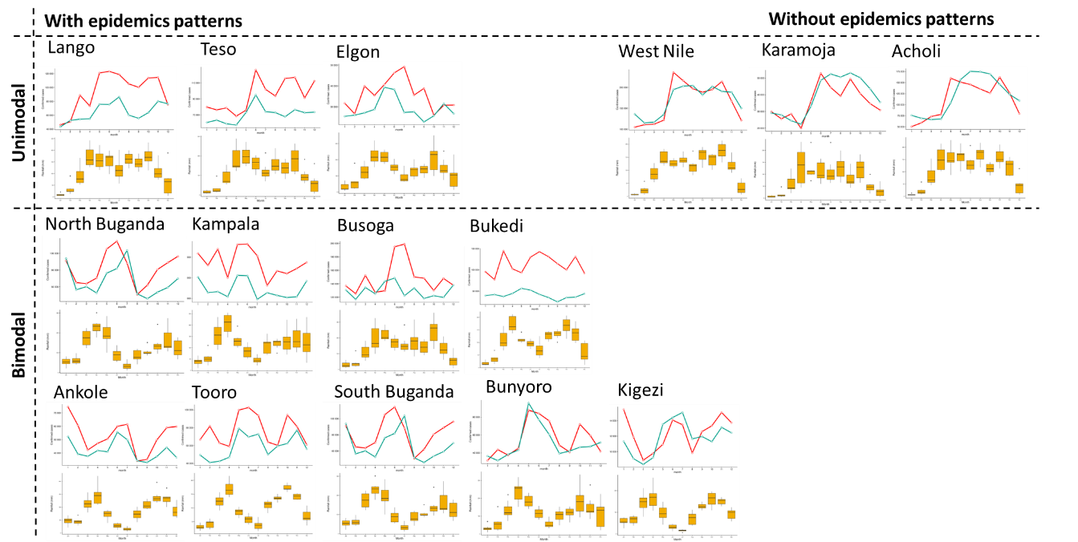

Fig. 14. Precipitation seasonality patterns by province using harmonic analysis (cutoff=1), showing unimodal and bimodal patterns, Uganda, 2022.
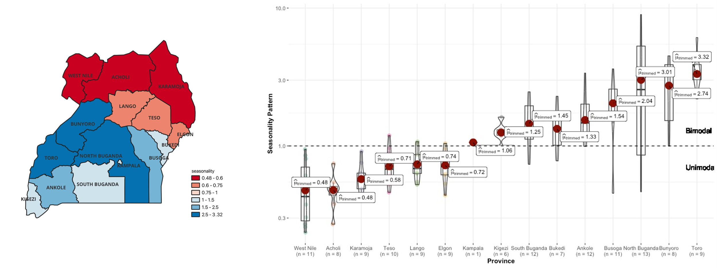

The standard deviation of malaria incidence and the seasonality pattern were compared between 2022 and the threshold (mean values from 2017 to 2021). Malaria incidence showed a substantial increase in 2022, while the seasonality pattern exhibited a slight shift toward a unimodal distribution (Fig. 15a). However, the relative analysis revealed a weak correlation between the two indicators (r = 0.09, p = 0.27), indicating that the observed shift in seasonality was not statistically significant as a driver of the malaria epidemic in 2022. This suggests that factors other than seasonality shifts are likely responsible for the increased malaria cases in 2022.
Scatterplot analysis of the aggregated rainfall for 2022 versus 2017 – 2021 (Fig. 15b) indicated no statistically significant correlation between rainfall deviation and incidence deviation (r = -0.06 [-0.23 – 0.10], p = 0.44) confirming the visual observation of lack of association between rainfall and malaria cases in Fig. 11.

Fig. 15. "Deviations in rainfall and malaria incidence (2022 vs. 2017-2021): a) Seasonality pattern vs. Incidence, b) seasonality deviation vs. Incidence."

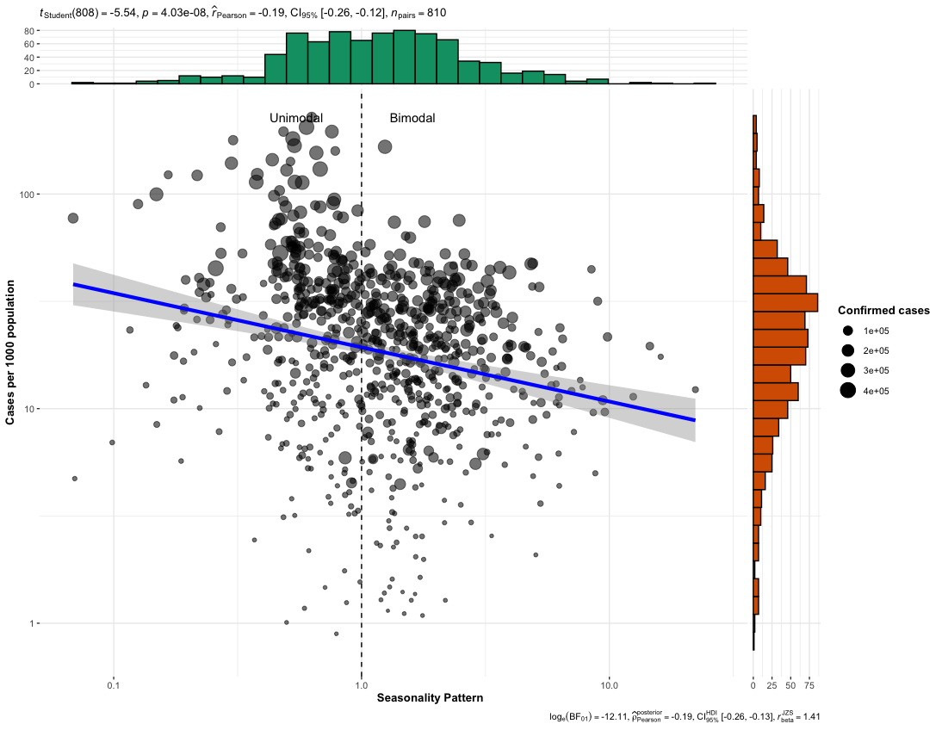
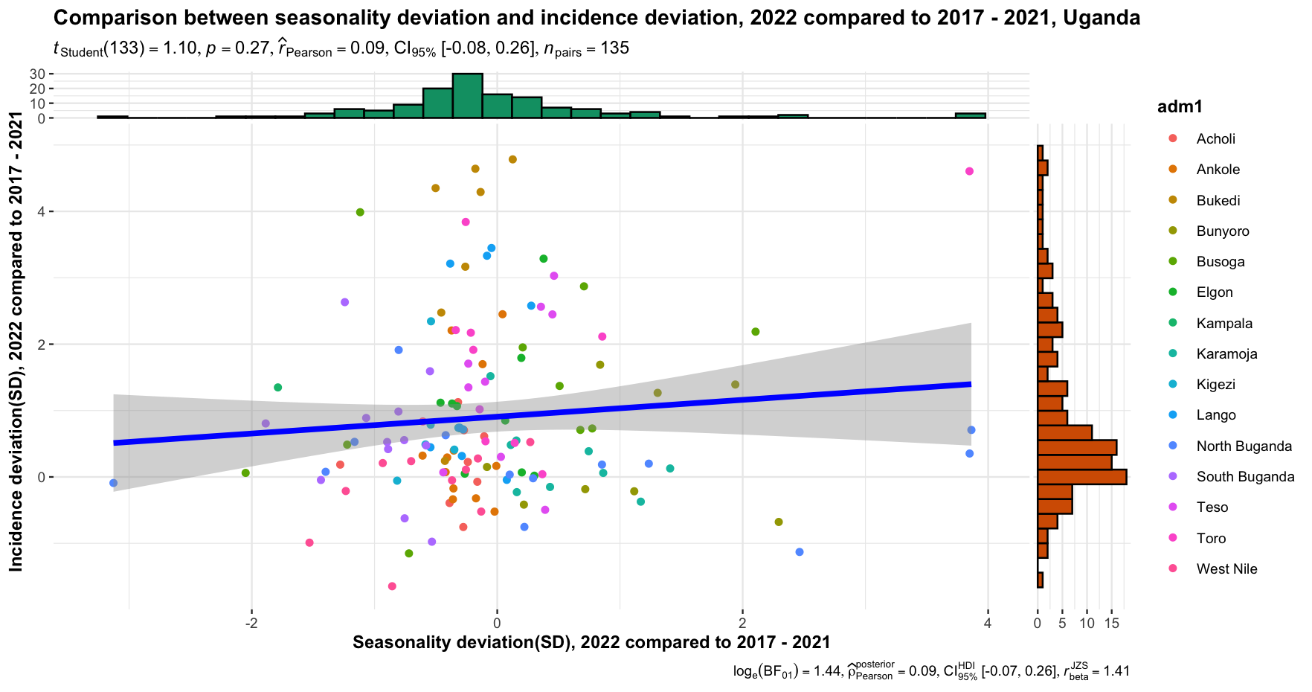
Fig. 16 shows that during 2017-2021, northern provinces had a strong correlation between increased malaria cases and higher rainfall (1-2 months prior). But, in 2022, this correlation was observed in both northern and southern provinces. The lags are described as: a) current month, b) one month (Lag 1), and c) two months prior to the reported month. Small r values indicate that rainfall had little correlation with malaria incidence, suggesting it was not the primary driver of the epidemics.
Fig. 16. Correlation between confirmed malaria cases and monthly rainfall (a=current, b=Lag 1, c=Lag 2) in Uganda.
