Supplementary figures and tables

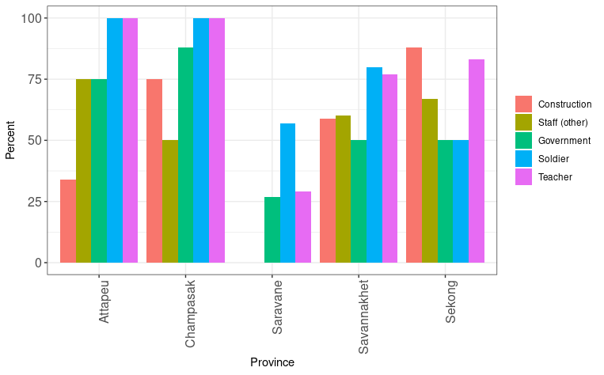
Supplementary figure 1. Proportion of people with the top five occupations using a mobile phone, among malaria patients by province

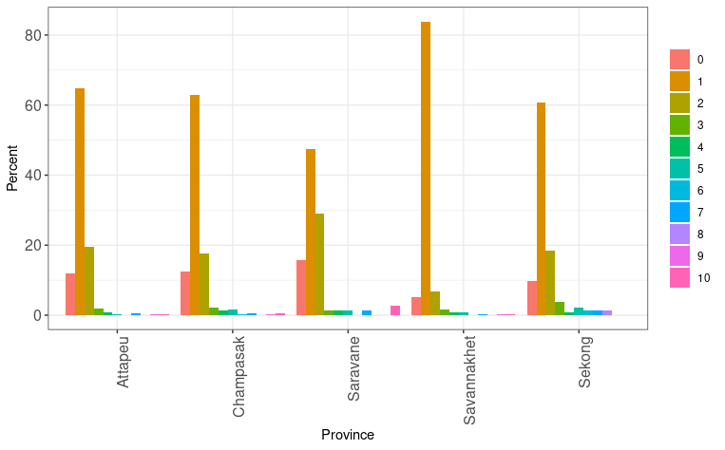
Supplementary figure 2. The percentage of mobile phone users or owners amongst malaria patients who share a mobile and the number of people they share a mobile phone with, by province.

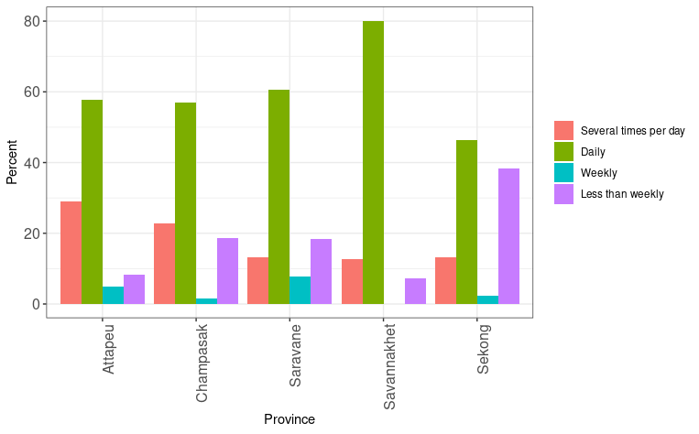

Supplementary figure 3. Frequency of mobile phone use in malaria patients, by province

Year | Number recruited
2017 | 1201
2018 | 1782
2019 | 1462
2020 | 1049
2021 | 826
Total | 6320

Supplementary table 1. Malaria patients recruited by year

 | Mobile phone ownership by malaria patients | Mobile phone ownership in 2017 census

Gender | Sample size | % | Sample size | % | P-value
Female | 1412 | 12 | 25305 | 73.1 | <0.001
Male | 3992 | 28 | 12017 | 84.3 | <0.001

 | Mobile phone use in malaria patients | Mobile phone use in 2017 census

Gender | Sample size | % | Sample size | %
Female | 1412 | 12 | 25305 | 79.6 | <0.001
Male | 3993 | 29 | 12017 | 87 | <0.001

Supplementary table 2. Comparison of gender in mobile phone ownership and use in malaria patients with the general population of Lao PDR from the 2017 Lao Social Indicator Survey II.

 | Mobile phone ownership in female malaria patients |  | Mobile phone ownership amongst females in 2017 census
Province | Sample size | % | Sample size | % | P-value
Attapeu | 318 | 12 | 541 | 67.5 | <0.001
Champasak | 100 | 50 | 2396 | 78.5 | <0.001
Saravane | 306 | 3 | 1510 | 52.5 | <0.001
Savannakhet | 443 | 8 | 3351 | 61.6 | <0.001
Sekong | 240 | 15 | 431 | 52.1 | <0.001
 | Mobile phone use by female malaria patients |  | Mobile phone use amongst females in 2017 census
Province | Sample size | % | Sample size | % | P-value
Attapeu | 318 | 13 | 541 | 76.6 | <0.001
Champasak | 100 | 51 | 2396 | 86.4 | <0.001
Saravane | 306 | 3 | 1510 | 54.6 | <0.001
Savannakhet | 443 | 9 | 3351 | 67.4 | <0.001
Sekong | 240 | 15 | 431 | 55.3 | <0.001

Supplementary table 3. Comparison of mobile phone ownership and use by province in female malaria patients with the female population of Lao PDR from the 2017 Lao Social Indicator Survey II.

 | Mobile phone ownership in female malaria patients |  | Mobile phone ownership amongst females in 2017 census
Age (years) | Sample size | % | Sample size | % | P-value
0-15 | 713 | 5 | - | - | -
15-19 | 176 | 16 | 4565 | 74.8 | <0.001
20-24 | 124 | 14 | 4024 | 77.2 | <0.001
25-29 | 103 | 21 | 4045 | 74.4 | <0.001
30-34 | 88 | 22 | 3824 | 73.8 | <0.001
35-39 | 68 | 24 | 3418 | 69.2 | <0.001
40-44 | 39 | 15 | 3076 | 68.7 | <0.001
45-49 | 58 | 22 | 2353 | 71.2 | <0.001
50+ | 80 | 18 | - | - | -

Supplementary table 4. Comparison of age of mobile phone ownership and use in female malaria patients with the female population of Lao PDR from the 2017 Lao Social Indicator Survey II.

 | Mobile phone ownership in male malaria patients |  | Mobile phone ownership amongst males in 2017 census
Province | Sample size | % | Sample size | % | P-value
Attapeu | 1314 | 30 | 243 | 80.1 | <0.001
Champasak | 561 | 59 | 1119 | 84.8 | <0.001
Saravane | 622 | 11 | 709 | 80.1 | <0.001
Savannakhet | 974 | 23 | 1619 | 72.4 | <0.001
Sekong | 476 | 20 | 209 | 70.4 | <0.001
 | Mobile phone use in male malaria patients |  | Mobile phone use amongst males in 2017 census
Province | Sample size | % | Sample size | % | P-value
Attapeu | 1314 | 30 | 243 | 86.3 | <0.001
Champasak | 561 | 59 | 1119 | 88.5 | <0.001
Saravane | 622 | 11 | 709 | 82.7 | <0.001
Savannakhet | 975 | 23 | 1619 | 72.1 | <0.001
Sekong | 476 | 21 | 209 | 70.2 | <0.001

Supplementary table 5. Comparison of locations of mobile phone ownership and use in male malaria patients with the male population of Lao PDR from the 2017 Lao Social Indicator Survey II.

 | Mobile phone ownership in male malaria patients |  | Mobile phone ownership amongst males in 2017 census
Age (years) | Sample size | % | Sample size | % | P-value
0-15 | 80 | 17 | - | - | -
15-19 | 691 | 31 | 2404 | 76.1 | <0.001
20-24 | 513 | 38 | 1774 | 84.5 | <0.001
25-29 | 482 | 39 | 1810 | 85.2 | <0.001
30-34 | 356 | 42 | 1772 | 87.9 | <0.001
35-39 | 300 | 38 | 1612 | 86.6 | <0.001
40-44 | 202 | 44 | 1412 | 87.4 | <0.001
45-49 | 107 | 35 | 1232 | 87.4 | <0.001
50+ | 188 | 25 | - | - | -
 | Mobile phone use in male malaria patients |  | Mobile phone use amongst males in 2017 census
Age (years) | Sample size | % | Sample size | % | P-value
0-15 | 1293 | 10 | - | - | -
15-19 | 692 | 31 | 2404 | 80.3 | <0.001
20-24 | 513 | 38 | 1774 | 86.9 | <0.001
25-29 | 482 | 40 | 1810 | 87.8 | <0.001
30-34 | 356 | 43 | 1772 | 89.1 | <0.001
35-39 | 300 | 38 | 1612 | 89.5 | <0.001
40-44 | 202 | 44 | 1412 | 90.1 | <0.001
45-49 | 107 | 33 | 1232 | 89.8 | <0.001
50+ | 188 | 25 | - | - | -

Supplementary table 6. Comparison of age of mobile phone ownership and use in male malaria patients with the male population of Lao PDR from the 2017 census

