Additional Files
- Follow-up status of households enrolled in Bo and Moyamba.

Additional Files
- Follow-up status of households enrolled in Bo and Moyamba.

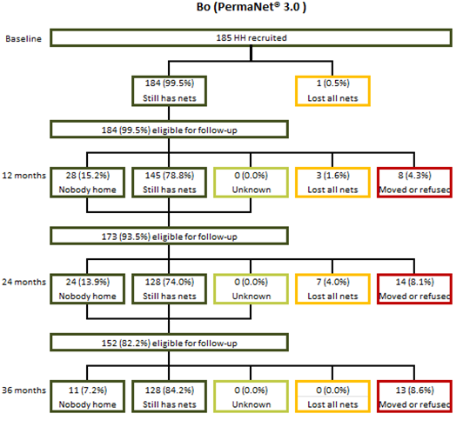
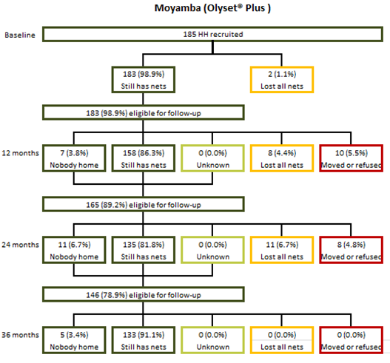
- Follow-up status of cohort ITNs enrolled in Bo and Moyamba.
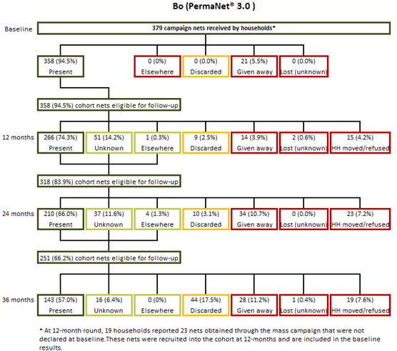
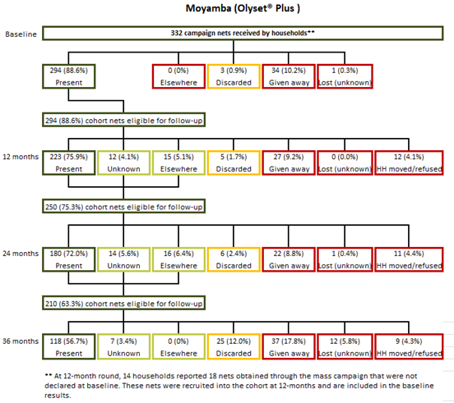
- Attrition Status at 36 months
 | District
Attrition status at 36-months | Bo |  | Moyamba |  | Total
 | % | CI | % | CI | % | CI
Net present | 46.7 | [38.3-55.3] | 40.5 | [33.3-48.1] | 43.7 | [38.1-49.5]
Given away – others | 7.5 | [4.7-12.0] | 3.6 | [1.8-7.0] | 5.6 | [3.8-8.2]
Destroyed by accident | 7.4 | [4.6-11.8] | 2.0 | [0.6-6.6] | 4.8 | [3.1-7.3]
Household moved away or refused | 0.0 |  | 0.0 |  | 0.0
Net lost (unknown reason) | 0.9 | [0.3-2.9] | 4.3 | [2.1-8.7] | 2.6 | [1.3-4.8]
Thrown away | 13.3 | [8.1-21.1] | 8.4 | [5.6-12.6] | 10.9 | [7.8-15.2]
Repurposed | 0.7 | [0.2-2.7] | 2.1 | [1.0-4.7] | 1.4 | [0.7-2.8]
Given away – relatives | 19.9 | [16.9-23.4] | 27.1 | [21.4-33.7] | 23.4 | [20.2-27.0]
Unknown | 0.0 |  | 0.0 |  | 0.0
Stolen | 3.5 | [1.3-9.1] | 12.0 | [9.2-15.4] | 7.6 | [5.5-10.4]
Total | 100.0 |  | 100.0 |  | 100.0
N | 306 |  | 291 |  | 597
Table 2. Baseline characteristics of households enrolled in the Sierra Leone 2020-2023 durability monitoring evaluation
Variable | Bo (PermaNet® 3.0)  % (95%CI) |  | Moyamba (Olyset® Plus)  % (95% CI) |  | p-value
Demographic
Mean number of household members | 4.28 | (3.99-4.58) | 4.15 | (3.76-4.54) | 0.585
Mean age of head of household (years) | 51.29 | (49.24-53.33) | 54.17 | (50.52-57.82) | 0.169
Percentage of female headed households | 18.7 | (12.9-26.2) | 36.4 | (29.7-43.8) | 0.001**
Education of head of household (male)
Non-literate | 74.3 | (63.7-82.7) | 72.0 | (58.9-82.2) | 0.593
Primary | 5.5 | (2.6-11.3) | 8.7 | (5.3-14.1) | 0.593
Secondary | 20.2 | (14.0-28.2) | 19.2 | (11.6-30.2) | 0.593
Education of head of household (female)
Non-literate | 85.7 | (55.8-96.6) | 86.6 | (80.0-91.3) | 0.973
Primary | 3.6 | (0.6-19.7) | 3.0 | (0.7-12.2) | 0.973
Secondary | 10.7 | (2.9-32.4) | 10.4 | (5.9-17.5) | 0.973
Housing characteristics
Improved roof materials | 83.8 | (72.5-91.0) | 76.4 | (65.2-84.9) | 0.279
Improved wall materials | 32.9 | (22.2-45.7) | 30.9 | (19.5-45.2) | 0.819
Improved floor materials | 22.9 | (15.5-32.4) | 27.1 | (16.6-41.0) | 0.561
Cook with charcoal (vs firewood) | 0.0 | (--) | 1.1 | (0.3-4.5) | 0.161
Access to safe water source | 39.1 | (18.6-64.4) | 18.0 | (6.7-40.1) | 0.152
Access to any latrine | 68.0 | (47.5-83.3) | 46.9 | (33.5-60.8) | 0.087
Household assets
Any transport | 15.3 | (9.2-24.4) | 10.7 | (6.6-16.7) | 0.278
Type of transport
Bicycle | 3.1 | (1.1-8.4) | 2.4 | (1.0-6.1) | 0.721
Moto | 11.3 | (6.8-18.3) | 8.9 | (5.4-14.2) | 0.479
Car | 1.1 | (0.3-4.5) | 0.0 | (0.6) | 0.161
Owns livestock | 63.6 | (53.8-72.3) | 55.8 | (43.0-67.8) | 0.316
Type of livestock
Chicken | 61.3 | (53.0-69.0) | 55.3 | (42.4-67.6) | 0.421
Goat | 21.3 | (14.2-30.8) | 13.6 | (7.5-23.2) | 0.181
Pig | 1.8 | (0.4-8.3) | 0.0 | (0.9) | 0.205
Items owned by household
Radio | 49.1 | (39.6-58.7) | 33.1 | (23.0-45.0) | 0.039*
TV | 2.0 | (0.4-8.5) | 1.3 | (0.2-9.7) | 0.743
Simple mobile | 51.8 | (40.4-63.0) | 61.1 | (52.4-69.2) | 0.191
Smartphone | 4.7 | (1.0-19.7) | 6.0 | (2.3-14.5) | 0.775
p-value for overall comparison of difference between sites; test for trend for education comparisons.
Table 3. Household-level risk factors across survey rounds
 | Bo (PermaNet® 3.0)  % (95%CI) |  | Moyamba (Olyset® Plus)  % (95% CI) |  | P-value
 | N=185 |  | N=185
Observed rodents in past six months
Never | 1.3 | (0.2-9.7) | 1.6 | (0.5-4.7) | <0.001***
At times | 9.8 | (5.6-16.5) | 37.3 | (28.4-47.2) | <0.001***
Always | 88.9 | (81.4-93.6) | 61.1 | (50.5-70.7) | <0.001***
Storing food in sleeping rooms
Never | 24.7 | (17.1-34.2) | 3.1 | (1.1-8.4) | <0.001***
At times | 72.9 | (64.0-80.3) | 49.3 | (37.3-61.4) | <0.001***
Always | 2.4 | (1.1-5.3) | 47.6 | (34.4-61.1) | <0.001***
Cooking in sleeping rooms
Never | 99.1 | (93.4-99.9) | 99.1 | (93.4-99.9) | 1.000
At times | 0.9 | (0.1-6.6) | 0.9 | (0.1-6.6) | 1.000
Always | 0.0 | (--) | 0.0 | (--) | 1.000
Exposure to net use or care messages
Never | 6.2 | (2.9-13.0) | 57.6 | (48.8-65.9) | <0.001***
Once | 31.1 | (23.9-39.3) | 37.3 | (29.2-46.2) | <0.001***
Twice or more | 62.7 | (52.8-71.6) | 5.1 | (2.1-11.8) | <0.001***
Very positive net use attitude (score > 1.0)
Never | 0.0 | () | 14.4 | (9.7-21.0) | <0.001***
Once | 13.8 | (8.1-22.4) | 50.4 | (42.5-58.4) | <0.001***
Twice or more | 86.2 | (77.6-91.9) | 35.1 | (26.9-44.4) | <0.001***
Very positive net care attitude (score > 1.0)
Never | 8.0 | (5.2-12.2) | 23.3 | (17.2-30.9) | <0.001***
Once | 36.4 | (30.3-43.1) | 40.7 | (32.9-48.9) | <0.001***
Twice or more | 55.6 | (49.0-61.9) | 36.0 | (28.4-44.3) | <0.001***
p-value from test for trend for comparison between sites and across categories.

Table 4. Net-level risk factors across all survey rounds
 | Bo (PermaNet® 3.0)  % (95%CI) |  | Moyamba (Olyset® Plus)  % (95% CI) |  | P-value
All labelled cohort ITNs | N=358 |  | N=294
Ever observed / reported hanging | 75.9 | (69.1-81.5) | 77.7 | (72.1-82.5) | 0.637
Ever reported used | 83.8 | (78.0-88.2) | 86.8 | (82.8-90.0) | 0.309
Ever reported washed | 76.2 | (69.8-81.6) | 80.0 | (73.4-85.3) | 0.366
Cohort ITN ever hung | N=272 |  | N=228
Tied up or folded when hanging
Never | 5.6 | (3.4-9.1) | 18.6 | (12.8-26.1) | <0.001**
At times | 12.8 | (8.1-19.7) | 36.6 | (28.6-45.4) | <0.001**
Always | 81.6 | (73.5-87.7) | 44.9 | (39.2-50.7) | <0.001**
Type of sleeping place | N=302 |  | N=257
Reed mat / Ground | 4.7 | (2.2-9.9) | 7.4 | (4.2-12.7) | 0.547
Bed frame (unfinished) | 62.0 | (46.9-75.1) | 53.6 | (40.6-66.1) | 0.547
Bed frame (finished) | 31.6 | (20.4-45.6) | 36.9 | (26.1-49.2) | 0.547
Foam mattress | 1.6 | (0.6-4.2) | 2.1 | (0.9-4.7) | 0.547
Cohort ITN ever used | N=300 |  | N=255
Net was used by
Children only | 4.8 | (2.7-8.5) | 1.4 | (0.5-4.1) | 0.015*
Children with adults | 64.3 | (58.6-69.6) | 58.3 | (50.9-65.2) | 0.015*
Adults only | 30.8 | (27.2-34.7) | 40.3 | (33.2-47.8) | 0.015*
Cohort ITN ever washed | N=273 |  | N=235
Washes last six months (Median [IQR]) | 2.0 | [1.0-2.0] | 1.0 | [1.0-2.0]
Use of detergent
Never | 62.9 | (48.1-75.7) | 46.8 | (37.0-56.8) | 0.074
At times | 28.5 | (17.5-42.9) | 36.4 | (29.5-43.9) | 0.074
Always | 8.6 | (4.7-15.0) | 16.8 | (12.6-22.1) | 0.074
Drying net outside
Never | 2.4 | (1.0-5.6) | 3.3 | (1.0-11.0) | 0.880
At times | 12.0 | (5.4-24.7) | 13.0 | (8.2-20.0) | 0.880
Always | 85.6 | (71.7-93.3) | 83.7 | (75.0-89.8) | 0.880
Drying over bush or fence
Never | 99.4 | (95.3-99.9) | 97.9 | (93.1-99.4) | 0.223
At times | 0.3 | (0.0-2.4) | 1.8 | (0.6-5.4) | 0.223
Always | 0.3 | (0.0-2.4) | 0.4 | (0.0-2.7) | 0.223
p-value for overall comparison between sites
IQR: interquartile range
Table 7. Modelled determinants of physical durability from Cox proportional hazard models
 | aHR | 95% CI | p-value
Household-level model: 630 ITNs in 364 households
Site [Ref: Moyamba]
Bo | 0.33 | (0.23-0.48) | <0.001***
Household with CU5 [Ref: At least one CU5]
No CU5 | 0.64 | (0.47-0.86) | 0.003**
Socio economic status [Ref: lowest]
Middle | 1.06 | (0.77-1.44) | 0.732
Highest | 0.63 | (0.44-0.92) | 0.016*
Net attitude score and net SBC exposure [Ref: Positive net attitude and never or once exposed to SBC messages]
Moderate positive net attitude and net SBC exposure (any combination of positive net attitude and/or exposure to SBC messages two or three times) | 0.63 | (0.45-0.89) | 0.008**
Higher positive net attitude and net SBC exposure (Always having positive net attitudes and exposure to SBC messages) | 0.56 | (0.33-0.94) | 0.028*
Ever seen rodent [Ref: Always seen rodent]
Never or at time seen rodent | 0.83 | (0.59-1.16) | 0.271
Net-level model: 500 ITNs ever hung in 319 households
Socio economic status [Ref: lowest]
Middle | 1.13 | (0.79-1.61) | 0.503
Highest | 0.66 | (0.42-1.03) | 0.067
Household with CU5 [Ref: At least one CU5]
No CU5 | 0.81 | (0.58-1.12) | 0.201
Ever seen rodent [Ref: Always seen rodent]
Never or at time seen rodent | 0.95 | (0.65-1.39) | 0.790
Household head went to school [Ref: No]
Yes went to school | 0.70 | (0.43-1.13) | 0.147
Net attitude score and net SBC exposure [Ref: Positive net attitude and never or once exposed to SBC messages]
Moderate positive net attitude and net SBC exposure (any combination of positive net attitude and/or exposure to SBC messages two or three times) | 0.59 | (0.41-0.86) | 0.006**
Higher positive net attitude and net SBC exposure (Always having positive net attitudes and exposure to SBC messages) | 0.47 | (0.29-0.76) | 0.002**
Household stored food in the sleeping room [Ref: Always]
Never or once | 0.56 | (0.37-0.85) | 0.006**
User of nets [Ref: Children or children and adults]
Adult only | 0.72 | (0.52-1) | 0.049*
Nets folded [Ref: Never or once]
Always | 0.67 | (0.49-0.92) | 0.015*
Net dried outside [Ref: Never]
Once or always | 0.44 | (0.24-0.8) | 0.008**
Table 8. Insecticide effectiveness and chemical content results of campaign ITNs of campaign ITNs: PermaNet® 3.0
 | Baseline |  | 12-months |  | 24-months |  | 36-months
 | % (95% CI) |  | % (95 % CI) |  | % (95 % CI) |  | % (95 % CI)
Bo (PermaNet® 3.0) | N=30 |  | N=30 |  | N=30 |  | N=30
Mean months since campaign | 6.3 |  | 11.9 |  | 23 |  | 34.1
Cone bioassays (Susceptible strain)
Sides (pyrethroid-only)
Knock down 60 minutes
Mean | 3.3 | (1.4-5.2) | 19.3 | (15.6-23.1) | 22.6 | (16.6-28.7) | 50.5 | (43.5-57.4)
Median [IQR] | 1.4 | (0.0-6.5) | 17.2 | (13.3-25.8) | 19.1 | (12.5-30.3) | 50.0 | (33.3-75.0)
Mortality 24 hours
Mean | 83.5 | (74.5-92.5) | 96.6 | (94.6-98.6) | 47.6 | (40.0-55.2) | 58.7 | (53.0-64.4)
Median [IQR] | 90.3 | (81.3-96.8) | 97.1 | (93.5-100.0) | 43.6 | (32.3-58.8) | 55.0 | (42.9-80.0)
Roof (pyrethroid + PBO)
Knock down 60 minutes
Mean | 40.3 | (30.2-50.5) | 49.8 | (44.1-55.5) | 45.4 | (39.7-51.2) | 81.9 | (74.4-89.5)
Median [IQR] | 40.9 | (20.0-56.7) | 49.3 | (40.0-60.0) | 40.0 | (33.3-56.8) | 88.2 | (73.9-100.0)
Mortality 24 hours
Mean | 98.6 | (96.6-100.6) | 99.2 | (98.4-99.9) | 79.8 | (75.6-84.0) | 88.9 | (83.2-94.7)
Median [IQR] | 100.0 | (100.0-100.0) | 100.0 | (100.0-100.0) | 80.2 | (73.3-90.0) | 100.0 | (78.3-100.0)
Cone bioassays (Resistant strain)
Sides (pyrethroid-only)
Knock down 60 minutes
Mean | 1.5 | (0.4-2.7) | 0.3 | (-0.0-0.7) | 0.2 | (-0.1-0.5) | 0.3 | (-0.1-0.8)
Median [IQR] | 0.0 | (0.0-3.3) | 0.0 | (0.0-0.0) | 0.0 | (0.0-0.0) | 0.0 | (0.0-0.0)
Mortality 24 hours
Mean | 17.4 | (11.7-23.2) | 19.6 | (14.8-24.4) | 2.6 | (0.7-4.6) | 3.2 | (1.7-4.6)
Median [IQR] | 16.7 | (6.7-20.0) | 21.2 | (6.7-29.0) | 0.0 | (0.0-6.1) | 2.5 | (0.0-5.0)
Roof (pyrethroid + PBO)
Knock down 60 minutes
Mean | 20.1 | (12.7-27.4) | 14.0 | (9.4-18.6) | 3.1 | (1.9-4.4) | 4.2 | (1.3-7.0)
Median [IQR] | 13.3 | (6.7-30.0) | 11.8 | (3.3-17.1) | 0.0 | (0.0-6.3) | 0.0 | (0.0-5.0)
Mortality 24 hours
Mean | 48.1 | (37.8-58.5) | 39.0 | (32.2-45.7) | 9.1 | (6.4-11.8) | 12.8 | (8.1-17.4)
Median [IQR] | 46.7 | (36.7-67.7) | 36.7 | (26.7-47.2) | 7.9 | (0.0-13.3) | 10.0 | (5.0-20.0)
Chemical Content | g/kg | (95% CI) | g/kg | (95% CI) | g/kg | (95% CI) | g/kg | (95% CI)
Pyrethroid - side panelsª
Mean | 1.5 | (1.2-1.8) | 1.0 | (0.7-1.3) | 0.8 | (0.5-1.0) | 0.6* | (0.4-0.8)
Median [IQR] | 1.5 | (0.7-2.1) | 0.8 | (0.4-1.6) | 0.4 | (0.1-1.6) | 0.4 | (0.2-0.8)
Pyrethroid - roof^{b}
Mean | 3.5 | (3.3-3.6) | 3.6 | (3.4-3.7) | 4.0 | (3.7-4.2) | 3.2 | (3.0-3.4)
Median [IQR] | 3.5 | (3.3-3.6) | 3.6 | (3.4-3.9) | 4.1 | (3.6-4.5) | 3.2 | (2.8-3.5)
PBO – roof^{c}
Mean | 15.9 | (14.6-17.2) | 11.0 | (9.8-12.2) | 8.4 | (7.4-9.4) | 13.4* | (12.5-14.3)
Median [IQR] | 15.8 | (13.8-17.4) | 10.4 | (8.4-13.3) | 7.7 | (6.2-10.4) | 13.9 | (12.6-14.6)
*Below the manufacturers threshold.
ªDeltamethrin content (manufactured with 2.1 g/kg on side panel; acceptable range 1.6-2.6 g/kg).
^{b}Deltamethrin content (manufactured with 4.0 g/kg on roof panel; acceptable range 3.0-5.0 g/kg).
^{c}PBO content (manufactured with 25 g/kg on roof panel; acceptable range 18.8-31.3 g/kg).
Table 9. Insecticide effectiveness and chemical content results of campaign ITNs of campaign ITNs: Olyset® Plus
 | Baseline |  | 12-months |  | 24-months |  | 36-months
 | % (95% CI) |  | % (95 % CI) |  | % (95 % CI) |  | % (95 % CI)
Moyamba (Olyset® Plus) | N=60 |  | N=60 |  | N=60 |  | N=60
Mean months since campaign | 6.3 |  | 11.9 |  | 22.9 |  | 34.1
Cone bioassays (Susceptible strain)
Knock down 60 minutes
Mean | 48.4 | (43.8-53.0) | 56.7 | (50.5-63.0) | 22.0 | (17.6-26.4) | 30.4 | (24.2-36.6)
Median [IQR] | 48.4 | (37.5-60.3) | 59.2 | (40.8-69.8) | 23.8 | (10.9-30.0) | 35.0 | (17.5-40.0)
Mortality 24 hours
Mean | 89.4 | (86.3-92.5) | 91.7 | (86.8-96.6) | 47.1 | (36.7-57.5) | 41.3 | (35.7-46.8)
Median [IQR] | 90.5 | (82.6-100.0) | 96.8 | (90.0-100.0) | 48.4 | (24.6-64.8) | 45.0 | (30.0-55.0)
Cone bioassays (Resistant strain)
Knock down 60 minutes
Mean | 5.2 | (2.5-8.0) | 5.0 | (2.1-7.9) | 1.6 | (-0.1-3.3) | 0.2 | (-0.1-0.4)
Median [IQR] | 0.0 | (0.0-9.7) | 0.0 | (0.0-8.0) | 0.0 | (0.0-0.0) | 0.0 | (0.0-0.0)
Mortality 24 hours
Mean | 15.9 | (12.2-19.6) | 26.5 | (19.5-33.5) | 4.1 | (1.7-6.6) | 2.9 | (1.8-4.1)
Median [IQR] | 16.1 | (6.9-22.2) | 25.8 | (11.9-40.0) | 0.0 | (0.0-6.6) | 0.0 | (0.0-5.0)
Chemical Content | g/kg | (95% CI) | g/kg | (95% CI) | g/kg | (95% CI) | g/kg | (95% CI)
Pyrethroidª
Mean | 22.3 | (20.3-24.4) | 16.4 | (15.5-17.2) | 15.7 | (14.2-17.3) | 14.1* | (12.9-15.3)
Median [IQR] | 21.7 | (20.3-22.8) | 16.6 | (15.0-18.1) | 16.3 | (14.5-18.1) | 14.7 | (13.5-15.5)
PBO^{b}
Mean | 9.5 | (8.8-10.1) | 8.8 | (7.8-9.8) | 4.3* | (3.6-5.0) | 2.3* | (1.8-2.7)
Median [IQR] | 9.4 | (8.4-10.2) | 8.4 | (7.1-10.3) | 4.4 | (2.6-5.6) | 2.2 | (1.3-2.9)
*Below the manufacturers threshold.
ªPermethrin content (manufactured with 20 g/kg; acceptable range 15-25 g/kg).
^{b}PBO content (manufactured with 10 g/kg on roof panel; acceptable range 7.5-12.5 g/kg).

