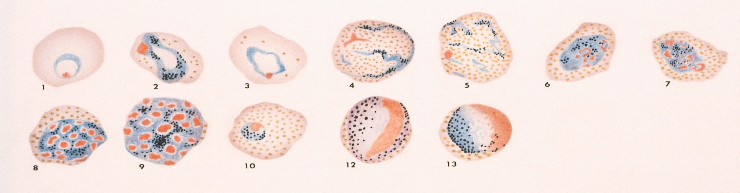

Vivax Working Group
APMEN Vivax Working Group Annual Meeting Agenda 2022 (OAT Session)
Double Tree by Hilton, Bangkok, 13th – 14th December
Day 2, Tuesday, 13th December 2022
OAT Piloting Meeting
Chairs: Dr Lyndes Wini and Dr Ngo Duc Thang. Facilitator: Josselyn Neukom
Start | Duration | Proceeding | Speaker/s
14:00 | 05 min | Session information | Dr Manash Shrestha
14:05 | 10 min | Overview of the Options Assessment Toolkit and its development | Dr. Ngo Duc Thang/ Dr. Karma
14:15 | 10 min | Tools of OAT | Dr Karma Lhazeen
14:25 | 15 min | Status of new evidence on test and treat options – summary of Day 1 – plus registration & recommendation status | Dr. Caroline Lynch
14.40 | 15 min | Question shout-outs: What have you heard about these new tools, what concerned do you have about them? What are your thoughts about implementing them in your country?  Introduction to online OR ranking tool (with printouts of OR too) | Collate and see if we can address throughout the sessions
14:55 | 15 min | OAT Baseline Assessment Template - Introduction | Dr Sanjaya Acharya
15:10 | 20 min | BREAK
15:35 | 45 min | Groupwork 3 - NMPs fill the Baseline Assessment Template | Facilitators
16:20 | 05 min | Energiser
16:25 | 15 min | Group Presentations
16:40 | 15 min | Country scenarios - Introduction | Dr Manash Shrestha
16:55 | 10 min | Country scenarios reading & questions
17:05 | 05 min | Close of day 2

Day 3, Wednesday, 14th December 2022
OAT Piloting Meeting
Chairs: Dr Lyndes Wini and Dr Ngo Duc Thang. Facilitator: Josselyn Neukom
Start | Duration | Proceeding | Speaker/s
9:00 | 10 min | Opening - recap of OAT tools and scenarios | Joss Neukom
9:10 | 25 min | Groupwork 4 - National Malaria Programs identify OAT country scenario | Facilitators
9:35 | 15 min | Facilitated Reveal of scenarios based on baseline assessment
9:50 | 10 min | Open session / facilitated feedback on scenarios
10:00 | 15 min | Scenario-based test and treat options suggested by experts | Dr Sanjaya Acharya
10:15 | 10 min | Informal Q&A on test and treat options
10:25 | 15 min | BREAK
10:40 | 50 min | Groupwork 5 - Implications for NMP decision making | Group work based on scenarios
11:30 | 15 min | Group presentations
11:45 | 15 min | Overview of planning for next steps and program approaches (with examples) | Dr Caroline Lynch
12:00 | 10 min | Plans and next steps to use the OAT
12:10 | 70 min | LUNCH
13:20 | 60 min | Groupwork 6 - Country programs set out approaches for test & treat options and make plans/next steps to use the OAT | Facilitators
14:20 | 35 min | Country presentations on test & treat choice, approaches, and next steps
14:55 | 15 min | BREAK
15:10 | 45 min | World Café on factors and accountability | Facilitators
15:55 | 25 min | Endorsement of validation & agreement on publications
16:20 | 15 min | Feedback on World Café – how will we keep each other accountable?
16:35 | 10 min | Country closing – reflections from two regional programs
16:45 | 10 min | Close out – Dr. Xavier Xuanhao Chan & Dr Karma Lhazeen

