Eschweilenol C and subfractions from Terminalia plants disrupt hemoglobin metabolism, inhibiting Plasmodium falciparum growth at rings and trophozoite stages
Mariscal Brice Tchatat Tali^{1,2*}, Cedric Derick Jiatsa Mbouna¹, Aafreen Zehra³, Steven Collins Njonte Wouamba ^{4,5}, Guy Paulin Kemayou Mouthe⁴, Aubin Youbi Kamche^{1,2}, Darline Dize^{1,5}, Simeon Fogue Kouam ⁴, Boniface Pone Kamdem^{1,6}, Jean Claude Tchouankeu⁴, Feroz Khan³, Fabrice Fekam Boyom^{1,2*}
Supplementary Materiel: NMR Spectra of the characterized compound 1.
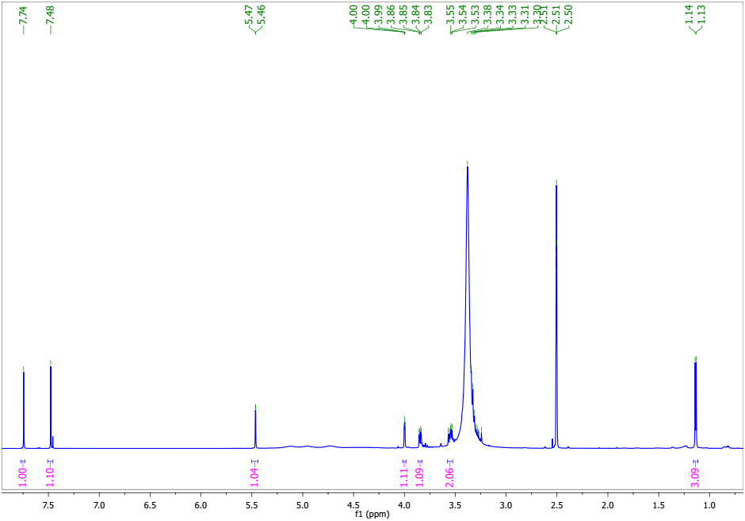
Fig. 1S: ¹H NMR spectrum (500 MHz, CD₃OD) of compound 1
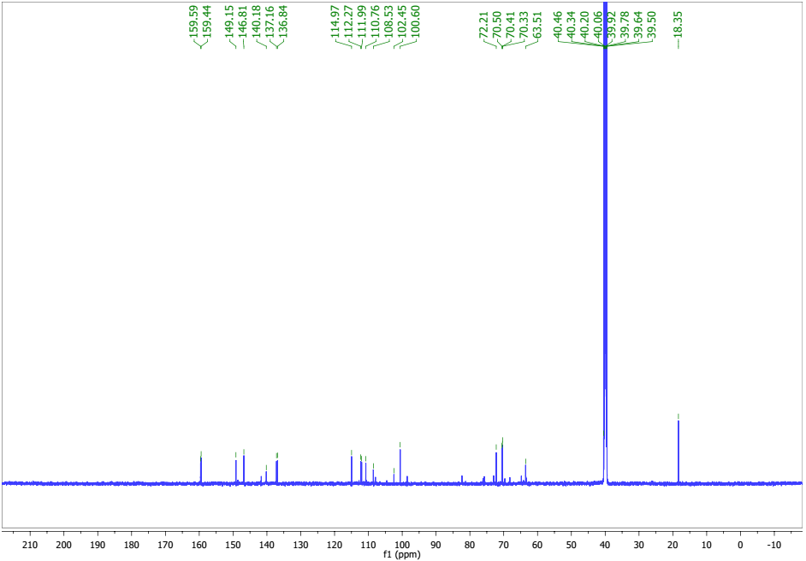
Fig. 2S: ¹³CNMR spectrum (125 MHz, CD₃OD) of compound 1
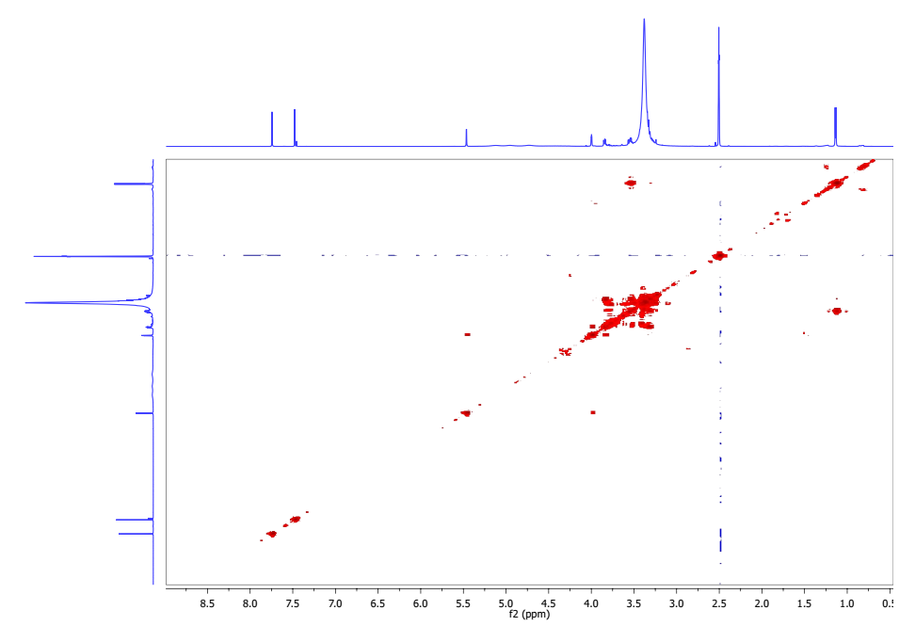
Fig. 3S: COSY spectrum (CD₃OD) of compound 1

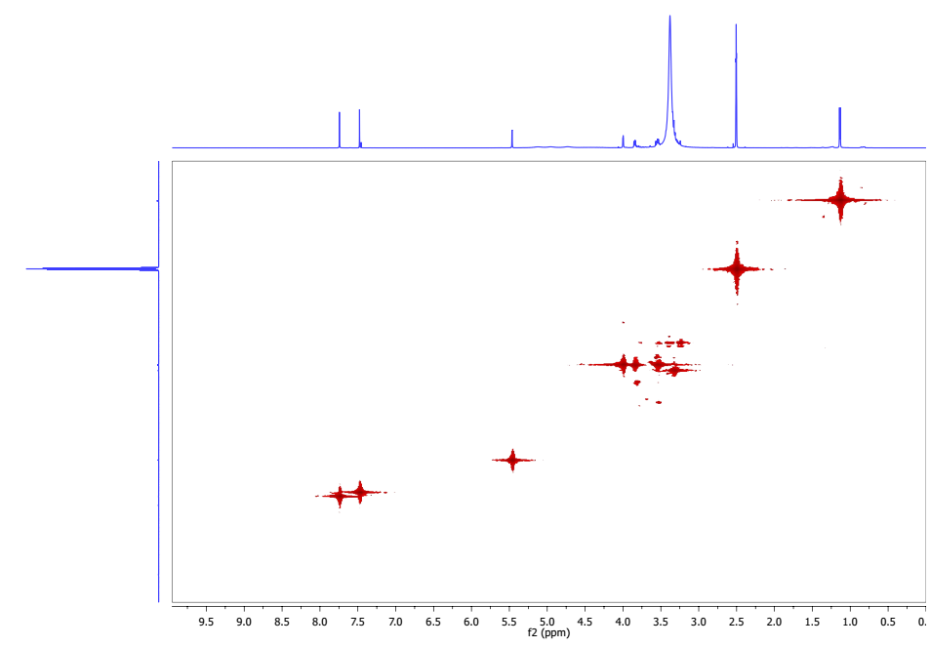
Fig. 4S: HSQC spectrum (CD₃OD) of compound 1

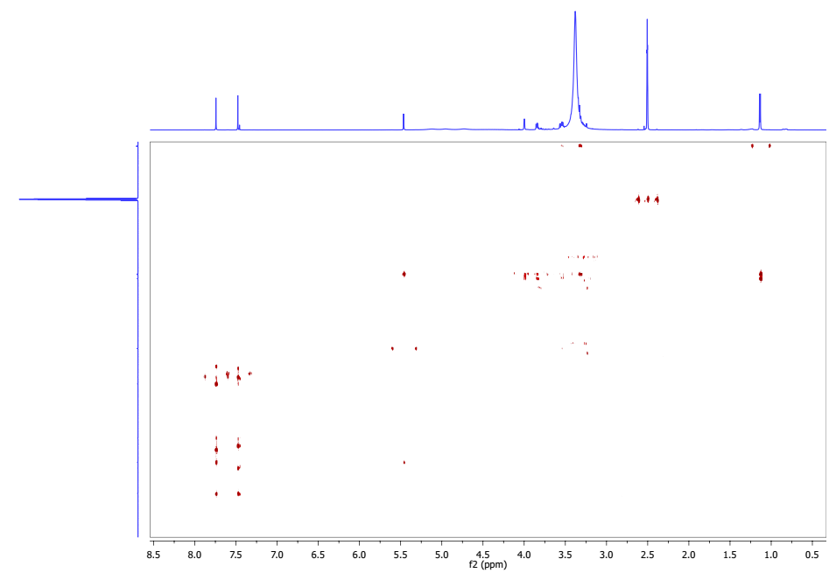
Fig. 5S: HMBC spectrum (CD₃OD) of compound 1

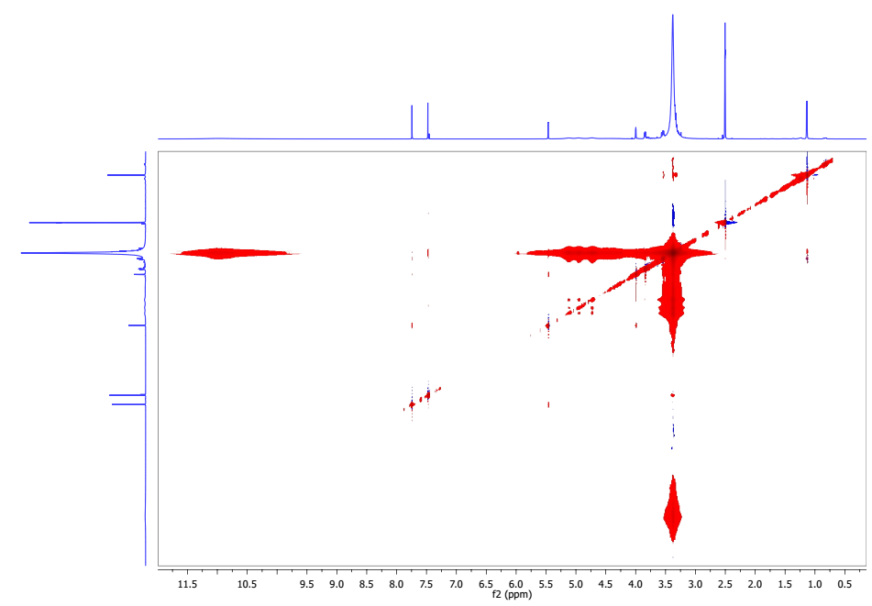
Fig. 6S: NOESY spectrum (CD₃OD) of compound 1

