Supplementary table 1. Description of RDT products recognized by the HealthPulse application.
RDT product (manufacturer) | Referred to as: | RDT cassette format
RDT cassettes with a single test line to detect Plasmodium falciparum-specific histidine-rich protein 2 (HRP2)
AdvDx Malaria Pf Rapid Malaria Ag Detection Test  (Advy Chemical, Mumbai, India) [35] | AdvDx Malaria Pf | 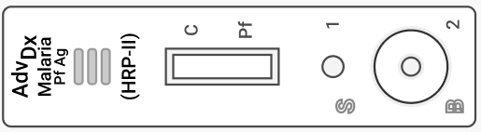
Bioline MALARIA Ag P.f  (Abbott, IL USA) [36]  Note: The same cassette previously was manufactured as SD Bioline. | Bioline Malaria Pf | 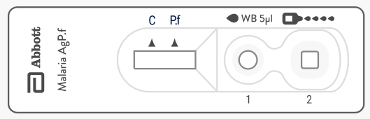  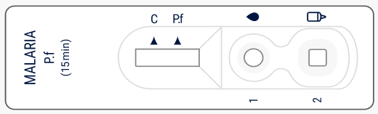
CareStart Malaria Pf (HRP2) Ag RDT  (Access Bio Inc, NJ USA)  Note: This product has been de-listed by WHO prequalification. | CareStart Malaria Pf | 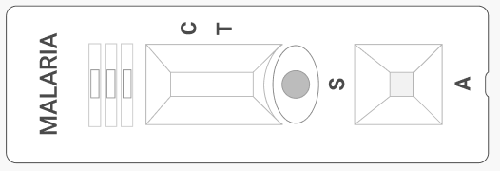
First Response Malaria Antigen P. falciparum (HRP2) Card Test (Premier Medical Corporation Ltd, Gujarat, India) [37] | First Response Malaria Pf | 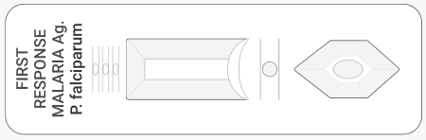
ParaHIT f Ver. 1.0 Rapid Test for P. falciparum Malaria Device  (Arkray Healthcare Prvt Ltd, Mumbai, India) [38] | ParaHIT Malaria Pf | 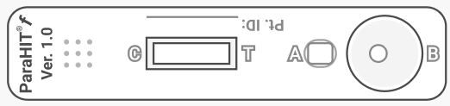
STANDARD Q Malaria P.f Ag Test (SD Biosensor, Gyeonggi-do, Republic of Korea) [39] | Standard Q Malaria Pf | 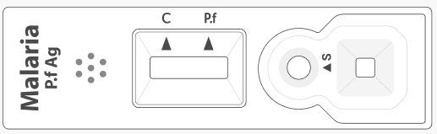
RDT cassettes with two test lines to detect P. falciparum HRP2 and P. falciparum-specific lactate dehydrogenase (pLDH)
Bioline Malaria Ag P.f (HRP2/pLDH)  (Abbott, IL USA) [40] | Bioline Malaria Pf (HRP2/pLDH) | 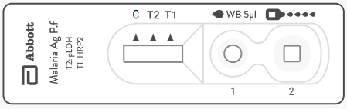
RDT cassettes with two test lines to detect P. falciparum HRP2 and pan-pLDH
Bioline Malaria Ag P.f/Pan  (Abbott, IL USA) [41] | Bioline Malaria Pf/Pan | 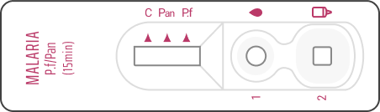
First Response Malaria Ag. pLDH/HRP2 Combo Card Test (Premier Medical Corporation Ltd, Gujarat, India)[42] | First Response Malaria Pf Ag (pLDH/HRP2) | 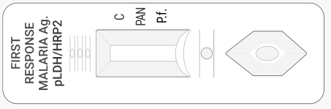

Supplementary Table 2. Fleiss’ kappa score calculated to measure interrater agreement on RDT results among three external panelists by country, 2023
Country | N | Kappa | P value
Benin | 2200 | 1.0 | < 0.0001
Côte d’Ivoire | 2200 | 1.0 | < 0.0001
Nigeria | 2200 | 0.998 | < 0.0001
Uganda | 3746 | 0.999 | < 0.0001

