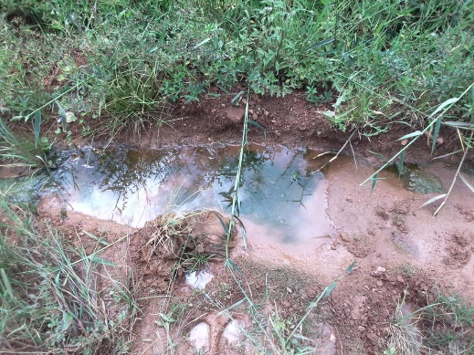
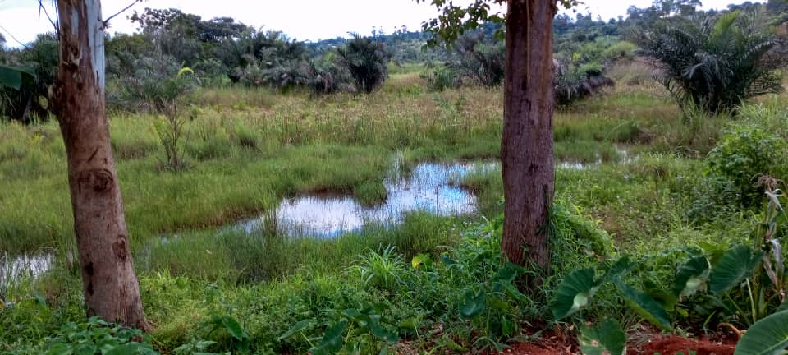
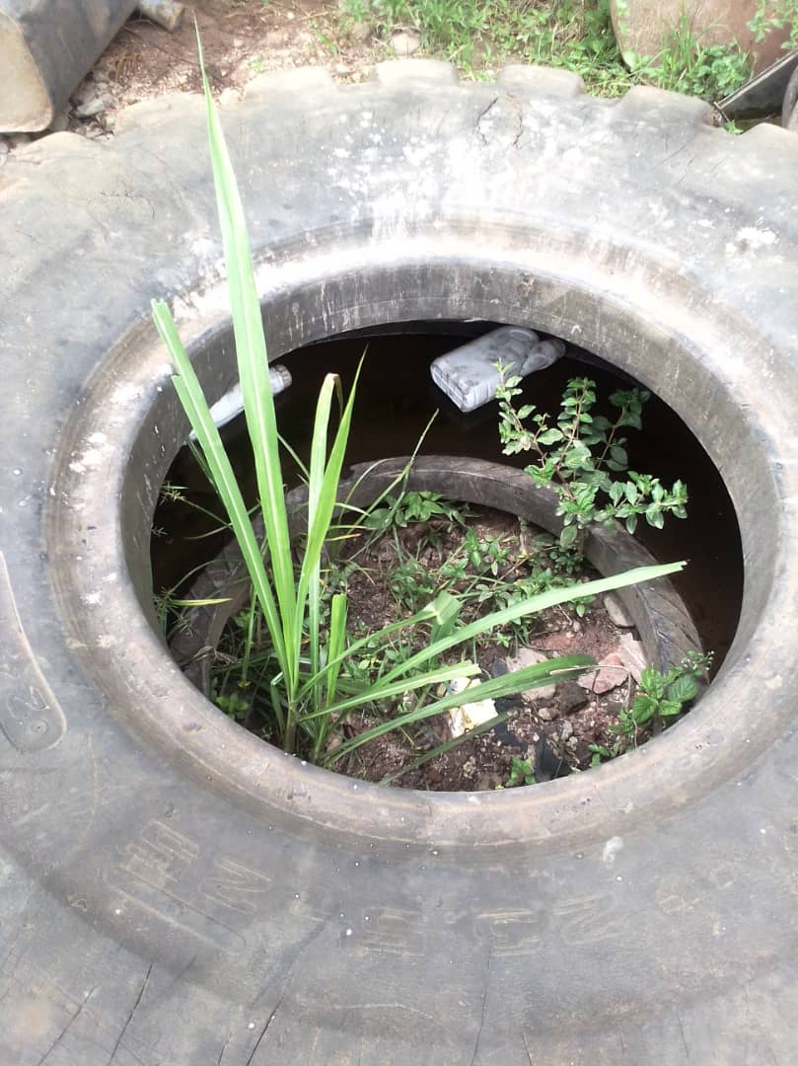
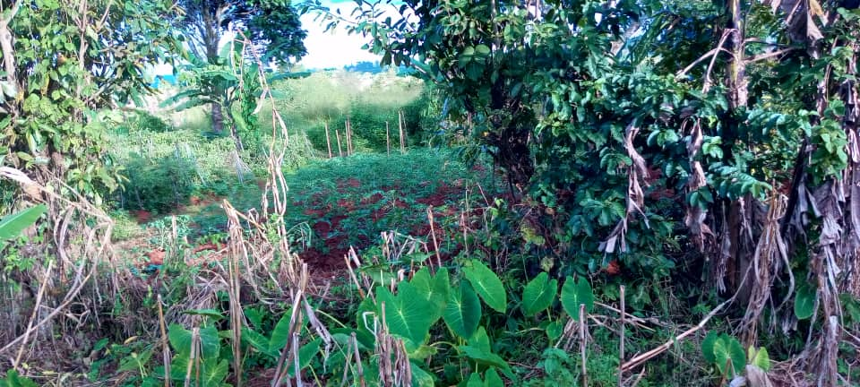
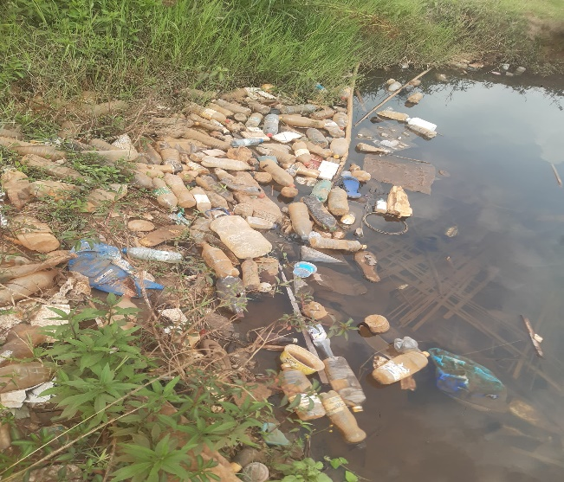
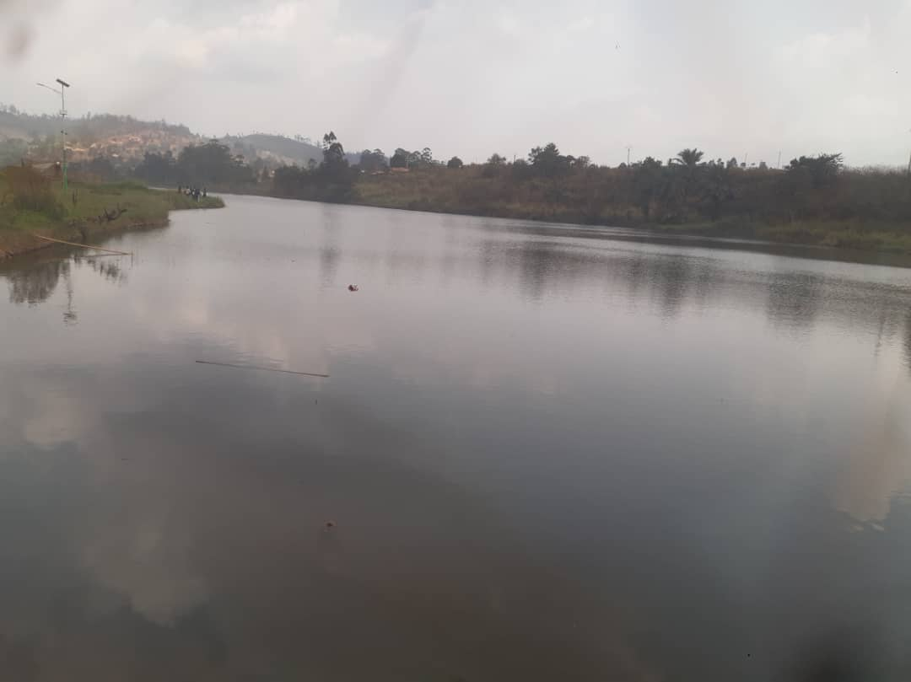
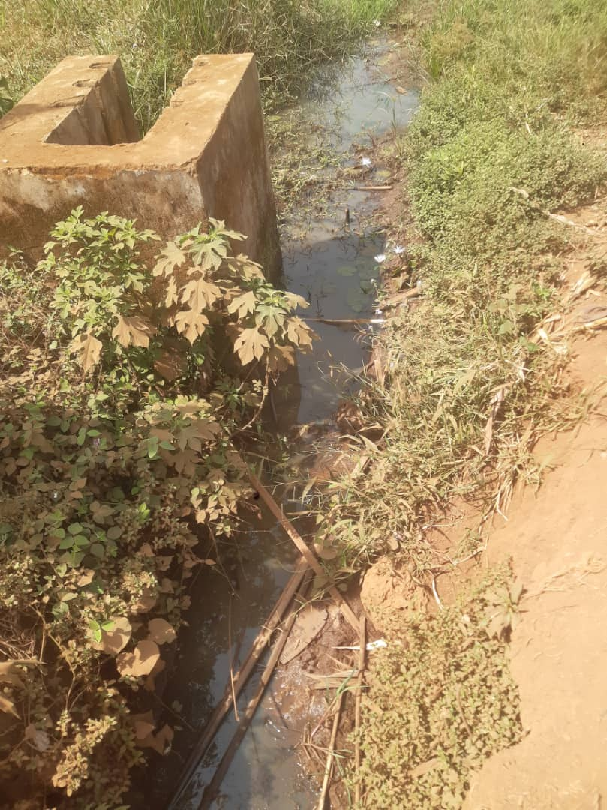
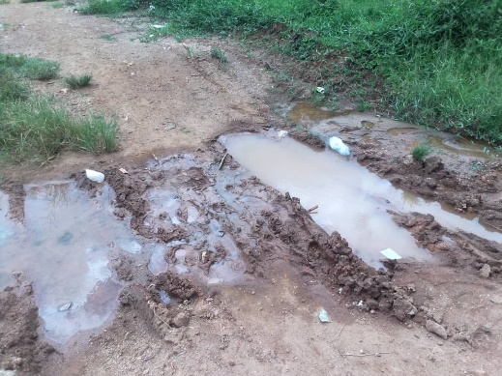
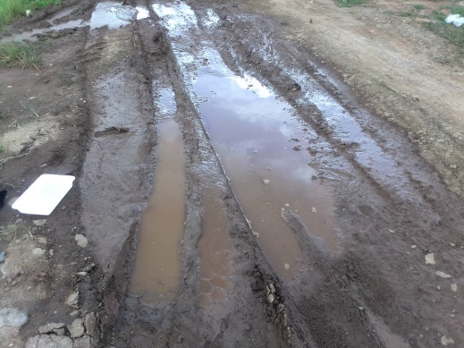
Santchou
Dschang
Penka Michel
A
B
C
D
E
F
G
H
I
Fig. S1: Identified breeding sites found Santchou, Dschang and Penka Michel.
A & B = road/tire track puddles, C= gutters, D & G = stagnant water pools, E=tires, F=lake, H= vegetable crop/farming landscape, I= swamps.

Table S1. Average Anopheles mosquitoes collected per night and person-night.
Site | Species | N_ mosquitoes collected | N_house | N_date | D  (IC 95%)
Santchou | An. gambiae s.l. | 241 | 14 | 5 | 3.44  (1.11 ; 10.24)
Santchou | An. nili s.l. | 3 | 14 | 5 | 0.04  (0.00 ; 0.32)
Santchou | An. ziemanni | 4 | 14 | 5 | 0.06  (0.00 ; 0.43)
Dschang | An. gambiae s.l. | 69 | 14 | 11 | 0.45  (0.04 ; 1.39)
Dschang | An. ziemanni | 7 | 14 | 11 | 0.04  (0.00 ; 0.3)
Penka Michel | An. funestus s.l. | 503 | 11 | 4 | 11.43  (9.56 ; 28.03)
Penka Michel | An. gambiae s.l. | 2, 308 | 11 | 4 | 52.45  (20.30 ; 85.65)
Penka Michel | An. ziemanni | 24 | 11 | 4 | 0.55  (0.00 ; 2.61)

