LAMP-TTA study - Questionnaire 2 : Post-initial training
Initial information

Health center : ____________________ | Participant ID :______________________
Date: Day:_____ Month: _____ Year: _____

LAMP related knowledge

When was your LAMP training ? : Day:________ Month: _______ Year:______

Did you attend the full training session?
YES NO UNSURE

How would you rate your knowledge regarding LAMP technique after the training?
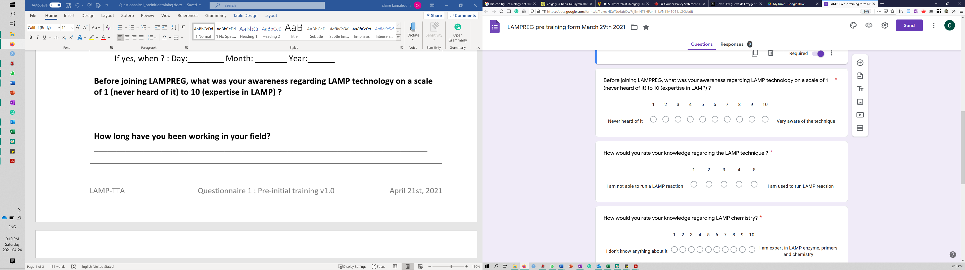
How would you rate your knowledge regarding LAMP chemistry after the training?
Would you feel comfortable running a LAMP reaction without supervision/an expert available?
YES NO UNSURE

What is your knowledge regarding raw results interpretation? (1: i don't know how to interpret results, 5: i need assistance, 10: i am independent and able to supervise staff for LAMP result interpretation)

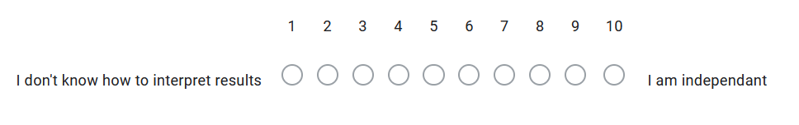
What are the 5 key words that come to your mind when you think about LAMP?
- ________________ 2. ___________________ 3. ___________________
4. __________________ 5. _______________________
Did the training modify your perception of LAMP technology?
________________________________________________________________________________________________________________________________________________________________________________________________________________________________________________________________________________________________________________________________________________________________________________________________________________________________________________________________________________________________________________________________________________________________________________________________________________________________

