Supplemental Figures

Supplemental Figure S1. Autocorrelation (top) and partial autocorrelation (bottom) of Pearson residuals from the final seasonal prediction model. All correlations fall within 95% confidence bounds, and Ljung–Box tests at lags 1–3 were not significant, indicating no evidence of residual serial correlation at the seasonal scale.

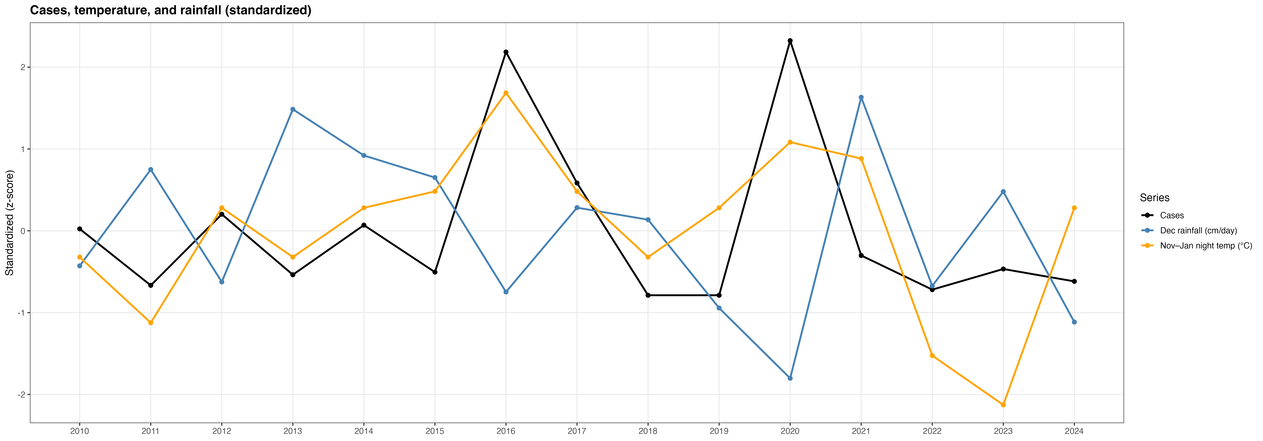

Supplemental Figure S2. Standardized (z‐score) trends of malaria cases, November–January nighttime temperature, and December rainfall in Macha, Zambia, 2010–2024. Each series was transformed to z‐scores (subtracting the mean and dividing by the standard deviation) to place malaria cases, temperature, and rainfall on a common scale for comparison. Higher values indicate above‐average conditions relative to the full period, and lower values indicate below‐average conditions. Outbreak years (2016 and 2020) coincide with above‐average temperature and below‐average rainfall.

