Supplemental table 1: Uncorrected and PCR-corrected efficacies of three study drugs, antimalarial therapeutic efficacy study, Burkina Faso, 2021 (2/3 match-counting method)

 | Niangoloko |  |  | Nanoro |  |  | Gourcy
 | AL | DP | AS-PYR | AL | DP | AS-PYR | AL | DP | AS-PYR
Kaplan-Meier, uncorrected Day 28 | 63.5 (55.9-70.1) | 96.6 (89.8-98.8) | 90.7 (82.3-95.2) | 57.1 (49.4-64.0) | 98.9 (92.2-99.8) | 83.2 (73.2-89.7) | 64.4 (56.8-71.0) | 96.6 (89.8-98.9) | 82.2 (72.2-88.9)
Kaplan-Meier, uncorrected Day 42 |  | 88.7 (80.0-93.7) | 71.0 (60.2-79.4) |  | 90.9 (82.6-95.3) | 53.6 (42.4-63.5) |  | 86.1 (76.8-91.9) | 66.1 (54.8-75.2)
Kaplan-Meier, corrected Day 28 | 89.5 (83.7-93.4) | 98.9 (92.2-99.8) | 97.7 (91.1-99.4) | 80.2 (78.2-85.7) | 100.0 | 93.9 (86.1-97.4) | 89.7 (83.9-93.5) | 98.9 (92.2-99.8) | 92.8 (84.7-96.7)
Kaplan-Meier, corrected Day 42 |  | 96.5 (89.5-98.9) | 93.9 (85.9-97.4) |  | 96.4 (89.3-98.8) | 82.5 (71.7-89.5) |  | 96.3 (88.9-98.8) | 87.9 (77.1-92.8)
Per protocol, uncorrected Day 28 | 63.4  (55.8-70.6) | 96.6  (90.3-99.3) | 90.5  (82.1-95.8) | 57.1  (49.4-64.5) | 98.9  (93.8-99.8) | 83.5  (73.3-90.5) | 64.2  (56.5-71.3) | 96.6  (89.8-98.9) | 81.7  (71.6-88.9)
Per protocol, uncorrected Day 42 |  | 88.6  (80.1-94.6) | 70.9  (60.1-80.2) |  | 90.9  (82.9-96.0) | 53.6  (42.4-64.5) |  | 85.7  (76.4-92.4) | 64.6  (53.0-75.0)
Par protocol, corrected Day 28 | 86.7 (79.6-92.1) | 98.8 (93.6-100.0 | 97.4 (91.0-99.7) | 77.1 (68.9-84.0) | 100.0 (95.8-100.0) | 93.2 (84.9-97.8) | 86.7 (79.6-92.1) | 98.8 (93.7-100.0) | 91.8 (83.0-96.9)
Par protocol, corrected Day 42 |  | 96.3 (89.6-99.2) | 92.4 (83.2-97.5) |  | 96.4 (89.8-99.2) | 77.6 (64.7-87.5) |  | 96.0 (88.8-99.2) | 83.6 (71.9-91.8)

AL : Artemether Lumefantrine
DP : Dihydroartemisinin piperaquine
AS-PYR : Artesunate – Pyronaridine

Supplemental table 2: classification of late treatment failure by drug arm according to the 3/3 method
 | Niangoloko |  |  |  |  |  | Gourcy |  |  |  |  |  | Nanoro
 | AL |  | AS-PYR |  | DHA-PPQ |  | AL |  | AS-PYR |  | DHA-PPQ |  | AL |  | AS-PYR |  | DHA-PPQ
 | N=62 |  | N=25 |  | N=10 |  | N=63 |  | N=28 |  | N=12 |  | N=70 |  | N=40 |  | N=8
 | N | % | N | % | N | % | N | % | N | % | N | % | N | % | N | % | N | %
REC | 5 | 8.1 | 3 | 12.0 | 1 | 10.0 | 3 | 4.8 | 3 | 10.7 | 1 | 8.3 | 10 | 14.3 | 2 | 5.0 | 0 | 0
NI | 56 | 90.3 | 21 | 84.0 | 9 | 90.0 | 60 | 95.2 | 25 | 89.3 | 11 | 91.7 | 59 | 85.3 | 37 | 92.5 | 8 | 100
IND | 1 | 1.6 | 1 | 4.0 | 0 | 0 | 0 | 0 | 0 | 0 | 0 | 0 | 1 | 1.4 | 1 | 2.5 | 0 | 0

REC= Number of samples classified as recrudescence. NI= Number of samples classified as new infections. IND= Indeterminate samples pairs without interpretable allelic data for at least one marker in both D0 and DF samples

Supplemental table 3: classification of late treatment failure by drug arm according to the 2/3 method
 | Niangoloko |  |  |  |  |  | Gourcy |  |  |  |  |  | Nanoro
 | AL |  | AS-PYR |  | DP |  | AL |  | AS-PYR |  | DP |  | AL |  | AS-PYR |  | DP
 | N=62 |  | N=25 |  | N=10 |  | N=63 |  | N=28 |  | N=12 |  | N=70 |  | N=40 |  | N=8
 | N | % | N | % | N | % | N | % | N | % | N | % | N | % | N | % | N | %
REC | 17 | 27.4 | 5 | 20.0 | 3 | 30.0 | 18 | 28.6 | 10 | 35.7 | 3 | 25.0 | 30 | 42.9 | 12 | 30.0 | 4 | 50.0
NI | 44 | 71.0 | 19 | 76.0 | 7 | 70.0 | 45 | 71.4 | 18 | 64.3 | 9 | 75.0 | 39 | 55.7 | 27 | 67.5 | 4 | 50.0
IND | 1 | 1.6 | 1 | 4.0 | 0 | 0 | 0 | 0 | 0 | 0 | 0 | 0 | 1 | 1.4 | 1 | 2.5 | 0 | 0

REC= Number of samples classified as recrudescence. NI= Number of samples classified as new infections. IND= Indeterminate samples pairs without interpretable allelic data for at least one marker in both D0 and DF samples

Supplemental Figure 1: Parasites genotyping and PCR- correction laboratory workflow, Burkina Faso Therapeutic Efficacy Study, 2020-2021
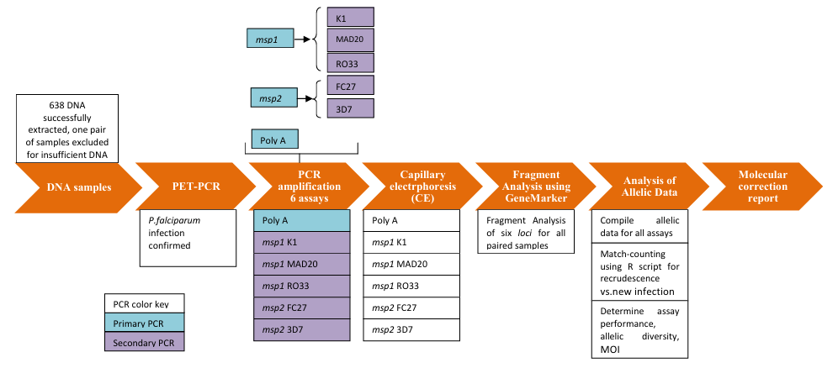

Supplemental figure 2: Day-7 lumefantrine levels in patients treated with artemether-lumefantrine by treatment outcome in Burkina Faso
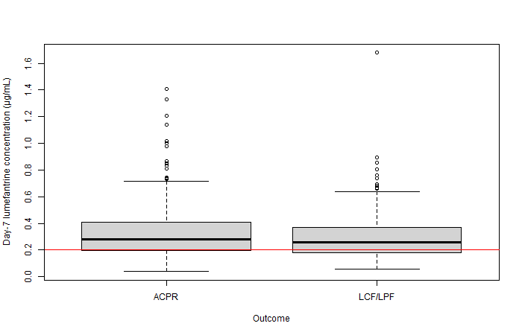

Supplemental Figure 3. Multiplex bead-based assay antigen detection and sample selection for genetic assays. Scatter plots compare the median fluorescence intensity minus background (MFI-bg) signal for pLDH (panel A), pAldolase (panel B) and PfLDH (panel C) antigens on the x-axis versus the HRP2 MFI-bg assay signal on the y-axis. Samples with low HRP2 levels relative to other antigens were selected for further genetic testing: yellow circles indicate samples selected based on HRP2 expression compared to pLDH, green circle indicates samples selected based on pAldolase and blue circle indicates sample selected based on PfLDH.

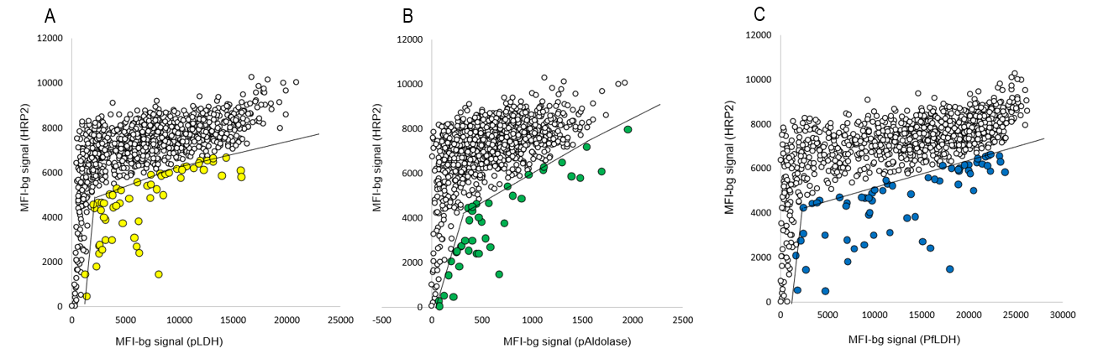

Supplemental Figure 4. Sample processing and results for pfhrp2 and pfhrp3 genotyping. Results presented as a flow chart for the entire sample set available for antigen screening. Terminal boxes show the presence (+) or absence (-) of the pfhrp2 and pfhrp3 genes from samples that passed DNA quality control. All percentages shown are out of the 1026 DBS analyzed.

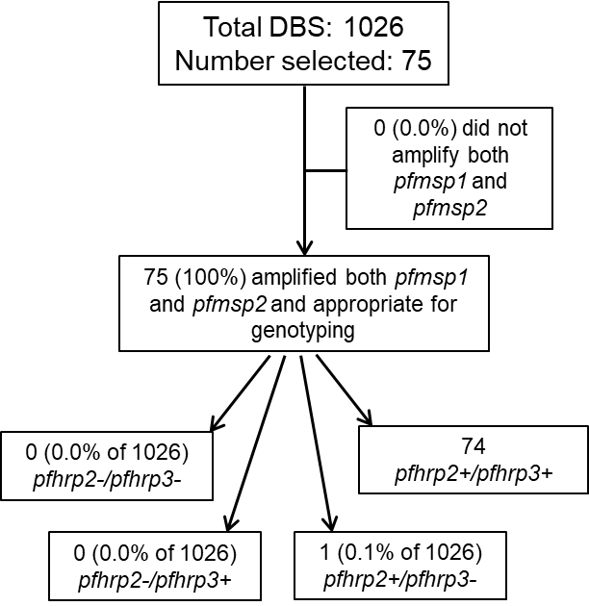

Supplemental figure 5. Correlation between counted parasitemia and extracted P. falciparum DNA quantified by PET-PCR. Scatter plots compare the logarithmic (log10) value of the parasitemia, parasites per microliter (p/µL), (y-axis) and the cycle threshold identified using PET-PCR for the P. falciparum target. This is shown for all of the samples evaluated from Niangoloko (blue, A), Gourcy (orange B), and Nanoro (green, C). The Pearson correlation (r) and p-value (p) indicate the correlation between the data points and the line of regression for each site plotted using Seaborn’s multiple linear regression plot (lmplot).
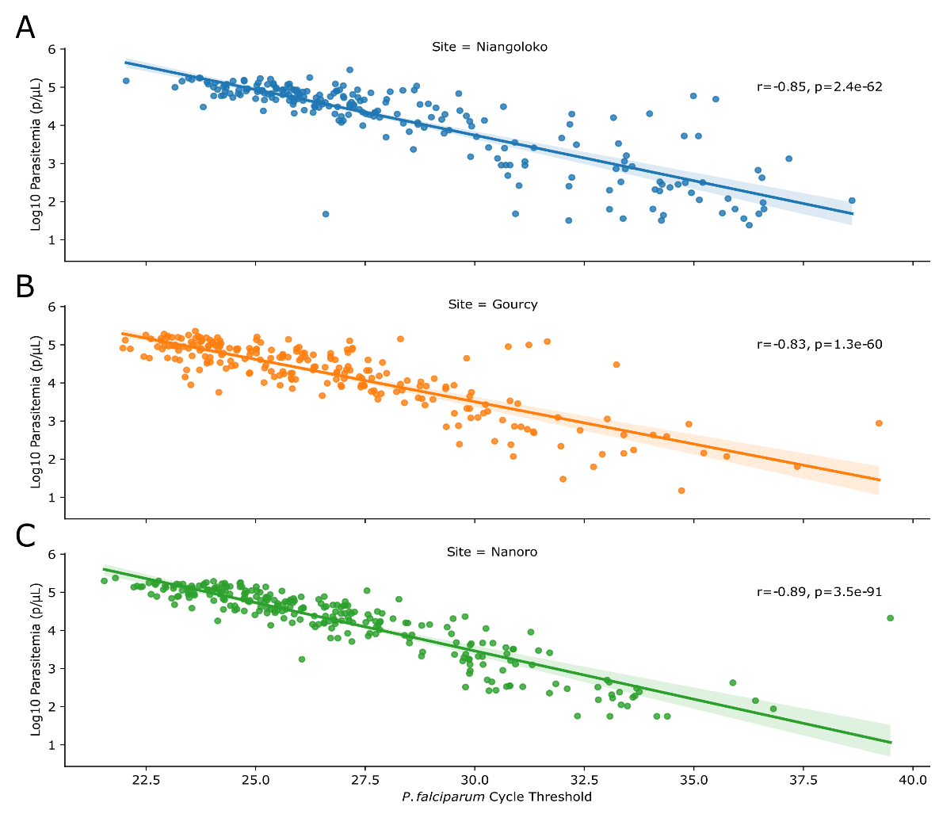

Supplemental Figure 6.
Observed Mutations and Sequencing Coverage. Heatmaps represent each sequenced sample (row) at each tracked amino acid for a given gene (column) for variant allele frequencies (z-axis, A and C, 0% light blue to 100% dark blue) or log10 of the number of reads (z-axis, B, 10^0 light green to 10^4 dark green) at each intersecting point. Each sample is labeled to the left of each heatmap with the site (navy = Gourcy, pink = Nanoro, brown = Niangoloko) that sample, or samples for pooled samples, belong(s) to. Each visualized amino acid is denoted at the bottom of the heatmap in numerical order within the gene, color-coded at the top of the heatmap (red = pfdhps, yellow = pfk13, green = pfmdr1), the amino acid belongs to. For all heatmaps, a white color (valued at -20 arbitrary units) indicates that no data was obtained for a given sample at those nucleotide positions. Samples are localized in the same rows in both of the unclustered heatmaps (A and B). C) Same heatmap as in A but the rows are hierarchically clustered based on row composition, indicating the relatedness between samples in the dataset according to the frequency of mutation(s) observed for that sample.

