Supplemental information
Additional file 1: Distribution of villages where focus groups and in-depth interviews were conducted: by levels of LLIN usage, and malaria prevalence per study arm
Region | District | Study arm | Net usage levels | Villages/hamlets | Malaria prevalence | Villages/hamlets
Mwanza | Misungwi | Olyset Plus | Low (≤40%) | Budutu, Mwajombo, Lukanga, Nyambiti | Low (≤30%) | Mwaholo
Mwanza | Misungwi | Olyset Plus | High (>40) | Ibongoya A, Ibongoya B, Ngwa’mazengo, Lubili A | High (>30) | Ibongoya A, Ibongoya B, Lubili A
Mwanza | Misungwi | Royal Guard | Low (≤40%) | Nya’nghomango, Lubili B, Busongo | Low (≤30%) | Masawe, Busolwa
Mwanza | Misungwi | Royal Guard | High (>40) | Mwagala, Mamaye, Masawe, Gulumungu, | High (>30) | Mwagala, Lubili B, Gulumungu, Busongo
Mwanza | Misungwi | Interceptor G2 | Low (≤40%) | Maganzo, Mbalama, Kifune | Low (≤30%) | Mbela
Mwanza | Misungwi | Interceptor G2 | High (>40) | Magaka, Mbela, Ngwa’mbola, Ngwa’mazengo | High (>30) | Mbalama, Ngwa’mazengo, Kifune
Mwanza | Misungwi | Interceptor | Low (≤40%) | Gambajiga, Ngh’amve | Low (≤30%) | Nghamve
Mwanza | Misungwi | Interceptor | High (>40) | Igongwa , Kwimwa | High (>30) | Gambajiga, Igongwa , Kwimwa, Ilalambogo
Kagera | Muleba | Olyset Net | Low (≤40%) | Kakoma, Nyakatanga | Low (≤30%) | Kyanshenge
Kagera | Muleba | Olyset Net | High (>40) | Kabirizi, Kyanshenge | High (>30) | Kakoma, Kabirizi,  Nyakatanga
Kagera | Muleba | Olyset Plus | Low (≤40%) | Ngenge, Biija | Low (≤30%) | Biija
Kagera | Muleba | Olyset Plus | High (>40) | Maigibili | High (>30) | Maigibili, Ngenge,
Kagera | Muleba | Olyset Net + IRS | Low (≤30%) | Rulanda | Low (≤30%) | Rulanda
Kagera | Muleba | Olyset Net + IRS | High (>40) | Kamatoju | High (>30) | Kamatoju
Kagera | Muleba | Olyset Plus + IRS | Low (≤40%) | Kashanda | Low (≤30%) | Kashanda
Kagera | Muleba | Olyset Plus + IRS | High (>40) | Kyamyorwa, Kangoma, | High (>30) | Kyamyorwa, Kangoma,

Additional file 2: Knowledge of malaria and preventive practices in Muleba and Misungwi (data from KAP surveys)
 | Muleba |  |  | Misungwi
 | Baseline (Dec 2014): % (n=560) | Post (April 2015): % (n=593) |  | Post-intervention (2020-2022)
How is malaria transmitted to humans?**
Bite of an infected mosquito | 92.5 (518) | 91.7 (544) |  | 86.6 (2,106)
Others | 27.9 (156) | 38.9 (230) |  | 15.7 (382)
Ways to prevent malaria**
Sleeping under LLINs | 90.5 (507) | 90.6 (537) |  | N/A
Spraying insecticide inside the house | 30.7 (172) | 43.5 (258) |  | N/A
Others | 43.2 (242) | 35.5 (210) |  | N/A
Personal protection measures against malaria
Mosquito nets | 87.7 (490) | N/A |  | N/A
Closing windows and doors | 15.9 (89) | N/A |  | N/A
Gauze wire in windows | 7.9 (44) | N/A |  | N/A
Mosquito coil | 4.3(24) | N/A |  | N/A
Where do you first seek malaria treatment?
Hospital, health center, or dispensary | 57.1 (320) | 76.1 (451) |  | 45.4 (1,535)
Drug shop/pharmacy/general shop | 35.9 (201) | 18.7 (111) |  | 54.0 (1,823)
Traditional healer (herbalist) | 5.5 (31) | 3.9 (23) |  | 0.3 (9)
Community Health Worker | 0.5 (3) | 0.3 (2) |  | 0.21 (7)
Traditional healer (spiritual) | 0.4 (2) | 0 |  | 0 (0)
How often do you sleep under the LLIN?
Always ‘right now’ | 47.8 (266) | 94.0 (549) |  | N/A
Never ‘right now’ | 27.2 (151) | 3.6 (21) |  | N/A
Sometimes | 25.0 (140) | 2.4 (14) |  | N/A
Why do you sometimes or never sleep under the LLIN?
Not enough nets | 144 (56.5%) | 5 (20%) |  | N/A
Net worn out/too torn | 75 (29.4%) | 2 (8%) |  | N/A
Other reasons | 36 (14.1%) | 18 (72%) |  | N/A

Additional file 3: Proportion of participants reporting nets as no longer protective
Variables | 24 months: % (n/N) | 30 months: % (n/N) | 36 months: % (n/N)
Other nets | 11.3 (412/3654) | 6.7 (198/2972) | 6.5 (273/4204)
Interceptor G2 | 6.8 (90/1315) | 5.7 (47/832) | 8.4 (58/690)
Olyset Plus | 17.8 (135/757) | 12.4 (51/411) | 15.2 (44/289)
Royal Guard | 11.7 (116/994) | 11.0 (67/610) | 13.4 (57/427)
Interceptor | 6.0 (69/1157) | 7.5 (59/790) | 9.3 (65/710)

Additional file 4: Proportion of participants reporting side effects caused by the LLINs
Variables | Interceptor G2: N=162 | Olyset Plus: N=162 | Royal Guard: N=168 | Interceptor: N=164
Participants with side effects: % (n) | 10.5 (17) | 10.5 (17) | 47.6 (80) | 54.9 (90)
Type of side effect experienced: % (n)
Skin irritation or paraesthesia | 70.6 (12) | 52.9 (9) | 63.8 (51) | 67.8 (61)
Facial burning | 5.9 (1) | 41.2 (7) | 31.3 (25) | 27.8 (25)
Feeling sick or nausea | 0 (0) | 0 (0) | 0 (0) | 1.1 (1)
Headache | 11.8 (2) | 0 (0) | 0 (0) | 0 (0)
Other | 11.8 (2) | 0 (0) | 0 (0) | 1.1 (1)
Runny eyes or nose or sneezing | 0 (0) | 5.9 (1) | 5.0 (4) | 2.2 (2)

Additional file 5: Eliud Lukole's 6.14 km GPS-track and superimposed pictures
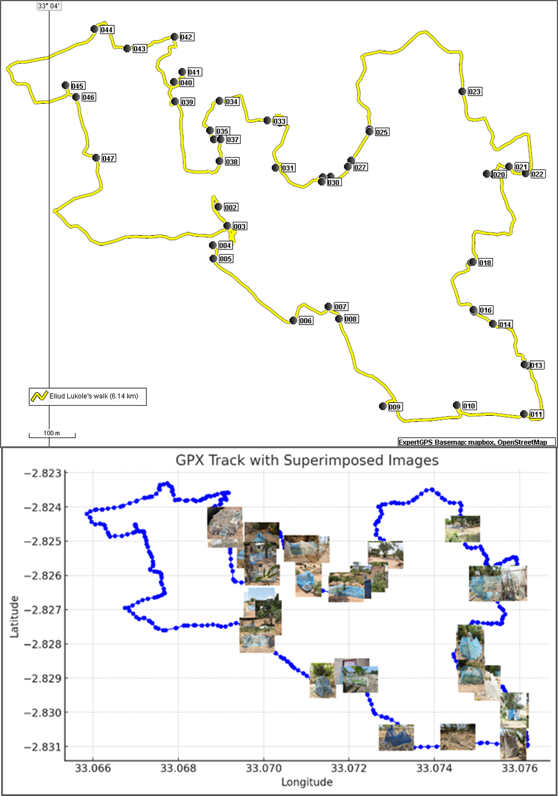

Additional file 6: Differences between Muleba and Misungwi districts
Category | Muleba | Misungwi
Ethnic Composition | Predominantly Haya, with a rich history in coffee and banana farming, and traditional iron smelting. | Predominantly Sukuma, strong agricultural and pastoral culture, focus on cotton and cattle herding.
Crop Types | Annual, less frequent farming needed | Perennial crops like rice, sweet potatoes, cassava, and sorghum, require seasonal farming and vegetation clearance.
Climate & Landscape | Greener, cooler, wetter, tropical rainforest climate, hilly, forested, nucleated settlements. | Hotter, drier, tropical savanna climate, flat landscape, scattered settlements, sparse tree cover.
Soil Fertility | More fertile soils, lush vegetation, farming done by hand hoe. | Less fertile soils, farming with ploughs drawn by cattle.
Housing | Traditional houses are made of bricks/mud and poles, thatched with banana leaves or dry barks, and tin roofs. | Simple houses made of mud bricks, thatched roofs, and increasing use of iron sheets.
Resource Use | Banana dry barks are used as ropes, less need for synthetic ropes. | With limited plant resources, LLINs were repurposed as ropes for various uses, including tying cattle yokes.
Crop Types | Annual, less frequent farming is needed. | Perennial crops like rice, cotton, and sorghum, require seasonal farming and vegetation clearance.
Literacy Rate | Relatively higher, better access to education due to historical missionary activities. | Lower literacy rate, challenges in education access due to economic constraints, and dispersed population.
Economic Development | Moderately developed, income from agriculture and fishing, higher per capita income from coffee. | Lower socio-economic status, income from agriculture and livestock, reliance on subsistence farming.

Additional file 7: All net (any net) and study nets use, malaria prevalence, population access and use:access ratio in the study sites from RCTs per survey timepoint
District | Survey timepoint | Transmission season | Mean malaria prevalence | Any net |  |  | Study net
 |  |  |  | Net use: % | Population access: % | Use:access ratio | Net use: % | Population access: % | Use:access ratio
Muleba | Baseline | High | 65 | 27.5 | 37 | 0.74 | n/a | n/a | n/a
Muleba | 4 months | High | 40 | 76 | 77.45 | 0.98 | 70.5 | 75.09 | 0.94
Muleba | 9 months | Low | 32 | 76 | 70.44 | 1.08 | 70.5 | 67.98 | 1.04
Muleba | 16 months | High | 38 | 49 | 55.41 | 0.88 | 44 | 53.87 | 0.82
Muleba | 22 months | Low | 49 | 53 | 57.62 | 0.92 | 41 | 45.88 | 0.89
Muleba | 28 months | High | 72 | 59 | 53.58 | 1.10 | 41 | 42.5 | 0.96
Muleba | 33 months | Low | 50 | 48 | 58.06 | 0.83 | 21.5 | 35.39 | 0.61
District | Survey timepoint | Transmission season | Malaria prevalence | Any net |  |  | Study net
 |  |  |  | Net use | Population access | Use:access ratio | Net use | Population access | Use:access ratio
Misungwi | Baseline | High | 44.2 | 61.0 | 65.8 | 0.93 | n/a | n/a | n/a
Misungwi | 3 months | High | n/a | 81.8 | 93.8 | 0.87 | 72.1 | 76.5 | 0.94
Misungwi | 12 months | Low | 18.7 | 83.0 | 84.3 | 0.98 | 61.8 | 55.8 | 1.11
Misungwi | 18 months | High | 46.7 | 72.2 | 80.8 | 0.89 | 47.8 | 41.2 | 1.16
Misungwi | 24 months | Low | 38.4 | 72.2 | 75.2 | 0.96 | 40.9 | 30.8 | 1.33
Misungwi | 30 months | High | 45.6 | 62.6 | 75.5 | 0.83 | 29.6 | 30.8 | 0.96
Misungwi | 36 months | Low | 31.1 | 66.7 | 76.1 | 0.88 | 20.8 | 15.4 | 1.35

