Supplementary Tables and Figures
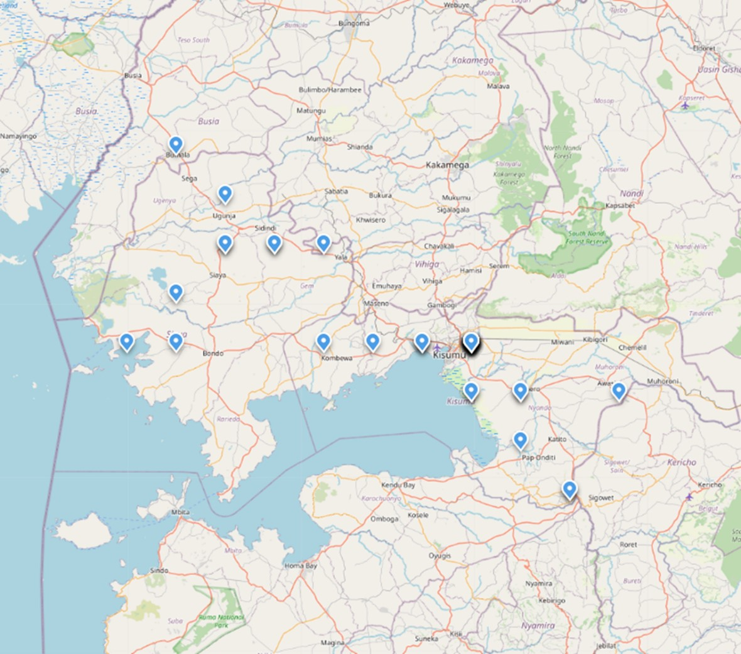
Figure 1. Map of study sites

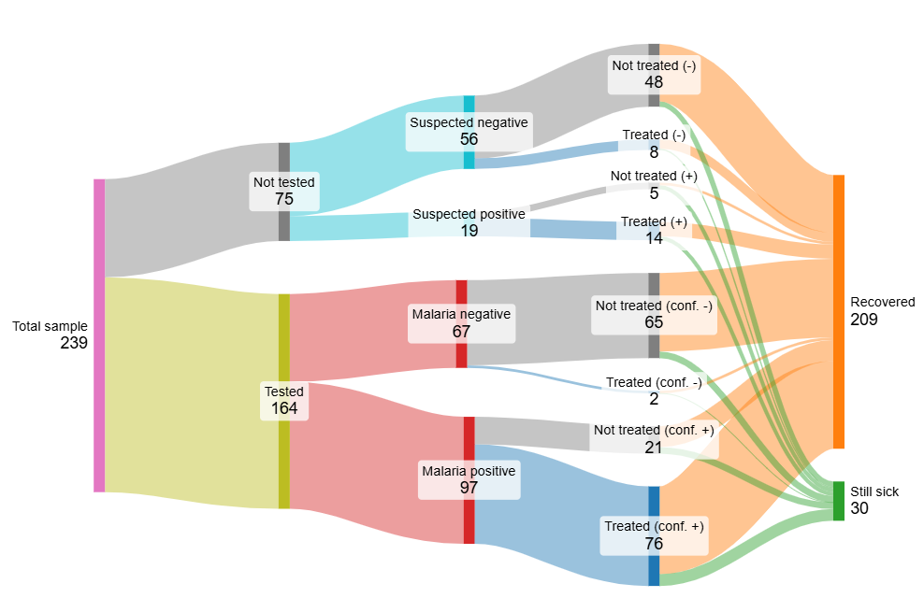
Figure 2. Care and illness episode outcomes for all pediatric fever cases in sample
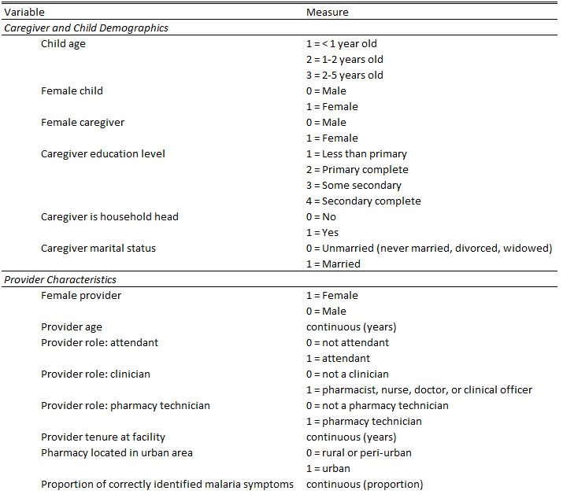

Table 1. Variable descriptions
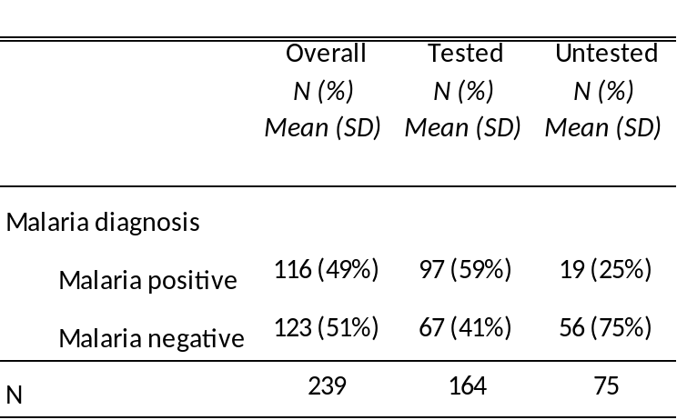
Table 2. Malaria diagnosis, by testing status

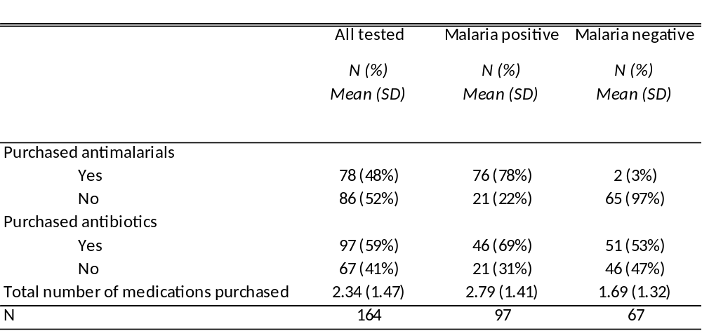
Table 3. Appropriate treatment, by malaria status

