Additional File 5: Quality assessment of included articles

Study identifier (year of publication) | Statement of decision problem | Statement of modeling objective | Perspective of the analysis identified | Health and other outcomes described | R code/model sharing | Parameters and initial values tabulated | Parameters and initial values labeled and described | Cost inputs described | Cost inputs tabulated | Linkage with previous modeling analyses | Sensitivity Analysis | Data validation | Spatial  Structure  included
Abboubakar et al. (2016 ) | Yes | Yes | Yes | Yes | No | Yes | Yes | No | No | Yes | No | No | Yes
Abiodun et al. (2018 ) | Yes | Yes | Yes | Yes | No | Yes | Yes | No | No | Yes | Yes | Yes | Yes
Abiodun et al. (2018 ) | Yes | Yes | Yes | Yes | No | Yes | Yes | No | No | Yes | Yes | Yes | Yes
Abioye et al. (2020 ) | Yes | Yes | Yes | Yes | No | Yes | Yes | No | No | Yes | No | No | No
Abioye et al. (2020 ) | Yes | Yes | Yes | Yes | No | Yes | Yes | No | No | Yes | No | No | No
Abioye et al. (2023 ) | Yes | Yes | Yes | Yes | No | Yes | Yes | No | No | Yes | Yes | No | No
Adegbite et al. (2023 ) | Yes | Yes | Yes | Yes | No | Yes | Yes | No | No | Yes | No | Yes | No
Adeniyi et al. (2023 ) | Yes | Yes | No | Yes | No | Yes | Yes | No | No | Yes | No | Yes | No
Adeniyi et al. (2024 ) | Yes | Yes | Yes | Yes | No | Yes | Yes | No | No | Yes | Yes | No | No
Adom-Konadu et al. (2022 ) | Yes | Yes | No | Yes | No | Yes | Yes | No | No | Yes | Yes | No | No
Agusto et al. (2015 ) | Yes | Yes | Yes | Yes | No | Yes | Yes | No | No | Yes | Yes | No | No
Anguelov et al. (2018 ) | Yes | Yes | Yes | Yes | No | Yes | Yes | No | No | Yes | No | No | No
Awine and Silal (2020 ) | Yes | Yes | Yes | Yes | No | Yes | Yes | No | No | Yes | Yes | Yes | Yes
Ayalew et al. (2024 ) | Yes | Yes | Yes | Yes | No | No | Yes | Yes | Yes | Yes | Yes | Yes | No
Baba et al. (2019 ) | Yes | Yes | Yes | Yes | No | No | No | No | No | Yes | No | No | No
Bakare (2015 ) | Yes | Yes | Yes | Yes | No | Yes | Yes | No | No | Yes | Yes | No | No
Bakare and Nwozo (2015 ) | Yes | Yes | Yes | Yes | No | No | Yes | No | No | Yes | No | No | No
Bakary et al. (2018 ) | Yes | Yes | No | Yes | No | Yes | Yes | No | No | Yes | Yes | No | No
Bimbiga et al. (2019 ) | Yes | Yes | Yes | Yes | No | Yes | Yes | No | No | Yes | Yes | No | No
Cai et al. (2013 ) | Yes | Yes | Yes | Yes | No | No | Yes | No | No | Yes | No | No | No
Chiyaka et al. (2008 ) | Yes | Yes | No | Yes | No | Yes | Yes | No | No | Yes | No | No | No
Collins and Duffy (2022 ) | Yes | Yes | Yes | Yes | No | Yes | Yes | No | No | Yes | Yes | Yes | No
Danquah et al. (2023 ) | Yes | Yes | Yes | Yes | No | Yes | Yes | No | No | Yes | No | No | No
Djidjou-Demasse cet al. (2020 ) | Yes | Yes | Yes | Yes | No | Yes | Yes | No | No | Yes | No | Yes | No
Drabo et al. (2024 ) | Yes | Yes | Yes | Yes | No | No | Yes | No | No | Yes | No | No | No
Ducrot et al. (2009 ) | Yes | Yes | No | Yes | No | Yes | Yes | No | No | Yes | No | No | No
Duve et al. (2024 ) | Yes | Yes | Yes | Yes | Yes | Yes | Yes | No | No | Yes | Yes | Yes | No
Edossa et al. (2023 ) | Yes | Yes | Yes | Yes | No | Yes | Yes | Yes | Yes | Yes | No | No | No
Garba and Danbaba (2020 ) | Yes | Yes | Yes | Yes | No | Yes | Yes | No | No | Yes | No | Yes | No
Garira and Mathebula (2019 ) | Yes | Yes | No | Yes | No | Yes | Yes | No | No | Yes | No | No | No
Gebremeskel (2018 ) | Yes | Yes | No | Yes | No | Yes | Yes | No | No | Yes | Yes | No | No
Gellow et al. (2023 ) | Yes | Yes | Yes | Yes | No | Yes | Yes | No | No | Yes | No | No | No
Ghosh et al. (2020 ) | Yes | Yes | No | Yes | No | Yes | Yes | Yes | Yes | Yes | No | No | No
Gizaw and Deressa (2024 ) | Yes | Yes | Yes | Yes | No | Yes | Yes | No | No | Yes | Yes | No | No
Gu et al. (2003 ) | Yes | Yes | Yes | Yes | No | No | Yes | No | No | Yes | Yes | No | Yes
Helikumi et al. (2024 ) | Yes | Yes | Yes | Yes | No | Yes | Yes | No | No | Yes | Yes | Yes | No
Kalula et al. (2023 ) | Yes | Yes | Yes | Yes | No | Yes | Yes | Yes | No | Yes | Yes | Yes | No
Kamgang and Tchoumi (2015 ) | Yes | Yes | No | Yes | No | Yes | Yes | No | No | Yes | No | No | No
Keno et al. (2021 ) | Yes | Yes | Yes | Yes | No | Yes | Yes | Yes | Yes | Yes | Yes | No | No
Keno et al. (2022 ) | Yes | Yes | Yes | Yes | No | Yes | Yes | Yes | Yes | Yes | No | No | No
Keno et al. (2022 ) | Yes | Yes | Yes | Yes | No | Yes | Yes | Yes | Yes | Yes | Yes | No | No
Keno et al. (2022 ) | Yes | Yes | Yes | Yes | No | Yes | Yes | Yes | Yes | Yes | Yes | No | No
Khiri et al. (2020 ) | Yes | Yes | No | Yes | Yes | Yes | Yes | No | No | Yes | No | Yes | No
Li et al. (2023 ) | Yes | Yes | Yes | Yes | No | Yes | Yes | Yes | Yes | Yes | Yes | Yes | No
Lou and Zhao (2010 ) | Yes | Yes | No | Yes | No | Yes | Yes | No | No | Yes | Yes | Yes | No
Mbogo et al. (2018 ) | Yes | Yes | No | Yes | No | Yes | Yes | No | No | Yes | No | No | No
Modu et al. (2023 ) | Yes | Yes | Yes | Yes | No | Yes | Yes | No | No | Yes | Yes | No | No
Mohammed-Awel et al. (2019 ) | Yes | Yes | Yes | Yes | No | No | Yes | No | No | Yes | No | No | No
Mukhtar et al. (2020 ) | Yes | Yes | No | Yes | No | Yes | Yes | No | No | Yes | No | Yes | No
Mukhtaret al. (2018 ) | Yes | Yes | Yes | Yes | No | Yes | Yes | No | No | Yes | Yes | Yes | Yes
Mukhtaret al. (2019 ) | Yes | Yes | Yes | Yes | No | Yes | Yes | No | No | Yes | Yes | Yes | Yes
Mwamtobe et al. (2014 ) | Yes | Yes | Yes | Yes | No | Yes | Yes | Yes | No | Yes | No | Yes | No
Nana-Kyere et al. (2024 ) | Yes | Yes | Yes | Yes | No | Yes | Yes | Yes | Yes | Yes | Yes | No | No
Ndam and. Azike (2024 ) | Yes | Yes | No | Yes | No | Yes | Yes | No | No | Yes | Yes | No | No
Ngarakana-Gwasira et al. (2014 ) | Yes | Yes | Yes | Yes | No | Yes | Yes | No | No | Yes | No | No | No
Ngarakana-Gwasira et al. (2016 ) | Yes | Yes | Yes | Yes | No | Yes | Yes | No | No | Yes | Yes | Yes | Yes
Ngwa (2004 ) | Yes | Yes | Yes | Yes | No | No | Yes | No | No | Yes | No | No | No
Ngwa et al. (2019 ) | Yes | Yes | Yes | Yes | No | No | No | No | No | Yes | No | No | No
Nwankwo and Okuonghae (2022 ) | Yes | Yes | No | Yes | No | Yes | Yes | No | No | Yes | Yes | No | No
Obabiyi and Olaniyi (2019 ) | Yes | Yes | Yes | Yes | No | No | No | No | No | Yes | No | No | No
Ochieng (2024 ) | Yes | Yes | Yes | Yes | No | Yes | Yes | No | No | Yes | No | Yes | No
Ojo and Goufo (2021 ) | Yes | Yes | Yes | Yes | No | Yes | Yes | No | No | Yes | Yes | No | No
Oke et al. (2020 ) | Yes | Yes | Yes | Yes | No | Yes | Yes | No | No | Yes | No | No | No
Okell et al. (2008 ) | Yes | Yes | Yes | Yes | No | Yes | Yes | No | No | Yes | Yes | Yes | Yes
Okosun et al. (2012 ) | Yes | Yes | Yes | Yes | No | No | Yes | Yes | Yes | Yes | Yes | No | No
Okosun et al. (2013 ) | Yes | Yes | Yes | Yes | No | Yes | Yes | Yes | Yes | Yes | Yes | No | No
Okuneye and Gumel (2017 ) | Yes | Yes | No | Yes | No | Yes | Yes | No | No | Yes | Yes | Yes | No
Olaniyi and. Obabiyi (2013 ) | Yes | Yes | No | Yes | No | Yes | Yes | No | No | Yes | No | No | No
Olaniyi et al. (2020 ) | Yes | Yes | Yes | Yes | No | Yes | Yes | Yes | No | Yes | No | Yes | No
Olaniyi et al. (2022 ) | Yes | Yes | Yes | Yes | No | Yes | Yes | Yes | Yes | Yes | Yes | No | No
Onifade et al. (2024 ) | Yes | Yes | No | Yes | No | Yes | Yes | No | No | Yes | Yes | Yes | No
Osman et al. (2019 ) | Yes | Yes | No | Yes | No | Yes | Yes | No | No | Yes | Yes | Yes | No
Otieno et al. (2016 ) | Yes | Yes | No |  | No | Yes | Yes | No | No | Yes | Yes | No | No
Parham and Michael (2010 ) | Yes | Yes | Yes | Yes | No | Yes | Yes | No | No | Yes | Yes | No | No
Ratti and Wallace (2020 ) | Yes | Yes | No | Yes | No | Yes | Yes | No | No | Yes | Yes | Yes | Yes
Rezapour et al. (2023 ) | Yes | Yes | Yes | Yes | No | No | Yes | No | No | Yes | No | No | No
Shalini et al. (2024 ) | Yes | Yes | Yes | Yes | No | Yes | Yes | No | No | Yes | No | Yes | No
Souleiman et al. (2024 ) | Yes | Yes | Yes | Yes | No | Yes | Yes | No | No | Yes | Yes | Yes | No
Tchoumi et al. (2011 ) | Yes | Yes | No | Yes | No | Yes | Yes | No | No | Yes | No | No | No
Tchoumi et al. (2018 ) | Yes | Yes | No | Yes | No | Yes | Yes | No | No | Yes | No | No | No
Tchoumi et al. (2021 ) | Yes | Yes | No | Yes | No | Yes | Yes | No | No | Yes | No | No | No
Tchoumi et al. (2023 ) | Yes | Yes | No | Yes | No | Yes | Yes | No | No | Yes | No | No | No
Tchoumi et al. (2023 ) | Yes | Yes | Yes | Yes | No | Yes | Yes | No | No | Yes | Yes | No | No
Traoré et al. (2017 ) | Yes | Yes | No | Yes | No | Yes | Yes | No | No | Yes | No | No | No
Traoré et al. (2018 ) | Yes | Yes | Yes | Yes | No | Yes | Yes | No | No | Yes | No | No | No
Traoré et al. (2020 ) | Yes | Yes | No | Yes | No | Yes | Yes | No | No | Yes | No | No | No
Traoré et al. (2020 ) | Yes | Yes | No | Yes | No | Yes | Yes | No | No | Yes | Yes | No | No
Traoré et al. (2021 ) | Yes | Yes | No | Yes | No | Yes | Yes | No | No | Yes | No | No | No
Tumwiine et al. (2007 ) | Yes | Yes | No | Yes | No | No | Yes | No | No | Yes | No | No | No
Tumwiine et al. (2007 ) | Yes | Yes | Yes | Yes | No | Yes | Yes | No | No | Yes | No | No | No
Tumwiine et al. (2010 ) | Yes | Yes | No | Yes | No | No | No | No | No | Yes | No | No | No
Uwineza et al. (2024 ) | Yes | Yes | No | Yes | No | Yes | Yes | No | No | Yes | No | No | No
Wallace et al. (2014 ) | Yes | Yes | No | Yes | No | Yes | Yes | No | No | Yes | Yes | No | No
Wang and Zhao (2017 ) | Yes | Yes | Yes | Yes | No | Yes | Yes | No | No | Yes | No | Yes | No
Wang and Zhao (2017 ) | Yes | Yes | No | Yes | No | Yes | Yes | No | No | Yes | No | Yes | No
Wang and Zhao (2018 ) | Yes | Yes | No | Yes | No | Yes | Yes | No | No | Yes | No | Yes | No
Witbooi et al. (2020 ) | Yes | Yes | Yes | Yes | No | Yes | Yes | No | No | Yes | No | No | No
Witbooi et al. (2021 ) | Yes | Yes | No | Yes | No | Yes | Yes | No | No | Yes | No | Yes | No
Witbooi et al. (2023 ) | Yes | Yes | Yes | Yes | No | Yes | Yes | No | No | Yes | No | No | No
Woldegerima et al. (2021 ) | Yes | Yes | No | Yes | No | Yes | Yes | No | No | Yes | No | Yes | No
Yiga et al. (2020 ) | Yes | Yes | Yes | Yes | No | Yes | Yes | No | No | Yes | Yes | No | No
Zhao et al. (2022 ) | Yes | Yes | Yes | Yes | No | Yes | Yes | No | No | Yes | Yes | Yes | No

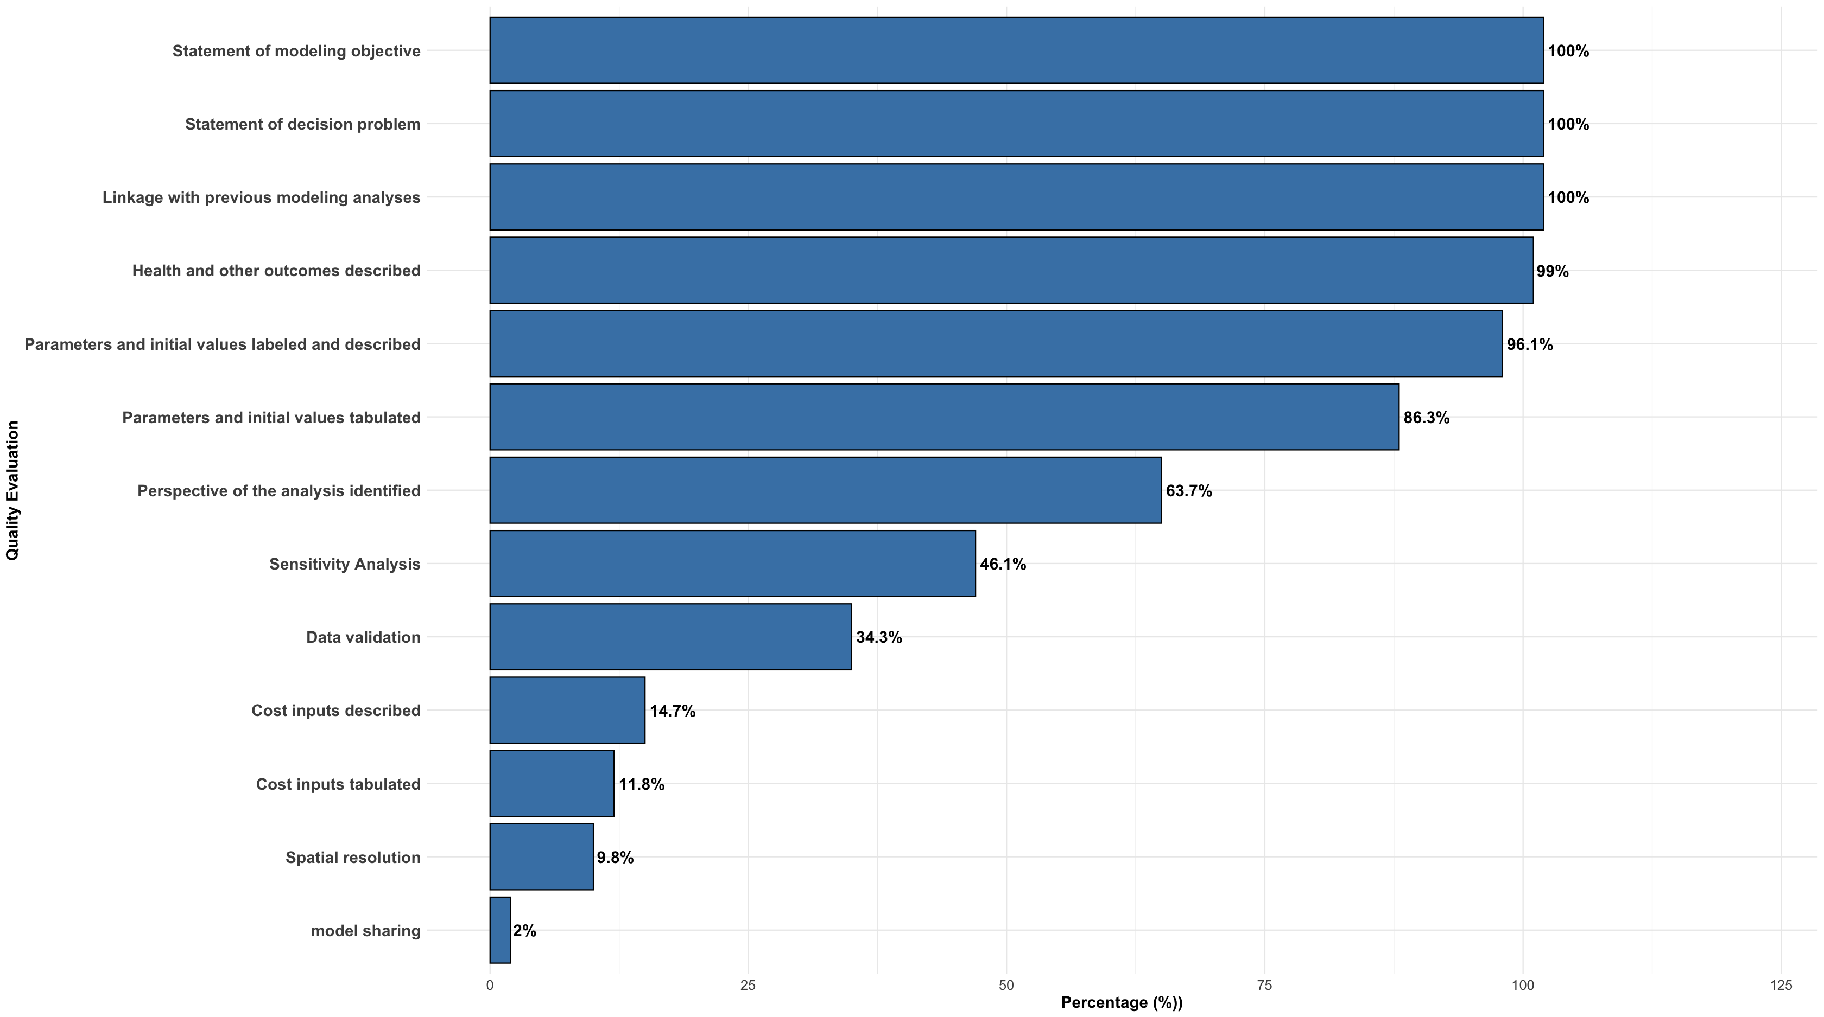

Figure S1. Quality assessment of included malaria modelling studies based on ISPOR–SMDM good research practices criteria.
Percentage of included studies satisfying selected methodological and reporting criteria, including modelling objectives,
parameter reporting, sensitivity analysis, validation, and model transparency.

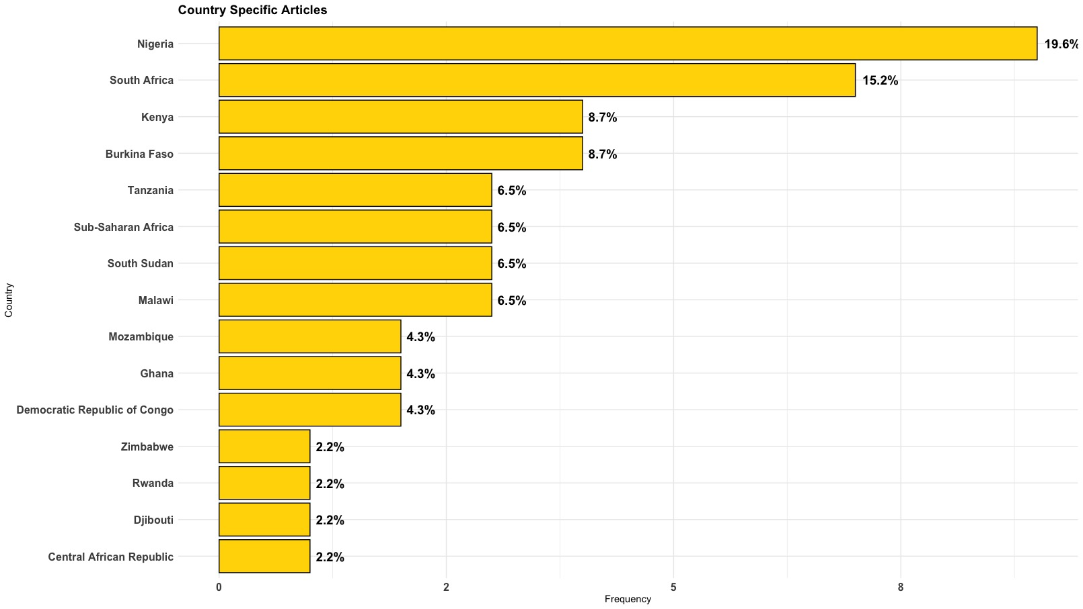

Figure S2. Country distribution of malaria modelling studies included in the systematic review.
Geographic distribution of studies by country or region within Sub-Saharan Africa represented in the
Included modelling studies.

