Supplementary Appendix

 | Page
Supplementary Table 1. Search strategy for each database. | 2
Supplementary Figure 1. Risk of bias assessment using ROB-2 tool. | 3
Supplementary Figure 2. Leave-one-out analysis for Mosquito Mortality | 6
Supplementary Figure 3. Random-effect meta-analysis of Pyrexia rates | 7
Supplementary Figure 4. Random-effect meta-analysis of Fatigue rates | 8
Supplementary Figure 5. Random-effect meta-analysis of Headache rates | 9
Supplementary Figure 6. Random-effect meta-analysis of Arthralgia rates | 10
Supplementary Figure 7. Random-effect meta-analysis of Pharyngitis rates | 11
Supplementary Figure 8. Random-effect meta-analysis of Gastrointestinal Disorders rates | 12
Supplementary Figure 9. Leave-one-out analysis for Gastrointestinal Disorders rates | 13
Supplementary Figure 10. Random-effect meta-analysis of Visual disturbance | 14
Supplementary Figure 11. Random-effect meta-analysis of Conjunctivitis | 15
Supplementary Figure 12. Random-effect meta-analysis of cardiovascular disorder rates | 16
Supplementary Figure 13. Random-effect meta-analysis of Urinary tract infection rates | 17
Supplementary Table 2. Table of excluded studies | 18
Supplementary Table 3. Data table | 19

Supplementary Table 1. Search strategy for each database.
Database | Search query | Filter | Search results
PubMed | (("Malaria"[MeSH Terms] OR malaria[Title/Abstract] OR plasmodium[Title/Abstract] OR anopheles[Title/Abstract] OR mosquito*[Title/Abstract])  AND  ("Ivermectin"[MeSH Terms] OR ivermectin[Title/Abstract] OR abamectin[Title/Abstract] OR avermectin[Title/Abstract]))  AND  ("Albendazole"[MeSH Terms] OR albendazole[Title/Abstract] OR placebo[Title/Abstract] OR "standard treatment"[Title/Abstract])  AND  (randomized controlled trial[Publication Type] OR randomi* [Title/Abstract] OR placebo[Title/Abstract] OR trial[Title/Abstract])  AND  ("malaria incidence"[Title/Abstract] OR "malaria transmission"[Title/Abstract] OR "adverse effects"[Title/Abstract] OR "adverse events"[Title/Abstract] OR outcome*[Title/Abstract])) | All fields | 16
Scopus | (TITLE-ABS-KEY(malaria OR plasmodium OR anopheles OR mosquito*))  AND  (TITLE-ABS-KEY(ivermectin OR abamectin OR avermectin))  AND  (TITLE-ABS-KEY(albendazole OR placebo))  AND  (TITLE-ABS-KEY("randomized controlled trial" OR randomized OR placebo OR randomly))  AND  (TITLE-ABS-KEY("malaria incidence" OR "adverse effects" OR "adverse events" OR outcome*)) | Article  title, Abstract, Keywords | 32
Web of Science | TS=(malaria OR plasmodium OR anopheles OR mosquito*)  AND  TS=(ivermectin OR abamectin OR avermectin)  AND  TS=(albendazole OR placebo)  AND  TS=("randomized controlled trial" OR randomized OR placebo OR randomly)  AND  TS=("malaria incidence" OR "adverse effects" OR "adverse events" OR outcome*) | Topic | 28
Cochrane | ([mh "Malaria"] OR malaria OR plasmodium OR anopheles OR mosquito*)  AND  ([mh "Ivermectin"] OR ivermectin OR abamectin OR avermectin)  AND  ([mh "Albendazole"] OR albendazole OR placebo)  AND  (randomized controlled trial OR randomized OR placebo OR randomly)  AND  ("malaria incidence" OR "adverse effects" OR "adverse events" OR outcome*) | Title, Abstract, Keyword | 31
Total | 107
After Duplicate Removing (By EndNote xx) | 97

Supplementary Figure 1. Risk of bias assessment using ROB-2 tool.
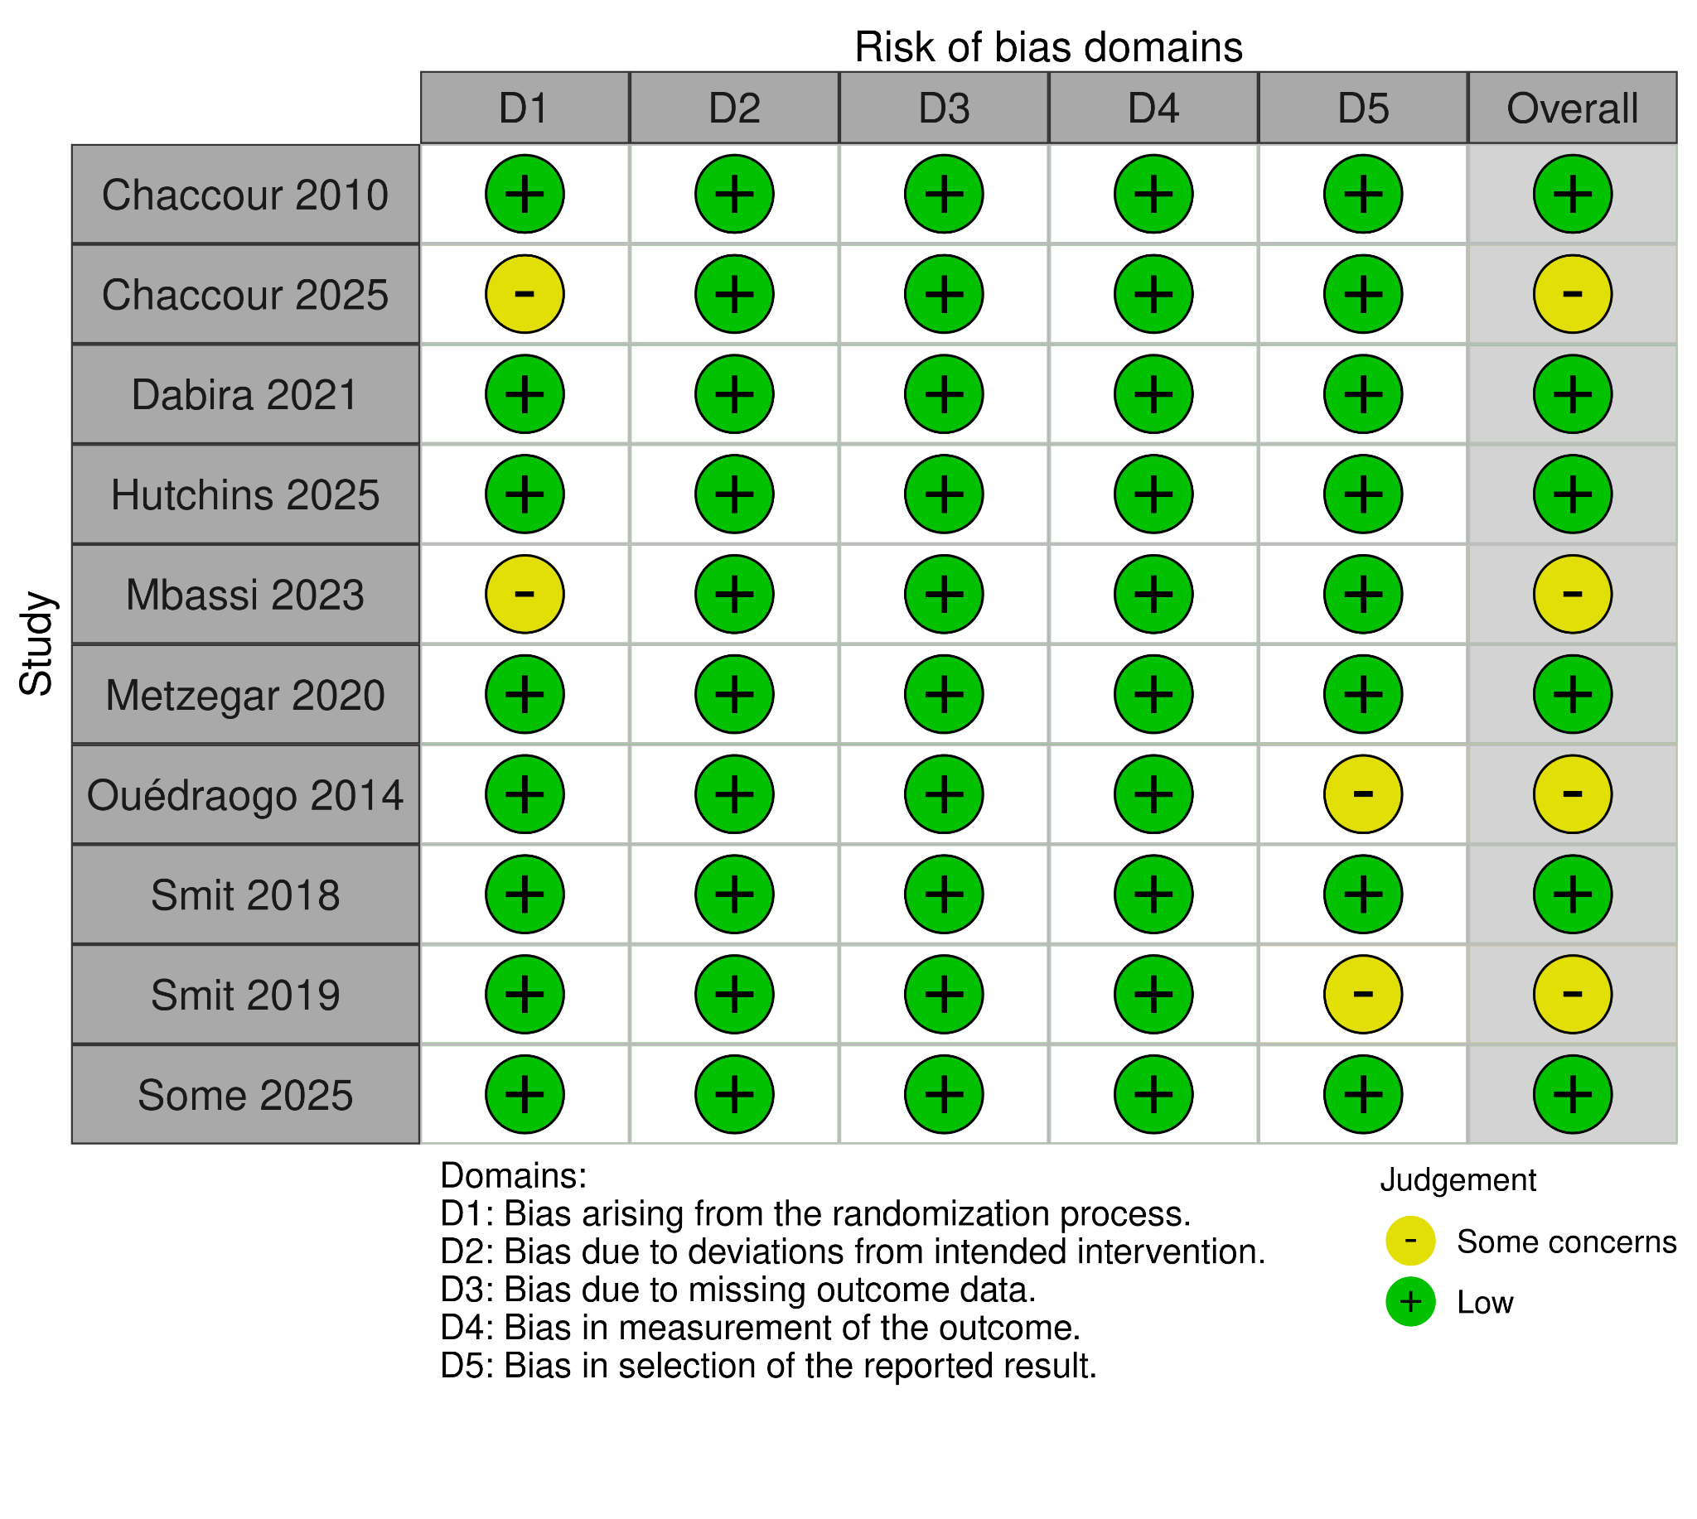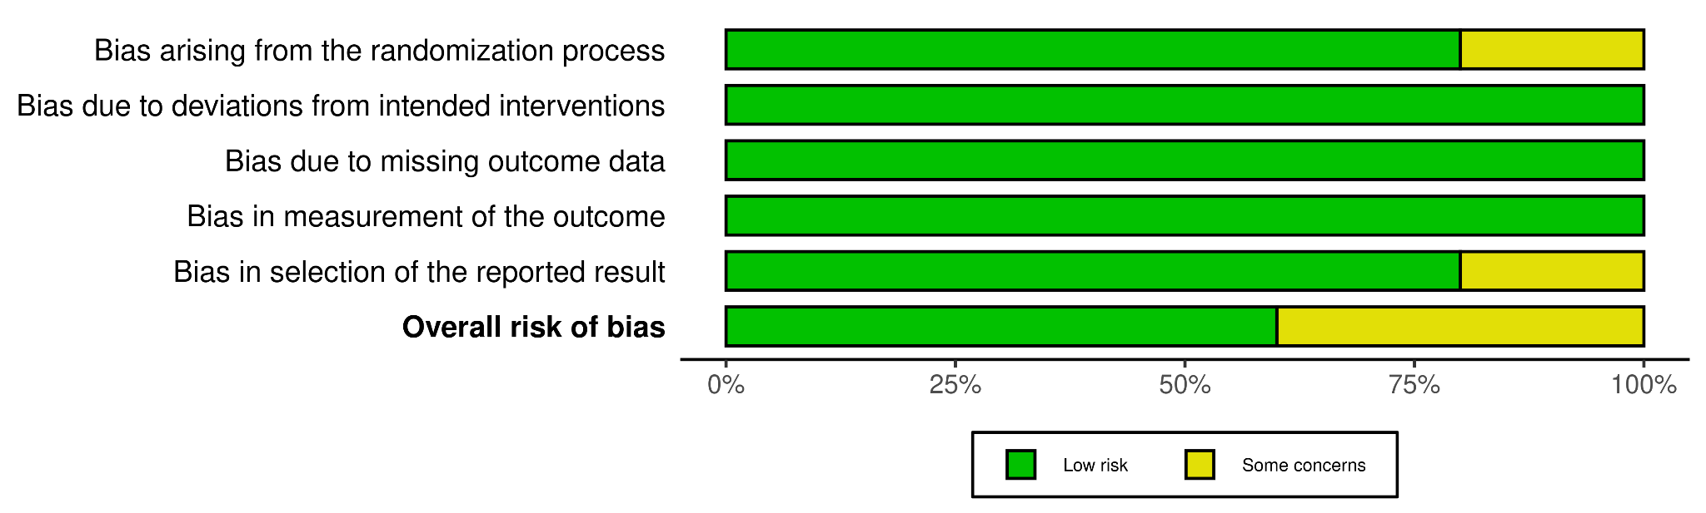
Supplementary Figure 2. Leave-one-out analysis for mosquito Mortality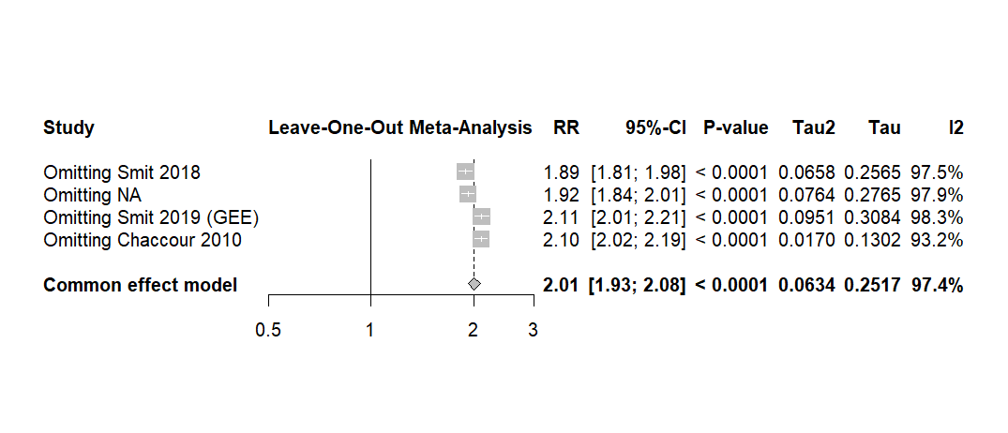

Supplementary Figure 3. Random-effect meta-analysis of Pyrexia rates
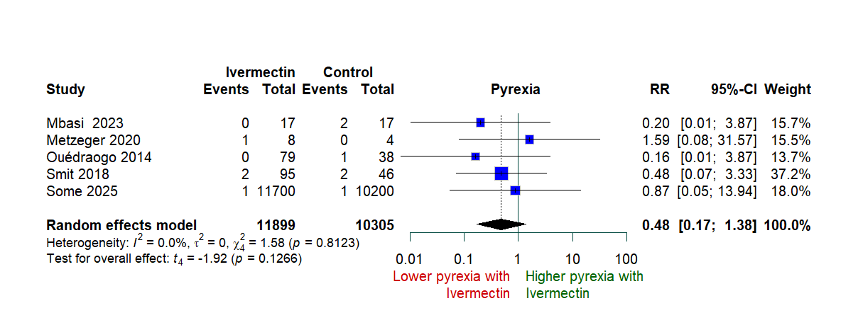

Supplementary Figure 4. Random-effect meta-analysis of Fatigue rates 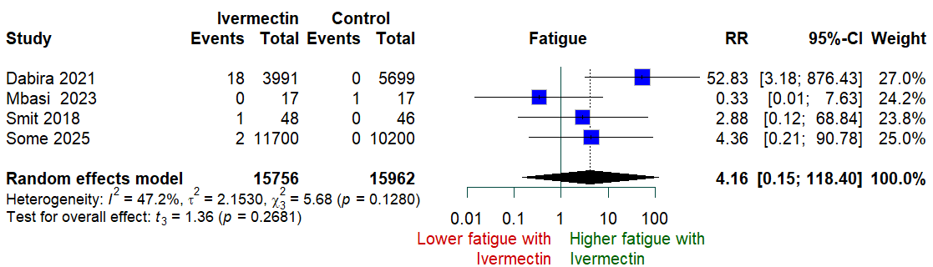

Supplementary Figure 5. Random-effect meta-analysis of Headache rates
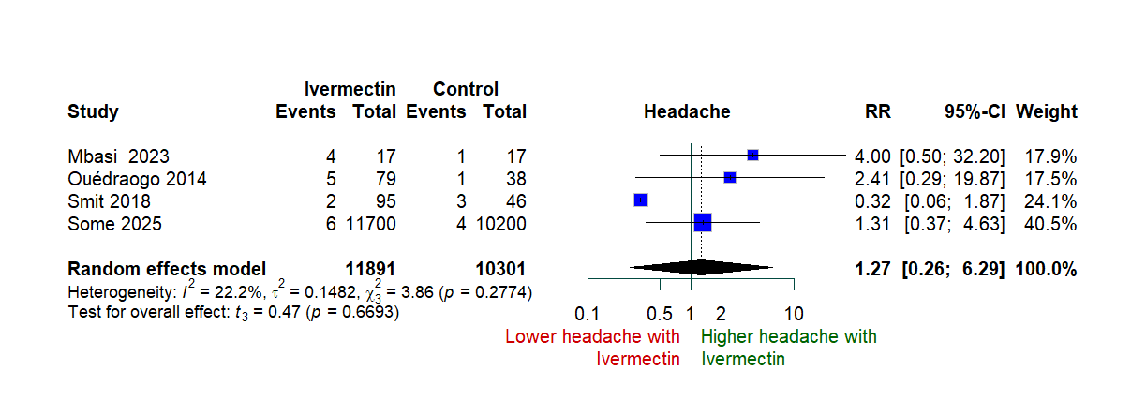

Supplementary Figure 6. Random-effect meta-analysis of Arthralgia rates
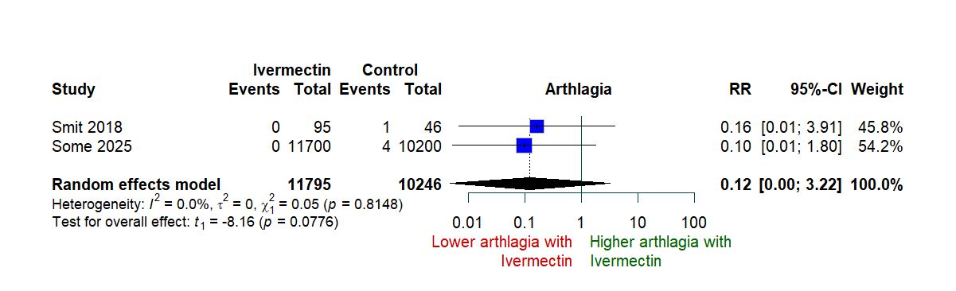

Supplementary Figure 7. Random-effect meta-analysis of Pharyngitis rates
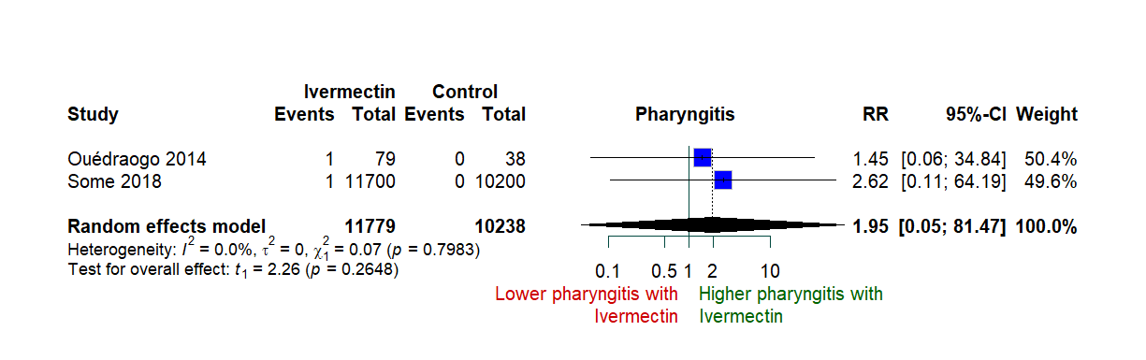

Supplementary Figure 8. Random-effect meta-analysis of Gastrointestinal Disorders rates
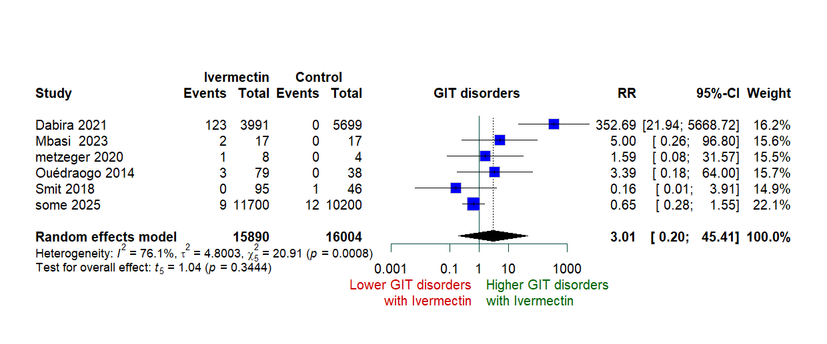

Supplementary Figure 9. Leave-one-out analysis for Gastrointestinal Disorders rates
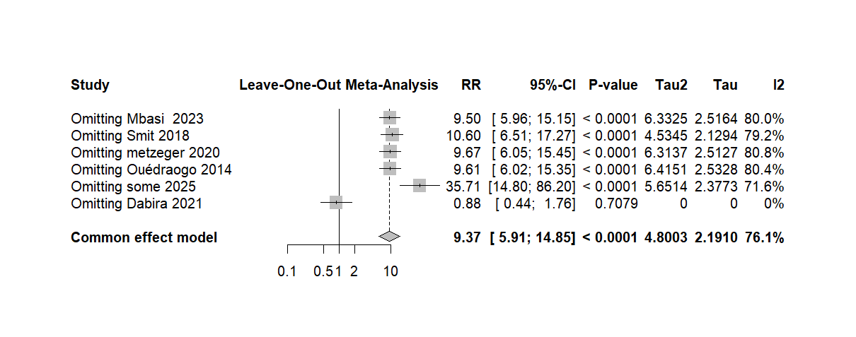

Supplementary Figure 10. Random-effect meta-analysis of Visual disturbance
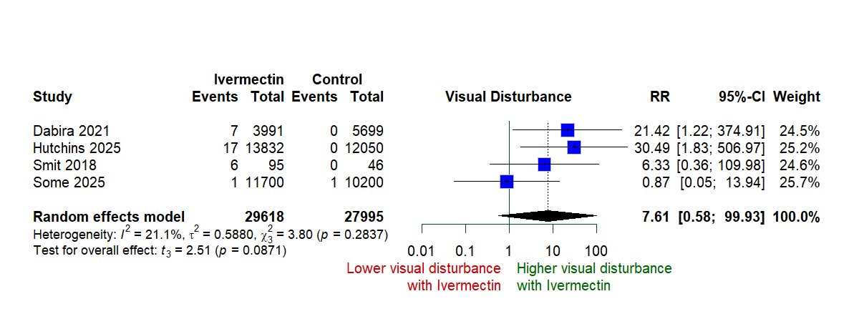

Supplementary Figure 11. Random-effect meta-analysis of Conjunctivitis
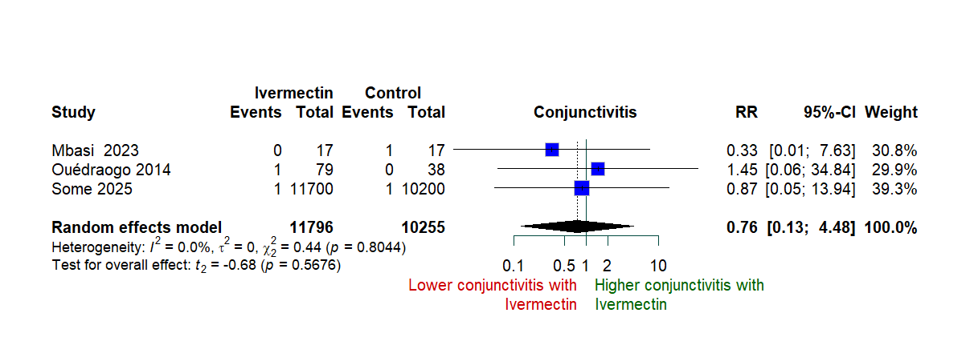

Supplementary Figure 12. Random-effect meta-analysis of Cardiovascular Disorders rates
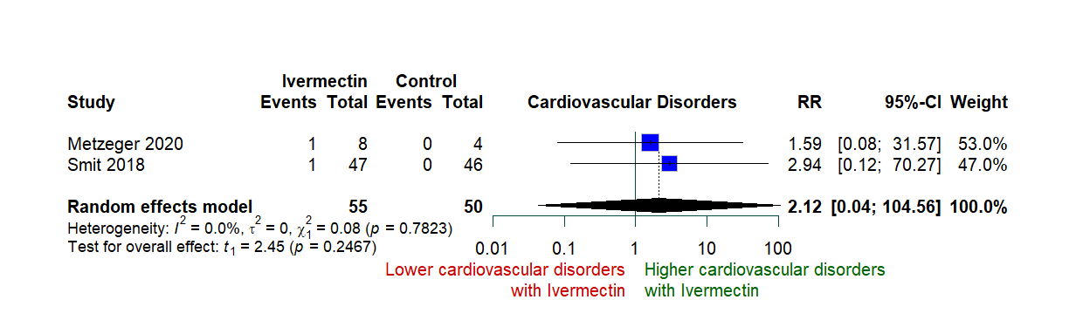

Supplementary Figure 13. Random-effect meta-analysis of Urinary tract infection rates
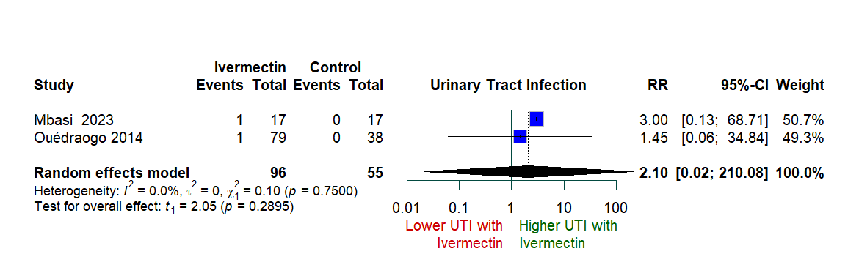

Supplementary Table 2. Table of excluded studies

Study ID | Reason of exclusion
Alout 2014 | Wrong design, observational study
Chaccour 2023 | Protocol
Derua 2015 | Wrong population, healthy volunteers
Mekuriaw 2019 | Wrong population, healthy volunteers
Pinilla 2018 | Wrong population, healthy volunteers
Foy 2019 | Primary outcomes reported only in children < 5 years; adult outcomes not available for pooling; cluster-level data prevented extraction for meta-analysis
Fabrice 2025 | Wrong population, healthy participants
Foy 2023 | Protocol
Foley 2000 | Wrong population, healthy volunteers

Supplementary Table 3. Data Table
Outcome | Study | Intervention | Event | Total | Control Event | Control Total
Mosquito Mortality: Direct Feeding
 | Smit 2018 | IVM 600 μg/kg/day ×3 | 918 | 950 | 392 | 946
 | Smit 2019 (GEE) | IVM 300 μg/kg/day ×3 | 941 | 1015 | 392 | 946
 | Chaccour 2010 | IVM 200 μg/kg | 255 | 267 | 179 | 250
Malaria Prevalence
 | Hutchins 2025 | IVM 300 μg/kg/day ×3 | 141 | 2083 | 118 | 2300
 | Dabira 2021 | IVM 300–400 μg/kg | 140 | 2722 | 324 | 2529
†Smit 2018: High-dose regimen (600 μg/kg/day ×3 days) with DHA-PQ; membrane feeding assay
‡Smit 2019: GEE-adjusted analysis; direct skin + membrane feeding on post-treatment day 7
§Chaccour 2010: Single 200 μg/kg dose; direct skin feeding 24h post-dose

