Supplementary Material/ Appendix
Table 1: Categories used to classify aquatic habitat types and physio-chemical characteristics.
Feature Category | Description | Measurement Method
Habitat Type  (category) | River streams (including stream pools formed after the evaporation), ground pools (such as marshes, swamps, and ponds), ditches (found within rice fields, beside rivers, and alongside roads), rice fields, spring-fed wells (comprising dug holes for spring water), pits (including brick pits and construction pits), puddles, hoofprints, and tire tracks | Visual observation
Water Movement | Slow, fast (moving), Stagnant | Visual observation, using dry stick
Water clarity | Clear, coloured (non-polluted), polluted | Visual observation
Water Source | Rainwater (surface water), non-rainwater (groundwater) | Local knowledge, visual observation
Water Permanence | Permanent- have water all year and historical stability across multiple seasons,  Semi-permanent - ones fluctuate but mostly retain water at least six months in a year,  Temporary - only have water temporarily mostly occurs during wet seasons, | Local knowledge, visual observation
Presence of vegetation | None or vegetated | Visual observation
Vegetation type | None, floating, emergent | Visual observation
Presence of algae | None or present | Visual observation
Algae type | Filamentous, green, blue-green, brown | Visual observation
Water Depth | Measured in cm, < 10 cm, 10-50 cm, > 50 cm | Long stick and measuring tape
Habitat Size, surface area | Measured in square meters, < 10 m², 10-100 m², 100-250 m², > 250 m² | GPS, measuring tape
Shade/canopy | Partial, heavily/fully (shaded), none | Visual observation
Surrounding Environment | Scrub/bush, cattle grazing, cultivated fields, residential area | Visual observation
Distance to the nearest house | Measured in square meters, < 100 m, 100-500 m, > 500 m | GPS

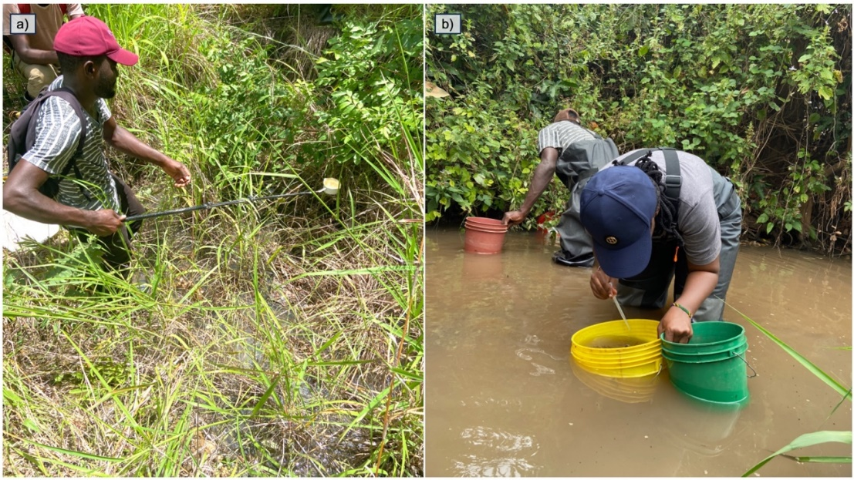
Figure 1: sampling techniques, a.) standard dipping b.) dipping using 10l bucket.

Table 2: Summary of Statistical Models used to include the primary response variable, explanatory variables, random effect variables, and statistical distribution used.
Model | Response variables | Fixed Effect variables | Random effect  variables | Statistical distribution
1 | Availability of aquatic habitats (water and non-water classes) | Multispectral images with 8 bands: band 1 (coastal blue), band 2 (blue), band 3 (green i), band 4 (green), band 5 (yellow), band 6 (red), band 7 (red edge), band 8 (near-ir) | NA | Binomial distribution for binary classification
2 | Presence or absence of An. funestus (positivity) | Season + Habitat type + Village + Habitat size + Water permanence + Water depth + Watercolor + Water source + Water movement + Algae type + Presence of shades + Vegetation + Distance from home + Habitat type: Season | Date | Binomial
3 | Densities of An. funestus larvae (abundance) | Season + Habitat type + Village + Habitat size + Water permanence + Water depth + Watercolor + Water source + Water movement + Algae type + Presence of shades + Vegetation + Distance from home + Habitat type: Season | Date | Negative binomial distribution with zero inflation
Model 1 is a classification tree model. For model 2 and 3, an offset term based on the volume of the water sample was included to account for variations in sampling effort, “:” indicates an “interaction”.
Table 3: Summary of stepwise model reduction for predicting An. funestus presence. The table shows the chi-squared statistics, degrees of freedom (d.f.), and p-values for the likelihood ratio test of each variable.
Deleted Variable | Chi-Sq | d.f. | P
Habitat size | 4.52 | 3 | 0.2108
Season * Village | 8.91 | 4 | 0.0633
Distance from home | 5.72 | 2 | 0.0573
Water type | 3.42 | 1 | 0.0644
Included variables
Season | 116.98 | 4 | <0.001
Habitat type | 58.34 | 6 | <0.001
Village | 147 | 4 | <0.001
Water depth | 12.09 | 2 | 0.0023
Water colour | 66.01 | 1 | <0.001
Water source | 38.39 | 1 | <0.001
Water movement | 5.66 | 1 | 0.0173
Algae type | 43.63 | 4 | <0.001
Shades | 15.72 | 1 | <0.001
Vegetation type | 57.49 | 3 | <0.001
Habitat type: Season | 49.62 | 3 | <0.001

Table 4: Summary of the coefficient estimate (β), standard errors, z values and p-value for each explanatory variable included in the logistic model for predicting the presence of An. funestus aquatic habitats.
 | Variable | β | Std error | z value | p-value
 | Intercept | -3.11 | 0.39 | -7.92 | <0.001
Season: Habitat type | Dry season: Ditch | 0.06 | 1.21 | 0.06 | 0.95
 | Dry season: Ground Pool | -1.35 | 0.55 | -2.44 | 0.015
 | Dry season: Dug pits | -3.23 | 0.58 | -5.51 | <0.001
Village | Ebuyu | 1.69 | 0.16 | 10.67 | <0.001
 | Ikungua | 0.17 | 0.16 | 1.07 | 0.28
 | Itete | 0.78 | 0.20 | 3.84 | <0.001
 | Sofi Majiji | 0.44 | 0.22 | 1.98 | 0.05
Water depth | Between 10-50 cm | 0.19 | 0.18 | 1.06 | 0.28
 | More Than 50 cm | 0.62 | 0.22 | 2.78 | 0.005
Water colour | Polluted | -1.29 | 0.17 | -7.51 | <0.001
Water source | Rainwater | 0.92 | 0.16 | 5.88 | <0.001
Water movement | Stagnant | -0.45 | 0.19 | -2.32 | 0.02
Algae type | Filamentous | 1.02 | 0.29 | 3.48 | <0.001
 | Green | 1.28 | 0.56 | 2.29 | 0.0221
 | Mixed | 0.79 | 0.39 | 2.03 | 0.042
 | None | 0.24 | 0.29 | 0.85 | 0.39
Shades | Shaded | 0.506 | 0.13 | 3.84 | <0.001
Vegetation type | Floating | -0.05 | 0.27 | -0.21 | 0.83
 | Mixed | 1.12 | 0.21 | 5.29 | <0.001
 | None | -0.42 | 0.12 | -3.36 | <0.001

Table 5: Summary of stepwise model reduction for predicting An. funestus abundance. The table shows the chi-squared statistics, degrees of freedom (d.f.), and p-values for the likelihood ratio test of each variable.
Variables | X² | df | p-value
Season | 106.69 | 32 | <0.001
Habitat type | 67.76 | 26 | <0.001
Village | 172.88 | 28 | <0.001
Habitat size | 12.05 | 29 | 0.007
Water type | 6.71 | 31 | 0.009
Distance from home | 11.09 | 30 | 0.003
Shades | 11.18 | 31 | 0.0008
Water depth | 23.96 | 30 | <0.001
Water source | 44.12 | 31 | <0.001
Algae type | 51.46 | 28 | <0.001
Water colour | 51.78 | 31 | <0.001
Vegetation type | 60.64 | 29 | <0.001
Habitat type: Season | 46.19 | 29 | <0.001

Table 6: Regression Coefficients from GLMM Model predicting An. funestus abundance.
 | Variable | β | Std. Error | z value | p-value
 | Intercept | -0.76 | 0.37 | -2.06 | 0.04 *
Season: Habitat type | Dry season: Ditch | -0.02 | 0.53 | -0.03 | 0.96
 | Dry season: Ground Pool | -1.26 | 0.36 | -3.44 | <0.001
 | Dry season: Dug pits | -2.52 | 0.53 | -4.70 | <0.001
Village | Ebuyu | 1.32 | 0.13 | 10.42 | <0.001
 | Ikungua | -0.14 | 0.16 | -0.91 | 0.36
 | Itete | 0.68 | 0.17 | 4.11 | <0.001
 | Sofi Majiji | 0.51 | 0.19 | 2.60 | 0.009 **
Habitat size | Between 10 - 100 m | 0.29 | 0.13 | 2.26 | 0.02 *
 | Between 100-250 m | 0.57 | 0.21 | 2.73 | 0.006 **
 | More than 250m | 0.06 | 0.14 | 0.43 | 0.66
Water type | Permanent | 0.51 | 0.20 | 2.47 | 0.01 *
Water depth | Between 10-50 cm | 0.20 | 0.14 | 1.38 | 0.16
 | More Than 50 cm | 0.65 | 0.17 | 3.82 | <0.001
Water colour | Polluted | -0.88 | 0.12 | -6.87 | <0.001
Water source | Rainwater | 0.83 | 0.13 | 6.20 | <0.001
Algae type | Filamentous | 0.83 | 0.24 | 3.41 | <0.001
 | Green | 0.62 | 0.37 | 1.68 | 0.09.
 | Mixed | 0.65 | 0.29 | 2.24 | 0.02 *
 | None | 0.19 | 0.24 | 0.80 | 0.42
Shades | Shaded | 0.33 | 0.10 | 3.27 | 0.001 **
Vegetation type | Floating | 0.23 | 0.19 | 1.18 | 0.23
 | Mixed | 0.73 | 0.13 | 5.43 | <0.001
 | None | -0.34 | 0.09 | -3.67 | <0.001
Distance from home | Between 100-500m | -0.01 | 0.15 | -0.07 | 0.94
 | More than 500m | 0.28 | 0.09 | 3.14 | <0.001
NB: Dug pits included spring fed wells and brick & concrete pits, rice field, tire track and hoofprints were removed from this analysis since they were only available in rainy season only

