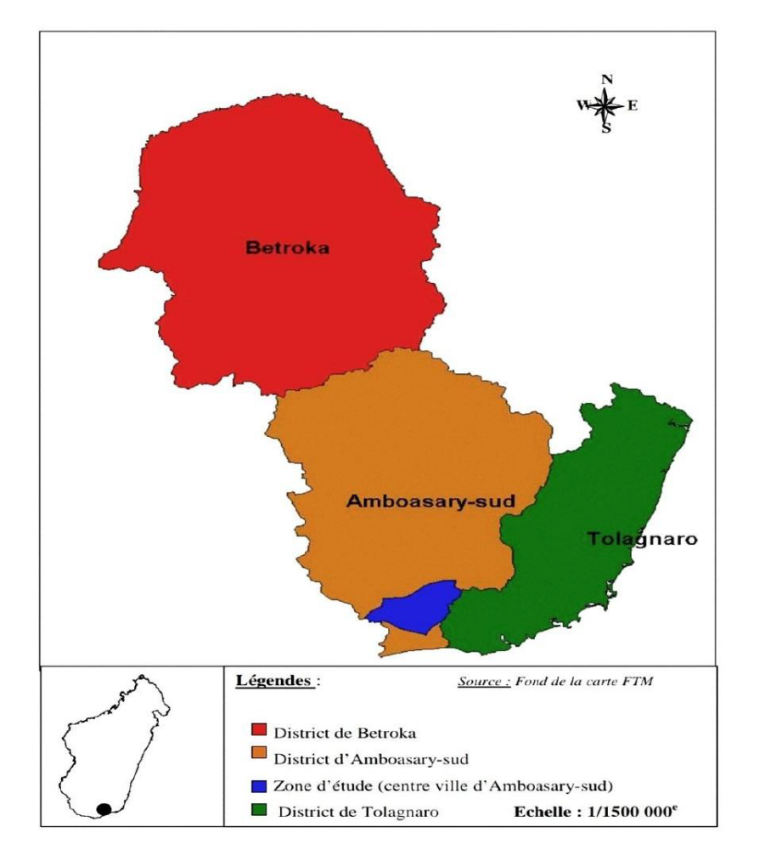
Figure 1 : "Map of the Anosy region, southern Madagascar, showing the location of Amboasary-Sud commune (Source: Foiben-Taosarintanin'i Madagasikara - FTM)

Study population
(Pregnant women in the health district of Amboasary-Sud town)
n=1579

Patients excluded
(no ANC attendance)
n=317

Final population
(pregnant women seen at ANC and registered in the records)
n=1262

Figure 2 : "Study flow diagram of pregnant women attending antenatal care in Amboasary-Sud, Madagascar, 2021.

