Supplementary Material

Table S1A. Sensitivity analysis: comparison of NB2 models with and without monthly fixed effects
ITS Parameter | Without monthly FE IRR (95% CI) | p | With monthly FE IRR (95% CI) | p | AIC without FE | AIC with FE
T (pre-COVID-19 trend) | 1.005 (1.000–1.010) | 0.032 | 1.005 (1.002–1.009) | 0.005 | 1457 | 1443
D₁ (March 2020) | 0.654 (0.560–0.762) | < 0.001 | 0.642 (0.566–0.728) | < 0.001 | 1457 | 1443
P₁ (post-March 2020) | 1.028 (1.016–1.039) | < 0.001 | 1.031 (1.021–1.040) | < 0.001 | 1457 | 1443
D₂ (Jan. 2022) | 0.760 (0.600–0.964) | 0.024 | 0.823 (0.664–1.020) | 0.076 | 1457 | 1443
P₂ (post-Jan. 2022) | 0.994 (0.965–1.024) | 0.698 | 0.983 (0.958–1.008) | 0.174 | 1457 | 1443
Note: Comparison of NB2 specifications with identical covariates and pre-specified ITS interruption points. FE = monthly fixed effects. AIC is reported for the model as a whole. Classical inference (non-HAC).

Table S1B. Sensitivity analysis: placebo test of the first interruption point date (NB2 with monthly fixed effects) .
Interruption point date 1 | D₁ IRR (95% CI) | P₁ Monthly IRR (95% CI) | AIC | BIC
January 2020 (placebo) | 0.627 (0.551–0.713) | 1.023 (1.015–1.032) | 1,444 | 1,494
March 2020 (selected date) | 0.642 (0.566–0.728) | 1.031 (1.021–1.040) | 1,443 | 1,493
May 2020 (placebo) | 0.735 (0.637–0.847) | 1.033 (1.021–1.045) | 1,459 | 1,509
Note: March 2020 shows the best AIC and the shock magnitude most consistent with the chronology of Cameroonian public health measures.

Table S2. National counterfactual analysis: cumulative and mean monthly notification differentials by phase (Cameroon, 2017–2022)
Period | Observed cases | Model-fitted cases | Counterfactual cases | Δ cases | Δ% (mean monthly)
Pre-interruption period (Feb. 2017–Feb. 2020) | 1,445,170 | 1,441,957 | 1,441,957 | 0 | 0.00 (0.00/month)
First post-interruption period (March 2020–Dec. 2021) | 1,039,540 | 1,041,031 | 1,110,739 | −69,708 | −6.28% (−3,168/month)
Second post-interruption period (Jan.–Dec. 2022) | 726,601 | 729,582 | 654,751 | +74,831 | +11.43% (+6,236/month)
Note: The counterfactual scenario was derived from the primary adjusted national NB2 model with monthly fixed effects, by constraining to zero all ITS parameters associated with the March 2020 and January 2022 interruption points (D₁, P₁, D₂, P₂). Mean monthly differentials were calculated by dividing Δ cases by the number of months in each phase (pre-COVID-19: 37 months from Feb. 2017 to Feb. 2020; COVID-19: 22 months; post-COVID-19: 12 months). The analysis period begins in February 2017 due to the one-month rainfall lag.

Table S3. Robustness of inference: classical vs. HAC standard errors (Newey–West, lag = 12 months)
ITS Parameter | Classical SE IRR (95% CI) | p | HAC SE (Newey–West) IRR (95% CI) | p
T (pre-COVID-19 trend) | 1.006 (1.003–1.010) | < 0.001 | 1.006 (1.000–1.013) | 0.038
D₁ (March 2020) | 0.631 (0.555–0.717) | < 0.001 | 0.631 (0.539–0.738) | < 0.001
P₁ (post-March 2020) | 1.031 (1.021–1.040) | < 0.001 | 1.031 (1.017–1.045) | < 0.001
D₂ (Jan. 2022) | 0.805 (0.647–1.000) | 0.050 | 0.805 (0.607–1.067) | 0.131
P₂ (post-Jan. 2022) | 0.984 (0.959–1.010) | 0.232 | 0.984 (0.960–1.009) | 0.203
Note: IRR point estimates are identical in both columns (same coefficients from the primary adjusted NB2 model); only standard errors, 95% CIs, and p-values differ according to the type of inference. HAC: Newey–West, Bartlett kernel, maximum lag = 12 months. The widening of confidence intervals and increase in p-values under HAC reflect correction for residual serial dependence.

Table S4. Monthly fixed effects from the primary adjusted national NB2 model (reference = January, N = 71 months)
Month (vs. January) | IRR | 95% CI | P-value
February | 0.845 | 0.738–0.967 | 0.014
March | 0.848 | 0.721–0.998 | 0.047
April | 0.816 | 0.641–1.038 | 0.098
May | 0.850 | 0.638–1.133 | 0.267
June | 0.843 | 0.643–1.103 | 0.213
July | 0.916 | 0.729–1.152 | 0.453
August | 1.284 | 0.935–1.762 | 0.122
September | 1.186 | 1.008–1.396 | 0.040
October | 1.271 | 1.070–1.511 | 0.006
November | 1.083 | 0.887–1.323 | 0.434
December | 0.950 | 0.743–1.214 | 0.683
Note: NB2 model with log offset (population <5 years), adjusted for ITS terms and covariates. A relative elevation of adjusted notifications is observed in September–October compared with January, consistent with the end-of-year transmission peak documented in national time series.

Figure S1. Residual diagnostics of the adjusted negative binomial model with monthly fixed effects.
Panel A: Pearson residuals over time, with vertical dashed lines indicating March 2020 (D₁) and January 2022 (D₂). Panels B and C: autocorrelation function (ACF) and partial autocorrelation function (PACF) of Pearson residuals, respectively. Panel D: Cook's distance by month, with the conventional influence threshold (4/n).
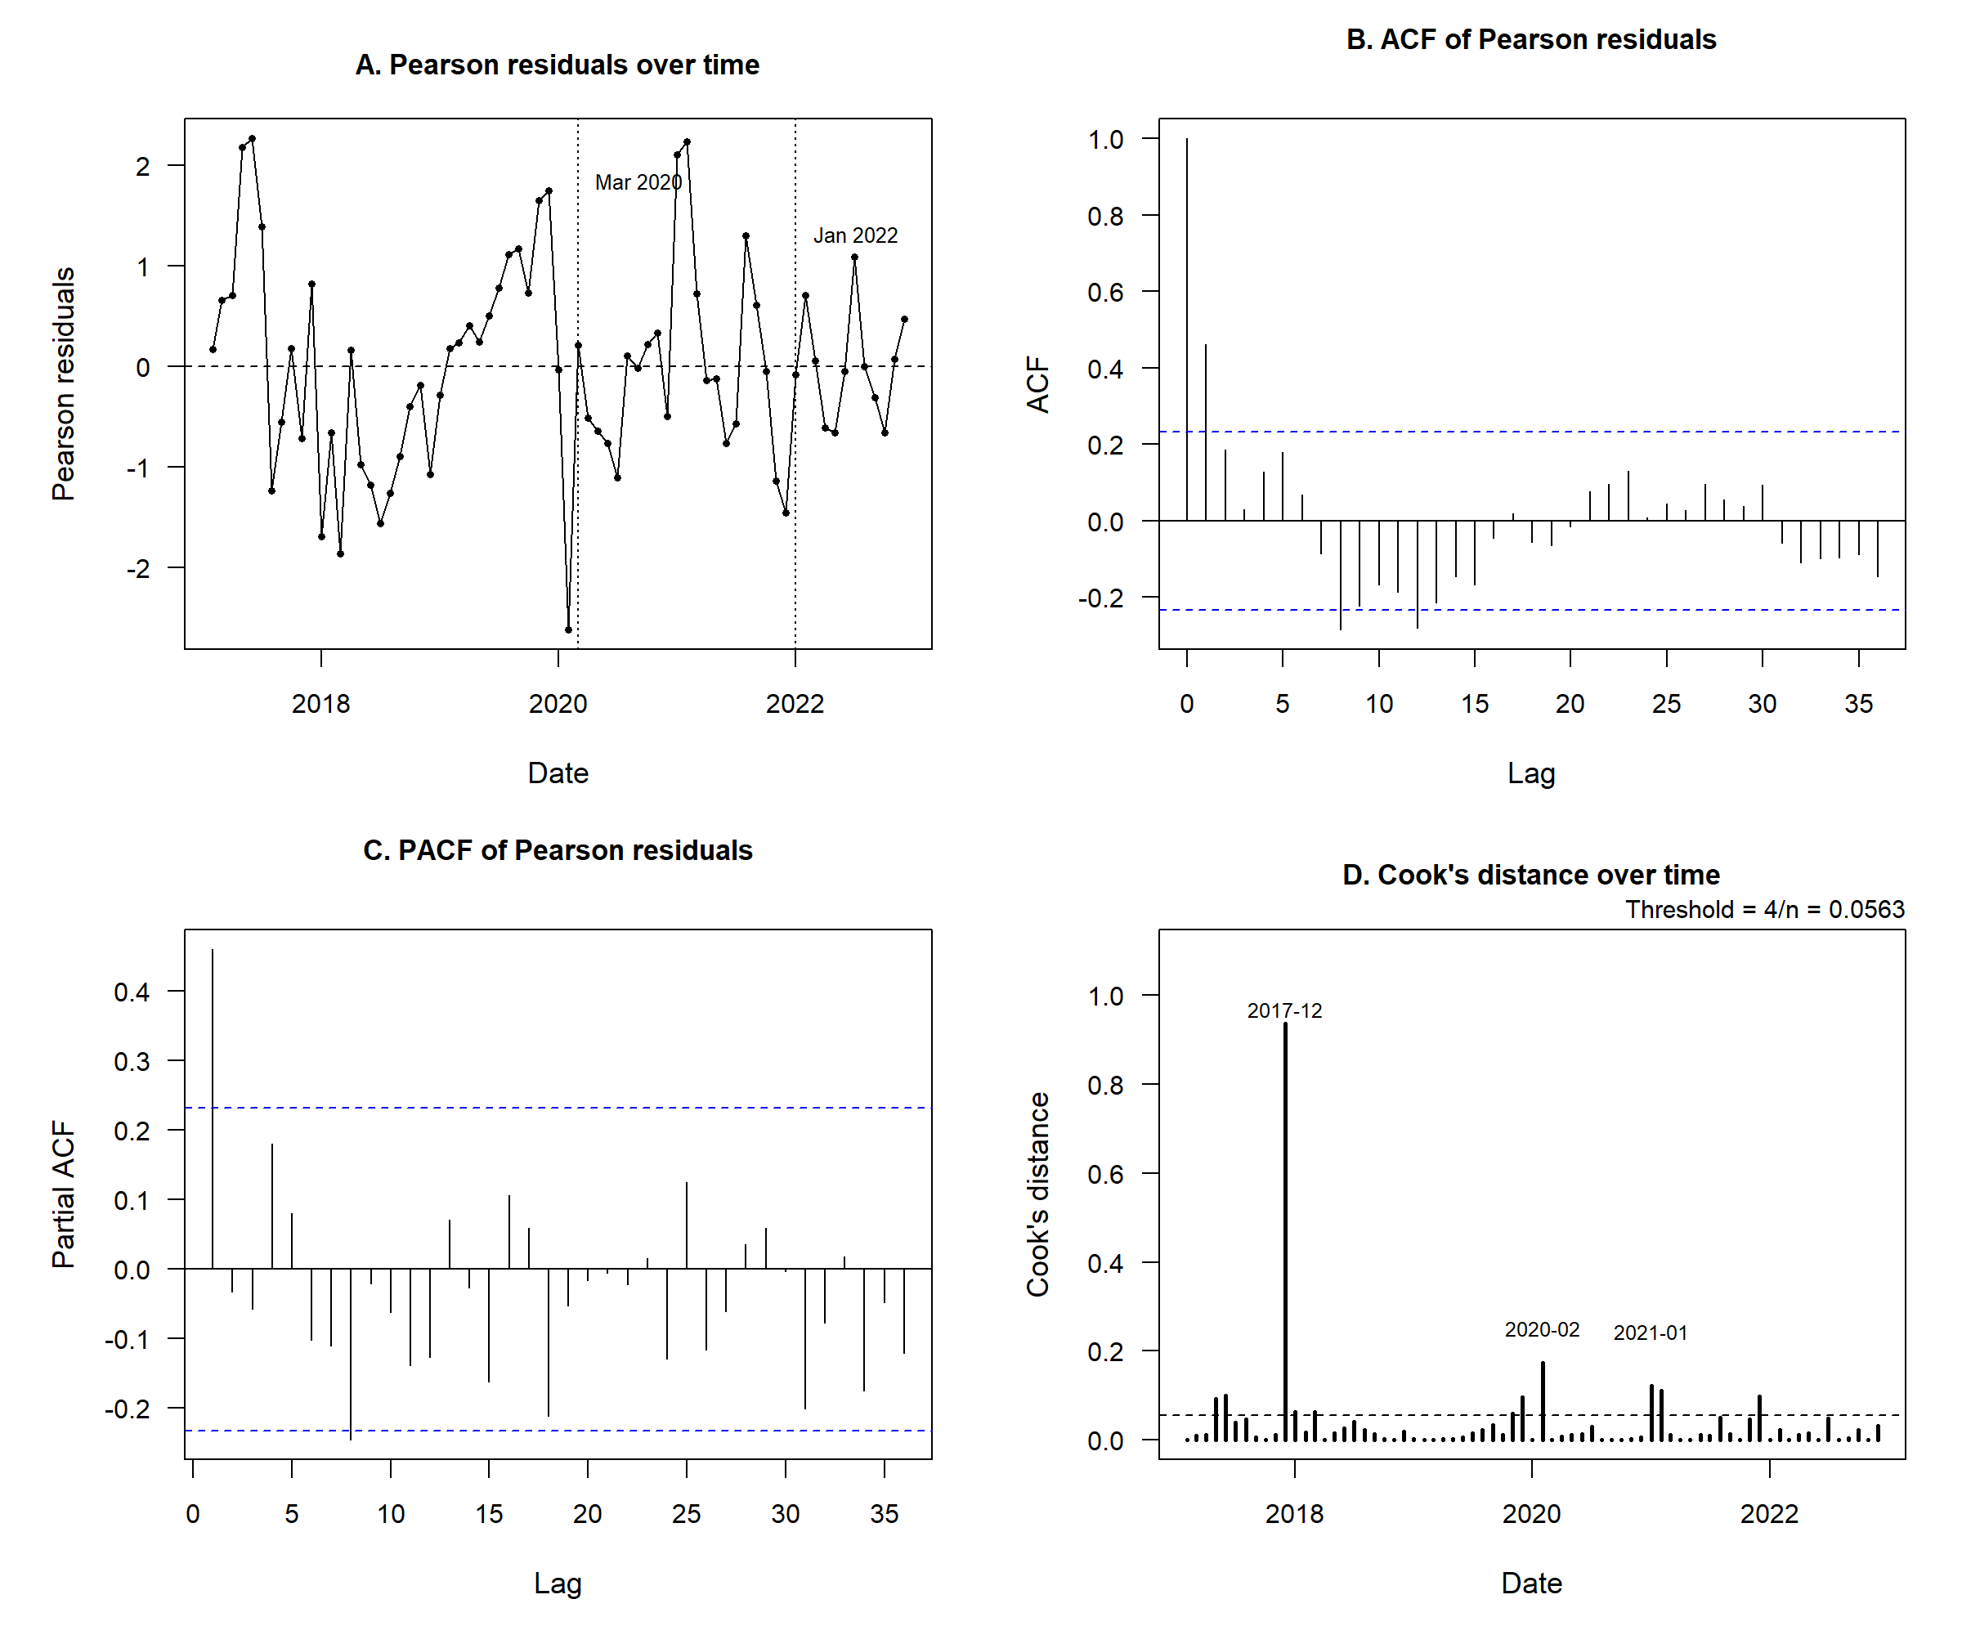

Figure S2. ITS analytical structure and national estimates from the unadjusted, adjusted, and HAC-robust models.

Panel A shows the interrupted time series analytical structure, including the pre-interruption period, the first post-interruption period, the second post-interruption period, and the two predefined interruption points. Panels B and C display incidence rate ratios and 95% confidence intervals for immediate level changes and trend/slope changes, respectively, across the unadjusted NB2 model, the adjusted NB2 model with classical inference, and the adjusted NB2 model with Newey–West HAC-robust inference. The vertical reference line indicates IRR = 1.
