The effect of mefloquine dose on outcome of uncomplicated falciparum malaria treated with artesunate-mefloquine: a WWARN systematic review and individual patient data meta-analysis.
The WWARN AS-MQ Dose Impact Study Group

Supplementary Material

1. Supplementary methods 4
1-1. Systematic Review of literature methods 4
1-2. Data Acquisition 5
1-3. Variable definitions 6
1-4. Definition of Endpoints 6
1-5. Model building strategy 7
2. Drug doses in the Fixed dose combination 7
Supplementary Table 2: Recommended AS and MQ dose in the FDC. 7
3. Main Analysis Supplementary Tables 8
Supplementary Table 3. Univariable analysis of parasite positivity on Day 2. 8
Supplementary Table 4. Univariable analysis of parasite positivity on Day 3 in Asia. 10
Supplementary Table 5. Kaplan Meier estimates of the proportion of patients with recrudescence by day 42. 12
Supplementary Table 6. Univariable analysis of recrudescence by day 42. 14
Supplementary Table 7. Univariable analysis of recrudescence by day 28. 16
Supplementary Table 8. Univariable analysis of recrudescence by day 63. 18
Supplementary Table 9. Univariable analysis of reinfection by day 42. 20
Supplementary Table 10. Univariable analysis of reinfection by day 28. 22
Supplementary Table 11. Univariable analysis of reinfection by day 63. 24
Supplementary Table 12. Univariable analysis of presence of gametocytes on day 7 in patients with gametocytaemia on enrollment. 26
Supplementary Table 13. Univariable analysis of presence of gametocytes on days 7-14 in patients without gametocytaemia on enrollment. 28
Supplementary Table 14. Multivariable analysis for Gametocyte carriage 31
Supplementary Table 15. Univariable analysis of presence of anaemia on day 7. 32
Supplementary Table 16. Serious Adverse Events and neurological adverse events in patients treated with AS-MQ 34
Supplementary Table 17. Proportion of patients with vomiting, days 0-3, by study 37
Supplementary Table 18. Proportion of patients with diarrhoea, days 0-3, by study 37
Supplementary Table 19. Univariable analysis of vomiting and diarrhoea on day 1-3. 38
Supplementary Table 20. Univariable analysis of vomiting and diarrhoea during 24h post dose. 40
4. Main Analysis Supplementary Figures 43
Supplementary Figure 1. Map of study sites 43
Supplementary Figure 2. Artesunate (panel A) and mefloquine (panel B) doses administered by weight, by study 44
Supplementary Figure 3. Artesunate (panel A) and mefloquine (panel B) doses administered, by treatment formulation 45
Supplementary Figure 4. Artesunate (A) and mefloquine (B) doses administered, by weight 46
Supplementary Figure 5. Day 2 positivity by study 47
Supplementary Figure 6. Day3 parasite positivity by study 48
Supplementary Figure 7. MQ dose by 24H effect for positivity on Day 2 by study 49
Supplementary Figure 8. MQ dose effect by study for parasite positivity on Day 3 in Asia 50
Supplementary Figure 9. Mefloquine dose (mg/kg) received at 24h by region. Data in Asia and South America include 2-dose regimens. Only 3-dose regimens were studied in Africa 51
Supplementary Figure 10. Recrudescence by study – outcome day 28,42,63 52
Supplementary Figure 11. Kaplan-Meier estimates of proportion of patients with recrudescence by region and artemisinin resistance level 53
Supplementary Figure 12. MQ dose effect for recrudescence by study 54
Supplementary Figure 13. Reinfection by study 55
Supplementary Figure 14. Kaplan-Meier estimate of proportion of patients with reinfection, by transmission intensity 57
Supplementary Figure 15: MQ dose effect for reinfection by study 58
5. Sensitivity analysis 60
Supplementary Figure 16. Estimates (95% CI) of the dose effect (as in multivariable analysis tables) after exclusion of one study at a time. Study ID of the excluded study is shown on the x-axis. All – denotes estimates from the model fitted on all data. Estimates are OR, HR, RR or IRR 61
Supplementary Figure 17. Estimates (95% CI) for the comparison between different MQ regimens after exclusion of one study at a time. The comparison group is 3-dose loose regimen. Study ID of the excluded study is shown on the x-axis. All – denotes estimates from the model fitted on all data. Estimates are OR, HR, RR or IRR 62
Supplementary Figure 18. Estimates (95% CI) of the dose effect ( as in multivariable analysis tables) after exclusion of one manufacturer at a time, for supervised data , and for studies using at least 3 markers for PCR genotyping. All – denotes estimates from the model fitted on all data. Estimates are OR, HR, RR or IRR 63
Supplementary Figure 19. Estimates (95% CI) for the comparison between different MQ regimens after exclusion of one manufacturer at a time, for supervised data only, and for studies using at least 3 markers for PCR genotyping. All – denotes estimates from the model fitted on all data. Estimates are OR, HR, RR or IRR 64
5 Supplementary References 65

Supplementary methods

Systematic Review of literature methods

Protocol and registration
A protocol for this systematic review has been published¹. The systematic review was registered with PROSPERO on 10th August 2018, and was last updated on 25th February 2019 (registration number CRD42018103776).
Identifying studies – information sources
Studies were identified by searching PubMed (1966 to present), EMBASE via OVID (1974 to present), BIOSIS via Web of Science (1969 to present) and Web of Science Core Collection via Web of Science (1969 to present). The search was carried out on 31st October 2018. The WWARN IPD repository was searched for additional studies.
Identifying studies – search
No limits were used for these searches.
PubMed
((("plasmodium falciparum"[MeSH Terms] OR ("plasmodium"[All Fields] AND "falciparum"[All Fields]) OR "plasmodium falciparum"[All Fields]) OR falciparum[All Fields]) OR ("malaria"[MeSH Terms] OR "malaria"[All Fields])) AND (((((artesunate-mefloquine[All Fields] OR artesunate/mefloquine[All Fields]) OR ASMQ[All Fields]) OR AS-MQ[All Fields]) OR AS/MQ[All Fields]) OR (("artesunate"[Supplementary Concept] OR "artesunate"[All Fields]) AND (("mefloquine"[MeSH Terms] OR "mefloquine"[All Fields]) OR MQ[All Fields])))
EMBASE
(plasmodium falciparum.mp. OR Plasmodium falciparum/ OR falciparum.mp. OR (falciparum.mp. AND (Plasmodium/ OR plasmodium.mp.)) OR malaria.mp. OR malaria/) AND (artesunate-mefloquine.mp. OR ASMQ.mp. OR AS-MQ.mp. OR ((artesunate/ OR artesunate.mp.) AND (mefloquine/ OR mefloquine.mp. OR MQ.mp.))
BIOSIS
(TS=(plasmodium falciparum) OR (TS=(falciparum AND plasmodium)) OR TS=(falciparum) OR TS=(malaria)) AND TS=(artesunate-mefloquine) OR TS=(ASMQ) OR TS=(AS-MQ) OR (TS=(artesunate) AND TS=(mefloquine OR MQ))
Web of Science Core Collection
(TS=(plasmodium falciparum) OR (TS=(falciparum AND plasmodium)) OR TS=(falciparum) OR TS=(malaria)) AND TS=(artesunate-mefloquine) OR TS=(ASMQ) OR TS=(AS-MQ) OR (TS=(artesunate) AND TS=(mefloquine OR MQ))
Study selection processes
Results were imported into EndNote and deduplication carried out automatically and manually. One reviewer screened all non-duplicate results and assigned reason for ineligibility. A second reviewer screened the results determined to be ineligible by the first reviewer. A third and fourth reviewer screened the results determined to be eligible by the first reviewer. Disagreements regarding reason for ineligibility and eligibility status were resolved by discussion.
Study Eligibility
Inclusion criteria
- Prospective clinical efficacy study of uncomplicated P. falciparum (either alone or mixed infections)
- Assessing the efficacy of a fixed-dose ASMQ combination, either as single tablet type, or co-blister pack of more than one tablet type, or assessing the efficacy of a loose combination of ASMQ
- Where AS was given over three days (with any number of doses per day) with a target total dose of 6-30mg/kg
- Where MQ was given over 2-3 days, on any of days 1-3 (with any number of doses per day) with a target total dose of 15-33mg/kg, which if MQ is split over two days, must be split 10mg/kg for the first day, and 15mg/kg the second day.
- Where all AS and MQ were administered orally
- With a minimum of 28 days follow up
- With genotyping performed for late parasite recurrence where there were treatment failures after day 7 (D7), and when patients were not retained in hospital for 28 days of follow-up.
- With individual patient data on dosage of mefloquine received (actual or per protocol) by patients (dosage per tablets, number of tablets given per dose and duration of treatment)

Exclusion criteria
- Where other antimalarial drugs were given in addition to the initial ASMQ treatment regimen, except for a single dose of primaquine of 0.25mg/kg in the first 3 days
- Where all participants are pregnant
- Where publication states that follow-up visits are less often than weekly
Participant Eligibility
Exclusion criteria
- Pregnant
- Received other antimalarial drugs during follow-up before recorded P. falciparum treatment failure
- Results of genotyping performed for late parasitological outcome are not available
- No or missing Plasmodium falciparum infection on enrolment
- Data on age and (or) weight and (or) gender are missing
- Any of these other deviations, as defined by Clinical Module DMSAP [1]:
- Haemoglobin < 5 g/dL on day 0
- Haematocrit < 15% on day 0

Data Acquisition
Investigators of studies satisfying the inclusion criteria were invited to participate in this IPD meta-analysis. Individual study protocols were available for all trials included, either from the publication or as a metafile submitted with the raw data. Individual patient data from eligible studies were previously shared with WWARN, collated and standardised using previously described methodology.¹ Analysis was conducted on data extracted as of 31 May 2024.

Variable definitions
The doses of artemisinin and mefloquine received were calculated from the number of daily tablets administered to each patient. If the daily tablet counts were not available, doses were back-calculated using the dosing scheme available from study protocols.
The study sites were classified into 3 categories of Plasmodium falciparum malaria transmission intensity: low, medium and high malaria based on the Plasmodium falciparum parasite prevalence (PfPR) estimates obtained from the Malaria Atlas Project for specific location and year of study (for methodology see ²). Study sites with a PfPR <0·10 were classified as low, with PfPR from 0·10 to <0·40 as moderate and with PfPR ≥0·40 as high transmission areas.³
Nutritional status was assessed in children < 5 years of age with standardised age, weight, height and gender specific growth reference according to the WHO 2006 recommendations using zscore06 stata command. The nutritional status of a child was given as a Z-score and classified as underweight (WAZ<-2), as defined in the WHO guidelines.^{4, 5}
In patients with missing haemoglobin concentration, haematocrit was converted to haemoglobin using the following relationship⁶:
$Hematocrit \left(ht\right)=5·62+2·60 ×Haemoglobin (hb)$
Anaemia was defined as severe when haemoglobin concentration was below 7g/dl and as moderate if haemoglobin concentration was between 7-10g/dL.

Definition of Endpoints

- Early Parasitological response
A pre-defined algorithm was used to estimate positivity status on days 2 or 3, if no observation of the blood film was recorded on that day as described in WWARN clinical Module DMSAP ¹. For studies with frequent or irregular sampling, a patient was classified as being positive on days 1, 2 and 3 after enrolment if the measurements within a window of ±2 hours of 24, 48 and 72 hours were positive.

- Plasmodium falciparum recrudescence
Recrudescence was defined as recurrence of asexual Plasmodium falciparum (Pf) parasitaemia of the same genotype(s) that caused the original illness, due to incomplete clearance of asexual parasites after antimalarial treatment.
For the analysis of Plasmodium falciparum recrudescence, event was defined as Polymerase Chain Reaction (PCR) confirmed Pf recrudescence. Patients who had a new infection (of any species) were censored at the first day the positive parasitaemia was recorded. Patients who had a reappearance of Pf parasites but the PCR result was not available were excluded from the analysis to avoid informative censoring.

- Plasmodium falciparum re-infection
Reinfection was defined as a new Pf infection that follows a primary infection; distinguished from recrudescence by the parasite genotype, which is often (but not always) different from that which caused the initial infection.
For the analysis of Plasmodium falciparum re-infection, failure were defined as PCR confirmed Pf re-infection. Patients who had a new infection other than Pf species or Pf recrudescence were censored at the first day the positive parasitaemia was recorded. Patients who had a reappearance of Pf parasites but the PCR result was available were excluded from the analysis to avoid informative censoring.

Model building strategy
For all multivariable analyses the same approach was used. The WHZ score, age category and ACT treatment were kept in the model regardless of their statistical significance. The remaining covariates were investigated for inclusion in the model using a general strategy recommended by Collett.⁷
- All possible risk factors were examined in a univariable analysis. The log-likelihood estimates $(-2×Log\hat{L})$ were compared against the null model to assess if any of the variables reduce its value at 5% level of statistical significance.
- All the variables identified in step (i) were fitted together in one model and variables which were not significant in the presence of other variables based on the results of the Wald test were identified.
- A likelihood ratio test was used to assess the impact of omitting variables identified in step (ii). If the omitted variable did not significantly impact the model log-likelihood, then they were dropped. Only variables which led to significant change in log-likelihood were retained.
- All variables excluded from step (i) were added to the model identified in step (iii) one by one to check if they provided any improvement to the model.
- A final check of the model identified in step (iv) was carried out to ensure that none of the variables in the model could be omitted without significantly increasing the model log-likelihood, and none of the excluded variables significantly reduced the model log-likelihood.
- In the final model identified in v) interaction term between ACT and WHZ was added and likelihood ratio test was used to assess the improvement to the model.
The underlying assumption of proportional hazards was tested in the final model using Schenfoeld residuals and reported when violated. For variables which violated the assumption, interaction between this variable and time intervals (0-28, 28-42 days) were considered for inclusion in the final model.
Fractional polynomials⁸ were used to adjust for the nonlinear relationship with continuous variables.

Drug doses in the Fixed dose combination

Supplementary Table 2: Recommended AS and MQ dose in the FDC.

Weight (kg) | Age | Recommended dose | AS total mg/kg | MQ total mg/kg
5-8 | 6 to 11 months | One tablet 25/55 mg daily for 3 days | 9.4 to 15 | 18.8 to 30
9-17 | 1 to 6 years | Two tablets 25/55 mg daily for 3 days | 8.8 to 16.7 | 17.6 to 33.3
18-29 | 7 to 12 years | One tablet 100/220 mg daily for 3 days | 10.3 to 16.7 | 20.7 to 33.3
>30 | >13 years | Two tablets 100/220 mg daily for 3 days | < 9.2 (if bw >65kg) to 20 | <18.5 (if bw >65kg) to 40
AS/MQ doses are shown in two different tablet strengths. Mefloquine HCl 55mg and 220 mg are equivalent to 50mg and 200mg mefloquine respectively

Main Analysis Supplementary Tables

Supplementary Table 3. Univariable analysis of parasite positivity on Day 2.
Logistic regression models with random intercept models for study-site were fitted. Models for Asia are adjusted for artemisinin resistance level.
 | Asia |  |  |  | Africa |  |  |  | South America
 | N | % | OR (⁹5% CI) | P-value | N | % | OR (95% CI) | P-value | N | % | OR (95% CI) | P-value
Number of MQ doses
Three | 1579 | 36.9 | 2.05 (1.57 - 2.69) | <0.001 | 1250 | 3.8 |  |  | 420 | 4.5 |  | 0.250*
Two | 2775 | 12.1 | Reference |  |  |  |  |  | 52 | 0
MQ dose (mg/kg) at 24h | 4354 | 21.1 | 0.93 (0.90 - 0.96) | <0.001 | 1250 | 3.8 | 1.00 (0.86 - 1.15) | 0.946 | 472 | 4.0 | 0.67 (0.47 - 0.95) | 0.025
Total MQ dose (mg/kg) over first 24h | 4354 | 21.1 | 1.02 (0.98 - 1.07) | 0.277 | 1250 | 3.8 | 1.00 (0.93 - 1.07) | 0.946 | 472 | 4.0 | 0.87 (0.72 - 1.06) | 0.172
Total AS dose (mg/kg) | 4354 | 21.1 | 1.02 (0.95 - 1.09) | 0.636 | 1250 | 3.8 | 1.00 (0.92 - 1.09) | 0.926 | 472 | 4.0 | 0.89 (0.69 - 1.15) | 0.363
Drug formulation
Fixed, 3 MQ doses | 415 | 39.5 | 0.76 (0.45 - 1.27) ¹ | 0.287 | 796 | 5.2 | 4.13 (0.56 – 30.42)² | 0.164 | 162 | 5.6 | 1.46 (0.58 - 3.67) | 0.423
Loose, 2 MQ doses | 2775 | 12.1 | 0.42 (0.29 - 0.62) | <0.001 | 0 |  |  |  | 52 | 0 |  | 0.223*
Loose, 3 MQ doses | 1164 | 35.9 | Reference |  | 77 | 1.3 | Reference |  | 258 | 3.9 | Reference
Co-blister, 3 MQ doses | 0 |  |  |  | 377 | 1.6 | 1.23 (0.15 – 10.36) | 0.850 | 0
Supervision
Partial | 605 | 27.9 | 1.27 (0.37 - 4.31) | 0.702
Full | 3749 | 20.0
Age (years) | 4354 | 21.1 | 0.99 (0.98 - 1.00) | 0.001 | 1250 | 3.8 | 0.98 (0.94 - 1.02) | 0.354 | 472 | 4.0 | 1.01 (0.98 - 1.04) | 0.411
Age group
< 1 year | 0 |  |  |  | 61 | 6.6 | 2.53 (0.69 - 9.28) | 0.163 | 0
1 to <5 years | 203 | 17.2 | 1.82 (1.17 - 2.84) | 0.008 | 562 | 4.4 | 1.72 (0.71 - 4.20) | 0.233 | 0
5 to <12 years | 622 | 18.2 | 1.33 (1.03 - 1.73) | 0.031 | 331 | 3.3 | 1.27 (0.48 - 3.38) | 0.635 | 74 | 4.1 | 1.01 (0.29 - 3.54) | 0.992
≥ 12 years | 3528 | 21.8 | Reference |  | 296 | 2.7 | Reference |  | 397 | 4.0 | Reference
Underweight (<5 years of age)³
Yes | 67 | 7.5 | 0.31 (0.09 – 1.09) | 0.067 | 98 | 2.0 | 0.38 (0.09 -1.64) |  | 0
No | 136 | 22.8 | Reference |  | 524 | 5.2 | Reference |  | 0
Sex
Male | 2854 | 22.1 | 1.21 (0.99 - 1.47) | 0.062 | 643 | 3.4 | 0.78 (0.44 - 1.40) | 0.412 | 284 | 4.9 | 1.90 (0.67 - 5.36) | 0.226
Female | 1500 | 19.1 | Reference |  | 607 | 4.3 | Reference |  | 188 | 2.7 | Reference
Haemoglobin (g/dL)⁴ | 4015 | 21.1 | 1.03 (0.99 - 1.07) | 0.122 | 1068 | 3.7 | 0.89 (0.73 - 1.07) | 0.213 | 472 | 4.0 | 0.95 (0.74 - 1.23) | 0.704
Moderate/Severe anaemia⁵
Yes | 490 | 14.7 | 0.94 (0.70 - 1.27) | 0.687 | 439 | 4.1 | 0.98 (0.49 - 2.00) | 0.965 | 31 | 3.2 | 0.78 (0.10 - 6.07) | 0.815
No | 3525 | 22.0 | Reference |  | 629 | 3.3 | Reference |  | 441 | 4.1 | Reference
Severe anaemia⁶
Yes | 22 | 9.1 | 0.69 (0.13 - 3.62) | 0.661 | 46 | 6.5 | 1.56 (0.45 - 5.44) | 0.484 | 0
No | 3993 | 21.2 | Reference |  | 1022 | 3.5 | Reference |  | 472 | 4.0
Temperature (C) | 3690 | 21.2 | 1.66 (1.52 - 1.82) | <0.001 | 1218 | 3.9 | 1.51 (1.11 - 2.05) | 0.009 | 472 | 4.0 | 1.49 (0.95 - 2.34) | 0.085
Fever or history of fever ⁷
Yes | 2247 | 25.2 | 2.29 (1.83 - 2.87) | <0.001 | 975 | 4.3 | 1.97 (0.80 - 4.82) | 0.139 | 338 | 4.4 | 1.51 (0.49 - 4.63) | 0.472
No | 1469 | 15.0 | Reference |  | 243 | 2.5 | Reference |  | 134 | 3.0 | Reference
Log10 Parasitaemia (/µL) | 4354 | 21.1 | 3.00 (2.63 - 3.44) | <0.001 | 1250 | 3.8 | 3.22 (1.73 - 6.00) | <0.001 | 472 | 4.0 | 3.98 (1.41 - 11.25) | 0.009
Hyperparasitaemia ⁸
Yes | 341 | 42.8 | 4.39 (3.30 - 5.85) | <0.001 | 162 | 8.6 | 2.93 (1.49 - 5.77) | 0.002 | 0
No | 4013 | 19.3 | Reference |  | 1088 | 3.1 | Reference |  | 472 | 4.0
Gametocytes on enrolment
Yes | 285 | 30.2 | 1.32 (0.97 - 1.82) | 0.082 | 63 | 1.6 | 0.38 (0.05 - 2.81) | 0.342 | 103 | 4.9 | 1.29 (0.45 - 3.68) | 0.629
No | 3630 | 21.1 | Reference |  | 1187 | 4.0 | Reference |  | 369 | 3.8 | Reference
Transmission Intensity⁹
High | 0 |  |  |  | 258 | 2.7 | 0.77 (0.27 - 2.24) | 0.636 | 0
Moderate | 0 |  |  |  | 306 | 4.6 | 1.18 (0.54 - 2.54) | 0.681 | 258 | 3.9 | 0.92 (0.37 - 2.30) | 0.856
Low | 4354 | 21.1 |  |  | 686 | 3.9 | Reference |  | 214 | 4.2 | Reference
¹comparison between Fixed, 3 MQ doses and Loose, 2 MQ doses: OR (95% CI)=1.69 (1.17-2.44), p=0.005.,² comparison between Fixed, 3 MQ doses and Loose, combined: OR (95% CI)=3.47 (1.54-7.69), p=0.003; ³Underweight defined in children <5 years of age, as weight-for age z-score <–2;⁴Ht converted to Hb using the formula $Hematocrit =5·62+2·60 ×Haemoglobin$ (Lee, 2008); ⁵Severe anaemia defined as haemoglobin <7 g/dL or haematocrit<20%; ⁶Moderate anaemia as 7 g/dL ≤haemoglobin <10 g/dL or 20%≤haematocrit<30%; ⁷Defined as temperature >37·5°C or reported history of fever; ⁸Defined as parasitaemia >10⁵/μL; ⁹Malaria transmission intensity defined from estimates of Plasmodium falciparum prevalence rate (PfPR) according to enrolment year and location, assuming low transmission for study sites with a PfPR <0·10, moderate transmission if PfPR 0·10 to <0·40, and high transmission if PfPR ≥0·40. *Fisher’s exact test

Supplementary Table 4. Univariable analysis of parasite positivity on Day 3 in Asia.
Logistic regression models with random intercept models for study-site were fitted. Models are adjusted for artemisinin resistance level.
 | Asia
 | N | % | OR (95% CI) | P-value
Total MQ dose (mg/kg) | 4304 | 5.9 | 0.99 (0.94 - 1.05) | 0.776
Number of MQ doses
Three | 1538 | 13.3 | 3.24 (1.96 - 5.35) | <0.001
Two | 2766 | 1.7 | Reference
MQ dose (mg/kg) at 24h | 4304 | 5.9 | 0.89 (0.83 - 0.95) | <0.001
Total MQ dose (mg/kg) over first 24h | 4304 | 5.9 | 1.04 (0.96 - 1.12) | 0.361
AS total dose (mg/kg) | 4304 | 5.9 | 0.98 (0.84 - 1.13) | 0.743
Drug formulation
Fixed, 3 MQ doses | 414 | 13.8 | 0.53 (0.21 - 1.36) ¹ | 0.188
Loose, 2 MQ doses | 2766 | 1.7 | 0.23 (0.12 - 0.45) | <0.001
Loose, 3 MQ doses | 1124 | 13.2 | Reference
Co-blister, 3 MQ doses | 0
Supervision
Partial | 600 | 5.8 | 2.14 (0.50 - 9.13) | 0.302
Full | 3704 | 5.9 | Reference
Age (years) | 4304 | 5.9 | 1.00 (0.99 - 1.01) | 0.796
Age group
< 1 year | 0
1 to <5 years | 205 | 2.4 | 1.11 (0.42 - 2.92) | 0.839
5 to <12 years | 619 | 4.8 | 1.47 (0.93 - 2.32) | 0.095
≥ 12 years | 3479 | 6.2 | Reference
Underweight (<5 years of age)²
Yes | 70 | 1.4 | 0.42 (0.04 -5.07) | 0.498
No | 135 | 3.0 | Reference
Sex
Male | 2828 | 6.7 | 1.13 (0.79 - 1.61) | 0.512
Female | 1476 | 4.2 | Reference
Haemoglobin³ | 3961 | 5.8 | 1.09 (1.02 - 1.17) | 0.014
Moderate/Severe anaemia ⁴
Yes | 490 | 1.6 | 0.47 (0.22 - 1.00) | 0.051
No | 3471 | 6.3 | Reference
Severe anaemia⁵
Yes | 23 | 0 |  | 0.640*
No | 3938 | 5.8
Temperature (C ) | 3634 | 5.9 | 1.52 (1.29 - 1.77) | <0.001
Fever or history of fever⁶
Yes | 2215 | 7.0 | 2.27 (1.55 - 3.33) | <0.001
No | 1449 | 4.1 | Reference
Log10 Parasitaemia (/µL) | 4304 | 5.9 | 3.32 (2.58 - 4.26) | <0.001
Hyperparasitaemia ⁷
Yes | 334 | 12.9 | 2.78 (1.81 - 4.27) | <0.001
No | 3970 | 5.3 | Reference
Gametocytes on enrolment
Yes | 274 | 6.9 | 0.91 (0.52 - 1.59) | 0.748
No | 3591 | 6.2 | Reference
¹comparison between Fixed, 3 MQ doses and Loose, 2 MQ doses: OR (95% CI)=2.29 (1.14-4.63), p=0.020; ² Underweight defined in children <5 years of age, as weight-for age z-score <–2; ³Ht converted to Hb using the formula $Hematocrit =5·62+2·60 ×Haemoglobin$ (Lee, 2008); ⁴Severe anaemia defined as haemoglobin <7 g/dL or haematocrit<20%; ⁵Moderate anaemia as 7 g/dL ≤haemoglobin <10 g/dL or 20%≤haematocrit<30%; ⁶Defined as temperature >37·5°C or reported history of fever; ⁷Defined as parasitaemia >10⁵/μL *Fisher’s exact test

Supplementary Table 5. Kaplan Meier estimates of the proportion of patients with recrudescence by day 42.

 | N studies | N  obs | Naïve KM estimate (95% CI) | Pooled KM estimate (95%CI) | N studies¹ | N  obs | I²
By region/ART resistance level
Asia, No ARTr | 14 | 2504 | 2.4 (1.8 – 3.1) | 3.2 (2.1-4.8) | 8 | 2065 | 57%
Asia, Low ARTr | 8 | 1968 | 3.5 (2.7 – 4.5) | 3.5 (1.7-7.0) | 5 | 1680 | 83%
Asia, High ARTr | 4 | 490 | 16.1 (12.9-19.9) | 5.3 (0.7-37.0) | 3 | 418 | 85%
Africa | 8 | 1257 | 2.5 (1.5-4.2) | 2.4 (1.3-4.4) | 2 | 518 | 0%
By age group (Asia + Africa, High ARTr excluded)
<1 year | 3 | 61 | 0.0
1-4 years | 20 | 818 | 3.6 (2.4 – 5.3) | 8.5 (3.3-21.2) | 6 | 524 | 75%
5-11 years | 20 | 1115 | 3.6 (2.6 – 5.0) | 6.2 (3.8-10.0) | 10 | 628 | 47%
12+ years | 24 | 3735 | 2.2 (1.8 – 2.8) | 2.3 (1.5 – 3.6) | 11 | 2966 | 61%
By age group (Asia)
<1 year
1-4 years | 16 | 280 | 4.7 (2.7-8.1) | 11.9 (4.7-28.1) | 5 | 143 | 57%
5-11 years | 17 | 830 | 5.1 (3.7-6.8) | 6.9 (4.0-11.6) | 9 | 605 | 60%
12+ years | 21 | 3851 | 3.9 (3.3 – 4.6) | 2.4 (1.4-4.1) | 12 | 3298 | 80%
By age group (Asia No ARTr)
<1 year | 1 | 1 | 0.0
1-4 years | 12 | 192 | 2.9 (1.20-6.7) | 7.9 (2.3 -25.1) | 4 | 107 | 49%
5-11 years | 12 | 577 | 4.5 (3.1-6.6) | 6.6 (3.8-11.5) | 8 | 463 | 50%
12+ years | 14 | 1734 | 1.6 (1.1 – 2.4) | 2.2 (1.3-3.5) | 8 | 1472 | 29%
By age group (Asia, high ARTr excluded)
<1 year | 1 | 1 | 0.0
1-4 years | 15 | 273 | 4.8 (2.7-8.3) | 12.0 (4.8-28.5) | 5 | 142 | 57%
5-11 years | 16 | 784 | 4.4 (3.2-6.2) | 6.7 (4.1-10.7) | 9 | 575 | 47%
12+ years | 19 | 3414 | 2.3 (1.9-3.0) | 2.3 (1.5-3.6) | 11 | 2933 | 61%
By age group ( Africa )
<1 year | 2 | 60 | 0.0
1-4 years | 5 | 545 | 3.3 (1.8-5.8) | 2.9 (1.5-5.6) | 1 | 382
5-11 years | 5 | 331 | 3.2 (0.8 – 12.7) | 2.3 (0.3 – 15.1) | 1 | 45
12+ years | 6 | 321 | 0.3 (0.05 -2.4) |  | 0
By MQ dose in children 1-5 years, 3-dose regimen (Asia+Africa, High ARTr resistance region excluded)
<20 mg/kg | 4 | 99 | 4.3 (1.6 – 11.1) | 33.3 (9.6 – 80.5) | 1 | 6
20 - <25 mg/kg | 8 | 169 | 3.9 (1.6 – 9.4) | 9.1 (0.4-88.3) | 2 | 141 | 90%
25+ mg/kg | 9 | 328 | 3.7 (1.8 – 7.4) | 13.7 (1.0 – 88.8) | 2 | 205 | 85%
¹ only studies with recorded recrudescences in the group of interest are included
ARTr = artemisinin resistance level
Naïve KM – Kaplan-Meier estimate from all data combined, unadjusted for studies
Pooled KM – pooled Kaplan Meier estimate from the random effect meta-analysis of study level KM estimates. Studies with no recrudescences recorded, and studies with follow-up <42 days were excluded for computational limitations.
I² – proportion of variability in a meta-analysis that is explained by differences between the included trials

Supplementary Table 6. Univariable analysis of recrudescence by day 42.
Cox regression models with shared frailty for study-site were fitted. Models for Asia are adjusted for artemisinin resistance level.
 | Asia |  |  |  | Africa
 | N | % | HR (95% CI) | P-value | N | % | HR (95% CI) | P-value
Total MQ dose (mg/kg) | 4962 | 3.7 | 0.94 (0.88 - 1.00) | 0.061 | 1257 | 1.4 | 1.04 (0.97 - 1.12) | 0.313
Number of MQ doses
Three | 1794 | 6.4 | 1.12 (0.68 - 1.84) | 0.67 | 1257 | 1.4 | Reference
Two | 3168 | 2.2 | Reference
AS total dose (mg/kg) | 4962 | 3.7 | 1.08 (0.97 - 1.21) | 0.168 | 1257 | 1.4 | 1.17 (1.04 - 1.31) | 0.007
Drug formulation
Fixed, 3 MQ doses | 582 | 1.5 | 0.27 (0.10 - 0.69) ¹ | 0.007 | 801 | 1.1 | 0.47 (0.15 – 1.45) | 0.188
Loose, 2 MQ doses | 3168 | 2.2 | 0.54 (0.30 - 1.00) | 0.049
Loose, 3 MQ doses | 1212 | 8.7 | Reference |  | 78 | 1.3 | Reference²
Co-blister, 3 MQ doses |  |  |  |  | 378 | 1.9 | Reference²
Supervision
Partial | 942 | 3.1 | 1.70 (0.62 - 4.68) | 0.304 | 0
Full | 4020 | 3.9 | Reference |  | 1257 | 1.4
Age (years) | 4962 | 3.7 | 0.96 (0.94 - 0.97) | <0.001 | 1257 | 1.4 | 0.94 (0.85 - 1.04) | 0.241
Age group
< 1 year | 1 | 0.0 |  |  | 60 | 0.0
1 to <5 years | 280 | 4.3 | 3.01 (1.60 - 5.64) | <0.001 | 545 | 2.2 | 5.18 (0.61 - 44.28) | 0.133
5 to <12 years | 830 | 4.8 | 2.20 (1.52 - 3.19) | <0.001 | 331 | 1.2 | 3.91 (0.41 - 37.03) | 0.235
≥ 12 years | 3851 | 3.5 | Reference |  | 321 | 0.3 | Reference
Underweight (<5 years of age)³
Yes | 118 | 2.5 | 0.75 (0.18 – 3.13) | 0.692 | 507 | 2.2 | 0.44 (0.06 – 3.42) | 0.434
No | 162 | 5.6 | Reference |  | 97 | 1.0 | Reference
Sex
Male | 3240 | 3.7 | 0.89 (0.65 - 1.22) | 0.470 | 634 | 1.3 | 0.94 (0.36 - 2.44) | 0.894
Female | 1722 | 3.8 | Reference |  | 623 | 1.4 | Reference
Haemoglobin⁴ | 4598 | 3.9 | 1.03 (0.96 - 1.10) | 0.459 | 1074 | 1.5 | 1.10 (0.84 - 1.44) | 0.497
Moderate/Severe anaemia ⁵
Yes | 732 | 2.5 | 1.05 (0.63 - 1.75) | 0.847 | 432 | 0.9 | 0.42 (0.13 - 1.33) | 0.139
No | 3866 | 4.2 | Reference |  | 642 | 1.9 | Reference
Severe anaemia⁶
Yes | 37 | 0.0 |  |  | 45 | 2.2 | 1.43 (0.19 - 10.97) | 0.733
No | 4561 | 3.9 |  |  | 1029 | 1.5 | Reference
Temperature (C ) | 4106 | 4.1 | 1.34 (1.16 - 1.54) | <0.001 | 1224 | 1.4 | 1.93 (1.12 - 3.33) | 0.018
Fever or history of fever⁷
Yes | 2461 | 4.3 | 1.39 (0.99 - 1.95) | 0.056 | 962 | 1.7 | 3.38 (0.44 - 26.04) | 0.242
No | 1675 | 3.6 | Reference |  | 262 | 0.4 | Reference
Log10 Parasitaemia (/µL) | 4962 | 3.7 | 1.73 (1.40 - 2.13) | <0.001 | 1257 | 1.4 | 2.18 (0.81 - 5.86) | 0.124
Hyperparasitaemia ⁸
Yes | 351 | 8.0 | 2.13 (1.42 - 3.20) | <0.001 | 154 | 1.9 | 1.18 (0.32 - 4.33) | 0.807
No | 4611 | 3.4 | Reference |  | 1103 | 1.3 | Reference
Gametocytes on enrolment
Yes | 452 | 2.0 | 0.48 (0.25 - 0.95) | 0.035 | 60 | 3.3 | 2.35 (0.51 - 10.75) | 0.270
No | 4075 | 4.1 | Reference |  | 1175 | 1.3 | Reference
Transmission Intensity⁹
High |  |  |  |  | 256 | 3.5 | 8.21 (2.22 - 30.36) | 0.002
Moderate |  |  |  |  | 322 | 1.6 | 2.01 (0.47 - 8.62) | 0.349
Low | 4962 | 3.7 |  |  | 679 | 0.4 | Reference
¹comparison between Fixed, 3 MQ doses and Loose, 2 MQ doses: p =0.087 ²Coblister and Loose 3 MQ doses groups combined as model not estimable when analysed separately; ³Underweight defined in children <5 years of age, as weight-for age z-score <–2;⁴Ht converted to Hb using the formula $Hematocrit =5·62+2·60 ×Haemoglobin$ (Lee, 2008); ⁵Severe anaemia defined as haemoglobin <7 g/dL or haematocrit<20%; ⁶Moderate anaemia as 7 g/dL ≤haemoglobin <10 g/dL or 20%≤haematocrit<30%; ⁷Defined as temperature >37·5°C or reported history of fever; ⁸Defined as parasitaemia >10⁵/μL; ⁹Malaria transmission intensity defined from estimates of Plasmodium falciparum prevalence rate (PfPR) according to enrolment year and location, assuming low transmission for study sites with a PfPR <0·10, moderate transmission if PfPR 0·10 to <0·40, and high transmission if PfPR ≥0·40.

Supplementary Table 7. Univariable analysis of recrudescence by day 28.
Cox regression models with shared frailty for study-site were fitted. Models for Asia are adjusted for artemisinin resistance level.
 | Asia |  |  |  | Africa
 | N | % | HR (95% CI) | P-value | N | % | HR (95% CI) | P-value
Total MQ dose (mg/kg) | 4976 | 3.0 | 0.94 (0.87 - 1.01) | 0.104 | 1270 | 0.9 | 1.03 (0.93 - 1.14) | 0.555
Number of MQ doses
Three | 1797 | 5.1 | 1.02 (0.57 - 1.81) | 0.952 | 1270 | 0.9
Two | 3179 | 1.9 | Reference |  | 0
Total AS dose (mg/kg) | 4976 | 3.0 | 1.10 (0.99 - 1.24) | 0.084 | 1270 | 0.9 | 1.17 (1.02 - 1.36) | 0.030
Drug formulation
Fixed, 3 MQ doses | 584 | 0.9 | 0.19 (0.06 - 0.62) ¹ | 0.006 | 814 | 0.5 | 0.31 (0.08 - 1.17)² | 0.083
Loose, 2 MQ doses | 3179 | 1.9 | 0.58 (0.30 - 1.13) | 0.109 | 0
Loose, 3 MQ doses | 1213 | 7.1 | Reference |  | 78 | 0.0 |  | 0.609*
Co-blister, 3 MQ doses |  |  |  |  | 378 | 1.9 | Reference
Supervision
Partial | 947 | 2.1 | 1.49 (0.49 - 4.51) | 0.480 | 0
Full | 4029 | 3.2 | Reference |  | 1270 | 0.9
Age (years) | 4976 | 3.0 | 0.95 (0.93 - 0.96) | <0.001 | 1270 | 0.9 | 0.95 (0.85 - 1.06) | 0.351
Age group
< 1 year | 1 | 0.0 |  |  | 60 | 0.0 |  | 1.000*
1 to <5 years | 282 | 3.9 | 3.94 (2.02 - 7.71) | <0.001 | 558 | 1.3 | 4.53 (0.47 - 44.12) | 0.193
5 to <12 years | 832 | 4.4 | 2.71 (1.83 - 4.03) | <0.001 | 331 | 0.9 | 2.67 (0.24 - 29.83) | 0.425
≥ 12 years | 3861 | 2.6 | Reference |  | 321 | 0.3 | Reference
Underweight (<5 years of age)³
Yes | 119 | 2.5 | 0.78 (0.19 – 3.30) | 0.741 | 99 | 0 |  | 0.605*
No | 163 | 4.9 | Reference |  | 518 | 1.4
Sex
Male | 3249 | 3.0 | 0.89 (0.63 - 1.28) | 0.539 | 642 | 0.9 | 1.25 (0.38 - 4.10) | 0.717
Female | 1727 | 3.0 | Reference |  | 628 | 0.8 | Reference
Haemoglobin⁴ | 4612 | 3.2 | 1.02 (0.95 - 1.10) | 0.506 | 1087 | 1.0 | 1.24 (0.91 - 1.68) | 0.167
Moderate/Severe anaemia ⁵
Yes | 737 | 2.2 | 1.17 (0.68 - 2.03) | 0.565 | 440 | 0.0 |  | 0.004*
No | 3875 | 3.4 | Reference |  | 647 | 1.7
Severe anaemia⁶
Yes | 38 | 0.0 |  | 0.633* | 46 | 0.0 |  | 1.000*
No | 4574 | 3.2 |  |  | 1041 | 1.1
Temperature (C ) | 4119 | 3.4 | 1.31 (1.12 - 1.53) | <0.001 | 1237 | 0.9 | 1.80 (0.90 - 3.56) | 0.095
Fever or history of fever⁷
Yes | 2468 | 3.4 | 1.35 (0.94 - 1.95) | 0.106 | 974 | 1.1 |  | 0.134*
No | 1681 | 3.2 | Reference |  | 263 | 0.0
Log10 Parasitaemia (/µL) | 4976 | 3.0 | 1.98 (1.56 - 2.53) | <0.001 | 1270 | 0.9 | 2.54 (0.71 - 9.06) | 0.152
Hyperparasitaemia ⁸
Yes | 351 | 7.4 | 2.47 (1.61 - 3.80) | <0.001 | 160 | 1.9 | 3.19 (0.76 - 13.49) | 0.115
No | 4625 | 2.7 | Reference |  | 1110 | 0.7 | Reference
Gametocytes on enrolment
Yes | 453 | 1.3 | 0.40 (0.17 - 0.90) | 0.028 | 63 | 0.0 |  | 1.000*
No | 4087 | 3.4 | Reference |  | 1185 | 0.9
Transmission Intensity⁹
High | 0 |  |  |  | 256 | 2.7 | 18.44 (2.27 - 149.86) | 0.006
Moderate | 0 |  |  |  | 327 | 0.9 | 6.26 (0.65 - 60.14) | 0.112
Low | 4976 | 3.0 |  |  | 687 | 0.1 | Reference
¹comparison between Fixed, 3 MQ doses and Loose, 2 MQ doses: HR 0.33, 95%CI 0.12-0.96, p=0.041; ² comparison between Fixed, 3 MQ doses and combined Loose, 3 MQ doses +Coblister: p =0.260; ³Underweight defined in children <5 years of age, as weight-for age z-score <–2;⁴Ht converted to Hb using the formula $Hematocrit =5·62+2·60 ×Haemoglobin$ (Lee, 2008); ⁵Severe anaemia defined as haemoglobin <7 g/dL or haematocrit<20%; ⁶Moderate anaemia as 7 g/dL ≤haemoglobin <10 g/dL or 20%≤haematocrit<30%; ⁷Defined as temperature >37·5°C or reported history of fever; ⁸Defined as parasitaemia >10⁵/μL; ⁹Malaria transmission intensity defined from estimates of Plasmodium falciparum prevalence rate (PfPR) according to enrolment year and location, assuming low transmission for study sites with a PfPR <0·10, moderate transmission if PfPR 0·10 to <0·40, and high transmission if PfPR ≥0·40.
*Fisher’s exact test

Supplementary Table 8. Univariable analysis of recrudescence by day 63.
Cox regression models with shared frailty for study-site were fitted. Models for Asia are stratified by artemisinin resistance level.
 | Asia |  |  |  | Africa
 | N | % | HR (95% CI) | P-value | N | % | HR (95% CI) | P-value
Total MQ dose (mg/kg) | 4952 | 3.9 | 0.94 (0.88 - 1.00) | 0.054 | 1251 | 1.8 | 1.01 (0.95 - 1.08) | 0.718
Number of MQ doses
Three | 1791 | 6.4 | 1.05 (0.65 - 1.72) | 0.836 | 1251 | 1.8
Two | 3161 | 2.5 | Reference |  | 0
Total AS dose (mg/kg) | 4952 | 3.9 | 1.08 (0.97 - 1.20) | 0.160 | 1251 | 1.8 | 1.11 (0.99 - 1.24) | 0.072
Drug formulation
Fixed, 3 MQ doses | 581 | 1.7 | 0.29 (0.12 - 0.74) ¹ | 0.009 | 795 | 1.9 | 1.62 (0.19-13.88)² | 0.660
Loose, 2 MQ doses | 3161 | 2.5 | 0.59 (0.32 - 1.07) | 0.080 | 0
Loose, 3 MQ doses | 1210 | 8.7 | Reference |  | 78 | 1.3 | Reference
Co-blister, 3 MQ doses |  |  |  |  | 378 | 1.9 | 7.28 (0.62 – 85.63) | 0.114
Supervision
Partial | 938 | 3.3 | 1.59 (0.60 - 4.21) | 0.355 | 0
Full | 4014 | 4.1 | Reference |  | 1251 | 1.8
Age (years) | 4952 | 3.9 | 0.96 (0.95 - 0.97) | <0.001 | 1251 | 1.8 | 0.95 (0.86 - 1.04) | 0.245
Age group
< 1 year | 1 | 0.0 |  |  | 59 | 0.0 |  | 1.000*
1 to <5 years | 279 | 4.3 | 2.75 (1.48 - 5.13) | 0.001 | 540 | 3.3 | 5.97 (0.69 - 52.02) | 0.106
5 to <12 years | 828 | 5.0 | 2.12 (1.48 - 3.05) | <0.001 | 331 | 1.2 | 4.34 (0.45 - 42.19) | 0.206
≥ 12 years | 3844 | 3.7 | Reference |  | 321 | 0.3 | Reference
Underweight (<5 years of age)³
Yes | 118 | 2.5 | 0.74 (0.18-3.11) | 0.688 | 95 | 2.1 | 0.62 (0.14 – 2.70) | 0.521
No | 161 | 5.6 | Reference |  | 503 | 3.2 | Reference
Sex | 3232 | 3.9 | 0.89 (0.65 - 1.22) | 0.464 | 630 | 2.1 | 1.37 (0.59 - 3.14) | 0.464
Male | 1720 | 4.0 | Reference |  | 621 | 1.6 | Reference
Female
Haemoglobin⁴ | 4589 | 4.1 | 1.02 (0.95 - 1.08) | 0.627 | 1068 | 2.1 | 1.13 (0.88 - 1.44) | 0.330
Moderate/Severe anaemia⁵
Yes | 730 | 2.6 | 1.05 (0.64 - 1.72) | 0.857 | 427 | 1.4 | 0.40 (0.15 - 1.06) | 0.064
No | 3859 | 4.4 | Reference |  | 641 | 2.5 | Reference
Severe anaemia⁶
Yes | 37 | 2.7 | 1.74 (0.23 - 13.09) | 0.589 | 45 | 2.2 | 1.03 (0.14 - 7.77) | 0.977
No | 4552 | 4.1 | Reference |  | 1023 | 2.1 | Reference
Temperature (C ) | 4096 | 4.3 | 1.37 (1.19 - 1.57) | <0.001 | 1218 | 1.9 | 1.85 (1.15 - 2.96) | 0.011
Fever or history of fever⁷
Yes | 2451 | 4.7 | 1.45 (1.04 - 2.03) | 0.029 | 958 | 2.2 | 2.00 (0.45 - 9.02) | 0.364
No | 1675 | 3.6 | Reference | . | 260 | 0.8 | Reference
Log10 Parasitaemia (/µL) | 4952 | 3.9 | 1.72 (1.41 - 2.11) | <0.001 | 1251 | 1.8 | 2.94 (1.14 - 7.56) | 0.026
Hyperparasitaemia⁸
Yes | 351 | 8.5 | 2.19 (1.48 - 3.25) | <0.001 | 151 | 4.0 | 1.54 (0.57 - 4.16) | 0.394
No | 4601 | 3.6 | Reference |  | 1100 | 1.5 | Reference
Gametocytes on enrolment
Yes | 451 | 2.2 | 0.53 (0.28 - 1.00) | 0.050 | 60 | 3.3 | 1.71 (0.38 - 7.63) | 0.485
No | 4066 | 4.3 | Reference |  | 1169 | 1.8 | Reference
Transmission Intensity⁹
High | 0 |  |  |  | 256 | 4.3 | 6.06 (2.10-17.45) | 0.001
Moderate | 0 |  |  |  | 320 | 2.2 | 1.39 (0.43 – 4.48) | 0.580
Low | 4952 | 3.9 |  |  | 675 | 0.7 | Reference
¹comparison between Fixed, 3 MQ doses and Loose, 2 MQ doses: p=0.079; ² comparison between Fixed, 3 MQ doses and combined Loose, 3 MQ doses +Coblister: p =0.261; ³Underweight defined in children <5 years of age, as weight-for age z-score <–2;⁴Ht converted to Hb using the formula $Hematocrit =5·62+2·60 ×Haemoglobin$ (Lee, 2008); ⁵Severe anaemia defined as haemoglobin <7 g/dL or haematocrit<20%; ⁶Moderate anaemia as 7 g/dL ≤haemoglobin <10 g/dL or 20%≤haematocrit<30%; ⁷Defined as temperature >37·5°C or reported history of fever; ⁸Defined as parasitaemia >10⁵/μL; ⁹Malaria transmission intensity defined from estimates of Plasmodium falciparum prevalence rate (PfPR) according to enrolment year and location, assuming low transmission for study sites with a PfPR <0·10, moderate transmission if PfPR 0·10 to <0·40, and high transmission if PfPR ≥0·40.
*Fisher’s exact test

Supplementary Table 9. Univariable analysis of reinfection by day 42.
Cox regression models with shared frailty for study-site were fitted.
 | Asia |  |  |  | Africa
 | N | % | HR (95% CI) | P-value | N | % | HR (95% CI) | P-value
Total MQ dose (mg/kg) | 4952 | 4.0 | 0.97 (0.92 - 1.02) | 0.222 | 1251 | 13.2 | 0.99 (0.96 - 1.02) | 0.404
Number of MQ doses
Three | 1791 | 4.2 | 0.85 (0.52 - 1.37) | 0.500 | 1251 | 13.2
Two | 3161 | 3.8 | Reference |  | 0
Drug formulation
Fixed, 3 MQ doses | 581 | 2.2 | 0.53 (0.22 - 1.26) ¹ | 0.151 | 795 | 16.6 | 3.85 (0.59-25.14)² | 0.159
Loose, 2 MQ doses | 3161 | 3.8 | 0.93 (0.52 - 1.66) | 0.798 | 0
Loose, 3 MQ doses | 1210 | 5.1 | Reference |  | 78 | 5.1 | Reference
Co-blister, 3 MQ doses |  |  |  |  | 378 | 7.7 | 2.22 (0.26-19.15) | 0.469
Supervision
Partial | 938 | 3.1 | 0.70 (0.31 - 1.59) | 0.393 | 0
Full | 4014 | 4.2 | Reference |  | 1251 | 13.2
Age (years) | 4952 | 4.0 | 0.98 (0.96 - 0.99) | <0.001 | 1251 | 13.2 | 0.87 (0.81 - 0.93) | <0.001
Age group
< 1 year | 1 | 0.0 |  |  | 59 | 28.8 | 23.66 (4.80 - 116.50) | <0.001
1 to <5 years | 279 | 5.0 | 2.02 (1.12 - 3.64) | 0.019 | 540 | 24.3 | 23.15 (5.06 - 105.95) | <0.001
5 to <12 years | 828 | 4.0 | 1.32 (0.88 - 1.96) | 0.175 | 331 | 4.5 | 6.59 (1.40 - 31.12) | 0.017
≥ 12 years | 3844 | 3.9 | Reference |  | 321 | 0.6 | Reference
Underweight (<5 years of age)³
Yes
No
Sex
Male | 3232 | 4.3 | 1.44 (1.04 - 1.99) | 0.029 | 630 | 12.9 | 1.10 (0.81 - 1.50) | 0.536
Female | 1720 | 3.3 | Reference |  | 621 | 13.5 | Reference
Transmission Intensity⁹
High | 0 |  |  |  | 256 | 19.9 | 3.47 (0.53 - 22.81) | 0.195
Moderate | 0 |  |  |  | 320 | 23.1 | 1.43 (0.39 - 5.23) | 0.589
Low | 4952 | 4.0 |  |  | 675 | 5.9 | Reference

¹comparison between Fixed, 3 MQ doses and Loose, 2 MQ doses: p=0.136; ² comparison between Fixed, 3 MQ doses and combined Loose, 3 MQ doses +Coblister: p =0.211; ³Underweight defined in children <5 years of age, as weight-for age z-score <–2;⁴Ht converted to Hb using the formula $Hematocrit =5·62+2·60 ×Haemoglobin$ (Lee, 2008); ⁵Severe anaemia defined as haemoglobin <7 g/dL or haematocrit<20%; ⁶Moderate anaemia as 7 g/dL ≤haemoglobin <10 g/dL or 20%≤haematocrit<30%; ⁷Defined as temperature >37·5°C or reported history of fever; ⁸Defined as parasitaemia >10⁵/μL; ⁹Malaria transmission intensity defined from estimates of Plasmodium falciparum prevalence rate (PfPR) according to enrolment year and location, assuming low transmission for study sites with a PfPR <0·10, moderate transmission if PfPR 0·10 to <0·40, and high transmission if PfPR ≥0·40.

Supplementary Table 10. Univariable analysis of reinfection by day 28.
Cox regression models with shared frailty for study-site were fitted.
 | Asia |  |  |  |  |  |  | Africa
 | N | % |  | HR (95% CI) |  | P-value |  | N |  | % |  | HR (95% CI) | P-value
Total MQ dose (mg/kg) | 4952 | 1.5 |  | 0.91 (0.82 - 1.00) |  | 0.053 |  | 1251 |  | 7.9 |  | 0.97 (0.94 - 1.01) | 0.121
Number of MQ doses
Three | 1791 | 2.2 |  | 1.42 (0.68 - 2.95) |  | 0.347 |  | 1251 |  | 7.9
Two | 3161 | 1.2 |  | Reference
Drug formulation
Fixed, 3 MQ doses | 581 | 1.0 |  | 0.65 (0.18 - 2.28) ¹ |  | 0.502 |  | 795 |  | 8.8 |  | 3.06 (0.54 -17.30) ² | 0.207
Loose, 2 MQ doses | 3161 | 1.2 |  | 0.61 (0.26 - 1.41) |  | 0.246
Loose, 3 MQ doses | 1210 | 2.7 |  | Reference |  |  |  | 78 |  | 0.0 |  | Reference
Co-blister, 3 MQ doses | 0 |  |  |  |  |  |  | 378 |  | 7.7 |  | Reference
Supervision
Partial | 938 | 0.9 |  | 0.51 (0.15 - 1.75) |  | 0.285 |  | 0
Full | 4014 | 1.7 |  | Reference |  |  |  | 1251 |  | 7.9
Age (years) | 4952 | 1.5 |  | 0.96 (0.94 - 0.98) |  | <0.001 |  | 1251 |  | 7.9 |  | 0.85 (0.78 - 0.93) | <0.001
Age group
< 1 year | 1 | 0.0 |  |  |  |  |  | 59 |  | 15.3 |  | 17.32 (3.06 - 98.14) | 0.001
1 to <5 years | 279 | 1.8 |  | 3.06 (1.14 - 8.21) |  | 0.026 |  | 540 |  | 14.3 |  | 14.67 (2.97 - 72.56) | <0.001
5 to <12 years | 828 | 1.9 |  | 2.13 (1.16 - 3.89) |  | 0.014 |  | 331 |  | 3.3 |  | 3.69 (0.72 - 19.01) | 0.118
≥ 12 years | 3844 | 1.4 |  | Reference |  |  |  | 321 |  | 0.6 |  | Reference
Underweight (<5 years of age)³
Yes | 118 |  | 0.9 |  | 0.37 (0.4 -3.53) |  | 0.385 |  | 95 |  | 12.6 | 0.81 (0.44 – 1.49) | 0.493
No | 161 |  | 2.5 |  | Reference |  |  |  | 503 |  | 14.7 | Reference
Sex
Male | 3232 | 1.7 |  | 1.24 (0.73 - 2.10) |  | 0.420 |  | 630 |  | 7.9 |  | 1.19 (0.80 - 1.77) | 0.388
Female | 1720 | 1.3 |  | Reference |  |  |  | 621 |  | 7.9 |  | Reference
Transmission Intensity⁹
High | 0 |  |  |  |  |  |  | 256 |  | 14.8 |  | 3.29 (0.21 - 52.76) | 0.400
Moderate | 0 |  |  |  |  |  |  | 320 |  | 13.4 |  | 1.50 (0.22 - 10.13) | .675
Low | 4952 | 1.5 |  |  |  |  |  | 675 |  | 2.7 |  | Reference
¹comparison between Fixed, 3 MQ doses and Loose, 2 MQ doses: p =0.799; ² comparison between Fixed, 3 MQ doses and Loose, 3 MQ doses: p =0.002*, comparison between Fixed, 3 MQ doses and Coblister: p =0.799; ³Underweight defined in children <5 years of age, as weight-for age z-score <–2;⁴Ht converted to Hb using the formula $Hematocrit =5·62+2·60 ×Haemoglobin$ (Lee, 2008); ⁵Severe anaemia defined as haemoglobin <7 g/dL or haematocrit<20%; ⁶Moderate anaemia as 7 g/dL ≤haemoglobin <10 g/dL or 20%≤haematocrit<30%; ⁷Defined as temperature >37·5°C or reported history of fever; ⁸Defined as parasitaemia >10⁵/μL; ⁹Malaria transmission intensity defined from estimates of Plasmodium falciparum prevalence rate (PfPR) according to enrolment year and location, assuming low transmission for study sites with a PfPR <0·10, moderate transmission if PfPR 0·10 to <0·40, and high transmission if PfPR ≥0·40.
*Fisher’s exact test

Supplementary Table 11. Univariable analysis of reinfection by day 63.
Cox regression models with shared frailty for study-site were fitted.
 | Asia |  |  |  | Africa
 | N | % | HR (95% CI) | P-value | N | % | HR (95% CI) | P-value
Total MQ dose (mg/kg) | 4952 | 6.0 | 0.98 (0.95 - 1.02) | 0.409 | 1251 | 16.5 | 0.99 (0.97 - 1.02) | 0.638
Number of MQ doses
Three | 1791 | 6.5 | 0.90 (0.61 - 1.32) | 0.580 | 1251 | 16.5 | Reference
Two | 3161 | 5.7 | Reference
Drug formulation
Fixed, 3 MQ doses | 581 | 6.7 | 1.03 (0.53 - 2.01) ¹ | 0.935 | 795 | 21.9 | 3.00 (0.61 – 26.15)² | 0.149
Loose, 2 MQ doses | 3161 | 5.7 | 1.13 (0.67 - 1.92) | 0.648 | 0
Loose, 3 MQ doses | 1210 | 6.4 | Reference |  | 78 | 5.1 | Reference
Co-blister, 3 MQ doses |  |  |  |  | 378 | 7.7 | 2.17 (0.25 – 18.82) | 0.481
Supervision
Partial | 938 | 6.4 | 0.79 (0.37 - 1.66) | 0.526 | 0
Full | 4014 | 5.9 | Reference |  | 1251 | 16.5
Age (years) | 4952 | 6.0 | 0.98 (0.97 - 0.99) | <0.001 | 1251 | 16.5 | 0.88 (0.83 - 0.94) | <0.001
Age group
< 1 year | 1 | 0.0 | 0.00 (0.00 - 0.00) |  | 59 | 35.6 | 23.82 (4.95 - 114.54) | <0.001
1 to <5 years | 279 | 6.5 | 1.53 (0.91 - 2.55) | 0.105 | 540 | 31.3 | 25.66 (5.66 - 116.25) | <0.001
5 to <12 years | 828 | 5.6 | 1.26 (0.90 - 1.75) | 0.179 | 331 | 4.5 | 7.12 (1.51 - 33.56) | 0.013
≥ 12 years | 3844 | 6.0 | Reference |  | 321 | 0.6 | Reference
Underweight (<5 years of age)²
Yes | 118 | 3.4 | 0.38 (0.12-1.17) | 0.093 | 95 | 36.8 | 1.06 (0.73 -1.53) | 0.761
No | 161 | 8.7 | Reference |  | 503 | 30.8 | Reference
Sex
Male | 3232 | 6.4 | 1.40 (1.08 - 1.83) | 0.012 | 630 | 16.3 | 1.09 (0.83 - 1.43) | 0.547
Female | 1720 | 5.2 | Reference |  | 621 | 16.7 | Reference
Transmission Intensity
High | 0 |  |  |  | 256 | 23.8 | 3.13 (0.47 - 21.02) | 0.239
Moderate | 0 |  |  |  | 320 | 26.9 | 1.09 (0.30 - 4.02) | 0.898
Low | 4952 | 6.0 | Reference |  | 675 | 8.9 | Reference

¹comparison between Fixed, 3 MQ doses and Loose, 2 MQ doses: p =0.702; ²comparison between Fixed, 3 MQ doses and combined Loose, 3 MQ doses +Coblister: p =0.181; ³Underweight defined in children <5 years of age, as weight-for age z-score <–2;⁴Ht converted to Hb using the formula $Hematocrit =5·62+2·60 ×Haemoglobin$ (Lee, 2008); ⁵Severe anaemia defined as haemoglobin <7 g/dL or haematocrit<20%; ⁶Moderate anaemia as 7 g/dL ≤haemoglobin <10 g/dL or 20%≤haematocrit<30%; ⁷Defined as temperature >37·5°C or reported history of fever; ⁸Defined as parasitaemia >10⁵/μL; ⁹Malaria transmission intensity defined from estimates of Plasmodium falciparum prevalence rate (PfPR) according to enrolment year and location, assuming low transmission for study sites with a PfPR <0·10, moderate transmission if PfPR 0·10 to <0·40, and high transmission if PfPR ≥0·40.

Supplementary Table 12. Univariable analysis of presence of gametocytes on day 7 in patients with gametocytaemia on enrollment.
Logistic regression models with random intercept for study were fitted. All results adjusted for primaquine administration.
 | All regions
 | N | N | OR(95% CI) | P-value
Total MQ dose (mg/kg) | 443 | 23.3 | 1.02 (0.97 - 1.08) | 0.391
Number of MQ doses | 266 | 24.8 | 2.13 (0.86 - 5.27) | 0.101
 | 177 | 20.9 | Reference
MQ dose at 24h | 443 | 23.3 | 0.96 (0.86 - 1.06) | 0.387
MQ dose over 24h | 443 | 23.3 | 1.05 (0.97 - 1.14) | 0.260
Total AS dose (mg/kg) | 443 | 23.3 | 1.06 (0.96 - 1.18) | 0.263
Primaquine administration
Yes | 30 | 10.0 | 0.10 (0.02 – 0.41) | 0.002
No | 413 | 24.2 | Reference
Drug formulation
Fixed, 3 MQ doses | 177 | 28.2 | 1.64 (0.50-5.34) | 0.413
Loose, 2 MQ doses | 177 | 20.9 | 0.66 (0.20-2.17) | 0.496
Loose, 3 MQ doses | 85 | 17.6 | Reference
Coblister, 3 MQ doses | 4 | 25.0 | 1.47 (0.10-22.73) | 0.782
Supervision | 113 | 32.7 | 1.81 (0.79 - 4.12) | 0.159
 | 330 | 20.0 | Reference
Age (years) | 443 | 23.3 | 0.99 (0.98 - 1.01) | 0.466
Age group
< 1 year | 3 | 0
1 to <5 years | 80 | 23.8 | 0.99 (0.47 - 2.08) | 0.973
5 to <12 years | 107 | 28.0 | 1.20 (0.67 - 2.16) | 0.538
≥ 12 years | 253 | 21.3 | Reference
Underweight (<5 years of age)²
Yes | 33 | 30.3 | 2.54 (0.66 – 9.78) | 0.174
No | 50 | 18.0 | Reference
Sex
Male | 263 | 25.5 | 1.58 (0.96 - 2.61) | 0.071
Female | 180 | 20.0 | Reference
Haemoglobin³ | 422 | 23.2 | 1.00 (0.88 - 1.12) | 0.939
Moderate/Severe anaemia ⁴
Yes | 179 | 25.7 | 1.08 (0.62 - 1.87) | 0.779
No | 243 | 21.4 | Reference
Severe anaemia⁵
Yes | 17 | 29.4 | 1.20 (0.38 - 3.80) | 0.752
No | 405 | 23.0 | Reference
Temperature (C ) | 379 | 22.2 | 0.85 (0.66 - 1.09) | 0.204
Fever or history of fever⁶
Yes | 242 | 22.3 | 0.98 (0.56 - 1.71) | 0.948
No | 140 | 21.4 | Reference
Log10 Parasitaemia (/µL) | 443 | 23.3 | 1.02 (0.72 - 1.43) | 0.921
Hyperparasitaemia ⁷
Yes | 11 | 27.3 | 2.08 (0.45 - 9.52) | 0.346
No | 432 | 23.1 | Reference
Transmission Intensity⁸
High | 2 | 0
Moderate | 75 | 16.0 | 0.69 (0.22 - 2.12) | 0.518
Low | 366 | 24.9 | Reference
Region
Africa | 51 | 17.7 | Reference
Asia | 294 | 24.5 | 1.54 (0.41-5.82) | 0.521
South America | 98 | 22.5 | 1.27 (0.23-6.90) | 0.785
Artemisinin resistance level⁹
None | 327 | 23.6 | Reference
Low | 92 | 28.3 | 1.29 (0.50 -3.36) | 0.602
High | 24 | 0 |  | 0.004*¹⁰
*Fisher’s exact test
¹comparison between Fixed, 3 MQ doses and Loose, 2 MQ doses: p =0.065; ²Underweight defined in children <5 years of age, as weight-for age z-score <–2; ³Ht converted to Hb using the formula $Hematocrit =5·62+2·60 ×Haemoglobin$ (Lee, 2008); ⁴Severe anaemia defined as haemoglobin <7 g/dL or haematocrit<20%; ⁵Moderate anaemia as 7 g/dL ≤haemoglobin <10 g/dL or 20%≤haematocrit<30%; ⁶Defined as temperature >37·5°C or reported history of fever; ⁷Defined as parasitaemia >10⁵/μL; ⁸Malaria transmission intensity defined from estimates of Plasmodium falciparum prevalence rate (PfPR) according to enrolment year and location, assuming low transmission for study sites with a PfPR <0·10, moderate transmission if PfPR 0·10 to <0·40, and high transmission if PfPR ≥0·40. ⁹None: 1995-1999 in Cambodia + 1995-2005 in other sites, Low: 2000-2004 in Cambodia + 2005-2010 in other sites, High: 2005-2018 in Cambodia + 2011-2018 in other sites; ¹⁰p=0.017* in those who have not received primaquine (n=345).

Supplementary Table 13. Univariable analysis of presence of gametocytes on days 7-14 in patients without gametocytaemia on enrollment.
Logistic (OR) and Poisson (RR) regression models with random intercept for study-site were fitted. Studies with primaquine administration (n=2) were excluded as no gametocytes carriage on day 7-14 was observed.
 | All regions (N=3,228, n=28, 21 studies) ¹ |  |  |  |  |  |  | All regions (N=4232, n=39, 21 studies)
 | N | % |  | OR (95% CI) |  | P-value |  | N |  | % |  | IRR (95% CI) | P-value
Total MQ dose (mg/kg) | 3218 | 0.9 |  | 0.96 (0.88 - 1.06) |  | 0.457 |  | 4232 |  | 0.9 |  | 0.97 (0.89 - 1.06) | 0.476
Number of MQ doses
Three | 1970 | 0.9 |  | 0.48 (0.13 - 1.78) |  | 0.275 |  | 2320 |  | 0.8 |  | 0.55 (0.22 - 1.41) | 0.215
Two | 1248 | 1.0 |  | Reference |  |  |  | 1912 |  | 1.1 |  | Reference
MQ dose (mg/kg) at 24h | 3218 | 0.9 |  | 1.03 (0.89 - 1.19) |  | 0.705 |  | 4232 |  | 0.9 |  | 1.04 (0.93 - 1.16) | 0.518
Total MQ dose (mg/kg) over first 24h | 3218 | 0.9 |  | 0.93 (0.81 - 1.08) |  | 0.366 |  | 4232 |  | 0.9 |  | 0.94 (0.82 - 1.07) | 0.349
Total AS dose (mg/kg) | 3218 | 0.9 |  | 0.92 (0.76 - 1.10) |  | 0.345 |  | 4232 |  | 0.9 |  | 0.92 (0.78 - 1.09) | 0.338
Drug formulation²
Fixed, 3 MQ doses | 984 | 0.9 |  | 0.21 (0.02 - 1.92) |  | 0.168 |  | 1142 |  | 0.8 |  | 0.28 (0.04 - 1.88) | 0.189
Loose, 2 MQ doses | 1248 | 1.0 |  | 0.46 (0.05 - 4.19) |  | 0.488 |  | 1912 |  | 1.1 |  | 0.53 (0.08 - 3.39) | 0.499
Loose, 3 MQ doses | 625 | 0.3 |  | 0.10 (0.01 - 1.73) |  | 0.112 |  | 810 |  | 0.4 |  | 0.15 (0.02 - 1.47) | 0.104
Co-blister, 3 MQ doses | 361 | 1.7 |  | Reference |  |  |  | 368 |  | 1.6 |  | Reference
Underweight (<5 years of age)³
Yes | 102 |  | 2.0 |  | 6.04 (0.64 -56.73) |  | 0.116 |  | 137 |  | 2.2 | 6.06 (0.97 -37.99) | 0.054
No | 452 |  | 0.2 |  | Reference |  |  |  | 529 |  | 0.4
Supervision
Partial | 461 | 1.5 |  | 3.43 (0.56 - 20.80) |  | 0.181 |  | 745 |  | 1.9 |  | 2.82 (1.06 - 7.50) | 0.038
Full | 2757 | 0.8 |  | Reference |  |  |  | 3487 |  | 0.7 |  | Reference
Age (years) | 3218 | 0.9 |  | 0.99 (0.96 - 1.02) |  | 0.581 |  | 4232 |  | 0.9 |  | 0.99 (0.97 - 1.02) | 0.511
Age group
< 1 year | 0 |  |  |  |  |  |  | 44 |  | 0.0
1 to <5 years | 518 | 0.6 |  | 0.59 (0.12 - 2.94) |  | 0.520 |  | 624 |  | 0.8 |  | 0.92 (0.30 - 2.83) | 0.888
5 to <12 years | 644 | 1.6 |  | 1.86 (0.72 - 4.78) |  | 0.200 |  | 850 |  | 1.3 |  | 1.28 (0.59 - 2.79) | 0.531
≥ 12 years | 2018 | 0.8 |  | Reference |  |  |  | 2714 |  | 0.9 |  | Reference
Sex
Male | 1855 | 0.9 |  | 1.09 (0.49 - 2.41) |  | 0.833 |  | 2487 |  | 0.8 |  | 0.96 (0.50 - 1.84) | 0.897
Female | 1363 | 1.0 |  | Reference |  |  |  | 1745 |  | 1.0 |  | Reference
Haemoglobin⁴ | 2916 | 1.0 |  | 0.80 (0.67 - 0.97) |  | 0.023 |  | 3890 |  | 0.9 |  | 0.81 (0.70 - 0.95) | 0.008
Moderate/Severe anaemia⁵
Yes | 507 | 1.0 |  | 1.08 (0.36 - 3.21) |  | 0.892 |  | 708 |  | 1.1 |  | 1.11 (0.48 - 2.56) | 0.805
No | 2409 | 1.0 |  | Reference |  |  |  | 3182 |  | 0.9 |  | Reference
Severe anaemia⁶
Yes | 37 | 2.7 |  | 2.36 (0.15 - 36.86) |  | 0.540 |  | 44 |  | 2.3 |  | 2.79 (0.36 - 21.38) | 0.324
No | 2879 | 0.9 |  | Reference |  |  |  | 3846 |  | 1.0 |  | Reference
Temperature (C ) | 3127 | 0.9 |  | 0.73 (0.47 - 1.15) |  | 0.173 |  | 4105 |  | 0.9 |  | 0.84 (0.61 - 1.15) | 0.276
Fever or history of fever⁷
Yes | 2045 | 0.9 |  | 0.68 (0.26 - 1.80) |  | 0.440 |  | 2625 |  | 0.9 |  | 0.78 (0.37 - 1.67) | 0.528
No | 1082 | 0.8 |  | Reference |  |  |  | 1480 |  | 0.9 |  | Reference
Log10 Parasitaemia (/µL) | 3218 | 0.9 |  | 0.91 (0.55 - 1.52) |  | 0.720 |  | 4232 |  | 0.9 |  | 0.88 (0.58 - 1.33) | 0.532
Hyperparasitaemia ⁸
Yes | 291 | 0.3 |  | 0.42 (0.05 - 3.27) |  | 0.407 |  | 346 |  | 0.3 |  | 0.35 (0.05 - 2.65) | 0.312
No | 2927 | 1.0 |  | Reference |  |  |  | 3868 |  | 1.0 |  | Reference
Transmission Intensity⁹
High | 224 | 1.8 |  | 2.28 (0.08 - 63.51) |  | 0.627 |  | 244 |  | 1.6 |  | 1.41 (0.16 - 12.18) | 0.752
Moderate | 397 | 1.0 |  | 2.36 (0.21 - 26.04) |  | 0.483 |  | 421 |  | 1.2 |  | 2.01 (0.34 - 11.83) | 0.442
Low | 2597 | 0.8 |  | Reference |  |  |  | 3567 |  | 0.8 |  | Reference
Region
Africa | 995 | 0.7 |  | Reference |  |  |  | 1061 |  | 0.7 |  | Reference
Asia | 1912 | 0.8 |  | 2.26 (0.35-14.74) |  | 0.395 |  | 2853 |  | 0.9 |  | 1.52 (0.45 – 5.07) | 0.498
South America | 311 | 1.9 |  | 7.39 (0.28-196.67) |  | 0.232 |  | 318 |  | 2.2 |  | 4.15 (0.53 – 32.42) | 0.175
Artemisinin resistance level¹⁰
None | 2626 | 1.3 |  | Reference |  |  |  | 3286 |  | 1.0 |  | Reference
Low | 460 | 1.1 |  | 0.88 (0.22 – 3.53) |  | 0.860 |  | 736 |  | 0.7 |  | 0.75 (0.24 – 2.34) | 0.618
High | 143 | 0 |  |  |  | 0.418* |  | 210 |  | 0
¹only patients with measurements on days 7 and 14 were included ²comparison between Fixed, 3 MQ doses and Loose, 2 MQ doses: p =0.311 in the logistic regression, and p =0.324 in the Poisson regression; ³Underweight defined in children <5 years of age, as weight-for age z-score <–2;⁴Ht converted to Hb using the formula $Hematocrit =5·62+2·60 ×Haemoglobin$ (Lee, 2008); ⁵Severe anaemia defined as haemoglobin <7 g/dL or haematocrit<20%; ⁶Moderate anaemia as 7 g/dL ≤haemoglobin <10 g/dL or 20%≤haematocrit<30%; ⁷Defined as temperature >37·5°C or reported history of fever; ⁸Defined as parasitaemia >10⁵/μL; ⁹Malaria transmission intensity defined from estimates of Plasmodium falciparum prevalence rate (PfPR) according to enrolment year and location, assuming low transmission for study sites with a PfPR <0·10, moderate transmission if PfPR 0·10 to <0·40, and high transmission if PfPR ≥0·40. ¹⁰ None: 1995-1999 in Cambodia + 1995-2005 in other sites, Low: 2000-2004 in Cambodia + 2005-2010 in other sites, High: 2005-2018 in Cambodia + 2011-2018 in other sites
*Fisher’s exact test

Supplementary Table 14. Multivariable analysis for Gametocyte carriage
Parameter |  | Gametocyte Positivity on Day 7*  (N=441, n=103, 18 studies) |  |  | Development of Gametocytes**  (N=3890, n=39, 21 studies)
Parameter |  | AOR | 95% CI | P-value | ARR | 95%CI | P-value
Total AS dose (mg/kg) |  | 1.04 | 0.86-1.26 | 0.694 | 1.02 | 0.81-1.30 | 0.850
Total MQ dose (mg/kg) |  | 1.01³ | 0.91-1.12 | 0.839 | 0.93⁴ | 0.83 – 1.06 | 0.291
Haemoglobin on Day 0 |  |  |  |  | 0.75 | 0.64 – 0.88 | <0.001
Primaquine (single low dose) |  | 0.11 | 0.03-0.46 | 0.002 | NA
Drug formulation
Fixed, 3 MQ doses |  | 2.86 | 1.12-7.31 | 0.028
Loose, 2 MQ doses |  | 0.43 | 0.16-1.15 | 0.093
Loose, 3 MQ doses¹ |  | Reference
Region
Africa |  | Reference |  |  | Reference
South America |  | 1.95 | 0.72-7.50 | 0.275 | 7.08 | 1.15-43.74 | 0.035
Asia, No artemisinin resistance |  | 7.50 | 2.30-35.56 | 0.004 | 2.38 | 0.70 – 8.16 | 0.167
Asia, artemisinin resistance² |  | 2.80 | 1.09 – 10.68 | 0.079 | 1.88 | 0.44 – 8.09 | 0.399
N=number of patients included, n=number of events observed
¹includes coblister formulation
²includes regions with low and high resistance due to computational limitations. All 24 patients in high artemisinin resistance areas cleared gametocytes by day 7).
³ all other representation of MQ dosing showed similar nonsignificant results and the same AIC
⁴ all other representation of MQ dosing showed similar results nonsignificant and AIC in range 421-422.
*Logistic regression model with random intercept for study was fitted for gametocyte positivity on Day 7 in patients who were gametocytaemic on enrolment, i.e. measuring persistence of gametocyte carriage. Model was adjusted for SLD primaquine use.
**Development of gametocytes after treatment, as measured by carriage of gametocytes (ARR) on days 7 or 14 in patients without gametocytes on enrolment, was modelled using Poisson regression with random intercept for study site. Patients who received primaquine were excluded, as no gametocytes on days 7 or 14 were detected.

Supplementary Table 15. Univariable analysis of presence of anaemia on day 7.
Logistic regression models with random intercept for study-site were fitted. Models adjusted for baseline anaemia.
 | All regions
 | N | n | OR(95% CI) | P-value
Total MQ dose (mg/kg) | 3798 | 25.7 | 1.06 (1.04 - 1.09) | <0.001
Number of MQ doses
Three | 2138 | 30.5 | 1.13 (0.81 - 1.58) | 0.473
Two | 1660 | 19.5 | Reference
MQ dose (mg/kg) at 24h | 3798 | 25.7 | 1.04 (1.01 - 1.08) | 0.025
Total MQ dose (mg/kg) over first 24h | 3798 | 25.7 | 1.09 (1.05 - 1.13) | <0.001
Total AS dose (mg/kg) | 3798 | 25.7 | 1.17 (1.11 - 1.23) | <0.001
Primaquine
Yes | 71 | 8.5 | 0.38 (0.08 – 1.74) | 0.213
No | 3727 | 26.0 | Reference
Drug formulation
Fixed, 3 MQ doses | 922 | 50.4 | 2.07 (1.25 – 3.43) ¹ | 0.005
Loose, 2 MQ doses | 1660 | 19.5 | 1.22 (0.82 – 1.81) | 0.336
Loose, 3 MQ doses | 1106 | 14.6 | Reference
Co-blister, 3 MQ doses | 110 | 22.7 | 1.49 (0.44 – 5.06) | 0.520
Supervision
Partial | 359 | 17.8 | 0.70 (0.27 - 1.83) | 0.464
Full | 3439 | 26.5 | Reference
Age (years) | 3798 | 25.7 | 0.98 (0.97 - 0.99) | <0.001
Age group
< 1 year | 57 | 87.7 | 14.64 (5.66 - 37.85) | <0.001
1 to <5 years | 553 | 68.4 | 5.80 (4.19 - 8.03) | <0.001
5 to <12 years | 549 | 33.9 | 2.03 (1.55 - 2.65) | <0.001
≥ 12 years | 2639 | 13.7 | Reference
Underweight (<5 years of age)²
Yes | 112 | 75.0 | 1.25 (0.72 – 2.18) | 0.423
No | 496 | 69.2 | Reference
Sex
Male | 2328 | 21.3 | 0.57 (0.46 - 0.69) | <0.001
Female | 1470 | 32.7 | Reference
Temperature (C ) | 3631 | 25.8 | 1.23 (1.12 - 1.35) | <0.001
Fever or history of fever⁶
Yes | 2387 | 28.8 | 1.27 (1.01 - 1.59) | 0.044
No | 1263 | 20.0 | Reference
Log10 Parasitaemia (/µL) | 3798 | 25.7 | 1.64 (1.43 - 1.88) | <0.001
Hyperparasitaemia ⁷
Yes | 342 | 41.5 | 1.89 (1.37 - 2.59) | <0.001
No | 3456 | 24.1 | Reference
Gametocytes on enrolment
Yes | 319 | 41.4 | 1.61 (1.16 - 2.22) | 0.004
No | 3456 | 24.4 | Reference
Transmission Intensity⁸
High | 60 | 75.0 | 4.03 (0.67 - 24.43) | 0.129
Moderate | 493 | 36.1 | 1.41 (0.58 - 3.43) | 0.443
Low | 3245 | 23.2 | Reference
Region
Africa | 705 | 62.8 | Reference
Asia | 2792 | 18.1 | 0.22 (0.15 – 0.32) | <0.001
South America | 301 | 9.3 | 0.12 (0.05 – 0.27) | <0.001
¹comparison between Fixed, 3 MQ doses and Loose, 2 MQ doses: OR 1.70, 95%CI 1.11 - 2.61, p= 0.014; comparison between Fixed, 3 MQ doses and combined Loose, 3 MQ doses + Coblister: OR 1.99, 95%CI 1.22 - 3.27, p= 0.006; ²Underweight defined in children <5 years of age, as weight-for age z-score <–2; ³Ht converted to Hb using the formula $Hematocrit =5·62+2·60 ×Haemoglobin$ (Lee, 2008); ⁴Severe anaemia defined as haemoglobin <7 g/dL or haematocrit<20%; ⁵Moderate anaemia as 7 g/dL ≤haemoglobin <10 g/dL or 20%≤haematocrit<30%; ⁶Defined as temperature >37·5°C or reported history of fever; ⁷Defined as parasitaemia >10⁵/μL; ⁸Malaria transmission intensity defined from estimates of Plasmodium falciparum prevalence rate (PfPR) according to enrolment year and location, assuming low transmission for study sites with a PfPR <0·10, moderate transmission if PfPR 0·10 to <0·40, and high transmission if PfPR ≥0·40.
Anaemia at baseline, young age, female sex, high temperature, high baseline parasitaemia, gametocyte carriage, transmission intensity and region were also associated with the increased risk of anaemia on day 7. No association was observed with artemisinin resistance level. In the sensitivity analysis, exclusion of study ID 7, the only study included in this analysis in which no MQ dose was given at 48 hours, gave smaller non-significant dose effect, with a much wider confidence interval. For this dataset, all other MQ dose variables were also non-significant. Risk of anaemia was significantly smaller for study ID7 (i.e. for no MQ at 48h) compared to other studies which gave MQ at 48h (AOR 0.36, 95%CI 1.06 – 1.19, p=0.003)

Supplementary Table 16. Serious Adverse Events and neurological adverse events in patients treated with AS-MQ

Study number | CNS AE or other SAE | Comments including AS-MQ formulation and brand
1 | Child 1-13y; seizures (n=1)  Child 1-13y; fractured radius requiring hospitalization (n=1) | PMID 20361381  Both received co-blister tablet formulation (Artequin™  300/750)  Both assessed as unrelated to study drugs
2 | None
3 | None
4 | None
5 | None
6 | None
7 | None
8 | None
9 | None
10 | None
11 | 30yM; Toxic metabolic encephalopathy (n=1)  41yM; weakness, anxiety, transient arrythmia (n=1)  6yM; palpitations and chest pain (n=1)  Adult female; anxiety and insomnia requiring medication | PMID 17971864  Regimen: MQ= 8 mg/kg/day (LariamTM, Hoffman-La Roche Co., Basel,  Switzerland) and AS = 4 mg/kg/day (Guilin Pharmaceutical  Factory, China)  Reactions necessitated stopping AS-MQ for 3 male patients.  Not specified if female patient received AS-MQ or DHA-piperaquine
12 | None
13 | None
14 | None
15 | None
16 | ARDS on day 4 (n=1) | PMID 22232454  AS-MQ = loose combination  of Plasmotrim and Mephaquin, Mepha, Aesch, Switzerland); artesunate once daily for 3 days with mefloquine on Days 2 and 3.  Assessed as unrelated to AS-MQ
17 | Seizures (n=2)  Cerebral malaria (n=1) | PMID 22475593  Artesunate (Guilin Pharmaceutical Co. China), 4 mg/kg/day for 3 days plus mefloquine (Lariam; Roche), 15 mg/kg on day 1 and 10 mg/kg on day 2  Seizures assessed as related to AS-MQ  AS-MQ treatment stopped for patient with severe malaria
18 | Adult men; severe nightmares and hallucinations (n=2)  8yF; hallucinations and anxiety | PMID 15486837  Artesunate (Guilin Pharmaceutical  Co., China), 4 mg/kg/day for 3 days (days  0–2), plus mefloquine (Lariam; Roche), 15 mg/kg on day 1 and 10 mg/kg on day 2  Assessed as related to AS-MQ
19 | 13yM; death with abdominal symptoms ?cause 6 days after presentation  3yM; anaemia requiring blood transfusion  5yM; seizure (?febrile convulsion)  50yF; jaundice, bleeding, hepatosplenomegaly 49 days after presentation (?alcoholic liver disease) | PMID 16028147  AS + MEF (Artequin™; Mepha Ltd., Basel, Switzerland)  Assessed as unrelated to AS-MQ
20 | 17yM; agitation, insomnia, severe nightmares, delirium, anxiety on day 3. | PMID 16903879  Artesunate, Mepha, Aesch-  Basel Switzerland), 4 mg/kg/day for 3 days  plus mefloquine (Mephaquin, Mepha, Aesch-  Basel Switzerland) 15 mg base/kg on day 1 and 10 mg  base/kg on day 2,  Relationship to AS_MQ not specified but likely related
21 | None
22 | 40yF; severe anaemia  Anaemia (n=1) on day 8  Seizure (n=1) on day 1  Encephalitis (n=1) on day 16-31 | PMID 22818552;20689583  Artesunate (Guilin  Pharmaceutical Factory,  China) or Arsumax (Sanofi-Aventis, Gentilly-France) 4 mg/kg/day for 3 days once daily, and mefloquine 25 mg base/kg, Lariam (Roche, Basel-Switzerland) or Mequin (Atlantic Laboratories, Bangkok-Thailand).  One anaemia case assessed as unrelated to AS-MQ. Other 3 SAEs assessed as related to AS-MQ
23 | 8 SAEs (during first period of follow up)  Infection (n=7)  Anaemia, severe malaria, sepsis (n=1)  Seizures (incl. febrile seizures) (n=6) | PMID 27430374  Patients with SAEs received fixed-dose tablets (Far-Manguinhos, Rio de Janeiro, Brazil;  2 SAEs led to drug discontinuation; 1 assessed as related to AS-MQ
24 | None
25 | Adults; severe malaria (n=2) | PMID 20547795  Artesunate (Arsumax; Sanofi-Aventis) and mefloquine (Eloquine; Medochemie)  Assessed as unrelated to AS-MQ
26 | 12 SAEs during 9 weeks  of follow-up; all required hospitalization. Child; repeated  vomiting requiring admission for intravenous hydration (n=1)  Measles (n=1)  Bacterial sepsis (n=1)  Renal colic (n=1)  Pyelonephritis (n=1)  Diarrhoea (n=1)  Vomiting (n=2)  Dehydration (n=1)  Relapse of pre-existing  nephrotic syndrome (n=1)  Palpitations (n=1)  Pyrexia of unknown origin(n=1) | PMID 17054744Artequin paediatric (Mepha) granules of 50 mg of artesunate and 125 mg of mefloquine as a  fixed-dose combination  Repeated vomiting assessed as related to AS_MQ
27 | None
28 | None
29 | None
30 | None
31 | Cutaneous hypersensitivity reaction (n=1) | PMID 11132386  Artesunate (Guilin Pharmaceutical Factory no.1, Guilin, China) and Mefloquine (Lariam@. Hoffman-La-Roche, Basel, Switzerland)Assessed related to AS or MQ and medicine discontinued

Note: AE: adverse event; SAE serious adverse event; PMID= PubMed ID

Supplementary Table 17. Proportion of patients with vomiting, days 0-3, by study

Study  ID |  | Day 0 |  | Day 1 |  | Day 2 |  | Day 3
Study  ID |  | N | % | N | % | N | % | N | %
4 | BXTRR | 75 | 9.3 | 74 | 0.0 | 75 | 0.0 | 73 | 0.0
5 | BYDYQ | 163 | 2.5 | 163 | 0.0 | 162 | 0.6 | 162 | 0.0
7 | CUDNY | 226 | 28.3 | 224 | 22.3 | 224 | 7.6 | 216 | 1.9
11 | FFNAU | 258 | 9.7 | 258 | 13.6 | 258 | 10.1 | 258 | 8.1
13 | GHGRR | 72 | 16.7 | 72 | 4.2 | 72 | 4.2 | 72 | 4.2
16 | HCEMT | 52 | 0.0 | 52 | 11.5 | 52 | 11.5 | 52 | 1.9
17 | HGNAF | 416 | 20.0 | 413 | 2.2 | 416 | 2.4 | 414 | 0.5
21 | NBSAE | 194 | 38.7 | 194 | 4.6 | 194 | 0.5 | 194 | 1.0
23 | RMRNH | 459 | 14.8 | 459 | 8.5 | 459 | 2.6 | 459 | 1.3
25 | SUGYV | 47 | 57.4 | 47 | 34.0 | 47 | 27.7 | 47 | 27.7
26 | SZRDK | 496 | 23.2 | 493 | 18.1 | 487 | 7.4 | 164 | 6.1
28 | XEKED | 157 | 19.1 | 156 | 7.1 | 156 | 3.2 | 155 | 0.6

Supplementary Table 18. Proportion of patients with diarrhoea, days 0-3, by study

Study  ID |  | Day 0 |  | Day 1 |  | Day 2 |  | Day 3
Study  ID |  | N | % | N | % | N | % | N | %
4 | BXTRR | 75 | 4.0 | 74 | 6.8 | 75 | 1.3 | 73 | 0.0
5 | BYDYQ | 163 | 0.6 | 163 | 0.0 | 162 | 0.0 | 162 | 0.6
7 | CUDNY | 226 | 18.1 | 223 | 15.2 | 224 | 6.7 | 216 | 3.2
11 | FFNAU | 258 | 1.6 | 258 | 9.7 | 258 | 8.9 | 258 | 4.7
13 | GHGRR | 72 | 15.3 | 72 | 12.5 | 72 | 9.7 | 72 | 1.4
16 | HCEMT | 52 | 0.0 | 52 | 9.6 | 52 | 1.9 | 52 | 1.9
21 | NBSAE | 194 | 8.8 | 194 | 0.5 | 194 | 0.0 | 194 | 0.5
23 | RMRNH | 459 | 10.0 | 459 | 6.1 | 459 | 2.2 | 459 | 1.7
25 | SUGYV | 47 | 34.0 | 47 | 27.7 | 47 | 27.7 | 47 | 29.8
26 | SZRDK | 496 | 3.8 | 493 | 5.5 | 487 | 4.1 | 164 | 1.8

Supplementary Table 19. Univariable analysis of vomiting and diarrhoea on day 1-3.
Poisson regression models with random intercept for study-site were fitted. Models adjusted for baseline symptoms.
 | Vomiting |  |  |  |  |  |  | Diarrhoea
 | N | %¹ |  | IRR (95% CI) |  | P-value |  | N |  | %¹ |  | IRR (95%CI) | P-value
Total MQ dose (mg/kg) | 2264 | 15.6 |  | 1.03 (1.01 - 1.05) |  | 0.005 |  | 1693 |  | 11.5 |  | 0.95 (0.92 - 0.98) | 0.004
Number of MQ doses
Three | 1753 | 12.4 |  | 0.77 (0.58 - 1.04) |  | 0.084 |  | 1182 |  | 10.4 |  | 1.19 (0.80 - 1.76) | 0.392
Two | 511 | 26.4 |  | Reference |  |  |  | 511 |  | 13.9 |  | Reference
MQ dose (mg/kg) at 24h | 2264 | 15.6 |  | 1.05 (1.02 - 1.09) |  | 0.003 |  | 1693 |  | 11.5 |  | 0.95 (0.91 - 1.00) | 0.046
Total MQ dose (mg/kg) over first 24h | 2264 | 15.6 |  | 1.04 (1.01 - 1.07) |  | 0.016 |  | 1693 |  | 11.5 |  | 0.94 (0.90 - 0.99) | 0.010
Maximum MQ dose (mg/kg) | 2264 | 15.6 |  | 1.06 (1.02 - 1.09) |  | <0.001 |  | 1693 |  | 11.5 |  | 0.95 (0.90 - 0.99) | 0.024
Total AS dose (mg/kg) | 2264 | 15.6 |  | 1.06 (1.02 - 1.11) |  | 0.004 |  | 1693 |  | 11.5 |  | 0.91 (0.86 - 0.97) | 0.006
Drug formulation²
Fixed, 3 MQ doses | 885 | 14.8 |  | 2.85 (1.22 - 6.65) |  | 0.016 |  | 730 |  | 10.8 |  | 0.64 (0.14 - 2.82) | 0.553
Loose, 2 MQ doses | 511 | 26.4 |  | 3.57 (1.52 - 8.40) |  | 0.004 |  | 511 |  | 13.9 |  | 0.55 (0.12 - 2.48) | 0.439
Loose, 3 MQ doses | 674 | 11.3 |  | Reference |  |  |  | 258 |  | 16.3 |  | Reference
Co-blister, 3 MQ doses | 194 | 5.7 |  | 0.58 (0.07 - 5.15) |  | 0.625 |  | 194 |  | 1.0 |  | 0.03 (0.03 - 0.39) | 0.007
Supervision
Partial | 494 | 22.5 |  | 1.93 (0.57 - 6.55) |  | 0.294 |  | 494 |  | 7.7 |  | 0.66 (0.25 - 1.76) | 0.402
Full | 1770 | 13.7 |  | Reference |  |  |  | 1199 |  | 13.0 |  | Reference | .
Age (years) | 2264 | 15.6 |  | 0.99 (0.98 - 1.00) |  | 0.007 |  | 1693 |  | 11.5 |  | 1.01 (1.00 - 1.02) | 0.075
Age group
< 1 year | 34 | 29.4 |  | 0.89 (0.42 - 1.88) |  | 0.759 |  | 32 |  | 40.6 |  | 2.47 (1.11 - 5.46) | 0.026
1 to <5 years | 284 | 19.7 |  | 1.08 (0.69 - 1.68) |  | 0.744 |  | 219 |  | 11.9 |  | 0.94 (0.47 - 1.88) | 0.865
5 to <12 years | 415 | 11.8 |  | 0.78 (0.57 - 1.07) |  | 0.120 |  | 273 |  | 3.7 |  | 0.52 (0.30 - 0.91) | 0.021
≥ 12 years | 1531 | 15.5 |  | Reference |  |  |  | 1169 |  | 12.4 |  | Reference
Underweight (<5 years of age)³
Yes | 47 |  | 14.9 |  | 0.83 (0.42 – 1.61) |  | 0.573 |  | 36 |  | 16.7 | 0.80 (0.37-1.72) | 0.564
No | 270 |  | 21.9 |  | Reference |  |  |  | 215 |  | 15.3 | Reference
Sex
Male | 1334 | 13.0 |  | 0.83 (0.68 - 1.01) |  | 0.067 |  | 912 |  | 12.1 |  | 0.86 (0.66 - 1.12) | 0.274
Female | 930 | 19.2 |  | Reference |  |  |  | 781 |  | 10.8 |  | Reference
Haemoglobin⁴ | 2086 | 16.5 |  | 1.05 (1.00 - 1.10) |  | 0.047 |  | 1681 |  | 11.4 |  | 1.05 (0.99 - 1.11) | 0.130
Moderate/Severe anaemia⁵
Yes | 344 | 16.9 |  | 0.89 (0.67 - 1.19) |  | 0.444 |  | 234 |  | 14.1 |  | 0.87 (0.60 - 1.26) | 0.464
No | 1742 | 16.5 |  | Reference |  |  |  | 1447 |  | 11.0 |  | Reference
Severe anaemia⁶
Yes | 35 | 40.0 |  | 2.65 (1.60 - 4.40) |  | <0.001 |  | 22 |  | 31.8 |  | 1.57 (0.76 - 3.25) | 0.224
No | 2051 | 16.1 |  | Reference |  |  |  | 1659 |  | 11.2 |  | Reference
Temperature (C ) | 2064 | 16.7 |  | 1.08 (0.99 - 1.18) |  | 0.081 |  | 1691 |  | 11.5 |  | 1.07 (0.96 - 1.19) | 0.244
Fever or history of fever⁷
Yes | 1753 | 17.3 |  | 1.12 (0.82 - 1.53) |  | 0.491 |  | 1480 |  | 11.0 |  | 1.17 (0.81 - 1.70) | 0.392
No | 313 | 13.7 |  | Reference |  |  |  | 213 |  | 14.6 |  | Reference
Log10 Parasitaemia (/µL) | 2264 | 15.6 |  | 0.90 (0.80 - 1.02) |  | 0.093 |  | 1693 |  | 11.5 |  | 0.97 (0.84 - 1.12) | 0.656
Hyperparasitaemia⁸
Yes | 131 | 29.0 |  | 1.01 (0.73 - 1.41) |  | 0.944 |  | 129 |  | 14.0 |  | 0.88 (0.58 - 1.32) | 0.532
No | 2133 | 14.8 |  | Reference |  |  |  | 1564 |  | 11.3 |  | Reference
Gametocytes on enrolment
Yes | 244 | 11.1 |  | 0.78 (0.55 - 1.10) |  | 0.149 |  | 189 |  | 9.5 |  | 0.84 (0.57 - 1.23) | 0.364
No | 2020 | 16.1 |  | Reference |  |  |  | 1504 |  | 11.7 |  | Reference
Transmission Intensity⁹
High | 207 | 6.3 |  | 0.33 (0.05 - 2.17) |  | 0.249 |  | 207 |  | 1.9 |  | 0.27 (0.05 - 1.36) | 0.113
Moderate | 403 | 23.8 |  | 1.07 (0.34 - 3.34) |  | 0.907 |  | 351 |  | 18.2 |  | 1.31 (0.49 - 3.50) | 0.596
Low | 1654 | 14.8 |  | Reference |  |  |  | 1135 |  | 11.1 |  | Reference
Region
Africa | 576 | 13.4 |  | 0.91 (0.36 - 2.33) |  | 0.852 |  | 343 |  | 10.5 |  | 0.87 (0.36 - 2.13) | 0.758
South America | 439 | 16.6 |  | 2.10 (0.48 - 9.09) |  | 0.322 |  | 439 |  | 11.4 |  | 1.46 (0.45 - 4.71) | 0.529
Asia | 1249 | 16.3 |  | Reference |  |  |  | 911 |  | 11.9 |  | Reference
¹ % of patients with symptoms over Days 1-3 ²comparison between Fixed, 3 MQ doses and Loose, 2 MQ doses: p =0.153 for vomiting, and p=0.445 for diarrhoea; ³Underweight defined in children <5 years of age, as weight-for age z-score <–2;⁴Ht converted to Hb using the formula $Hematocrit =5·62+2·60 ×Haemoglobin$ (Lee, 2008); ⁵Severe anaemia defined as haemoglobin <7 g/dL or haematocrit<20%; ⁶Moderate anaemia as 7 g/dL ≤haemoglobin <10 g/dL or 20%≤haematocrit<30%; ⁷Defined as temperature >37·5°C or reported history of fever; ⁸Defined as parasitaemia >10⁵/μL; ⁹Malaria transmission intensity defined from estimates of Plasmodium falciparum prevalence rate (PfPR) according to enrolment year and location, assuming low transmission for study sites with a PfPR <0·10, moderate transmission if PfPR 0·10 to <0·40, and high transmission if PfPR ≥0·40

Supplementary Table 20. Univariable analysis of vomiting and diarrhoea during 24h post dose.
Logistic regression models with random intercept for patient and fixed effect for study were fitted. Models adjusted for baseline symptoms.
 | Vomiting |  |  |  |  |  |  | Diarrhoea
 | N | %¹ |  | OR (95% CI) |  | P-value |  | N |  | %¹ |  | IRR (95%CI) | P-value
Total MQ dose (mg/kg) in the last 24h | 6208 | 7.4 |  | 1.05 (1.03 - 1.07) |  | <0.001 |  | 4722 |  | 6.0 |  | 1.05 (1.02 - 1.08) | <0.001
Maximum MQ dose (mg/kg) in the last 24h | 6208 | 7.4 |  | 1.02 (0.99 - 1.04) |  | 0.277 |  | 4722 |  | 6.0 |  | 1.03 (0.98 - 1.07) | 0.205
Total AS dose (mg/kg) in the last 24h | 6208 | 7.4 |  | 0.80 (0.67 - 0.96) |  | 0.016 |  | 4722 |  | 6.0 |  | 0.47 (0.35 - 0.62) | <0.001
Maximum AS dose (mg/kg) in the last 24h | 6208 | 7.4 |  | 0.89 (0.75 - 1.07) |  | 0.219 |  | 4722 |  | 6.0 |  | 0.48 (0.35 - 0.66) | <0.001
Number of MQ doses
Three | 5917 | 5.1 |  | 0.77 (0.49 - 1.20) |  | 0.246 |  | 4337 |  | 9.4 |  | 1.29 (0.79 - 2.11) | 0.312
Two | 1796 | 10.8 |  | Reference |  |  |  | 1793 |  | 6.9 |  | Reference
Drug formulation²
Fixed, 3 MQ doses | 2860 | 6.4 |  | 1.78 (0.82- 3.83) |  | 0.142 |  | 2529 |  | 5.7 |  | 0.50 (0.32 - 0.79) | 0.003
Loose, 2 MQ doses | 1796 | 10.8 |  | 2.32 (0.95 – 5.64) |  | 0.064 |  | 1793 |  | 6.9 |  | 0.39 (0.24 - 0.64) | <0.001
Loose, 3 MQ doses | 2281 | 4.8 |  | Reference |  |  |  | 1032 |  | 6.5 |  | Reference
Co-blister, 3 MQ doses | 776 | 1.5 |  | 0.75 (0.33 – 1.70) |  | 0.493 |  | 776 |  | 25.3 |  | 5.09 (3.53-7.32) | <0.001
Supervision
Partial | 1581 | 8.8 |  | 3.90 (2.05 - 7.39) |  | <0.001 |  | 1581 |  | 3.5 |  | 0.18 (0.10 - 0.31) | <0.001
Full | 6132 | 5.9 |  | Reference |  |  |  | 4549 |  | 10.4 |  | Reference
Age (years) | 7713 | 6.5 |  | 0.98 (0.97 - 0.99) |  | 0.004 |  | 6130 |  | 8.6 |  | 1.01 (1.00 - 1.02) | 0.041
Age group
< 1 year | 105 | 10.5 |  | 0.80 (0.25 - 2.55) |  | 0.709 |  | 100 |  | 22.0 |  | 2.45 (1.04 - 5.79) | 0.041
1 to <5 years | 1005 | 7.7 |  | 1.08 (0.56 - 2.09) |  | 0.824 |  | 750 |  | 15.1 |  | 0.75 (0.47 - 1.21) | 0.238
5 to <12 years | 1556 | 3.7 |  | 0.83 (0.54 - 1.27) |  | 0.385 |  | 1045 |  | 11.2 |  | 0.74 (0.50 - 1.08) | 0.117
≥ 12 years | 5047 | 7.0 |  | Reference |  |  |  | 4235 |  | 6.6 |  | Reference
Underweight (<5 years of age)³
Yes | 159 |  | 6.3 |  | 0.62 (0.26-1.51) |  | 0.295 |  | 117 |  | 16.2 | 0.92 (0.53-1.61) | 0.771
No | 936 |  | 8.33 |  |  |  |  |  | 722 |  | 15.4
Sex
Male | 4474 | 5.8 |  | 0.81 (0.61 - 1.08) |  | 0.155 |  | 3380 |  | 8.8 |  | 0.93 (0.73 - 1.19) | 0.571
Female | 3239 | 7.4 |  | Reference |  |  |  | 2750 |  | 8.4 |  | Reference
Haemoglobin⁴ | 7168 | 6.8 |  | 1.06 (0.99 - 1.13) |  | 0.108 |  | 6093 |  | 8.6 |  | 1.04 (0.98 - 1.10) | 0.222
Moderate/Severe anaemia⁵
Yes | 1188 | 6.7 |  | 0.88 (0.58 - 1.32) |  | 0.531 |  | 806 |  | 10.7 |  | 0.85 (0.60 - 1.21) | 0.370
No | 5980 | 6.9 |  | Reference |  |  |  | 5287 |  | 8.3 |  | Reference
Severe anaemia⁶
Yes | 119 | 16.8 |  | 4.30 (1.90 - 9.73) |  | <0.001 |  | 71 |  | 19.7 |  | 1.75 (0.79 - 3.87) | 0.164
No | 7049 | 6.7 |  | Reference |  |  |  | 6022 |  | 8.5 |  | Reference
Temperature (C ) | 7113 | 6.9 |  | 1.17 (1.03 - 1.33) |  | 0.019 |  | 6124 |  | 8.7 |  | 1.06 (0.94 - 1.19) | 0.320
Fever or history of fever⁷
Yes | 6082 | 7.2 |  | 1.26 (0.81 - 1.96) |  | 0.309 |  | 5346 |  | 9.2 |  | 1.42 (0.93 - 2.16) | 0.104
No | 1037 | 5.2 |  | Reference |  |  |  | 784 |  | 5.1 |  | Reference
Log10 Parasitaemia (/µL) | 7713 | 6.5 |  | 0.87 (0.72 - 1.03) |  | 0.111 |  | 6130 |  | 8.6 |  | 0.92 (0.79 - 1.09) | 0.342
Hyperparasitaemia⁸
Yes | 447 | 10.7 |  | 1.04 (0.63 - 1.72) |  | 0.865 |  | 443 |  | 10.2 |  | 0.84 (0.55 - 1.29) | 0.433
No | 7266 | 6.2 |  | Reference |  |  |  | 5687 |  | 8.5 |  | Reference
Gametocytes on enrolment
Yes | 861 | 4.9 |  | 0.73 (0.45 - 1.19) |  | 0.212 |  | 719 |  | 5.3 |  | 0.83 (0.53 - 1.31) | 0.428
No | 6852 | 6.7 |  | Reference |  |  |  | 5411 |  | 9.1 |  | Reference
Transmission Intensity⁹
High | 815 | 1.7 |  | 0.22 (0.03 - 1.48) |  | 0.119 |  | 815 |  | 24.4 |  | 0.59 (0.13 - 2.72) | 0.495
Moderate | 1471 | 9.4 |  | 1.25 (0.60 - 2.62) |  | 0.554 |  | 1321 |  | 8.2 |  | 1.41 (0.66 - 3.03) | 0.373
Low | 5427 | 6.4 |  | Reference |  |  |  | 3994 |  | 5.6 |  | Reference
Region
Africa | 2079 | 4.6 |  | 0.69 (0.20 - 2.41) |  | 0.561 |  | 1236 |  | 20.6 |  | 2.32 (1.46 - 3.68) | <0.001
South America | 1735 | 6.0 |  | 22.27 (4.19 - 118.34) |  | <0.001 |  | 1733 |  | 4.3 |  | 5.42 (2.07 - 14.18) | <0.001
Asia | 3899 | 7.7 |  | Reference |  |  |  | 3161 |  | 6.3 |  | Reference
¹ % of patients with symptoms over Days 1-3 ²comparison between Fixed, 3 MQ doses and Loose, 2 MQ doses: p =0.153 for vomiting, and p=0.445 for diarrhoea; ³Underweight defined in children <5 years of age, as weight-for age z-score <–2;⁴Ht converted to Hb using the formula $Hematocrit =5·62+2·60 ×Haemoglobin$ (Lee, 2008); ⁵Severe anaemia defined as haemoglobin <7 g/dL or haematocrit<20%; ⁶Moderate anaemia as 7 g/dL ≤haemoglobin <10 g/dL or 20%≤haematocrit<30%; ⁷Defined as temperature >37·5°C or reported history of fever; ⁸Defined as parasitaemia >10⁵/μL; ⁹Malaria transmission intensity defined from estimates of Plasmodium falciparum prevalence rate (PfPR) according to enrolment year and location, assuming low transmission for study sites with a PfPR <0·10, moderate transmission if PfPR 0·10 to <0·40, and high transmission if PfPR ≥0·40

Main Analysis Supplementary Figures

Supplementary Figure 1. Map of study sites

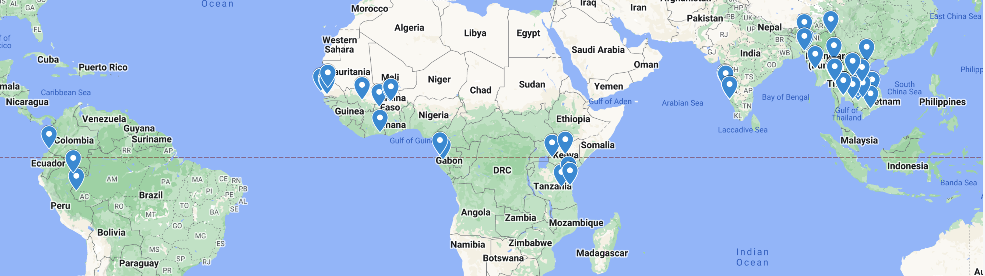

Supplementary Figure 2. Artesunate (panel A) and mefloquine (panel B) doses administered by weight, by study

B
A

Supplementary Figure 3. Artesunate (panel A) and mefloquine (panel B) doses administered, by treatment formulation

Supplementary Figure 4. Artesunate (A) and mefloquine (B) doses administered, by weight

B
A

Supplementary Figure 5. Day 2 positivity by study

.

Supplementary Figure 6. Day3 parasite positivity by study

Supplementary Figure 7. MQ dose by 24H effect for positivity on Day 2 by study

Supplementary Figure 8. MQ dose effect by study for parasite positivity on Day 3 in Asia

Supplementary Figure 9. Mefloquine dose (mg/kg) received at 24h by region. Data in Asia and South America include 2-dose regimens. Only 3-dose regimens were studied in Africa

Supplementary Figure 10. Recrudescence by study – outcome day 28,42,63

Supplementary Figure 11. Kaplan-Meier estimates of proportion of patients with recrudescence by region and artemisinin resistance level

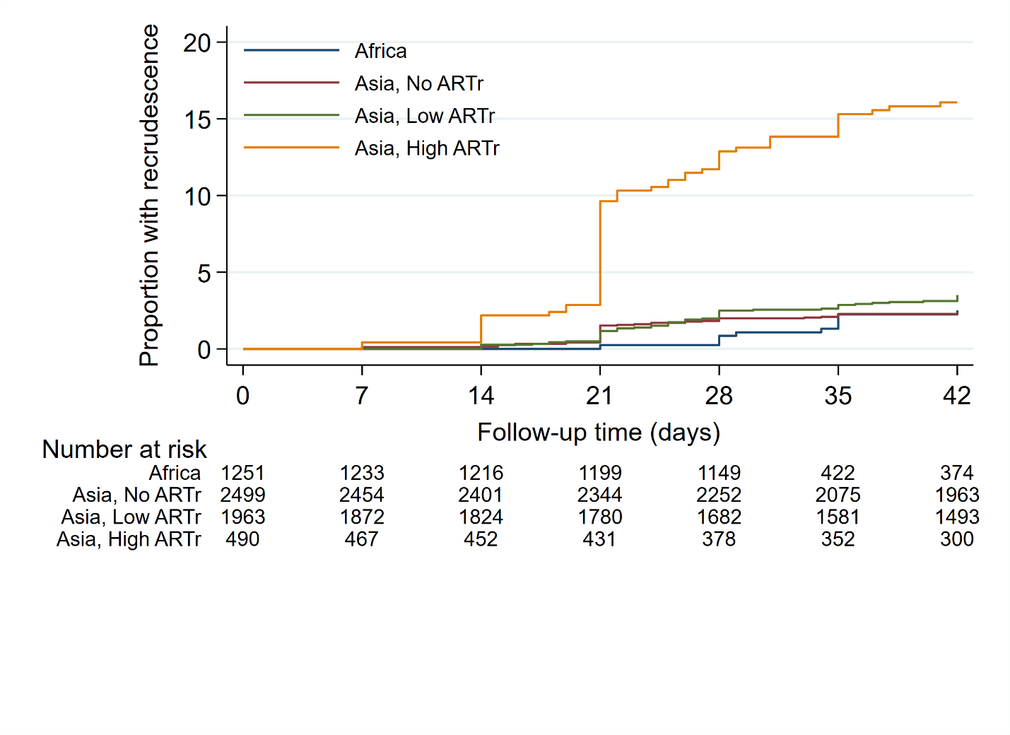
ARTr – Artemisinin resistance level

Supplementary Figure 12. MQ dose effect for recrudescence by study

Supplementary Figure 13. Reinfection by study

B

Supplementary Figure 14. Kaplan-Meier estimate of proportion of patients with reinfection, by transmission intensity

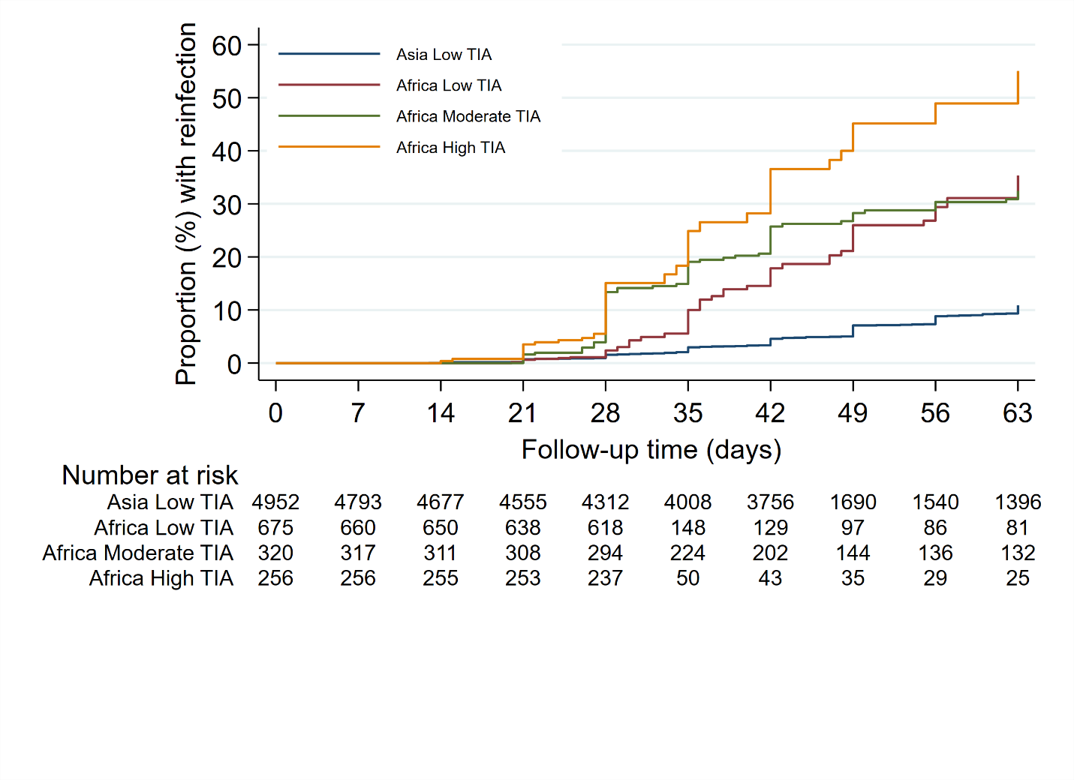
TIA - Transmission Intensity Area

Supplementary Figure 15: MQ dose effect for reinfection by study

Sensitivity analysis

Early Parasitological Response
These findings were confirmed in the sensitivity analysis (Additional File 1) for day 2 positivity. For day 3, one study (ID 29, N=855/6028 patients, n =131/254 positive slides) had impact on the findings, with a slightly reduced dose effect and wider non-significant confidence intervals including 1 observed after its exclusion, while the effect of excluding the MQ manufacturer was small and only affected confidence intervals due to the reduced sample size (Additional File 1: Supplementary Table 18). While slide positivity on day 2 or 3 among patients receiving fixed or loose 3-dose formulations were not significantly different in Asia (Table 3), in Africa and South America, patients treated with the fixed combination had higher risk of a parasite positive slide on day 2 (Africa AOR 2.66, 95%CI 1.16-6.11, p=0.021; South America AOR 2.49, 95%CI 0.94 -6.63, p=0.068 adjusted for baseline parasitaemia) compared to those treated with 3-day loose combinations (including co-blister in Africa).
In studies from Africa and South America, no other variables were independently associated with parasite positivity, so no multivariable models were built.

Supplementary Figure 16. Estimates (95% CI) of the dose effect (as in multivariable analysis tables) after exclusion of one study at a time. Study ID of the excluded study is shown on the x-axis. All – denotes estimates from the model fitted on all data. Estimates are OR, HR, RR or IRR
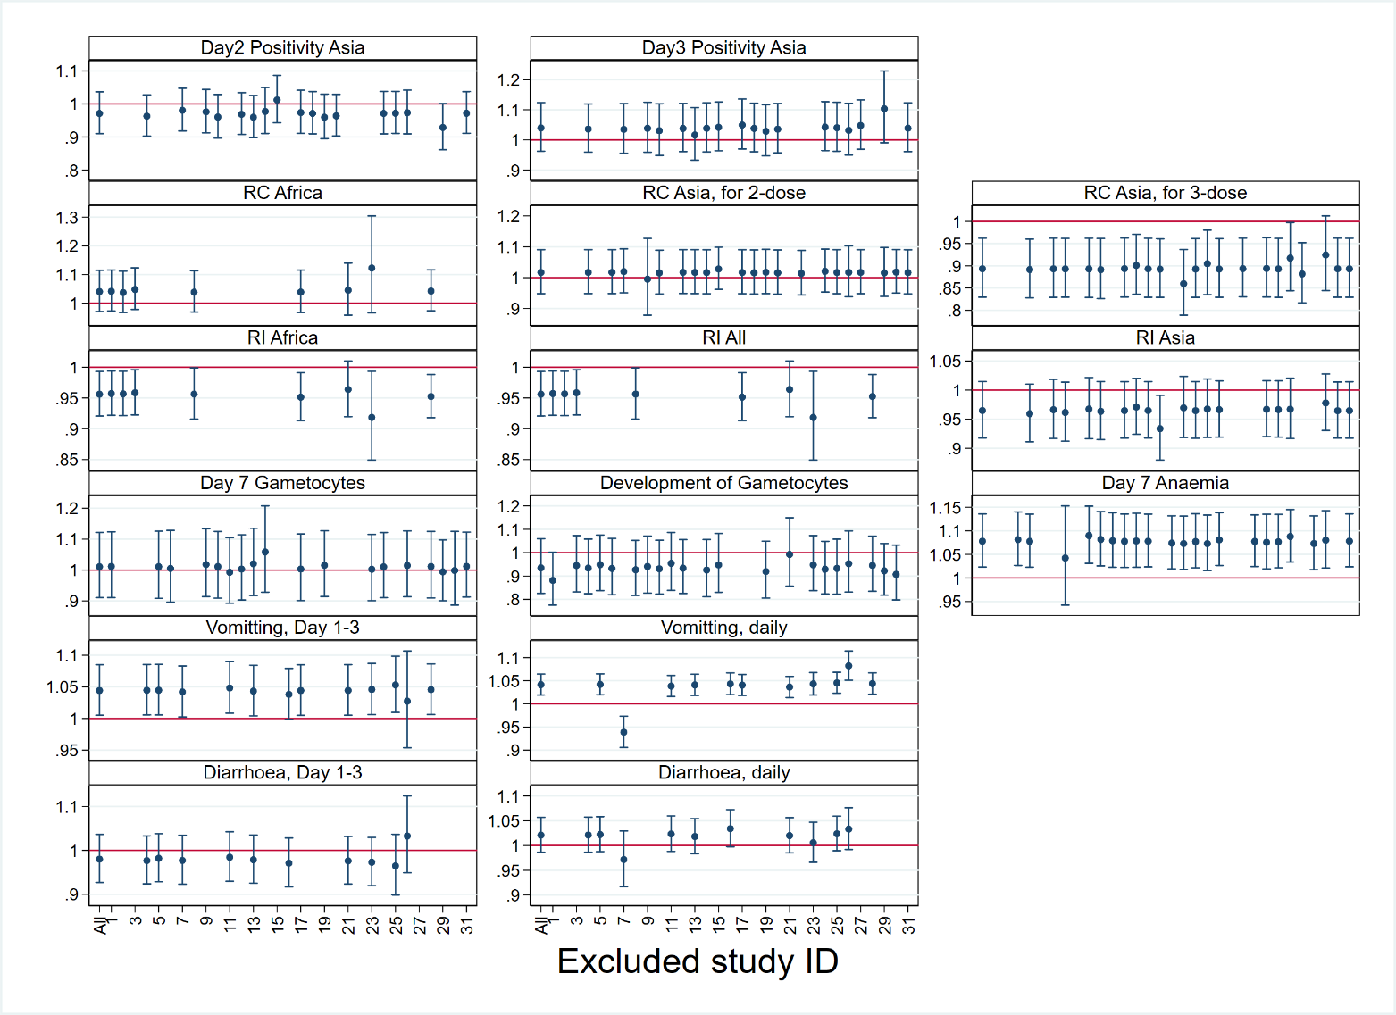

Supplementary Figure 17. Estimates (95% CI) for the comparison between different MQ regimens after exclusion of one study at a time. The comparison group is 3-dose loose regimen. Study ID of the excluded study is shown on the x-axis. All – denotes estimates from the model fitted on all data. Estimates are OR, HR, RR or IRR
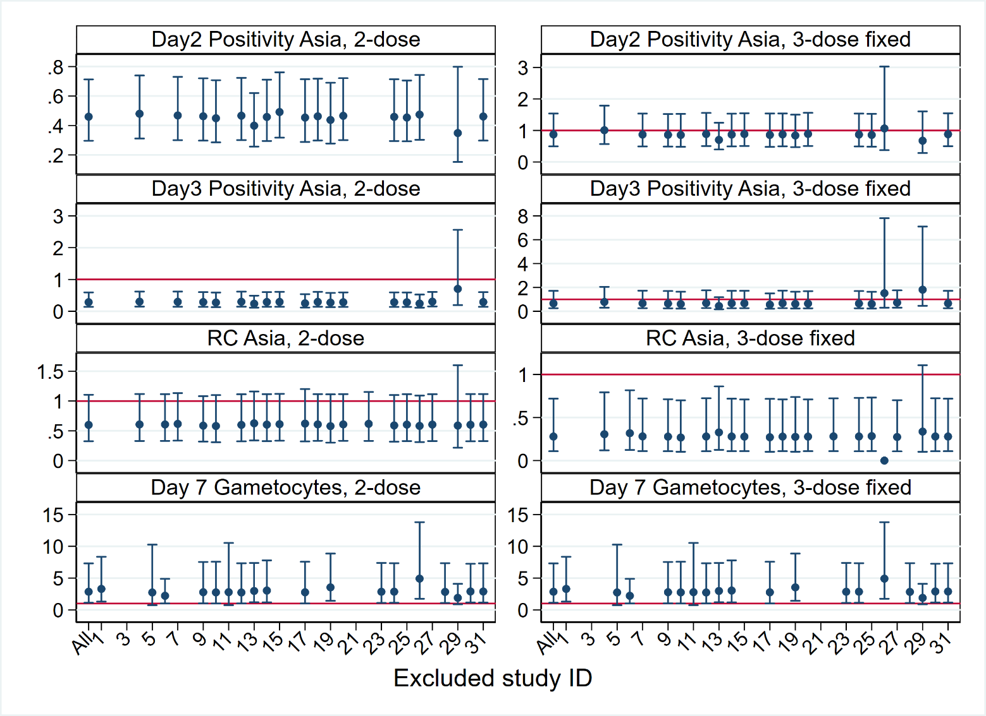

Supplementary Figure 18. Estimates (95% CI) of the dose effect ( as in multivariable analysis tables) after exclusion of one manufacturer at a time, for supervised data , and for studies using at least 3 markers for PCR genotyping. All – denotes estimates from the model fitted on all data. Estimates are OR, HR, RR or IRR

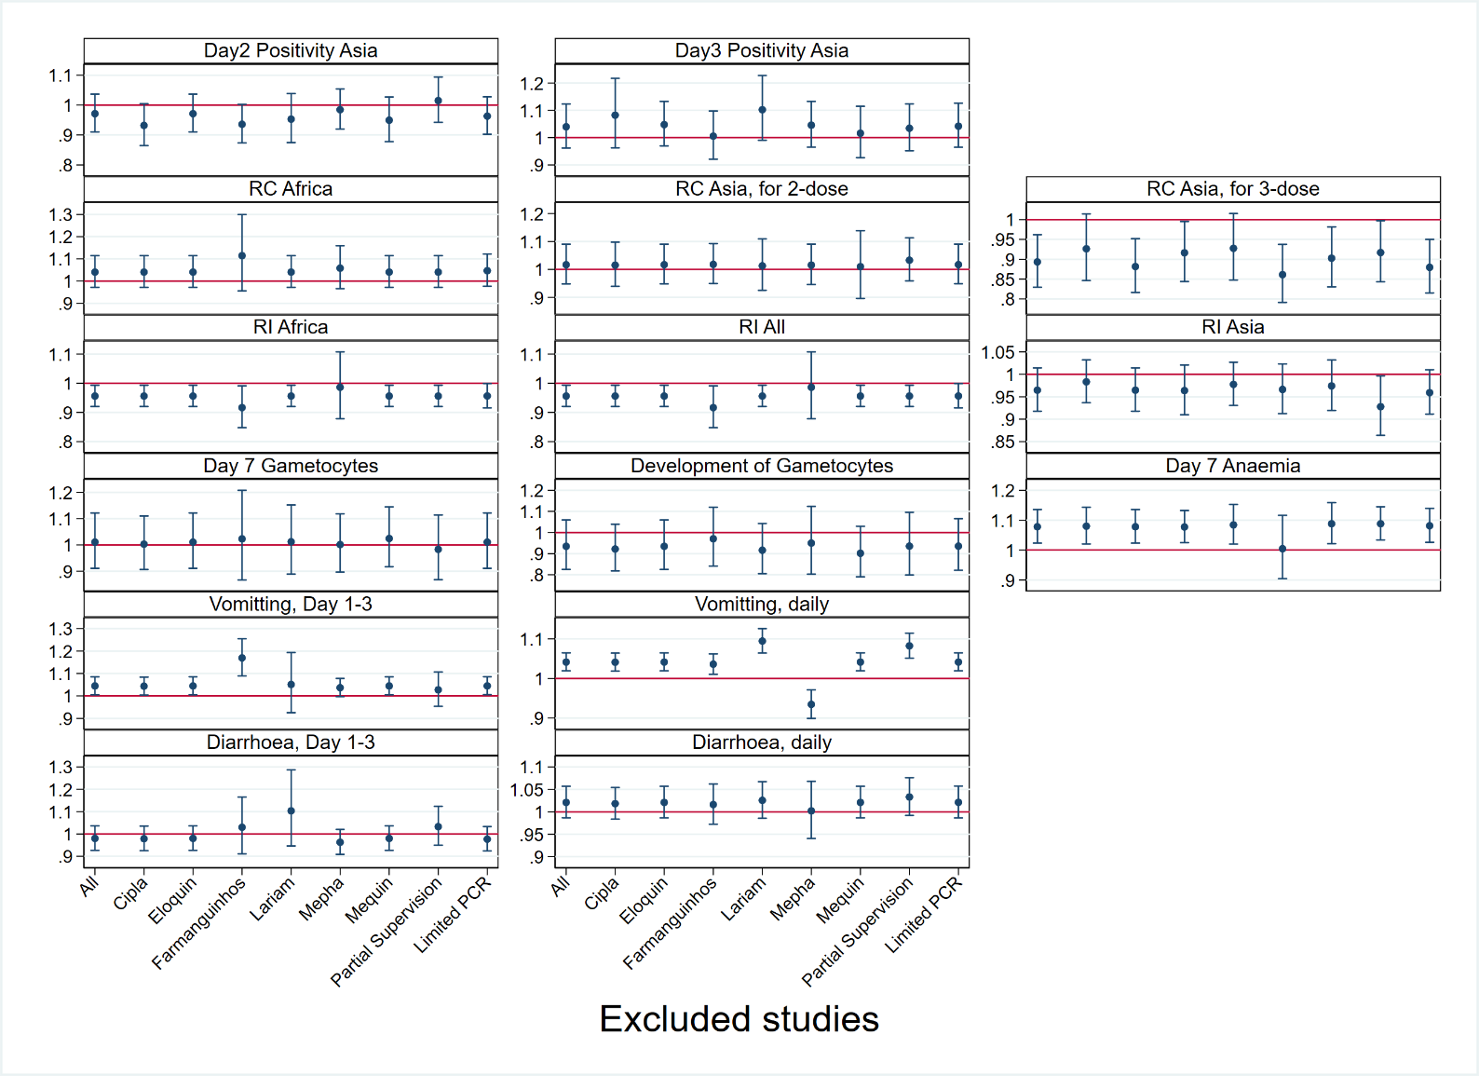

Supplementary Figure 19. Estimates (95% CI) for the comparison between different MQ regimens after exclusion of one manufacturer at a time, for supervised data only, and for studies using at least 3 markers for PCR genotyping. All – denotes estimates from the model fitted on all data. Estimates are OR, HR, RR or IRR

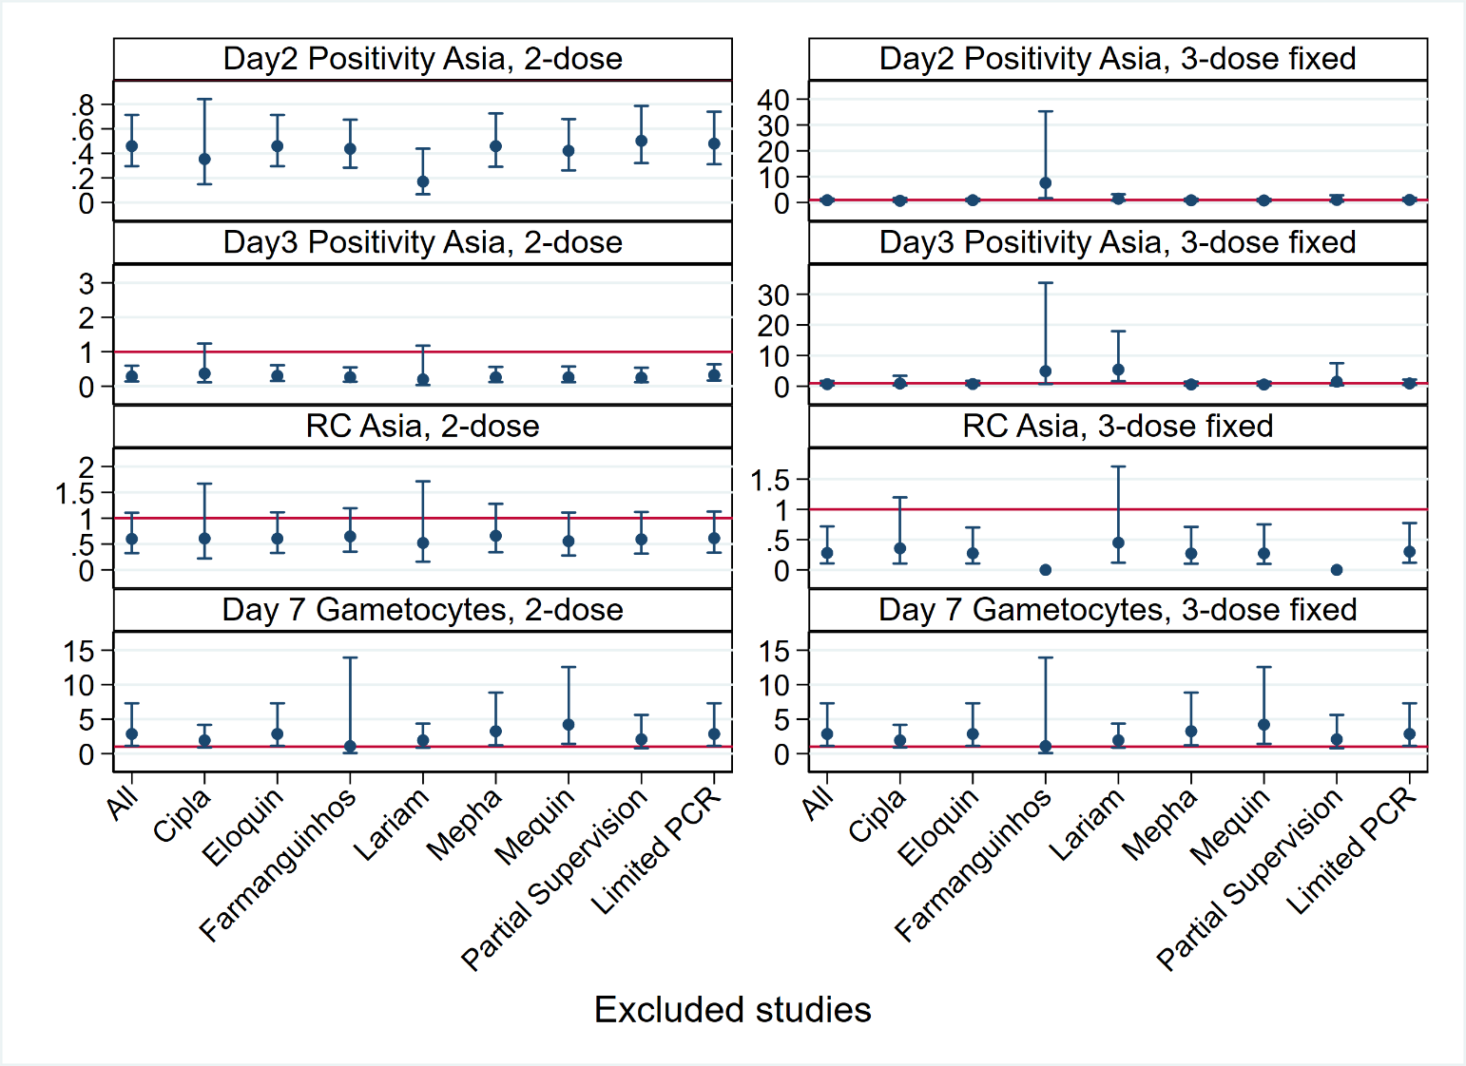

5 Supplementary References

1. WorldWide Antimalarial Resistance Network. Clinical Module: Data Management and Statistical Analysis Plan Version 1.2. 2012 [Available from: http://www.wwarn.org/sites/default/files/ClinicalDMSAP.pdf.
2. Gething PW, Patil AP, Smith DL, Guerra CA, Elyazar IR, Johnston GL, et al. A new world malaria map: Plasmodium falciparum endemicity in 2010. Malaria journal. 2011;10:378.
3. World Health Organization. Malaria surveillance, monitoring & evaluation: a reference manual 2018 [Available from: https://apps.who.int/iris/bitstream/handle/10665/272284/9789241565578-eng.pdf.
4. de Onis M, Garza C, Victora CG, Onyango AW, Frongillo EA, Martines J. The WHO Multicentre Growth Reference Study: planning, study design, and methodology. Food and nutrition bulletin. 2004;25(1 Suppl):S15-26.
5. WHO Multicentre Growth Reference Study Group. WHO Child Growth Standards: Length/height-for-age, weight-for-age, weight-for-length, weight-for-height and body mass index-for-age: Methods and development. Geneva World Health Organization. 2006:312.
6. Lee SJ, Stepniewska K, Anstey N, Ashley E, Barnes K, Binh TQ, et al. The relationship between the haemoglobin concentration and the haematocrit in Plasmodium falciparum malaria. Malaria journal. 2008;7:149.
7. Collett D. Modelling Survival Data in Medical Research. 3rd ed: CRC Press; 2015.
8. Royston P, Altman DG. Regression using fractional polynomials of continuous covariates: parsimonious parametric modelling. Applied Statistics. 1994;43:429-67.

