Supplementary materials

Supplementary Table 1. Primer and probe sequences for species-specific qPCR assays
Species | Primers and probes | Sequences (5’ -> 3’)
P. falciparum | Pf18S forward primer | GTAATTGGAATGATAGGAATTTACAAGGT
P. falciparum | Pf18S reverse primer | TCAACTACGAACGTTTTAACTGCAAC
P. falciparum | Pf18S probe | FAM-AACAATTGGAGGGCAAG-MGBNFQ
P. vivax | Pv18S forward primer | AGCAGCCGCGGTAATTCCA
P. vivax | Pv18S reverse primer | ATGCGCACAAAGTCGATACGAAG
P. vivax | Pv18S probe | TEXASRED-AGCAACGCTTCTAGCTTAATCCACAT-BHQ2

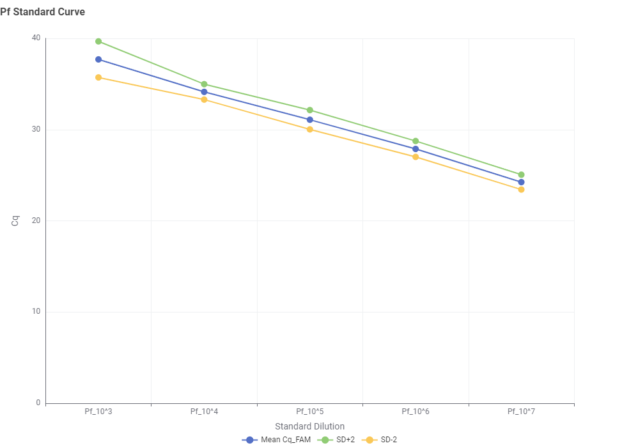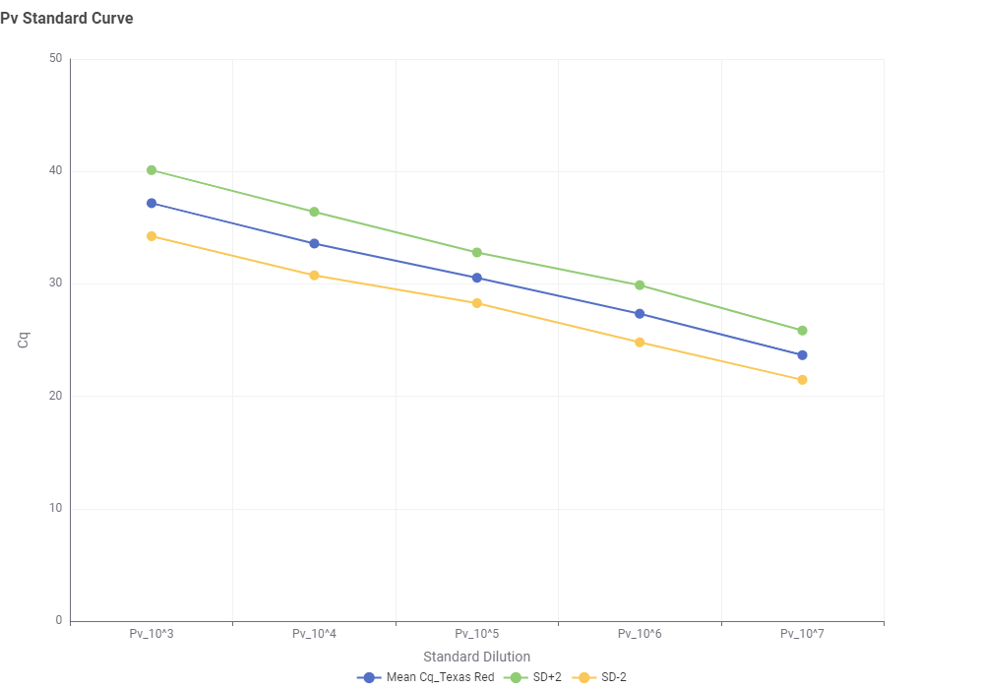
Supplementary Figure 1. Standard curves for P. falciparum and P. vivax qPCR multiplex experiments with the equation and R-squared values

Average Ct values for P. falciparum and P. vivax plasmids
Supplementary Table 2. Average Ct values of standards for both P. vivax and P. falciparum experiments
Plasmid serial dilution (10^n) | P. vivax averages | P. falciparum averages
3 | 37.18 | 37.69
4 | 33.59 | 34.13
5 | 30.54 | 31.08
6 | 27.35 | 27.88
7 | 23.66 | 24.24

Summary of average slope and efficiency in qPCR analysis
The slope, efficiency, and R² values obtained from the average of all qPCR experiments are presented in the table below.
Supplementary Table 3. Slope, efficiency, and R² values averaged across all qPCR experiments
Target | Average slope | Average efficiency (%) | R²
Pf18S DNA | -3.32 | 100.3 | 0.9996
Pv18S DNA | -3.33 | 99.7 | 0.9994

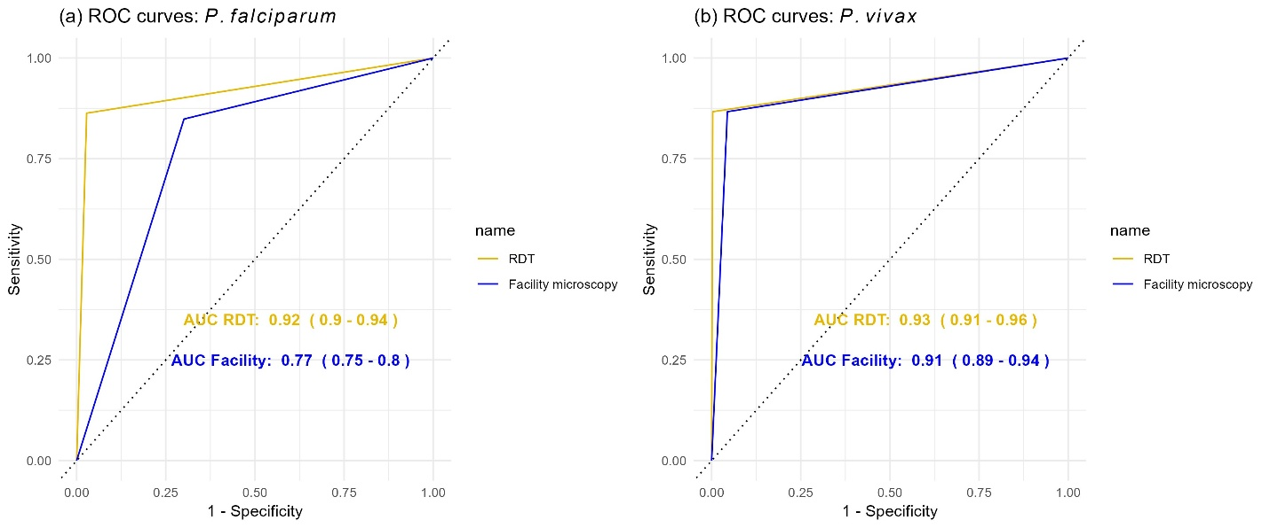
Supplementary Figure 2. ROC curves for the diagnostic performance of BIOCREDIT Ag Pf/Pv (pLDH/pLDH) RDT and microscopy against qPCR (reference standard)
The curves compare the BIOCREDIT Ag Pf/Pv (pLDH/pLDH) RDT (yellow) and facility microscopist (blue), with area under the curve values and 95% confidence intervals annotated. Panel (a) shows ROC curves for P. falciparum, and panel (b) for P. vivax.

Supplementary Table 4. A 2x2 contingency table for the BIOCREDIT Ag Pf/Pv (pLDH/pLDH) RDT and facility microscopy versus 18S rRNA qPCR (reference standard)
Test | TP | FP | TN | FN | Total qPCR+ | Total qPCR-
RDT vs qPCR (Any Plasmodium) | 437 | 30 | 683 | 50 | 487 | 713
RDT vs qPCR (P. falciparum) | 296 | 24 | 833 | 47 | 343 | 857
RDT vs qPCR (P. vivax) | 156 | 3 | 1017 | 24 | 180 | 1020
Microscopy vs qPCR (Any Plasmodium) | 291 | 26 | 687 | 196 | 487 | 713
Microscopy vs qPCR (P. falciparum) | 197 | 19 | 838 | 146 | 343 | 857
Microscopy vs qPCR (P. vivax) | 115 | 10 | 1010 | 65 | 180 | 1020
TP: True positive, FP: False positive, TN: True negative, FN: False negative

Supplementary Table 5. Descriptive statistics of qPCR-detected parasite densities by species
Species | N Positives | Median (copies/µL) | Mean (copies/µL) | Q1 | Q3 | Max (copies/µL)
P. falciparum | 343 | 364 | 27,781 | 18 | 10,456 | 1,017,020
P. vivax | 180 | 173 | 9,114 | 2 | 6,767 | 150,505
Mixed infections | 36 | Pf: 302 | Pf: 8,245 | 48 | 1,856 | 126,974
Mixed infections | 36 | Pv: 165 | Pv: 4,872 | 32 | 1,234 | 51,945
Q1: 25th percentile; Q3: 75th percentile

Supplementary Table 6. Sensitivity of the BIOCREDIT Ag Pf/Pv (pLDH/pLDH) RDT and microscopy by parasite density as measured by copies/µL of the 18S rRNA qPCR, P. falciparum (n=343) and P. vivax (n=180)
Species | Method | <1,000 copies/µL  n, % (95% CI) | 1,000–4,999 copies/µL  n, % (95% CI) | ≥5,000 copies/µL  n % (95% CI) | Spearman's rho | Logistic OR
P. falciparum | RDT | 144, 67.4 (59.1–74.9) | 53, 100 (93.3–100) | 146, 100 (97.5–100) | 0.564 (p<0.001) | 121.26 (31.21–695.78)
P. falciparum | Facility microscopy | 144, 78.5 (71.2–84.6) | 53, 96.6 (88.3–99.6) | 146, 99.2 (95.7–100) | 0.53 (p<0.001) | 10.77 (5.88–22.55)
P. vivax | RDT | 66, 68.2 (55.6–79.1) | 32, 98.4 (89.7–100) | 82, 100 (95.6–100) | 0.469 (p<0.001) | 6.84 (3.5–16.35)
P. vivax | Facility microscopy | 66, 72 (60.9–81.3) | 32, 90.6(75–98) | 82, 100 (91.6–100) | 0.446 (p<0.001) | 5.52 (3.01–12)
n: Number of qPCR-confirmed positives in stratum; % (95% CI): Sensitivity percentage (95% confidence interval); Spearman's rho: Correlation between density and detection (p-value); Logistic OR: Odds ratio of detection per log₁₀ density increase (95% CI); RDT: BIOCREDIT Ag Pf/Pv (pLDH/pLDH) RDT.

